

Plant Guide

# grassy tarweed

## Madia gracilis (Sm.) D.D. Keck

Plant Symbol = MAGR3

*Contributed by*: *USDA NRCS Corvallis Plant Materials Center, Oregon*

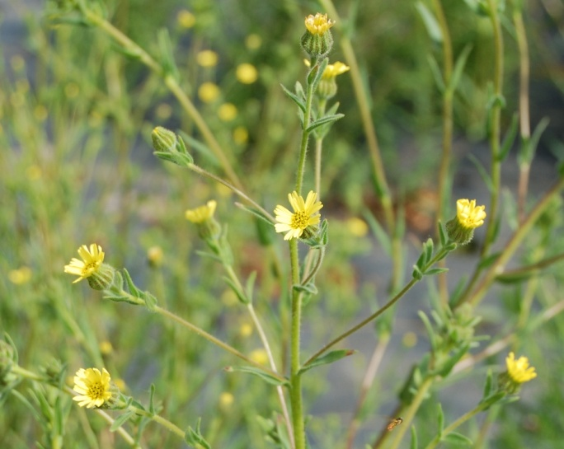 *Photo by Amy Bartow, NRCS Corvallis Plant Materials Center, 2012.*

### Alternate Names

*Alternate Common Names*: slender tarweed, slender gumweed, grassy tarplant, gumweed madia, sticky madia

*Alternate Scientific Names: Madia dissitiflora, Madia gracilis* spp. *collina, Madia gracilis* spp. *pilosa*

### Uses

*Pollinator habitat:* Grassy tarweed attracts many native pollinators and other beneficial insects. It can be included in roadside revegetation mixes and in pollinator hedgerows along farm edges.

*Wildlife:* The seeds are used as food by birds and small mammals.

*Restoration*: This native plant is useful to help control erosion in areas with disturbed soils that are low in nutrients. It is used for NRCS Conservation Reserve Program (CRP), Wetland Reserve Program (WRP), and Wildlife Habitat Incentives Program (WHIP) plantings.

**Ethnobotany**

People of the Mendocino, Miwok, and Pomo tribes used seeds of grassy tarweed to make pinole, which was a staple food source (Moerman, 2012).

**Status**

Please consult the PLANTS Web site and your State Department of Natural Resources for this plant’s current status (e.g., threatened or endangered species, state noxious status, and wetland indicator values).

**Description**

*General*: Grassy tarweed is an aromatic annual herb growing up to 36 inches in height; its stems are branching and hairy (Cronquist, 1961; Jepson Flora Project, 2012). The leaves are up to 4 inches long and covered in soft hairs and stalked resin glands. The flowers are racemes or panicle-like structures with 3 to 9 lemon yellow ray flowers and 2 to 12 disk flowers. The seeds are brown to black, often mottled achenes.

*Distribution*: Grassy tarweed is native to western North America from southern British Columbia to northern Baja California and east to Utah and Montana, at elevations from sea level to 7,800 ft (Cronquist, 1961; Jepson Flora Project, 2012; USDA-NRCS, 2012). For current distribution, please consult the Plant Profile page for this species on the PLANTS Web site.

*Habitat*: Grassy tarweed grows on open or partially shaded slopes or in flats in grasslands, meadows, shrublands, woodlands, forests, disturbed sites, stream banks, and roadsides (Jepson Flora Project, 2012). This species is found in full sun along roadsides and in other openings created by natural or manmade disturbance.

**Adaptation**

Grassy tarweed is adapted to quickly cover recently disturbed land. It often grows in coarse, sandy or gravelly soils, but is also found on silty/clayey soils, and sometimes on serpentine soils. It prefers full sun, but can tolerate light shade (Cronquist, 1961).

### Establishment

Seeds germinate in cool temperatures and naturally germinate in late fall. Seeds should be broadcast on the site in the fall so they can germinate and become established over the winter. There are approximately 300,000 seeds per pound. Sowing one pound of seed per acre will result in a rate of 7 seeds per square foot. For solid stands, sow at a rate of 5–7 pounds per acre.

### Management

Control of weedy perennial species that may out-compete grassy tarweed over time may be necessary. Encroachment of trees and shrubs will shade out this species. Grazing and periodic burning or mowing will help to maintain the habitat. Although this species is an annual herb, it readily self-sows and persists. It is avoided by livestock due to its odor, but is not known to be toxic.

### Pests and Potential Problems

There is no current information on pests or diseases of this species.

### Environmental Concerns

This plant readily self-sows and may spread and become weedy in pastures/rangeland or other neighboring habitat.

### Control

Please contact your local agricultural extension specialist or county weed specialist to learn what works best in your area and how to use it safely. Always read label and safety instructions for each control method.

### Seeds and Plant Production

*Field establishment:* For best establishment in seed production fields, grow plugs in a greenhouse (70°F days, 50°F nights) in late winter and transplant out in spring. Transplant into a field covered with weed fabric containing holes on 1ft by 1 ft spacing. Seeds can also be sown directly into holes in the weed fabric in late fall. Place 10 seeds per hole (2 pounds per acre) and cover them lightly with soil or vermiculite. For direct seeding of production fields (without weed fabric) use a rate of 50 seeds per square foot or 6 pounds per acre. Sow in fall at a depth of ¼ inch or less into rows 12 to 24 inches apart. Weed fabric is highly recommended because seeds shatter as they ripen and the fabric catches the seed so it can be collected after the plants are removed.

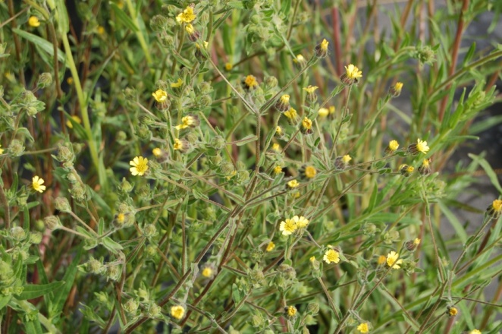*Photo by Amy Bartow, NRCS Corvallis Plant Materials Center, 2012.*

For agronomic seed increase, hand weeding and fertilization may be necessary. Types and rates of fertilizer have not been studied, but the application of nitrogen at a rate of 50 pounds per acre has boosted yields at the NRCS Plant Materials Center in Corvallis, Oregon. This species may become weedy in production areas, but does not become a persistent weed.

*Harvesting techniques:* Seeds fall from the plant as they mature and can shatter over a period of weeks. When seed production has commenced, cut plants at the base and place on tarps to dry, and then vacuum remaining seed off of the fabric and from the holes in the fabric.

Large fields, with or without weed fabric, can be directly combined. This method will result in much lower yields than fields with weed fabric due to high amount of shattering that occurs prior to and during harvest. Plants can be very sticky when green and should not be combined until sufficiently dried and less sticky. Seed yields are highly variable for this species and depend greatly on harvest method and size of mature plants. In Corvallis, OR, yields have averaged 100 to 200 pounds per acre for a field without weed fabric,or 400 to 1200 pounds per acre when using weed fabric.

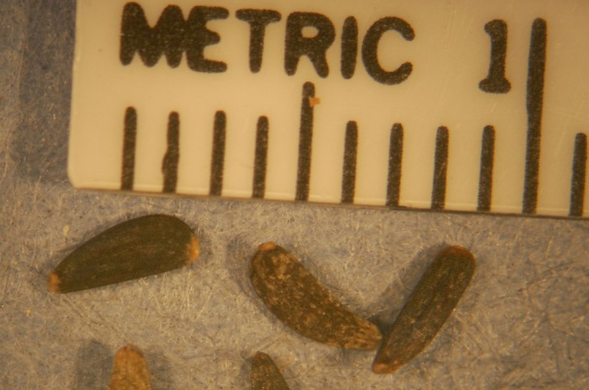*Photo by R.C. Hoffman, NRCS Corvallis Plant Materials Center, 2012.*

*Seed Cleaning Techniques:* Use a thresher, combine, or hammer mill to break seeds loose from plant material. Use an air screen machine to remove stems, chaff and unfilled seeds to reach desired purity standards. Distinguishing filled seed from non-filled seeds can be challenging with this species.

### Cultivars, Improved, and Selected Materials (and area of origin)

Seed of this species may be available from native plant nurseries from within its range. Contact your local Natural Resource Conservation Service office for more information on availability.

### References

Cronquist, A. 1961. Vascular plants of the Pacific Northwest. Part 5: Compositae. Univ. of Washington Press, Seattle.

Jepson Flora Project. 2012 (v. 1.0). Jepson eFlora, *Madia gracilis*, B.G. Baldwin, http://ucjeps.berkeley.edu/ cgi-bin/get_cpn.pl?MAGR3 (accessed 8 May 2012).

Moerman, D. 2012. *Madia gracilis*. In: Native American Ethnobotany Database [Online]. Univ. of Michigan, Dearborn. http://herb.umd.umich.edu/ (accessed 8 May 2012).

USDA-NRCS. 2012. The PLANTS Database, National Plant Data Team, Greensboro, NC. http://plants.usda.gov (accessed 8 May 2012).

**Prepared By**:

*Tyler C. Ross and Amy Bartow*

USDA-NRCS Corvallis Plant Materials Center, Oregon

### Citation

Ross, T.C. 2012. Plant guide for grassy tarweed (*Madia gracilis)*. USDA-Natural Resources Conservation Service, Plant Materials Center, Corvallis, OR.

Published December 2012

Edited: 13Dec2012 aym; 16Jan2013 jab

For more information about this and other plants, please contact your local NRCS field office or Conservation District at <http://www.nrcs.usda.gov/> and visit the PLANTS Web site at <http://plants.usda.gov/> or the Plant Materials Program Web site <http://plant-materials.nrcs.usda.gov>.

PLANTS is not responsible for the content or availability of other Web sites.

**USDA IS AN EQUAL OPPORTUNITY PROVIDER AND EMPLOYER**