

Plant Guide

# purple oniongrass

## Melica spectabilis Scribn.

Plant Symbol = MESP

*Contributed by*: USDA NRCS Idaho and Utah Plant Materials Program

color photograph of purple onion grass.
http://farm3.staticflickr.com/2733/4026974685_9356fe36e7.jpg**Purple oniongrass. Photo by Matt Lavin., Montana State University.**

### Alternate Names

*Common Alternate Names:* showy oniongrass, melica

*Scientific Alternate Names: Melica bulbosa* Geyer ex Porter & J.M. Coult. var. *spectabilis* (Scribn.) B. Boivinand *Bromelica spectabilis* (Scribn.) W. A. Weber

### Uses

Purple oniongrass is usually found in scattered amounts so is not considered a major forage species. However, it is ranked as providing good to excellent forage for cattle and horses and good for sheep and elk. Horses and cattle will utilize the plant during the entire growing season and are especially fond of the stalks and seed heads but sheep usually do not graze the plant much until late fall (Forest Service, 1937). However, purple oniongrass was found in the summer diets of sheep in a study in southwestern Montana (Buchanan et. al., 1972) but amounts could not be quantified. Deer and elk often graze it lightly (Forest Service, 1937). Extensive use of the corms (dense, underground vertical stems with dry papery leaf bases similar to a bulb) by grizzly bears in Yellowstone National Park have been documented (Mealey, 1980). Restoration of disturbed areas using purple oniongrass has been done with limited success (Noller, 2001).

### Status

Please consult the PLANTS Web site and your State Department of Natural Resources for this plant’s current status (e.g., threatened or endangered species, state noxious status, and wetland indicator values).

### Description

*General*: Grass Family (Poaceae). Purple oniongrass is a native, perennial, loosely tufted, rhizomatous, cool season grass. Culms are 45-100 cm (17-39 in) tall and the plant forms corms. The corms are connected to the rhizomes by a root-like structure which usually remains attached to the corm. Leaves are 2-5 mm (0.08-0.20 in) wide and 5-18 cm (2-7 in) long. Sheaths are usually glabrous and often pilose at the throat and collar. Ligules are 1-2mm (0.04-0.08 in) long, acute, erose or lacerate and glabrous. The panicle is 5-26 cm (2-10 in) long, narrow to occasionally open and branches are 2-5 cm (0.8-2 in) long, usually appressed but sometimes divergent and flexuous with 2-3 spikelets that disarticulate above the glumes. Spikelets are 7-19 mm (0.28-0.75 in) long with 3-7 florets. Glumes are usually less than half the length of the spikelets. The spikelets have purplish colored bands that appear regularly spaced. Lower glumes are 3.5-6.4 mm (0.14-0.25 in) long, 1.5-3 mm (0.06-0.12 in) wide, and 1-3 veined. Upper glumes are 5-7 mm (0.20-0.28 in) long, 2.3-3.5 mm (0.09-0.14 in) wide, and 5-7 veined. Chromosome number is 2n = 18. Purple oniongrass is often confused with *Melica bulbosa* (oniongrass) which has longer glumes and sessile corms. The purplish colored bands on spikelets of *M. bulbosa* also appear to be more concentrated towards the tips (Barkworth, 2007; Perryman and Skinner, 2007)

*Distribution*: Purple oniongrass is found from Alberta and British Columbia in Canada south to Montana, Wyoming, and Colorado and westward to the Pacific Coast states of California, Washington, and Oregon. For current distribution, please consult the Plant Profile page for this species on the PLANTS Web site.

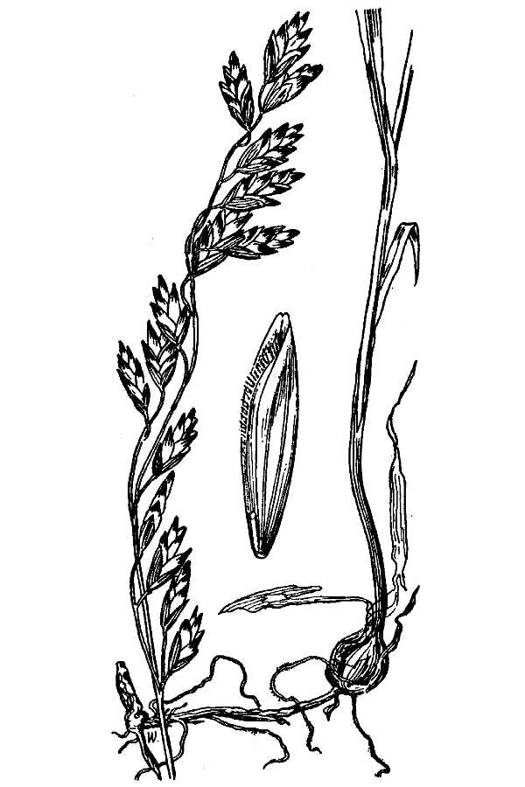 **Purple oniongrass. USDA-NRCS PLANTS Database / Hitchcock, A.S. (rev. A. Chase). 1950. Manual of the grasses of the United States. USDA Miscellaneous Publication No. 200. Washington, DC.**

*Habitat*: Purple oniongrass is found scattered throughout foothill and lower elevation mountain shrub covered slopes and along forest margins from 3900-8500 feet (1200-2600 m) elevation and in 16-20+ inch (406-508+ mm) annual precipitation zones.

**Adaptation**

Purple oniongrass is adapted to medium to fine textured, fertile soils and grow in areas with moderate shade. It grows in soils with a pH of 6.0 to 7.5 (USDA-NRCS, 2012).

### Establishment

Information in the scientific literature on establishment of purple oniongrass is very limited. Link (1993) reports there are approximately 556,000 seeds per pound. The seed matures in July/August and the seed needs cold stratification for 80 days at 32°F prior to planting. The Upper Colorado Environmental Plant Center in Meeker, Colorado has limited experience with growing the species. They attempted to grow plants from seed for Sequoia National Park with poor results. The plants did not establish well and did not produce much seed (Parr, personal communication; Noller, 2001)). The closely related species *M. bulbosa* has also been documented as producing relatively small amounts of poorly germinating seed (Forest Service, 1937).

### Management

Purple oniongrass appears to decrease when subjected to overgrazing by large animals (Skinner, 2010).

### Pests and Potential Problems

Purple oniongrass is susceptible to stripe smut fungus (*Ustilago striiformis*) but is not susceptible to flag smut fungus (*Urocystis agropyri*) (University of Illinois, Online). It may be susceptible to other unknown pests or other problems.

### Environmental Concerns

Purple oniongrass is a species native to the western United States and is not considered a weedy or invasive species. Under ideal climatic conditions it might very slowly spread into adjoining vegetative communities.

### Seed and Plant Production

There is very little published information available regarding seed or plant production of purple oniongrass.

### Cultivars, Improved, and Selected Materials (and area of origin)

There are no improved, selected materials or cultivars of purple oniongrass. There may be unnamed selections or ecotypes of this species available from commercial sources.

### References

Barkworth, M., 2007. *Melica,* p.88-102 in Barkworth, M., Capels, K. Long, S., Anderton, L. and Piep, M. (Eds.) 2007, Flora of North America North of Mexico, volume 24. Oxford University Press, New York and Oxford. http:/herbarium.usu.edu/Meliceae/Melica/Melica_spectabilis.htm [Accessed January 26, 2012]

Buchanan, H., Laycock, W. and Price, D. 1972. Botanical and Nutritive Content of the Summer Diet of Sheep on a Tall Forb Range in Southwestern Montana. Journal of Animal Science (35) 2. p 423-430.

Forest Service, 1937. Range Plant Handbook. Forest Service, U.S. Department of Agriculture. United States Government Printing Office. Variously paginated.

Link, E. 1993. Native Plant Propagation Techniques for National Parks. U.S. Department of Agriculture – Soil Conservation Service and U.S. Department of the Interior - National Park Service. 240 p.

Mealey, P. 1980.The Natural Food Habits of Grizzly Bears in Yellowstone National Park, 1973-74 *Bears: Their Biology and Management* Vol. 4, A Selection of Papers from the Fourth International Conference on Bear Research and Management, Kalispell, Montana, USA, February 1977 (1980), pp. 281-292

Noller, G., 2001. Propagation protocol for production of Melica spectabilis Scribn. Plants: Upper Colorado Environmental Plant Center, Meeker, Colorado. In: Native Plant Network. http://www.nativeplantnetwork.org Moscow, ID: University of Idaho College of Natural Resources, Forest Research Nursery. [Accessed January 26, 2012]

Parr, S. personal communication. Manager, Upper Colorado Environmental Plant Center, Meeker, Colorado.

Perryman, B. and Skinner, Q., 2007. A Field Guide to Nevada Grasses. Indigenous Rangeland Management Press, Lander, Wyoming. 256 p.

Skinner, Q. 2010. A Field Guide to Wyoming Grasses. Education Resources Publishing, Cumming, Georgia. 596 p.

University of Illinois Extension, online. Report on Plant Disease. Leaf Smuts of Turfgrasses. Department of Crop Sciences, University of Illinois at Urbana-Champaign. http://ipm.illinois.edu/diseases/index.html [Accessed February 3, 2012]

[USDA NRCS] USDA Natural Resources Conservation Service. 2012. The PLANTS Database, version 3.5. http://plants.usda.gov (accessed 6 Feb 2012). Baton Rouge (LA): National Plant Data Center.

**Prepared By**:

Loren St. John, USDA NRCS Plant Materials Center, Aberdeen, ID

Derek Tilley, USDA NRCS Plant Materials Center, Aberdeen, ID

### Citation

St. John, L., and D. Tilley. 2012. Plant guide for Purple oniongrass (*Melica spectabilis*) USDA-Natural Resources Conservation Service, Plant Materials Center, Aberdeen, Idaho 83210.

Published March 2012

Edited: 6Feb2012 ls; 6Feb2012 dt; 17Feb2012 jab; 17Feb2012 ls; 27Feb gm

For more information about this and other plants, please contact your local NRCS field office or Conservation District at <http://www.nrcs.usda.gov/> and visit the PLANTS Web site at <http://plants.usda.gov/> or the Plant Materials Program Web site <http://plant-materials.nrcs.usda.gov>.

PLANTS is not responsible for the content or availability of other Web sites.

**USDA IS AN EQUAL OPPORTUNITY PROVIDER AND EMPLOYER**