|  |  |
| --- | --- |
| **Natural Resources Conservation Service** | Plant Guide |

# SCARLET BEEBALM

## Monarda didyma L.

Plant Symbol = MODI

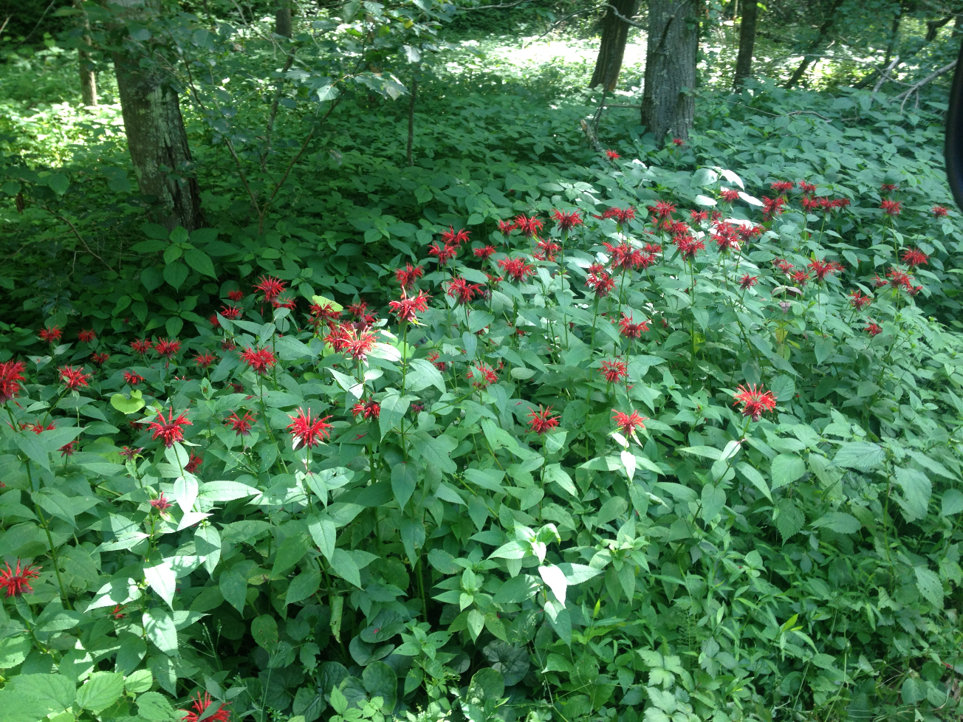

Natural stand of Monarda didyma. Photo by John C. Vandevender 2013.

### Alternate Names

*Common Names: s*carlet beebalm, oswego tea, bergamot, crimson beebalm

*Scientific Names: Monarda didyma*

### Description

*General*: Scarlet beebalm is a member of the mint family (Lamiaceae). This aromatic herbaceous perennial plant grows to a height of 2.0 to 5 feet (0.7 to 1.5 m) on branched, hairy, square stems. The leaves are opposite, ovate-lanceolate, acuminate, 3 to 6 inches (7.5 to 15 cm) long and dark green. The flowers bloom from June through September in beautiful clusters of scarlet red. The flowers are solitary, terminal and rounded on the end of the branching stems, supported by leafy bracts. The flowers are tubular in shape, long and narrow with two lips. The upper lip is narrow and the lower lip is wider. They have 2 long stamens which protrude past the upper lip. The flowers are perfect (containing both male and female parts).

*Distribution*: Scarlet beebalm is native to Eastern North America and Canada. The native range extends from Quebec south to Maine and down to Georgia and westward from Ontario to Minnesota and down to Missouri. It is also native to Washington and Oregon in the west.

For current distribution, please consult the Plant Profile page for this species on the PLANTS Web site.

*Habitat*: Scarlet beebalm prefers moist but well drained soils. It preforms best in full sunlight but is very adaptable to partial shade conditions. It can often be found along stream banks, thickets, road edges and at the borders to woodland openings.

***Adaptation***

The USDA hardiness zones for scarlet beebalm are 4 – 9. It grows best in a moist, rich loamy soil with high organic matter content but can tolerate almost any well-drained soil. Scarlet beebalm prefers a pH in the 6.0 – 7.0 range. Although it can tolerate drought, scarlet beebalm performs better with adequate soil moisture.

### Uses

Medicinally, it is a natural source for the antiseptic Thymol, which is the active ingredient in many modern mouthwashes (Wikipedia, The Free Encyclopedia, 2015). It is used as an anthelmintic, antiseptic, diaphoretic, diuretic, and a stimulant. Dried leaves and flower heads are used to make aromatic teas. Fresh leaves and shoot tips are used to add flavoring to salads. It is suitable for use in fresh and dried flower arrangements. Because of the minty odor, it is frequently used to make potpourri.

Scarlet beebalm is an important plant for pollinators including hummingbirds, butterflies and, to a lesser extent, moths, bees and other pollinating insects. Because of the structure of the flower tubes, long proboscises are needed to be able to reach the nectar.

### Ethnobotany

Scarlet beebalm was used extensively by Native Americans to treat a wide range of ailments. As the common name implies, scarlet beebalm was used to soothe bee stings by crushing the leaves of the plant and rubbing them on the skin. The Blackfeet used the plant as an antiseptic for skin and mouth infections (Georgetown, 2015). Poultices were applied directly to the skin to treat infections and minor wounds. Plant leaves were used to make an herbal tea for infections in the mouth and throat (Wikipedia, The Free Encyclopedia, 2015). The Cherokee and the Teton Dakota used the herb to treat stomach ailments (Georgetown, 2015). The Winnebago concocted a tea from the plant which they used as a general stimulant (Wikipedia, The Free Encyclopedia, 2015). Scarlet beebalm was used as a carminative to treat flatulence and as an anthelmintic for treatment of internal parasites. It has also been used for headaches, fevers, colds, sore throats, insomnia, nausea, vomiting, and bronchial ailments. One of the common names, Oswego tea, is derived from to the Oswego Native American tribe in upstate New York who taught the early settlers how to make the plant into an herbal tea. Settlers used scarlet beebalm when regular tea was scarce and as a replacement for black tea after high British taxation and the Boston Tea Party.

### Status

Scarlet beebalm is exploitably vulnerable in New York and probably extirpated in Michigan.

*Wetland Indicator:*

Facultative (FAC) status in Atlantic and Gulf Coastal Plains, Eastern Mountains and Piedmont and the Western Mountains, Valleys, and Coast. Status is facultative upland (FACU) in Northcentral and Northeast, obligated upland (UPL) in the Midwest.

*Weedy or Invasive:*

This plant may become weedy or invasive in some regions or habitats and may displace desirable vegetation if not properly managed. Please consult with your local NRCS Field Office, Cooperative Extension Service office, state natural resource, or state agriculture department regarding its status and use.

Please consult the PLANTS Web site (<http://plants.usda.gov/>) and your State Department of Natural Resources for this plant’s current status (e.g., threatened or endangered species, state noxious status, and wetland indicator values).

### Planting Guidelines

Seed ripens in the late fall to a medium brown color with a firm texture. When the seeds are ripe, the seed heads should be clipped from the plants and allowed to air-dry for several days. Once dry, inverting the seed heads and tapping them will dislodge most of the seed. This can also be accomplished by placing the seed heads in a paper bag and shaking to dislodge the seed. Remove the chaff from the seed by running it through a sieve. Stratify the seed for three months in wet sand or peat prior to planting at 34 to 40 0F (1 to 4 0 C).

Seed can be planted directly to the desired site by broadcasting in late winter through spring. Planting sites should be sunny with adequate soil moisture and reduced weed competition. Once seedlings emerge, apply water during extended dry periods to aid in survivability.

Germinate seed indoors by sowing in flats or plug trays containing a suitable soil mixture, e.g. one-third sand and two-thirds commercial plug mix. The soil should be moist and firm before seeding. Cover the seed with a thin 1/8” (3 mm) layer of soil to keep the seed moist. Seed should germinate in 1 to 2 weeks. Add water to the flats when the soil surface is dry to the touch. Apply a starter fertilizer when the seedlings are 2 to 3 weeks old. Transplant seedlings into larger containers after 6 – 8 weeks.

Space plants transplanted to the field 18 to 24 inches (45 to 60 cm) apart. This allows for sufficient air flow, reducing the chances of powdery mildew infection. Also, providing room for growth as the plants develop into 24 to 36 inch (60 to 91 cm) diameter clumps.

### Management

Scarlet beebalm is a low maintenance plant but benefits from care. Before planting, the addition of leaf mold and compost increases soil organic matter and improves the moisture holding capacity. Fertilize plantings in the spring with an all-purpose fertilizer (e.g. 10-10-10). Thinning stems early in the season will allow air circulation helping reduce mildew. Stems developing mildew are removed at the base of the plant and discarded. In sunny locations, scarlet beebalm is a prolific producer of blooms. Removal of the senesced flowers will prolong the blooming period and provide additional resources for pollinators. Clumps can be divided every 2 to 3 years in early spring while still dormant. It is also a good practice to mow the area, once a year, after the hardest killing frost. This keeps woody plants from encroaching and removes plants that have died back.

### Pests and Potential Problems

Powdery mildew is the most common disease problem associated with Monarda (Hawke, 1998). Outbreaks are often caused by poor air circulation because of the thick foliage and inadequate soil moisture. Scarlet beebalm has moderate resistance to damage by deer.

### Control

Please contact your local agricultural extension specialist or county weed specialist to learn what works best in your area and how to use it safely. Always read label and safety instructions for each control method. Trade names and control measures appear in this document only to provide specific information. USDA NRCS does not guarantee or warranty the products and control methods named, and other products may be equally effective.

### Cultivars, Improved, and Selected Materials (and area of origin)

Over 50 cultivars of scarlet beebalm are readily available from commercial sources. These cultivars have been developed for flower color, bloom period, plant height, disease resistance, flavor (teas), essential oil production, winter injury and deer resistance.

Cultivars should be selected based on the local climate, resistance to local pests, and intended use. Consult with your local land grant university, local extension or local USDA NRCS office for recommendations on adapted cultivars for use in your area**.**

**Literature Cited**

Georgetown University Medical Center. Urban Herbs: Medicinal plants at Georgetown University. (<http://units.georgetown.edu/gumc/urbanherbs/bee_balm.htm>, 19 February 2015.

Hawke, R.G. Issue 12, 1998. Plant evaluation notes – Monarda and powdery mildew resistance. Chicago Botanic Garden, Glencoe, IL.

Wikipedia contributors, “Monarda didyma,” Wikipedia, The Free Encyclopedia, (<https://en.wikipedia.org/w/index.php?title=Monarda_didyma&oldid=641341505> (accessed August 21, 2015).

Wikipedia contributors, “ Monarda,” Wikipedia, The Free Encyclopedia, ([https://en.wikipedia.org/w/index.php?title=Monarda&oldid=672369655 (accessed August 21, 2015).](https://en.wikipedia.org/w/index.php?title=Monarda&oldid=672369655%20(accessed%20August%2021,%202015).)

### Citation

Lester, Randall K. and John Vandevender. 2015. Plant Guide for scarlet beebalm (Monarda didyma*)*. USDA-Natural Resources Conservation Service, Appalachian Plant Materials Center, Alderson, WV 24910.

Published: July 2015

Edited:

For more information about this and other plants, please contact your local NRCS field office or Conservation District at <http://www.nrcs.usda.gov/> and visit the PLANTS Web site at <http://plants.usda.gov/> or the   
Plant Materials Program Web site:

<http://plant-materials.nrcs.usda.gov>.

PLANTS is not responsible for the content or availability of other Web sites.

***Helping People Help the Land***

**USDA IS AN EQUAL OPPORTUNITY PROVIDER AND EMPLOYER**