

Plant Guide

# PURPLE NEEDLEGRASS

*Nassella pulchra* (Hitchc.) Barkworth

Plant Symbol = NAPU4

Contributed by: USDA NRCS California State Office and Lockeford Plant Materials Center, California

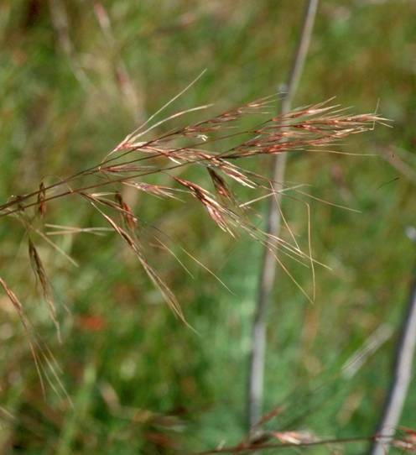 Purple needlegrass. Photo by Lynn Watson.

### Alternate Names

Purple stipa, purple tussockgrass

**Uses**

*Restoration*

Purple needlegrass, the state grass of California, is appropriate for restoration and range improvement throughout much of California’s Central Valley and foothills. The species is highly valued as an erosion control grass due to its longevity, tolerance to poor soil conditions and its ability to establish a coarse root system on disturbed sites with low soil fertility. The species is known for establishing easily on disturbed soils, roadsides and gopher mounds. It has been successfully used in re-establishing native perennial grasses following weed control on sites previously occupied by introduced annual species.

*Wildlife/livestock*

Purple needlegrass is a valuable forage species which provides food for deer, elk and other wildlife. It can be an important source of food for livestock, having moderate protein values and high palatability (USDA 2009). The leaves green up early in the season and provide good quality early forage for grazing animals. Unfortunately, but the sharp-tipped seeds and awns can become injurious as they dry later in the season. However, shatter is complete within a month of maturity and difficulties can be avoided through pasture management. This species is generally not that important as a livestock forage as it fails to make up a significant portion of the forage base over most of its range, and because under rangeland conditions livestock tend to avoid it later in the season. The fact that livestock do not prefer the species over others is part of reason why it persists in such abundance when compared to other natives of greater palatability for livestock.

*Low water use lawn and landscaping*

Purple needlegrass is an excellent native grass for use in low water landscaping. The species has also been used in native grass lawns, but its bunching habit prevents it from forming a uniform sod. Animals such as dogs have been known to get the seed lodged in their fur. The awns then break off leaving the small, sharp seed which can burrow under the skin. These problems can be avoided by mowing the seed prior to maturity. Lawns should be mowed to no lower than 4 inches (10 cm).

**Status**

Consult the PLANTS Web site and your State Department of Natural Resources for this plant’s current status (e.g. threatened or endangered species, state noxious status, and wetland indicator values).

**Description**

*General*: Grass Family (*Poaceae*). Purple needlegrass is a densely tufted, long-lived, upright perennial bunchgrass with conspicuously long awns. It has numerous basal leaves and a distinct nodding habit at anthesis. Plants are generally 2 to 3 feet tall (0.6 to 0.9 m) producing an open, nodding panicle of 4 to 8 inches (10 to 20 cm). The leaf blades are smooth to finely hairy. Basal blades are long, flat and 0.03 to 0.2 inches (0.8 to 3.5 mm) wide. The seeds (florets) range from 0.3 to 0.4 inches (7.5 to 11.5 mm) long with a hairy lemma and a twice-bent awn reaching 1.5 to 4 inches (38 to 100 mm) in length (Hickman 1993). There are typically between 115,000 and 150,000 seeds/lb in a well processed seed lot. Unprocessed seed with the awns still attached can have as few as 50,000 seeds/lb.

Purple needlegrass has been reported to root as deep as 16 feet (4.8 m) in deep soils (Netstate 2009), but the roots more typically range from 2 to 6 feet deep (pers. obs.). Plants become dormant after seed production, but begin growth again with fall rain. Plants will also regreen after summer dormancy even without the presence of precipitation. This is believed to be in response to shortening day lengths.

Purple needlegrass is wind pollinated. Plants can regenerate either asexually by tillering and bunch fragmentation, or via seed dispersal. Seed burial is facilitated by the sharp pointed seed and long awns which twist as they dry, driving the seed into the soil.

Purple needlegrass has been shown to have very high self pollinating rates (Larsen et al. 2001). Results indicate that inbreeding and/or selection have contributed to the significant differentiation of needlegrass populations.

There are two native and one introduced *Nassella* species which are commonly mistaken for purple needlegrass in California. The native needlegrasses, nodding needlegrass (*N. cernua*) and foothill needlegrass (*N. lepida*), have a wavy distal awn segment which differs from the straight distal awn segment found on purple needlegrass (Hickman 1993). Additionally, nodding needlegrass typically has a longer awn and thinner seed than purple needlegrass, while foothill needlegrass has much smaller seed and shorter awns than purple needlegrass.

*Nassella manicata* is native to South America and has been detected in California in the San Francisco Bay area and near Folsom, California (Amme 2003). It was previously misidentified as *N. formaricum* in The Jepson Manual (Barkworth 2007). The Flora of North America separates the two species with *N. manicata* having florets 6-8 mm long with lemmas glabrous between the veins at maturity, and *N. pulchra* having florets 7.5 –11.5 mm long with lemmas evenly pubescent at maturity (Barkworth 2007).

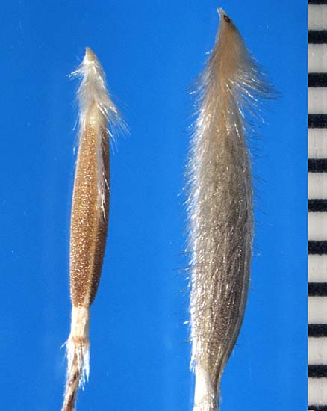

Seed of *Nassella manicata* (left) and *N. pulchra* (right). Photo by James Effenberger, California Department of Food and Agriculture, 2009.

**Distribution**

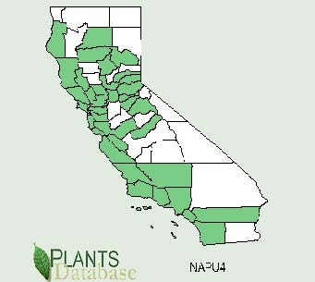

County level distribution map of purple needlegrass. Image from PLANTS database (2009).

The distribution of purple needlegrass prior to European settlement is undetermined. It was previously widely believed that purple needlegrass was a climax species in California, occupying much of the valley and coastal grasslands. New studies suggest, however, that beardless wildrye may have been more dominant on heavier clays, while purple needlegrass was the dominant grass in more sandy areas (Holstein 2001). Purple needlegrass currently occurs on the west side of the Coast Range from northern Baja California north to southern Oregon, the Central Valley and foothills of the Cascade Range and Sierra Nevada as well as the Channel Islands. For current distribution consult the Plant Profile page for this species on the PLANTS Web site.

**Habitat**

Prior to European settlement, purple needlegrass was one of the dominant grass species of California’s valley grasslands and foothills. The species now occurs in grasslands, oak and pine woodlands, mixed evergreen forests, chaparral, and coastal scrub, but has been replaced in many instances by introduced annual grasses such as annual rye (*Lolium perenne* ssp. m*ultiflorum*), wild oat (*Avena fatua*), slender oat (*A. barbata*), ripgut brome (*Bromus diandrus*), soft chess (*B. hordeaceus*), mouse barley (*Hordeum murinum*), and rattail fescue (*Vulpia myuros*).

In natural plant communities it is frequently associated with Idaho fescue (*Festuca idahoensis*), prairie junegrass (*Koeleria macrantha*), Sandberg bluegrass (*Poa secunda*) and bottlebrush squirreltail (*Elymus elymoides*) (Heady 1977). It can also be found with California oatgrass (*Danthonia californica*), California fescue (*Festuca californica*), tussockgrass (*Nassella lepida*), beardless wildrye (*Leymus triticoides*), and melic grass (*Melica* spp.). In coastal areas purple needlegrass is found in association with red fescue (*Festuca rubra*) and California brome (*Bromus carinatus*).

**Adaptation**

Purple needlegrass grows in oak woodland, chaparral and grasslands in areas receiving between 8 and 40 inches (20 to 100 cm) of annual precipitation. Its elevational range extends from sea level to 4,300 feet (1300 m). It is well adapted to droughty soils, clays and serpentine soils. The species grows well in full sun as well as partial shade and is tolerant of extreme summer heat and drought. Purple needlegrass does not tolerate being overshaded by non-native annuals. Some ecotypes of the species have partial flood tolerance.

**Establishment**

For best results, seed should be planted to a depth of ¼ to ½ inch into a firm weed-free seedbed. The pure stand recommended drill seeding rate is 9.5 lb pure live seed (PLS) per acre for approximately 25 seeds/ft². This is based on 115,000 PLS/lb. For broadcast applications the pure seed rate is 15 lbs/ac. Planting 1 lb/acre yields approximately 3 seeds/ft². Seed can be planted in early spring, but late dormant fall seeding is recommended for best emergence and competition against annual weeds. For seed mixtures, using rice hulls or another dilutent is recommended to prevent the settling of smaller seed in the mixture. Like other native perennial grasses, this platn should generally not be seeded in mixes including annual grasses which reduce the likelihood of establishment.

During establishment, disturbance should be minimized. Purple needlegrass does not compete well with annual grass or broadleaf weeds during the establishment period because of slow establishment during the first year. It requires bare ground to re-seed, but volunteers readily into openings and increases once it is established. Stands are usually maintained by abundant seed production in non-grazed or properly grazed areas. The species can also expand vegetatively when tussocks are fragmented.

**Management**

The most important management issue for purple needlegrass seedings is preventing overwhelming weed competition, especially from exotic grasses but also aggressive broadleaf weeds. Studies have shown the presence of annual exotic grasses can reduce the growth and seed production of purple needlegrass at all developmental stages (Hamilton et al. 1999). Young needlegrass seedlings grow at a much slower rate than most weeds. The weeds easily overshade and outcompete new seedlings for sunlight and can dramatically impact establishment. Where possible, control competing vegetation. Some options for competition control include mowing, herbicide applications and closely controlled and timed grazing. It is a good idea to control weeds prior to needlegrass emergence if possible. Other options include mowing, herbicide wicking and limited grazing.

New seedings should not be grazed for two to three years following planting to ensure full establishment. However, under heavy competition by weeds, limited grazing can open the plant canopy and allow sunlight for new seedlings. Purple needlegrass should not be grazed during flowering to ensure formation of the seed and to allow food storage in the crown. The plants have a good tolerance for mowing, especially after seed maturity, but can be mowed earlier.

Purple needlegrass is fire tolerant and may benefit from prescribed burning. It commonly produces a more abundant seed crop the year after a fire. The season during which the fire occurs may determine the effects on the grass. It typically will re-sprout after spring or fall burns, but does not recover as well after a summer burn due to typically higher fire temperatures at the soil surface. Larger plants often do not recover due to higher crown temperatures especially when excessive thatch has been allowed to build up, increasing fire temperatures.

**Pests and Potential Problems**

Seedlings are susceptible to damping off in cold wet weather, especially in December and January. Pre-treating seed with a fungicide has been used to effectively reduce fungal problems. Smut has been detected in purple needlegrass plantings, but is not typically a problem. Seed can be affected by smut but this has not been very prevalent. Rust can also be a problem in green house seedling transplants but has not been a problem in field plantings.

**Seed and Plant Production**

Seed production fields can be planted at a rate of 4.4 lbs PLS/ac using 20 or 30 inch row spacing. Some growers have also planted purple needlegrass on 5 foot beds with 4 rows per bed at 8 inch spacing. Seed matures in mid- to late spring and can be collected for two to four weeks but shatters very quickly during hot, dry weather.

Fields can be harvested several times as seed matures using a seed stripper. Stripped seed should be dried prior to processing. During drying and curing the awns curl up on each other and the product becomes a connected mat of seed and awns. This can be run through a stationary combine to separate the awns from the seed, but some seed is broken during this process. Heavy fields can be swathed into windrows and combined once the seed and straw have cured.

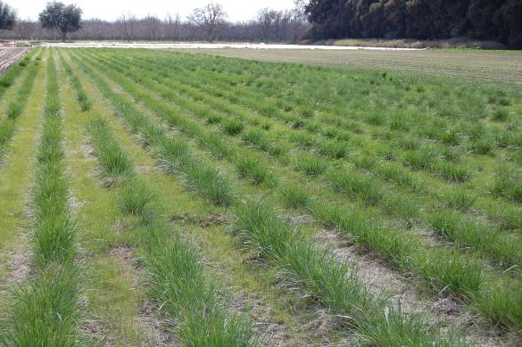

First year purple needlegrass seed production field at the NRCS Plant Materials Center in Lockeford, CA.. Photo by Derek Tilley.

It is important to accurately determine when the field is mature enough to swath. It is also very important to form the windrows so that the seed is incorporated into or on top of the straw. The seed in the panicles that hang over the side of the windrow will shatter on to the ground during curing, but this is minimal. If windrows are rained on or are cut with high moisture levels, black mold can infect the material and the seed which can adversely affect viability.

Seed yields vary considerably ranging between 75 to 600 pounds/acre depending on the year, wind, rains, and age of the stand. If desired, straw can be baled directly after swathing for seed bales. Bales made after combining and windrowing also contain small amounts of seed.

**Cultivars, Improved, and Selected Materials (and area of origin)**

There are numerous germplasms of purple needlegrass available from the commercial seed industry.

The NRCS Lockeford Plant Materials Center has released three purple needlegrass accessions in 1997 following a common garden study evaluating 32 accessions. They were chosen for natural-track, selected class release based on their early flowering, superior vigor, height and plant establishment density compared to other accessions. The assigned names were designations of release origin (LK=Lockeford), sequential number release (1 through 3) and recommended area of use by Major Land Resource Area (MLRA) and 4Eta zone (b through h) as used by Arkley and Ulrich (1962). The selected natural germplasm releases have been found to be genetically well defined and most similar to natural seed collected near the corresponding source populations (Larsen et al., 2001). Thus, these commercial germplasm sources should be useful for conservation plantings within the intended areas of utilization. Breeder and Foundation seed of these releases is maintained at the NRCS Lockeford Plant Materials Center.

LK 115d Selected Germplasm: This collection was made in Tehama County, California along Highway at approximately 2,300 feet (700 m) in elevation. Mean annual precipitation at the site is 25 inches (0.6 m). LK 115d was released primarily for use in northern portions of California’s Central Valley and southern foothills of the Cascade Range.

LK 215e Selected Germplasm was collected in Colusa County, California at the Walnut Valley Ranch near Lodoga, California. Elevation at the site was approximately 1,280 feet (390 m) with annual precipitation ranging from 9 to 40 inches (0.2 to 1.0 m). Potential area of adaptation includes the Central Valley and inner coastal foothills.

LK 315d Selected Germplasm was collected in Alameda County, California at Rancho Los Mochos Boy Scout Camp. The elevation of the original collection was approximately 2,056 feet (627 m). Mean annual precipitation at the collection site is 14 to 35 inches (0.3 to 0.9 m). LK 315d was released primarily for use in the Bay area and outer coastal foothills.

**References**

Amme, D. 2003. Nassella Notes. Grasslands: A Publication of the California Native Grass Association 13(4):3p

Arkley, R., and R. Ulrich. 1962. The use of calculated actual and potential evapotranspiration for estimating potential plant growth. Hilgardia 32(10): 444-462. Barkworth, M.E. 2007. *Poaceae*. For: Flora of North America Editorial Committee, eds. Flora of North America North of Mexico. 12+ vols. New York and Oxford. Vol. 24.

Hamilton, Jason G.; Holzapfel, Claus; Mahall, Bruce E. 1999. Coexistence and interface between a native perennial grass and non-native annual grasses in California. Oecologia. 121(4): 518-526.

Heady, Harold F. 1977. Valley grassland. In: Barbour, Michael G.; Major, Jack, eds. Terrestrial vegetation of California. New York: John Wiley and Sons: 491- 514.

Hickman, James C., ed. 1993. The Jepson manual: Higher plants of California. Berkeley, CA: University of California Press. 1400p.

Holstein, Glen. 2001. Pre-agricultural grassland in central California. Madrono. 48(4): 253-264.

Larson, S. R., Cartier, E., McCracken, C. L. and D. Dyer. 2001. Mode of reproduction and amplified fragment length polymorphism variation in purple needlegrass (*Nassella pulchra*): utilization of natural germplasm sources. Molecular ecology 10(5):1165-77.

Netstate. 2009. URL: http://www.netstate.com/

states/symb/grasses/ca_grass.htm. [2009, August 6].

Steinberg, Peter D. 2002. Nassella pulchra. In: Fire Effects Information System, [Online]. U.S. Department of Agriculture, Forest Service, Rocky Mountain Research Station, Fire Sciences Laboratory (Producer). Available: http://www.fs.fed.us/database/feis/ [2009, August 6].

USDA Natural Resources Conservation Service. 2008. The PLANTS database, version 3.5. URL: http://plants.usda.gov (accessed 13 Aug 2008). Baton Rouge, LA. National Plant Data Center.

**Prepared By**

Derek Tilley, USDA NRCS Plant Materials Center, Lockeford, CA

David Dyer, USDA NRCS Plant Materials Center, Lockeford, CA (retired).

John Anderson, Hedgerow Farms, Winters, CA.

**Species Coordinator**

Derek Tilley, USDA NRCS Plant Materials Center, Lockeford, CA

Published September, 2009

Edited: 082009 djt; 081109 ja; aym 080709; 081909 rb; 081909 jg.

For more information about this and other plants, please contact your local NRCS field office or Conservation District at <http://www.nrcs.usda.gov/> and visit the PLANTS Web site at <http://plants.usda.gov/> or the Plant Materials Program Web site <http://plant-materials.nrcs.usda.gov>.

PLANTS is not responsible for the content or availability of other Web sites.

**USDA IS AN EQUAL OPPORTUNITY EMPLOYER**