

Plant Guide

# PINK PAPPUSGRASS

## Pappophorum bicolor

## E. Fourn.

### Plant Symbol = PABI2

#### Contributed by: USDA NRCS, E. “Kika” de la Garza Plant Materials Center

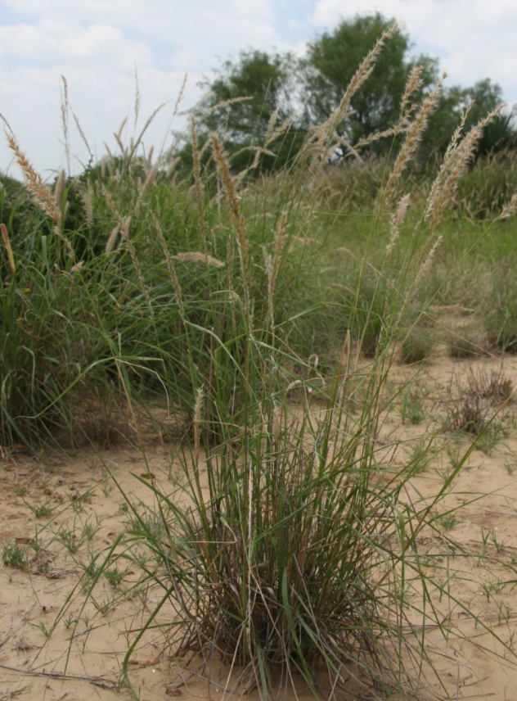 Forrest Smith, South Texas Natives

#### **Alternate Names**

*Pappophorum mucronulatum*

## Uses

Pink pappusgrass is useful for upland wildlife plantings, highway right-of-ways and ecosystem restoration. It provides fair forage for livestock. It also may have uses in urban landscaping and ornamental plantings. The foliage is a deep green color and seedheads are an attractive pink coloration.

#### **Status**

#### Please consult the PLANTS Web site and your State Department of Natural Resources for this plant’s current status (e.g. threatened or endangered species, state noxious status and wetland indicator values).

#### **Description**

*General:* Pink pappusgrass is a native, warm‑season, perennial bunch grass with a height of 2 to 5 feet tall. The leaf blade is flat, narrow up to 10 inches long with edges that may roll inward. The seedhead is 4 to 8 inches long, narrow, tightly contracted but sometimes with erect spreading branches. Pink pappusgrass, as its name implies, has a pink or purplish tinge at maturity (Gould, 1975).

*Distribution*: For current distribution, please consult the Plant Profile page for this species on the PLANTS Web site. It is found in Texas, New Mexico, and Arizona.

*Habitat*: Pink pappusgrass is found in the dry rangelands of Texas to Arizona with annual rainfall of 10 to 20 inches. It is located on a wide variety of range sites including gray sandy loam, clayloam, and saline clay. It is associated with Arizona cottontop, false Rhodes grass, alkali sacaton, plains bristlegrass, and curly-mesquite. Pink and whiplash pappusgrass have considerable overlap in range and habit, and often grow together (Reeder, 2008).

#### **Adaptation**

Pink pappusgrass grows well on most soil types, including sandy loam, clay, clay loam and saline clay soils

#### **Establishment**

Seedbed preparation should begin well in advance of planting. Planting can be scheduled for early spring or where there are few cool-season weeds, pink pappusgrass can be planted in the late summer. In Arizona and New Mexico planting should be timed to catch the summer monsoons. Establish a clean, weed-free seedbed by either tillage or herbicides. Prior to planting, the site should be firm and have accumulated soil moisture.

Pink pappusgrass is best seeded using a native-grass drill with picker wheels to ensure a good planting of the fluffy seed. Broadcast seeding may be used in areas not easily planted with a drill, but some type of additional coverage such as culti-packing or light dragging will be beneficial to ensure good seed to soil contact. Seed coatings (talc based) can also be used to increase the flowability of the fluffy seed through standard seed drills.

Seed should be planted 1/8 to 1/4 inch deep. It is better to plant too shallow than too deep. For calibration purposes, Maverick Germplasm pink pappusgrass contains approximately 322,000 uncoated seeds per bulk pound. A seeding rate of 3 pounds of pure live seed (PLS) per acre is recommended. In planting mixtures, reduce the rate according to the percent of pink pappusgrass in the mixture.

Soil analysis should be performed prior to planting to determine the necessary levels of nitrogen, phosphorus and potassium. Nitrogen should not be applied until the stand is established. If 1 to 2 plants per square foot have become established, than the planting has been successful.

#### **Management**

Pink pappusgrass should not be grazed the first year. After a stand is established, either continuous or rotational grazing can be used. Contact your local NRCS field office for assistance in developing a prescribed grazing plan.

Plants should be allowed to produce seed occasionally to insure stand health. Pink pappusgrass is a long-lived perennial that is extremely drought and fire tolerant once established.

#### **Pests and Potential Problems**

Common pests of pink pappusgrass seed include fall armyworms (*Spodoptera* spp.), thrips (*Thrips* spp.), and rice stink bugs (*Oebalus pugnax*). Control of pests may be necessary in order to produce seed crops in dry years under irrigation

#### **Seeds and Plant Production**

Seed increase plots have been planted on 36” bedded rows, however flat plantings may be possible with frequent weeding. Pink pappusgrass can also be established with vegetative transplants. Rapid spread and growth has been observed in transplant established stands providing seed harvests within the first year. Furthermore transplants stands facilitate better weed control in the seed production fields.

Deep soil tillage or frequent close cultivation is recommended to promote seed production. Commercial herbicides are available for weed control once plants are beyond the seedling growth stage. Consult your local extension weed specialist for recommended herbicides.

Pink pappusgrass produces seed throughout the year. Seed is harvested with a Flail Vac or similar brush-type harvester. The use of slow travel and RPM speeds while harvesting results in relatively clean seed, needing little cleaning or processing. Debearding of the seed has been accomplished through the use of a Westrup brush machine. However, do not aggressively debeard the seed such that it removes the caryopsis from the glumes as seed damage or reductions in seed life have been observed. To clean stems and chaff from harvests, a clipper seed cleaner has been used following the debearding treatment.

On average one should expect to produce 150 bulk pounds per harvest of clean seed per acre. Purity of the seed is usually around 55% and germination rates are about 40%. Adequately stored seed in humidity and temperature controlled facilities can be expected to stay viable for 5 to 10 years.

#### **Cultivars, Improved, and Selected Materials (and area of origin)**

Maverick Germplasm pink pappusgrass is a blend of 7 collections from the Rio Grande Plains of Texas and was released by Texas A&M-Kingsville *South Texas Native*, the USDA-NRCS E.”Kika” de la Garza Plant Materials Center and Texas AgriLife Research Station in Beeville, Texas in 2010. It was selected for its good seed germination and seedling vigor, as well as excellent soil, seed viability. It is predominantly adapted to sandy loam, clayloam, and saline clay range sites in south Texas. Breeder seed is maintained by *South Texas Natives* in conjunction with Texas Foundation Seed Service.

#### **References**

Gould, F.W. 1975. The Grasses of Texas. Texas A&M University Press. College Station, TX.

Reeder, J.R. 2008. 18.01 PAPPOPHORUM Schreb *in* Manual of Grasses for North America. Utah State University, Logan, UT.

#### **Prepared By**

*John Lloyd-Reilley*, Manager

USDA-NRCS, E. “Kika” de la Garza Plant Materials Center, Kingsville, Texas

#### **Citation**

Lloyd-Reilley, J. 2010. Plant guide for whiplash pappusgrass (*Pappophorum vaginatum)*. USDA-Natural Resources Conservation Service, E. “Kika” de la Garza Plant Materials Center. Kingsville, TX.

Published October, 2010

Edited: [14Sep2010 sdm]

For more information about this and other plants, please contact your local NRCS field office or Conservation District at <http://www.nrcs.usda.gov/> and visit the PLANTS Web site at <http://plants.usda.gov/> or the Plant Materials Program Web site <http://plant-materials.nrcs.usda.gov>.

PLANTS is not responsible for the content or availability of other Web sites.

**USDA IS AN EQUAL OPPORTUNITY PROVIDER AND EMPLOYER**