|  |  |
| --- | --- |
| **Natural Resources Conservation Service** | Plant Guide |

# Kleingrass

## Panicum coloratum L.

Plant Symbol = PACO2

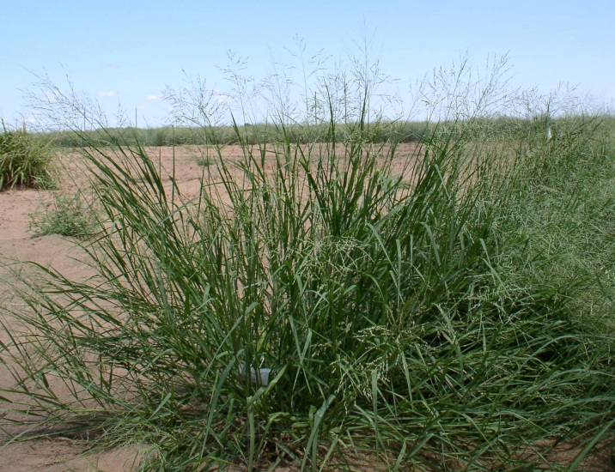 USDA-NRCS James E. “Bud” Smith Plant Materials Center (PMC)-Knox City, Texas

### Alternate Names

*Common Names:* Blue Panicgrass, Klein Grass, Klinegrass

### Description

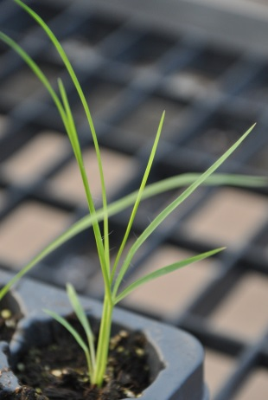*General*: Kleingrass is a warm-season, perennial bunchgrass native to Africa (USDA NRCS, 2003). It begins green up in late winter or early spring and continues to grow until late fall (Alderson and Sharp, 1994). Plants grow 3 to 4 feet tall with erect stems ranging from 20 to 47 inches from a knotty base (Hatch et al., 1993). The seed head is a fan-shaped, fine-branched panicle similar to switchgrass. Kleingrass reproduces by seed and rhizomes (Gould, 1975). Breeding and selection programs have utilized the variability in kleingrass germplasm to expand the area of adaptation and use in the southern plains (Holt and Conrad, 1966). Kleingrass has an average of 500,000 seeds per pound (USDA NRCS, 2012b).

USDA-NRCS/James E. "Bud" Smith PMC Knox City, TX

*Distribution*: For current distribution, please consult the Plant Profile page for this species on the PLANTS Web site.

**Adaptation**

Kleingrass is adapted to a variety of soils and environments. It will thrive on heavy soils, under dry or wet conditions, shallow sandy soils, and river bottom clays. It is also successful on sites with deep sands and medium textured soils (Holt et al., 1968). Kleingrass is also drought hardy and tolerates moderate salinity (Alderson and Sharp, 1994). It will produce optimum forage in areas receiving 18-30 inches of annual precipitation or under irrigation management.

### Uses

*Livestock:*

Kleingrass provides excellent forage for livestock. It is commonly used as a forage or hay for cattle. The plant produces an abundance of high quality forage. Forage quality research conducted at the James E. “Bud” Smith Plant Materials Center found kleingrass produced a crude protein level which ranged from 17% in April to 7% in November, while digestibility (*in vitro* dry matter digestibility) ranged from near 70% to 53% for the same time period. Kleingrass forage yields ranged from 1,500 lb/acre to approximately 12,500 lb/acre at the end of the growing season (USDA NRCS, 2012a).

*Wildlife:*

Kleingrass provides fair grazing for wildlife as well as seed for birds and small mammals (Texas A&M, 2014). The dense foliage also provides excellent cover for nesting birds and small mammals (Alderson and Sharp, 1994).

*Conservation:*

Kleingrass has many other conservation benefits including: soil stabilization and re-vegetation on depleted soils or range conditions. It can also be used to prevent soil erosion on embankments, ditches, and other highly erodible sites (USDA NRCS, 2012b).

### Status

This plant may become weedy or invasive in some regions or habitats and may displace desirable vegetation if not properly managed. Please consult with your local NRCS Field Office, Cooperative Extension Service office, state natural resource, or state agriculture department regarding its status and use.

Please consult the PLANTS Web site (<http://plants.usda.gov/>) and your State Department of Natural Resources for this plant’s current status (e.g., threatened or endangered species, state noxious status, and wetland indicator values).

### Planting Guidelines

The full seeding rate for kleingrass is 1.5 pure live seed per acre. When planting this as a component of a seed mixture, the seeding rate should be adjusted to the desired percent of the mix. Seed should be placed ¼ to ½ inch deep (USDA NRCS, 2012b).

Seedbed preparation should begin the year prior to spring planting to reduce weed problems during the first year of establishment. Work the site as necessary during the summer or early fall prior to establishment to create a firm, weed-free seedbed. Work should be completed in the fall to allow time for the soil to settle and accumulate moisture. Minimum and no-till operations should use herbicide applications to control weeds.

### Management

Plantings should be well established before livestock grazing is permitted. Twelve months grazing deferment should give plants enough time to become established. Established stands of kleingrass should not be grazed lower than 4-6 inches, depending upon the prescribed grazing system (USDA NRCS, 2012b). Contact your local U.S. Department of Agriculture-NRCS field office for assistance in planning and applying prescribed grazing plans.

Soil test should be conducted to determine the amount of fertilizer to apply to sustain a medium fertility level. Kleingrass responds well to fertilizer applications (Alderson and Sharp, 1994). Nitrogen should not be used during the establishment year because it will encourage weed growth. Consult your local extension weed specialist for recommendations on herbicides for kleingrass.

### Pests and Potential Problems

Photosensitization is a disease associated with a hypersensitivity of small ruminants such as sheep and goats to sunlight (Bridges et al., 1987). The disease has been linked to small ruminants grazing *Panicum* species, including *Panicum coloratum*. Regrowth following defoliation or from favorable moisture conditions has shown to be more toxic than older or dormant foliage. Symptoms include discharges from the eyes and nose and sunburn and edema of skin on the muzzle, and must be removed immediately from the pasture to avoid death. Signs in horses are more difficult to detect (Texas A&M, 2014). Cattle appear to be unaffected from this toxin.

### Environmental Concerns

None Known

### Control

Please contact your local agricultural extension specialist or county weed specialist to learn what works best in your area and how to use it safely. Always read label and safety instructions for each control method

### Seeds and Plant Production

Kleingrass is indeterminate in seed maturity, which means seed matures at different times making harvesting a challenge. A good time to plan harvests is 5 to 10 days after the first seed shattering occurs (Holt et al., 1968). Kleingrass is harvested by direct combining, or by swathing and windrowing the plant, then combining the windrows. Seed can also be harvested with a seed stripper. Long-term harvest records at the James E. “Bud” Smith Plant Materials Center shows kleingrass produces on average about 40 bulk pounds in June and 75 pounds in September. The majority of seed is set between May and September (Gould, 1978).

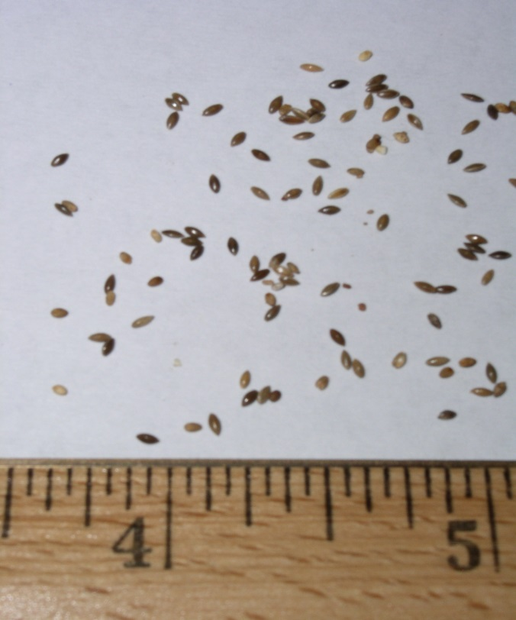USDA-NRCS James E. "Bud" Smith PMC

### Cultivars, Improved, and Selected Materials (and area of origin)

‘Selection 75’ kleingrass was released in 1969 from the USDA-NRCS James E. “Bud” Smith Plant Materials Center in Knox City, TX. It was selected at the USDA Soil Conservation Service Nursery in San Antonio, Texas from a large number of similar African accessions.

USDA ARS and Texas Agriculture Experiment Station released ‘TEM-LD1’ in 1991. ‘TEM-LD1’ originated from a base population of Selection 75 and OKPC-1germplasm for quick germination.

USDA ARS released ‘TEM-SR1’ in 1992. ‘TEM-SR1’ was selected for seed shatter resistance.

‘Verde’ was released from Texas Agriculture Experiment Station and the James E. “Bud” Smith Plant Materials Center in 1982. ‘Verde’ was selected for larger seed size and improved seedling vigor over ‘Selection 75’ kleingrass.

‘OKPC-1’ was released by the Oklahoma Agriculture Experiment Station in 1982. ‘OKPC-1’ was selected for increased cold tolerance.

Cultivars should be selected based on the local climate, resistance to local pests, and intended use. Consult with your local land grant university, local extension or local USDA NRCS office for recommendations on adapted cultivars for use in your area**.**

**Literature Cited**

Alderson, J. and W.C. Sharp. 1994. Grass varieties in the United States. USDA Agr. Handbook 170. p. 190-191.

Bridges, C.H., B.J. Camp, C.W. Livingston, and E.M. Bailey. 1987. Kleingrass (Panicum coloratum L.) Poisioning in Sheep. Vet Pathol 1987 24:525.

Gould, F.W. 1975. The Grasses of Texas. Texas A&M Univ. Press, College Station. p. 452-454.

Gould, F.W. 1978. Common Texas grasses an illustrated guide. Texas A&M Univ. Press, College Station. pp. 165.

Hatch, S.L. and J. Pluhar. 1993. Texas Range Plants. Texas A&M Univ. Press, College Station. p. 136-137.

Holt, E.C., A.C. Novosad, J.N. Pratt. 1968. Kleingrass. Texas A&M Univ. Press, College Station. pp2.

Holt, E.C., and B.E. Conrad. 1966. Kleingrass. Soil and Crop Sciences Department, College Station, and Coastal Bend Experiment Station, Beeville, TX.

Texas A&M Extension Service. 2014. Kleingrass (*Panicum coloratum*). Plants of Texas Rangelands. Available at: <http://essmextension.tamu.edu/plants/plant/kleingrass/>. Accessed 31 March 2014.

USDA, NRCS 2014. The PLANTS database, Version

3.5 (<http://plants.usda.gov>) . National Plant Data Center, Baton Rouge, LA 70874-4490 USA.

USDA NRCS 2012a. Technical Note: Forage Production, Nutritive Quality and Growth Patterns of Various Warm Season Grasses. Available at: <http://www.nrcs.usda.gov/Internet/FSE_PLANTMATERIALS/publications/txpmctn11188.pdf>. Published May 2012.

USDA NRCS. 2012b. Release Brochure for Kleingrass, (*Panicum coloratum* L.). Available at: <http://www.nrcs.usda.gov/Internet/FSE_PLANTMATERIALS/publications/txpmcrb11371.pdf>. Published August 2012.

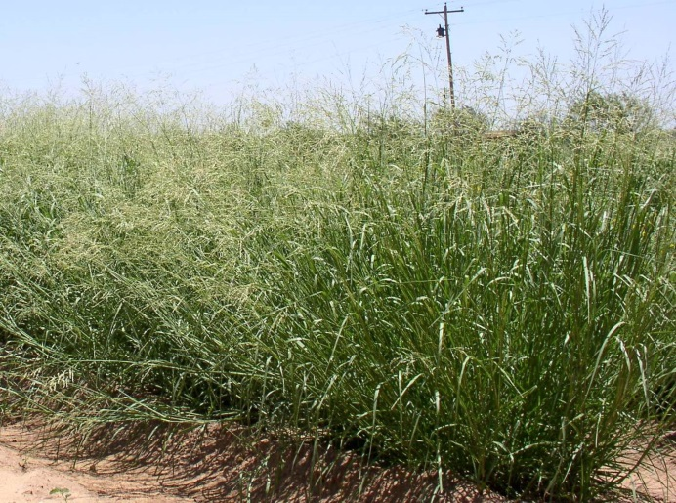 USDA-NRCS James E. "Bud" Smith PMC

### Citation

Carr, B.C. 2014. Plant Guide for Kleingrass (*Panicum* coloratum L.). USDA-Natural Resources Conservation Service, James E. “Bud” Smith Plant Materials Center. Knox City, TX, 79529.

April, 2014

For more information about this and other plants, please contact your local NRCS field office or Conservation District at <http://www.nrcs.usda.gov/> and visit the PLANTS Web site at <http://plants.usda.gov/> or the   
Plant Materials Program Web site:

<http://plant-materials.nrcs.usda.gov>.

PLANTS is not responsible for the content or availability of other Web sites.

***Helping People Help the Land***

**USDA IS AN EQUAL OPPORTUNITY PROVIDER AND EMPLOYER**