

Plant Guide

# TAPER-LEAVED PENSTEMON

## Penstemon attenuatus Douglas ex Lindl.

Plant Symbol = PEAT3

*Contributed by*: NRCS Plant Materials Center, Pullman, WA

### Photo of Penstemon attenuatus by Pamela Pavek

*Penstemon attenuatus.* Pamela Pavek

### Alternate Names

*Common Alternate Names:* taper-leaf penstemon, sulphur penstemon, sulphur beardtongue (*P. attenuatus* var. *palustris*), south Idaho penstemon (*P. attenuatus* var. *militaris*), small penstemon (*P. attenuatus* var. *pseudoprocerus*)

*Scientific Alternate Names:* None

### Uses

*Pollinator habitat: Penstemon attenuatus* is a source of pollen and nectar for a variety of bees, including honey bees and native bumble bees, as well as butterflies and moths.

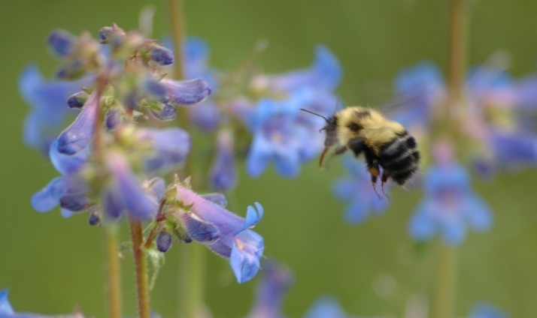

Bumble bee visiting a *Penstemon attenuatus* flower. Pamela Pavek

*Rangeland diversification:* This plant can be included in seeding mixtures to improve the diversity of rangelands.

*Ornamental: Penstemon attenuatus* is very attractive and easy to manage as an ornamental in urban, water-saving landscapes. Rugged Country Plants (2012) recommends placing *P. attenuatus* in the back row of a perennial bed, in rock gardens and on embankments. It is hardy to USDA Plant Hardiness Zone 4 (Rugged Country Plants 2012).

### Status

Please consult the PLANTS Web site and your State Department of Natural Resources for this plant’s current status (e.g., threatened or endangered species, state noxious status, and wetland indicator values).

### Description

*General*: Figwort family (Scrophulariaceae). *Penstemon attenuatus* is a native, perennial forb that grows from a dense crown to a height of 10 to 90 cm (4 to 35 in). Leaves are dark green, opposite and entire, however the margins of *P. attenuatus* var. *attenuatus* leaves are often, at least in part, finely toothed (Strickler 1997). Basal leaves are petiolate, up to 4 cm (1.5 in) wide and 17 cm (7 in) long. Stem leaves are smaller and mostly clasping. Flowers bloom in May and June, and can be blue to purple and pink, or pale yellow to nearly white. The inflorescence consists of two whorls of flowers around the stem at each leaf axis. Flowers have five lanceolate to ovate or obovate petals with translucent margins, and are 1 to 2 cm (3/8 to 3/4 in) long. The petals are fused to form a tube that is expanded toward the mouth and has two lips. The lower lip and staminode are hairy. Seeds are dark brown, round, and occur in capsules 3 to 6 mm (1/8 to 1/4 in) long. Overall the appearance of *P. attenuatus* is very similar to other *Penstemon* species, causing difficulties in identification. (Hitchcock and Cronquist 1973; Lyons and Merilees 1995; Burke Museum of Natural History and Culture 2012).

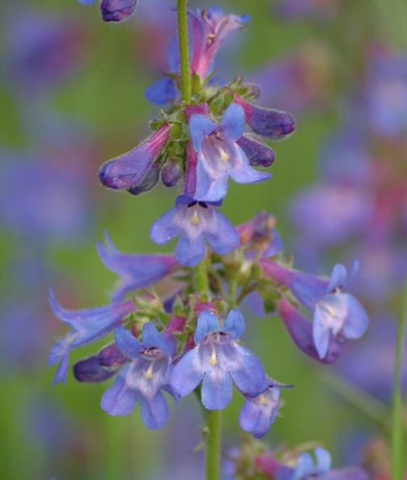

*Penstemon attenuatus* flowers*.* Pamela Pavek

The genus name *Penstemon* is derived from Greek “pente” meaning five and “stemon” meaning thread, referring to the five stamens (Charters 2012). The species name *attenuatus* translated from Latin is “tapering gradually to a very slender tip” (Hitchcock and Cronquist 1973).

*Distribution*: The range of *Penstemon attenuatus* extends from eastern Washington and Oregon to western Montana, southern Idaho and north-central Wyoming (Burke Museum of Natural History and Culture 2012). The species is currently divided into four varieties (ecotypes): var. *attenuatus* (found in Washington, Oregon, Idaho and Montana), var. *militaris* (found in Idaho and Montana), var. *palustris* (found in Oregon and Idaho), and var. *pseudoprocerus* (found in Idaho, Montana and Wyoming). For current distribution, please consult the Plant Profile page for this species on the PLANTS Web site.

*Habitat*: *Penstemon attenuatus* grows in dry meadows and moist, open to wooded slopes in the mountains and foothills (Burke Museum of History and Culture 2012).

**Adaptation**

*Penstemon attenuatus* is adapted to areas receiving 30 to 64 cm (12 to 25 in) annual precipitation at elevations up to 3,000 m (5,000 ft). It grows in well-drained, medium-textured soils.

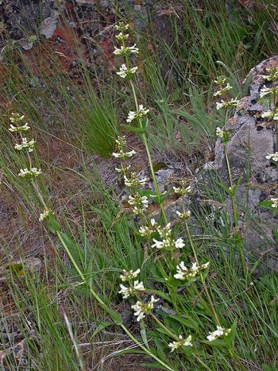

*Penstemon attenuatus* var. *attenuatus*. G.D. Carr, University of Washington Burke Herbarium

### Establishment

Plants can be established by seed or seedlings. Seed should be planted in a firm, weed-free seed bed in the fall at a rate of 1.65 kg PLS/ha (1.5 lb PLS/ac). If the seed is planted in a mix, the seeding rate should be adjusted according to the proportion of *P. attenuatus* in the mix. Penstemon seed is very small compared to other species, and will be dispersed by the implement too quickly unless the drill box has constant agitation and rice hulls are used, or the drill can be set to have a very low seeding rate without rice hulls.

The seed should be planted at a depth no greater than 0.3 cm (1/8 in). If the seed is drilled, the drill should be set no deeper than 0.3 cm (1/8 in) or the seed should be placed in a separate drill box (with other small-seeded species) and the tubes for this box should be pulled so the seed is dropped on the soil surface. Drag chains or press wheels should be used as long as the seed is not covered with more than 0.3 cm (1/8 in) of soil. Skinner (2007) found germination rates were higher among seed that had been covered lightly with soil than seeds left bare, and he attributed this to protection from fluctuating moisture levels.

The seed can also be broadcast onto the soil surface with a broadcast spreader, and pressed into the soil with a roller packer. When using a broadcast seeding method, the seeding rate should be doubled to account for predation and environmental factors that cause damage to the seed during the winter months.

To establish plants by seedlings, the seed should be planted in containers in October, left outside to stratify in cold and moist conditions for a minimum of 90 days, and moved into a greenhouse in January. Alternatively, the seed could be moist stratified in a refrigerator at 2 to 4 degrees C (35 to 40 degrees F) for a minimum of 90 days, and planted in a greenhouse (Skinner 2007). If the soil is kept moist, germination occurs within four to seven days (Skinner 2007). The plants should be kept in the greenhouse for three to four months, and hardened off in a cold frame for two to four weeks prior to transplanting to a prepared field site in the spring (Skinner 2007). Ideal plant spacing is 15 to 45 cm (6 to 18 in).

### Management

*Penstemon attenuatus* is able to withstand infrequent mowing. This method may be used for weed control in newly-established forb plantings, however mowing should be delayed until after seed maturity. Pre-emergent herbicides can be used to control annual weeds in fields with at least one year of growth, or where seedlings have been transplanted.

### Pests and Potential Problems

### None known.

### Environmental Concerns

None.

### Seeds and Plant Production

### Experiments with seed of *P. attenuatus* var. *attenuatus* at the Pullman Plant Materials Center demonstrated an extended cold moist stratification period is needed to break seed dormancy. Skinner (2007) had 0% emergence with no seed treatment, 10% emergence with 45 days of cold, moist stratification, and 72% emergence with 90 days of cold, moist stratification. Containers left outside during the winter and spring months had 95% emergence. Skinner attributed this higher emergence to a longer stratification period, and not fluctuating spring temperatures, since plants in the greenhouse thrived at a constant warm temperature. Skinner (2007) also found seed covered lightly with soil had higher germination rates than seed left uncovered on the soil surface.

### *Penstemon attenuatus* has approximately 3,300,000 seeds per kg (1,500,000 seeds per lb) (Barner 2009). Seeds are mature when the capsules begin to split. Plants retain the seed for a long period if wind is not excessive (Skinner 2007) which facilitates seed harvesting. Small amounts of seed can be obtained by removing the plant stems, crushing them on a rub board, and separating the seed from the plant material with an air column separator. Larger amounts of seed can be threshed with a brush machine or hammer mill and cleaned with air screen equipment (Skinner 2007; Barner 2009).

### Cultivars, Improved, and Selected Materials (and area of origin)

None, but seed and plants are available from several vendors.

### References

**Barner, J. 2009. Propagation protocol for production of *Penstemon attenuatus* Douglas ex Lindl. seeds; USDA-FS-R6 Bend Seed Extractory, Bend, Oregon. In:** Native Plants Network. [Online]. Available at: http://www.nativeplantnetwork.org (accessed 17 January 2012). Moscow, ID: University of Idaho, College of Natural Resources, Forest Research Nursery.

**Burke Museum of Natural History and Culture. [Online]. Available at: http://biology.burke.washington.edu/herbarium/imagecollection.php (accessed 17Jan 2012). University of Washington, Seattle, WA.**

Charters, M.L. 2012. California Plant Names: Latin and Greek Meanings and Derivations. [Online] Available at: http://www.calflora.net/botanicalnames/ (accessed 17 Jan 2012).

Hitchcock, C.L. and A. Cronquist. 1973. Flora of the Pacific Northwest. University of Washington Press, Seattle and London.

Lyons, C.P. and B. Merilees. 1995. Trees, Shrubs and Flowers to Know in Washington and British Columbia. Lone Pine Press, Auburn, WA, Vancouver, BC, and Edmonton, AB.

Rugged Country Plants. 2012. [Online] Available at: http://www.ruggedcountryplants.com/penstemon-attenuatus.htm (Accessed 18 Jan 2012).

Skinner, D.M. 2007. Propagation protocol for production of container *Penstemon attenuatus* Dougl. ex Lindl. plants (10 cu in); USDA-NRCS Pullman Plant Materials Center, Pullman, Washington. In: Native Plants Network. [Online]. Available at: http://www.nativeplantnetwork.org (accessed 17 January 2012). Moscow, ID: University of Idaho, College of Natural Resources, Forest Research Nursery.

Strickler, D. 1997. Northwest Penstemons. The Flower Press, Columbia Falls, MT.

**Prepared By**

*Pamela L.S. Pavek*, USDA NRCS Plant Materials Center, Pullman, Washington

*David M. Skinner,* USDA NRCS Plant Materials Center, Pullman, Washington (*retired*)

### Citation

Pavek, P.L.S., and D.M. Skinner 2012. Plant guide for taper-leaved penstemon (*Penstemon attenuatus*). USDA Natural Resources Conservation Service, Pullman Plant Materials Center. Pullman, WA.

Published February 2012

Edited: 18Jan2012 dms; 07Feb2012 mes; 17Feb2012 jab; 17Feb2012 plsp

For more information about this and other plants, please contact your local NRCS field office or Conservation District at <http://www.nrcs.usda.gov/> and visit the PLANTS Web site at <http://plants.usda.gov/> or the Plant Materials Program Web site <http://plant-materials.nrcs.usda.gov>.

PLANTS is not responsible for the content or availability of other Web sites.

**USDA IS AN EQUAL OPPORTUNITY PROVIDER AND EMPLOYER**