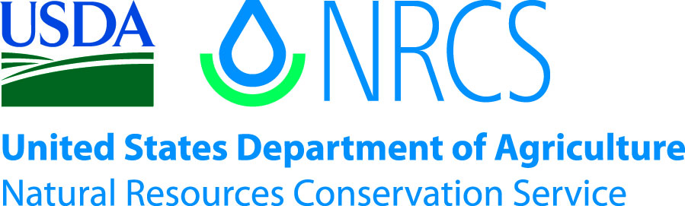

Plant Guide

# Hotrock penstEmon

***Penstemon deustus* Douglas ex Lindl.**

Plant Symbol = PEDE4

Contributed by: Aberdeen Plant Materials Center and Idaho NRCS State Office

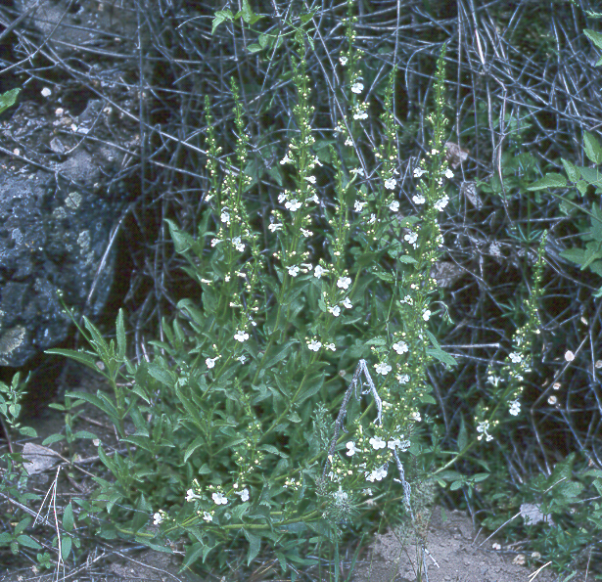

**Hotrock penstemon (Nancy Shaw, USDA, FS, Boise, ID)**

Alternate Names

Scabland penstemon

Uses

Hotrock penstemon is chiefly used as a forb component for wildlife habitat enhancement and restoration efforts. Its showy flowers attract numerous pollinators and other insects which provide a food source for birds and other vertebrates. This species is also commonly used in xeriscaping and other low-water-use landscaping. It is suited for roadside and other beautification plantings.

Status

Consult the PLANTS Web site and your State Department of Natural Resources for this plant’s current status (e.g. state noxious status).

Description

*General*: Figwort Family (Scrophulariaceae).

Hotrock penstemon is a short-lived perennial forb 20 - 60 cm (8 - 24 inches) tall. Stems are glabrous, woody and much branched near the base. The leaves are bright green, glabrous, coarsely dentate-serrate, linear lanceolate to elliptic, 2 - 5 cm long and 6 - 20 mm wide. Flowers are nearly tubular, creamy white to tan, 8 - 15 mm long in loose whorls along the upper stem. Flowering season is from May to July. Seeds are very small with approximately 2,900,000 seeds per pound.

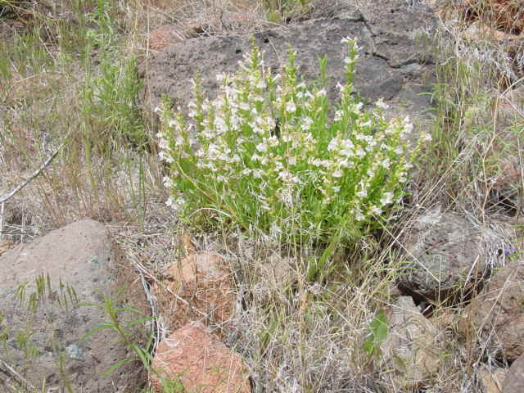  
**Hotrock penstemon in natural habitat (Nancy Shaw, USDA, FS, Boise, ID)**

*Distribution*: Hotrock penstemon is found in scattered populations in eastern Washington, southern Idaho, southwestern Montana and south through Oregon to the central Sierra Nevada in California, the northern 2/3 of Nevada, northwestern Utah and western Wyoming.

*Habitat*: Hotrock penstemon inhabits dry rocky places, basalt flows, pressure ridges and cliffs and occasionally limestone outcrops in sagebrush, juniper and pinyon-juniper plant communities. Plants typically occur at elevations from 2600 to 8200 feet.

Adaptation

This species is adapted to well-drained loam to fine sandy loam soils with a pH range of 5.0 to 8.0. For xeriscaping and low water gardening, the species is recommended for use in USDA hardiness zones 6-8 in areas receiving 8 - 10 inches or more annual precipitation.

Management

When planted in a native reclamation mix, hotrock penstemon should be a minor component of the establishing plant community; therefore management should be based on other key species in the mixture. Grazing on seeded lands should be deferred for at least two growing seasons to allow for establishment.

Pests and Potential Problems

Impact from insect pests on penstemon seed production can be significant. Penstemon borer larva can infect the crown and upper root area of all penstemon species resulting in the loss of individual plants to entire fields. Presently, penstemon borers are known only from extreme southwestern Colorado.Penstemonclearwing (Penstemonia spp.) attacks multiple Penstemon species. The larvae feed within the stems of the crown and lower above ground portions of the plant. A pheromone is available for monitoring of adults. Other potentially significant pests include Lygus bugs and raceme-boring moths Hotrock penstemon is also susceptible to soil-borne fusarium and rhizoctonia root rot, which can be severe in poorly drained loam and clay-textured soils.

**Seed and Plant Production**

Fields for seed production can be established by transplanting greenhouse grown containerized stock or from direct seeding. Direct seeding should take place in the fall to allow for natural stratification of the seed. Greenhouse materials can be established by seeding into cones or flats in winter for natural stratification or by stratifying the seed for 8 - 12 weeks in cold/moist conditions. Prechilling requirements can be reduced with a liquid smoke treatment. Germination can also be enhanced by watering with a weak solution of giberellic acid (250 ppm) though treated seedlings appear to be less vigorous than non-treated. Seed should be planted to a depth of 0 - 6 mm (0 - 0.25 in).

Chemical weed control in seed production fields of forbs is a challenge and preliminary work is only getting underway. In herbicide tolerance screening trials conducted at the Malheur Experiment Station in Oregon, hotrock penstemon had good tolerance (based on seed yields) to post emergence applications of Select (Clethodim), Outlook (Dimethenamid-P), and Prowl (Pendimethalin). Hotrock penstemon showed sensitivity to post emergence applications of Buctril (bromoxynil octanoate), Goal (oxyfluorfen), Caparol (Prmetryn) and Lorox (Linuron). Considerable efforts to register herbicides for use on native forb seed production will be required.

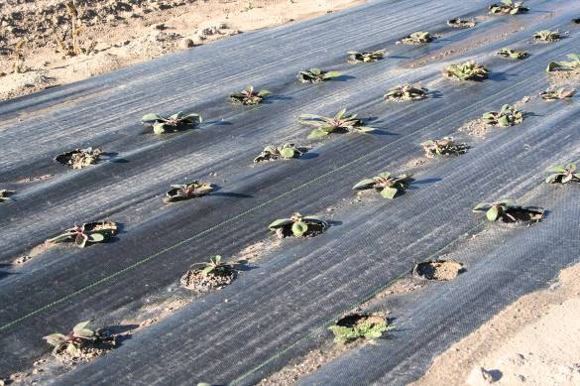

**Penstemon seedlings grown in weed barrier fabric for seed production. (Derek Tilley, USDA, NRCS, Aberdeen, ID)**

Because of the limited number of available herbicides that can be used on broadleaf forbs, planting into weed-barrier fabric (pictured above) is a viable alternative to control weeds in forb seed production fields. Holes should be three to four inches in diameter at 9 - 18 inch spacing.

Successful pollination is essential for commercial seed production of hotrock penstemon. Bees and wasps that have been observed pollinating hotrock penstemon include sweat bees, bumble bees, honey bees and leafcutter bees. The flowers bloom from May to July. The seed is mature when the capsule turns brown and begins to open. This typically occurs 5 - 8 weeks after flowering. The brown to black seed persists in the capsule for several weeks.

Seed harvest can be accomplished by hand or by direct combining. Harvest should occur when the stems and capsules begin to dry and open. Seed can be cleaned with a small clipper or air-screen cleaner. Seed yields range from 20 - 50 lb/ac (22 – 56 kg/ha). The seed capsules stay closed for some time after maturation, so it is not essential to harvest seed immediately.

Cultivars, Improved, and Selected Materials (and area of origin)

There are currently no releases of hotrock penstemon. Wildland harvested seed is available through commercial sources.

References

Chicago Botanic Garden’s Restoration Research in the Great Basin Staff. Penstemon Pollinators. URL: http://cbscience.org/great_basin/pollinators_penstem on.htm (accessed 17 Dec. 2008).

Davis, R.J. 1952. Flora of Idaho. WM. C. Brown Company. Dubuque, Iowa. 828 p.

Debolt, A. and H. Parkinson. 2005. Propagation protocol for production of container *Penstemon deustus* plants. USDA FS – Rocky Mountain Research Station, Boise, Idaho. In: Native Plant Network. URL: http://www.nativeplantnetwork.org (accessed 16 Dec 2008). Moscow (ID): University of Idaho, College of Natural Resources, Forest Research Nursery.

Las Pilatas Nursery. 2008. www.laspilitas.com/plants/486.htm (accessed 16 Dec 2008). San Margarita, CA.

Shaw, N., Walker, S., Jensen, S., Thompson, T. and A. DeBolt. 2003. Native plant material development and seed and seeding technology for native Great Basin forbs and grasses. In: Great Basin Native Plant Selection and Increase Project FY03 Progress Report.

Shock, C., Ishida, J. and E. Feibert. 2008. Identification of herbicides for use in native forb seed production. In: Great Basin Native Plant Selection and Increase Project FY07 Progress Report.

UC/JEPS: Jepson Manual treatment for *Penstemon deustus*. URL: http://ucjeps.berkeley.edu?cgi- bin/get_JM_treatment.pl?Penstmon+deustus

(accessed 16 Dec 2008)

USDA Natural Resources Conservation Service. 2008. The PLANTS database, version 3.5. URL: http://plants.usda.gov (accessed 15 Dec 2008). Baton Rouge, LA. National Plant Data Center.

Western Colorado Extension: Native Plant Seed Production. 2008. http://wsprod.colostate.

edu/cwis487/wci/seed_production.html. (accessed 16 Dec 2008).

Prepared By

Loren St. John, USDA NRCS Plant Materials Center, Aberdeen, ID

Dan Ogle, USDA NRCS Idaho State Office, Boise, ID

Nancy L. Shaw, USDA Forest Service,

Rocky Mountain Research Station, Boise, ID

Species Coordinator

Dan Ogle, USDA NRCS Idaho State Office, Boise, ID

#### **Citation**

St. John, L., D.G. Ogle, D. Tilley. 2010. Plant Guide for hotrock penstemon *(Penstemon deustus* Douglas ex Lindl.*)*. USDA-Natural Resources Conservation Service, Aberdeen Plant Materials Center, Aberdeen, ID 83210.

Published January, 2009

Edited: 121708LWS; 010709DGO; 010709NLS

For more information about this and other plants, please contact your local NRCS field office or Conservation District at <http://www.nrcs.usda.gov/> and visit the PLANTS Web site at <http://plants.usda.gov/> or the Plant Materials Program Web site <http://plant-materials.nrcs.usda.gov>.

PLANTS is not responsible for the content or availability of other Web sites.

**USDA IS AN EQUAL OPPORTUNITY PROVIDER AND EMPLOYER**