

Plant Guide

# FireCracker Penstemon

## Penstemon eatonii A. Gray

Plant Symbol = PEEA

*Contributed by*: USDA NRCS Idaho and Utah Plant Materials Program

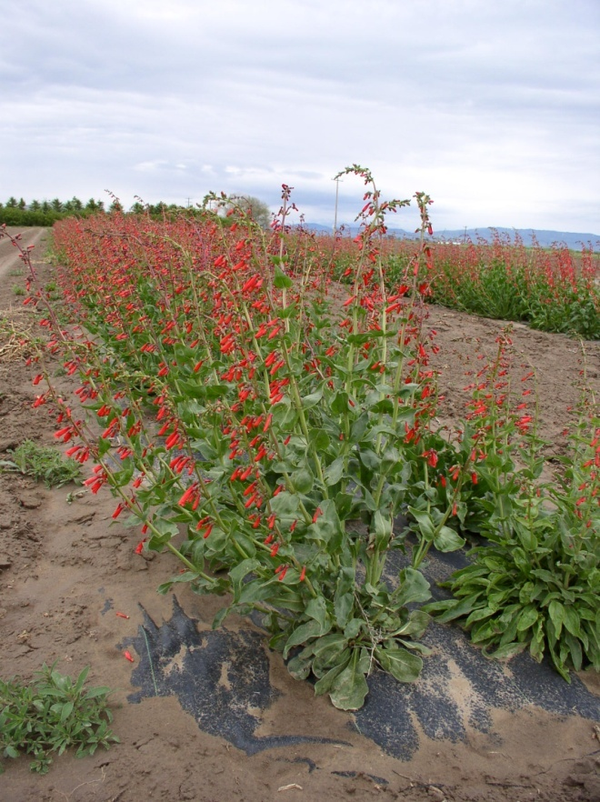

Richfield Selection firecracker penstemon (Derek Tilley, Aberdeen PMC)

### Alternate Names

Eaton’s beardtongue, scarlet-bugler penstemon*, Penstemon eatonii* ssp*. eatonii, Penstemon eatonii* ssp. *exsertus, Penstemon eatonii* spp. *undosus*

### Uses

Firecracker penstemon is chiefly used as a forb component for restoration and wildlife enhancement projects. It is not noted for having value as forage for livestock and forage use is limited by big game. Its showy flowers attract pollinators and other insects which provide a food source for birds and other animals. The fibrous root system and wide canopy cover make it a good plant for low-water use landscaping (i.e. roadsides) and other ornamental plantings.

Firecracker penstemon was used by Native Americans for the treatment of: spider bites, stomach troubles, to reduce bleeding, backache, snakebite, as a veterinary aid, and for healing of burns (Native American Ethnobotany Database).

### Status

Consult the PLANTS Web site and your State Department of Natural Resources for this plant’s current status (e.g., threatened or endangered species, state noxious status, and wetland indicator values).

### Description

*General*: Figwort Family (Scrophulariaceae). Firecracker penstemon is an erect, perennial, cool-season, short-lived forb, 40-100 cm (16-39 in) tall with scarlet (bright red) colored flowers. Leaves are cauline, 30-90mm (1.2-3.5 in), widely lanceolate to ovate, and entire. The flower calyx is 3.5-6 mm (0.1-0.2 in), lobes ovate. The corolla is 24-33 mm (0.9-1.3 in), cylindric, obscurely 2 lipped, lobes sub equal, barely spreading, glabrous (Hickman, 1993). Chromosome number is n=8 (Parfitt, et al, 1990).

There are three subspecies recognized. *P. eatonii* ssp. *eatonii*, *P. eatonii* ssp. *exsertus*, and *P. eatonii* ssp. *undosus*. Cronquist et al. (1984) provides a key separating *eatonii* from u*ndosus* and notes the key characteristics for *exsertus*. The ssp. *eatonii* is glabrous throughout and ssp. *undosus* is puberulent (covered in soft downy hairs). The ssp. *exsertus* has conspicuous exerted anthers and is also puberulent.

*Distribution*: Firecracker penstemon is found in North America, west to southwest from Colorado to California and south into New Mexico and Arizona. The *Penstemon* genus is common to western North America and except for one minor species, does not occur naturally outside of North America. The ssp. *eatonii* occurs in the northern portion of the species range from Idaho to California and Colorado. The ssp. *undosus* occurs from southern Utah to New Mexico, Arizona and southern California. The ssp. *exsertus* is limited in distribution, occurring in central Arizona. For additional information on distribution, consult the Plant Profile page for this species on the PLANTS Web site.

*Habitat*: Firecracker penstemon is found on dry slopes and flats in sagebrush, pinyon-juniper, mountain mahogany and ponderosa pine plant communities at 3,300-8,000 feet elevation in 10-16 inch annual rainfall zones (Ogle et al. 2011).

**Adaptation**

Firecracker penstemon is adapted to shallow rocky, to stony loams, sandy loams, and gravelly loams that are moderately to very well-drained. It does not grow well in areas with poor drainage. It can survive in full sunlight, but may not tolerate hot, dry areas. It survives cold winter temperatures in the northern portion of its range if snow depths are adequate to cover the plant (USDA-NRCS, 2006). It is adapted to USDA Plant Hardiness Zones 4a to 8b and pH ranges of 6.6 (slightly acidic) to 8.5 (alkaline) (Dave’s Garden, 2011).

### Establishment

A study conducted to correlate habitat and germination response found that firecracker penstemon seed from colder winter sites had longer chill (stratification) requirements and were slower to establish than seed from warmer winter sites (Meyer,1992). Because of the seed stratification requirement, firecracker penstemon should be seeded in late fall with a drill or broadcast planted and then pressed to a depth of ⅛ to ¼ inch into a firm seedbed. Good seed to soil contact is important for germination and establishment. The full seeding rate is 3 pounds Pure Live Seed (PLS) per acre and there are approximately 315,000 seeds per pound (Ogle, et al. 2011). When used as a component of a seed mix, adjust to the percent of mix desired.

Mulching, irrigation and weed control benefit stand establishment. Some planted seed may not germinate until the second growing season. Flowering should not be expected until the second growing season.

Weed control will be required during establishment. Because penstemon is a broadleaf plant, the use of broadleaf type herbicides is not recommended. Mow weeds at or prior to bloom stage.

### Management

Firecracker penstemon should be used as a minor component of seed mixtures. Management strategies should be based on the key species in the established plant community. Grazing should be deferred on seeded lands for at least two growing seasons to allow for full stand establishment.

### Pests and Potential Problems

Firecracker penstemon is susceptible to soil-borne fusarium and rhizoctonia root rot which can be severe in poorly drained loam and clay textured soils (USDA-NRCS, 2006). There are no known insect problems (USDA-NRCS, 2006).

### Environmental Concerns

Firecracker penstemon is a native plant species in western North America and has no known negative impacts on wild or domestic animals. It is not considered a weedy or invasive species but can spread to adjoining vegetative communities under ideal conditions. It co-exists with other native species and adds biodiversity to plant communities.

### Seed and Plant Production

Fields for seed production can be established from direct seeding or from transplanting greenhouse grown containerized stock. Direct seeding should take place in late fall to allow for natural stratification of the seed. Firecracker penstemon should be seeded in 30-36 inch rows at a rate of 1.3 pounds PLS per acre (target 30 pure live seeds per linear foot of drill row) to allow for mechanical weed control. The use of weed barrier fabric is an alternative to allow closer spacing, reduce weeds and conserve soil moisture. Plant spacing of 18 inches provides for maximum growth and seed yield when using weed barrier fabric.

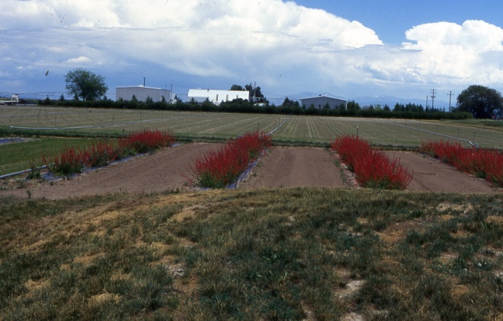

Richfield Selection firecracker penstemon seed production field at Aberdeen PMC utilizing weed barrier fabric. (Loren St. John, Aberdeen PMC).

Transplants grown in a greenhouse can be established by seeding into cones or flats in winter for natural stratification or by stratifying the seed for 8 to 12 weeks in cold and moist conditions prior to planting seed. Treatment of seed with gibberellic acid (GA3) may reduce the stratification requirement (Kitchen and Meyer, 1991). Seed should be surface sown and pressed firmly into the soil surface. Flats or containers should be blocked from sunlight during the stratification period to prevent mold and fungus from establishing on the soil surface during stratification. A very thin covering of fine to medium grade perlite on the soil surface after emergence in containers or flats helps to prevent excessive moisture around the emerging seedling and limits damping-off of young seedlings. Allow seedlings to grow in the greenhouse for 8-12 weeks before transplanting to the field. Transplants can also be made from dividing the base of older plants.

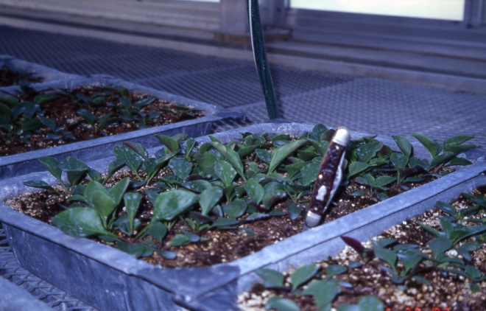

Firecracker penstemon seedlings growing in greenhouse trays. (Loren St. John, Aberdeen PMC)

Seed harvest can be accomplished by hand or by mechanical means. Seed is mature when capsules are dry and seed is hard and dark in color. Flowering is indeterminate with mature capsules and flowers present at harvest. Harvest should occur when the majority of seed capsules begin to dry and open. Plants may be swathed ahead of combining to allow more uniform ripening and drying. Plants are swathed to a height above most leaves to capture flower stalks. Stalks are then allowed to sit on top of the swathed plants for 4-5 days before combining. Seed can be separated from the capsule by use of a hammer mill or debearder and processed with an air-screen cleaner. Estimated seed yield is about 100 pounds per acre. Seed will maintain viability under cool and dry storage conditions for about 7-8 years with a gradual decline in viability over time. Seed production peaks at about 3 years and then plants start to die due to the short-lived nature of the species.

Pollinators can enhance seed production and seed yield. It is generally reported that hummingbirds are the sole pollinators of firecracker penstemon (Bateman, 1980) but recent studies by Cane and Dunne (in progress) suggest that generalist bees (*Apis*, *Anthophora*) consistently generated larger seed yields of firecracker penstemon with seed yields approaching 275 pounds per acre by the placement of hives near the field and in the absence of hummingbirds.

### Cultivars, Improved, and Selected Materials (and area of origin)

**Richfield Selection firecracker penstemon** was released by the Aberdeen, Idaho Plant Materials Center in 1994 as pre-variety germplasm. The original collection was made near Richfield, Utah in 1974 and was selected from a collection of 119 penstemon accessions. The Richfield Selection was released for its beauty, hardiness, seed production and natural range of adaptability. It had the best stand establishment and longest survival. Certified seed is available and Generation 1 (G1) seed is maintained by the Aberdeen Plant Materials Center. Growers may produce one generation each of G2 and G3 seed (USDA-NRCS, 2006).

### References

Bateman, L. 1980. Comparative floral biology of Penstemon eatonii and Penstemon cyananthus in central Utah: A preliminary study. Western North American Naturalist. V. 40 No. 3 p 268-272.

Cane, J., Dunne, R. (in progress). Generalist bees pollinate Penstemon eatonii: revisiting the hummingbird pollination syndrome. 14 p.

Cronquist, A., Holmgren, A. Holmgren, N., Reveal, J., Holmgren, P. 1984. Intermountain Flora. Volume Four. Subclass Asteridae (except Asteraceae). The New York Botanical Garden, Bronx, New York.

Dave’s Garden, 2011. http://davesgarden.com/guides/pf/go/53555/ (accessed November 1, 2011)

Hickman, J. (ed). 1993. The Jepson Manual: Higher Plants of California. University of California Press.

Native American Ethnobotany: A database of foods, drugs, and fibers of Native American Peoples, derived from plants. http://herb.umd.umich.edu/herb/search. (accessed August 23, 2011)

Kitchen, S., Meyer, S. 1991. Seed Germination of Intermountain Penstemons as influenced by Stratification and GA3 Treatments. Journal of Environmental Horticulture. 9(1):51-56.

Meyer, S. 1992. Habitat correlated variation in Firecracker Penstemon (Penstemon eatonii Gray: Scrophulariaceae) seed germination response. Bulletin of the Torrey Botanical Club 119(3). p 268-279.

Ogle, D., L St. John, M Stannard, L. Holzworth. 2011 Conservation Plant Materials for the Intermountain West. Technical Note 24. USDA-Natural Resources Conservation Service. Boise, ID. 57 p.

Parfitt, B., Pinkava, D., Rickel, D., Fillipi, D., Eggers, B., Keil, D. 1990. Documented Chromosome Numbers 1990: 1. Miscellaneous North American Vascular Plants. SIDA 14(2):305-308.

USDA-NRCS, 2006. Plants for Solving Resource Problems: Richfield Selection Firecracker Penstemon. Aberdeen Plant Materials Center. 2p.

**Prepared By**:

Loren St. John, USDA NRCS Plant Materials Center, Aberdeen, ID

Derek Tilley, USDA NRCS Plant Materials Center, Aberdeen, ID

Dan Ogle, USDA NRCS Idaho State Office, Boise, ID

### Citation

St. John, L., D. Tilley, and D. Ogle. 2011. Plant Guide for firecracker penstemon (*Penstemon eatonii*). USDA-Natural Resources Conservation Service, Plant Materials Center. Aberdeen, Idaho 83210.

Revised December, 2011. Original plant guide published September, 2002.

Edited: 14Nov2011 ls; 14Nov2011djt; 15Nov2011dgo; 28Nov2011jab

For more information about this and other plants, please contact your local NRCS field office or Conservation District at <http://www.nrcs.usda.gov/> and visit the PLANTS Web site at <http://plants.usda.gov/> or the Plant Materials Program Web site <http://plant-materials.nrcs.usda.gov>.

PLANTS is not responsible for the content or availability of other Web sites.

**USDA IS AN EQUAL OPPORTUNITY PROVIDER AND EMPLOYER**