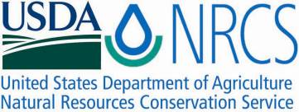

Plant Guide

# white river penstemon

***Penstemon scariosus* Pennellvar*. albifluvis* (England) N.H. Holmgren**

Plant Symbol = PESCA

*Contributed by*: USDA NRCS Idaho and Utah Plant Materials Program

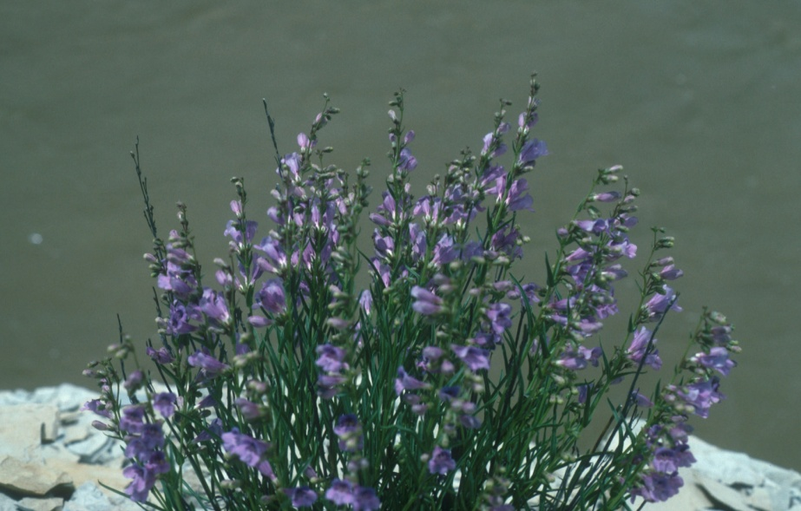**White River penstemon (*Penstemon scariosus* var. *albifluvis*). Photo by Carol Dawson**

### Alternate Names

*Penstemon albifluvis*

White River beardtongue

### Uses

There are no known human uses of White River penstemon. It is highly palatable to livestock and wildlife (USDI-FWS, 2010).

### Status

White River penstemon is currently a candidate for Federal protection following its official proposal in 1983. It is currently protected on USDI-BLM lands from development within its habitat. It has a listing priority of 9, moderate magnitude of an imminent threat, primarily from oil and gas exploration (USDI-FWS, 2010).

Consult the PLANTS Web site and your State Department of Natural Resources for this plant’s current status (e.g., threatened or endangered species, state noxious status, and wetland indicator values).

### Description

*General*: Figwort family (Scrophulariaceae). White River penstemon is a herbaceous perennial forb with multiple stems arising from a woody root crown. Mature plants are approximately 15 to 50 cm (6 to 20 in) tall. Leaves are opposite, linear to linear-lanceolate, 3 to 17 cm (1.2 to 6.7 in) long and 2 to 23 mm (0.08 to 0.91 in) wide. The inflorescence is a glandular-pubescent, congested raceme bearing pale blue to lavender flowers. The flower is comprised of five petals fused to form a bilateral tube approximately 20 to 22 mm (0.79 to 0.87 in) long. The staminode (sterile stamen) is 9 to 10 mm (0.35 to 0.4 in) long, and the fertile stamens are 10 to 11 (0.4 to 0.43 in) long. The anther sacs are dark blue, 1.3 to 2.6 mm (0.05 to 0.10 in) long, and moderately bearded with white slender flexuous hairs. The anther sacs dehisce nearly the full length, except across the center connective tissue (Welsh et al., 2003). The fruit is a capsule; 8 to 11 mm (0.31 to 0.43 in) long bearing 10 to 20, 2 mm (0.08 in) long seeds (USDI-FWS, 2010). Flowering occurs in May and early June, with fruiting and seed set in late June (Lewinsohn and Tepedino, 2007).

*Distribution*:

White River penstemon occurs in 15 sites forming an arc from Rio Blanco County, Colorado west of Rangely, Colorado and westward into southern Uintah County, Utah. Total area occupied by known populations is approximately 200 acres (USDI-FWS, 2010). Approximately 70 percent of White River penstemon habitat is located on public lands managed by the USDI-BLM.

For current distribution, consult the Plant Profile page for this species on the PLANTS Web site.

*Habitat*:

White River penstemon grows in mixed desert shrub and pinyon-juniper communities on sparsely vegetated shale slopes. Plants growing in association with this species include shadscale (*Atriplex* *confertifolia*), yellow rabbitbrush (*Ericameria* *viscidiflorus*), Salina wildrye (*Elymus salinus*) Indian ricegrass (*Achnatherum hymenoides*), pinyon pine (*Pinus edulis*) and Utah juniper (*Juniperus* *osteosperma*) (USDI-FWS, 2010; Welsh et al., 2003).

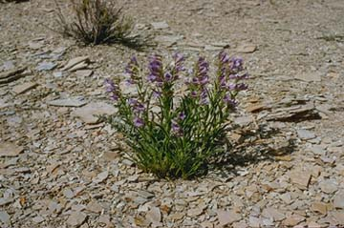

**White River penstemon in its native habitat. Photo by Ben Franklin**

**Adaptation**

White River penstemon is endemic to oil shale barrens of the Green River Formation in the Uinta Basin in Utah and Colorado from 1525 to 2075 m (5,000 to 6,800 ft) (USDI-FWS, 2010). The soils are calcareous, often white or red, fine textured and mixed with shale. The range of this species is found in a 13 to 23 cm (6 to 12 in) precipitation zone (WRCC, 2011).

### Management

The greatest potential threat to White River penstemon is oil and gas development. Habitat disturbance from off road vehicle (ORV) use and trampling from cattle and sheep may be a factor, but these effects have not been sufficiently monitored (USDI-FWS, 2010).

White River penstemon is currently a BLM special status species, which offers some protection against oil and gas development in a portion of its range.

### Pests and Potential Problems

White River penstemon is palatable to wildlife and livestock, and some herbivory has been documented.

### Environmental Concerns

Climate change could negatively impact this and other species with restricted distributions.

### Seed and Plant Production

Although this species is self-compatible, pollinators are required for maximum seed production. The flowers are primarily visited by native, solitary bees including *Anthophora* spp., *Ceratina* spp., *Dialictus* spp., *Halictus* spp., and *Osmia* spp. In field surveys, Lewinsohn and Tepedino (2007) identified 12 bee species visiting White River penstemon, two of which were potentially undescribed species. Of the ten identified species, only one was considered a penstemon specialist.

### References

Lewinsohn, J.S. and V.J. Tepedino. 2007. Breeding biology and flower visitors of the rare White River penstemon, *Penstemon scariosus* var. *albifluvis* (Scrophulariaceae). Western North American Naturalist. 67(2): 232-237.

U.S. Fish and Wildlife Service. 2010. Species assessment and listing priority assignment for White River penstemon (*Penstemon scariosus* var. *albifluvis*. U.S. Fish and Wildlife Service. Denver, Colorado. 17p.

Welsh, S.L., N.D. Atwood, S. Goodrich, and L.C. Higgins. 2003. A Utah Flora. Third Edition, revised. Brigham Young University, Provo, UT.

Western Regional Climate Center. 2011. Online. http://www.wrcc.dri.edu/index.html. Accessed January 13, 2011.

**Prepared By**:

*Derek Tilley*; USDA NRCS Plant Materials Center, Aberdeen, Idaho.

*Loren St. John*, USDA NRCS Plant Materials Center, Aberdeen, Idaho.

*Dan Ogle*, USDA NRCS, Boise, Idaho.

### Citation

Tilley, D., L. St. John and D. Ogle. 2011. Plant guide for White River penstemon (*Penstemon scariosus* var*. albifluvis)*. USDA-Natural Resources Conservation Service, Idaho Plant Materials Center. Aberdeen, ID.

Published Jan 2011

Edited: 14Jan2011djt; 14jan2011ls; 14jan2011dgo;

For more information about this and other plants, please contact your local NRCS field office or Conservation District at http://www.nrcs.usda.gov/ and visit the PLANTS Web site at http://plants.usda.gov/ or the Plant Materials Program Web site http://plant-materials.nrcs.usda.gov.

PLANTS is not responsible for the content or availability of other Web sites.

**USDA IS AN EQUAL OPPORTUNITY PROVIDER AND EMPLOYER**