

Plant Guide

# atwood’s phacelia

## Phacelia argillacea Atwood

Plant Symbol = PHAR2

*Contributed by*: USDA NRCS Idaho and Utah Plant Materials Program

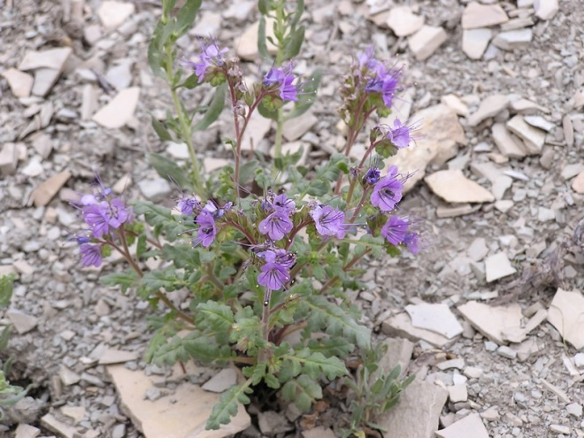**Atwood’s phacelia (Phacelia argillacea). Photo by Denise Van Keuren**

### Alternate Names

### Clay phacelia

### Uses

There are no known human uses of Atwood’s phacelia. The stems are eaten by rock squirrels (USDI-FWS, 1982).

### Status

Atwood’s phacelia was listed as endangered in 1978 by the USDI Fish and Wildlife Service (USDI-FWS, 1978). At the time of listing, the species was known from a single population containing nine individuals. In 1980 a second population was discovered bringing the total number of individuals to approximately 200 (USDI-FWS, 1982). In 2005, seed collections and germination studies yielded 53 potted plants, which subsequently produced 11,000 seeds. These seeds are to be used in further studies and reestablishment ventures (USDA-FS, 2011).

Consult the PLANTS Web site and your State Department of Natural Resources for this plant’s current status (e.g., threatened or endangered species, state noxious status, and wetland indicator values).

### Description

*General*: Waterleaf family (Hydrophyllaceae). Atwood’s phacelia is a winter annual forb with one to several stems. It grows to a height of 36 cm (14 in) tall. The leaves are 5 to 25 cm (2 to 10 in) long and deeply lobed. The inflorescence is a compound, scorpioid cyme (curling like a scorpion’s tail), with blue to violet bell-shaped flowers with 4 to 6 mm (0.16 to 0.24 in) long petals (Welsh et al., 2003).

*Distribution*:

Atwood’s phacelia is known from two locations near Tucker, Utah in Utah County. Another population, from which herbarium specimens were taken in 1883, has not been relocated (USDI-FWS, 1982).

For current distribution, consult the Plant Profile page for this species on the PLANTS Web site.

*Habitat*:

Atwood’s phacelia is found on shaley-clay slopes in pinyon-juniper and mountain brush communities at 2,015 m (7,050 ft) elevation. The nearby Soldier Summit weather station indicates an average of 35 cm (14 in) of annual precipitation (WRCC, 2010).

**Adaptation**

Atwood’s phacelia is endemic to clay and shale soils of the Green River Formation on east and southeast facing slopes. The locations of the two populations, though high in elevation, are considered to be on xeric sites because of the steepness and exposure (USDI-FWS, 1982).

### Management

The existing populations of Atwood’s phacelia are located on private property owned by the D&G RGW Railroad. The primary threat to the species is habitat destruction due to construction activities by the railroad company. A major goal in the recovery effort is to establish new populations on publically owned lands that can receive a higher level of protection (USDA-FS, 2010). The objective of the recovery plan is to establish a self-sustaining population of 2,000 to 3,000 individuals on 120 acres of protected habitat, and to possibly establish at least one new population (USDI-FWS, 1982).

### Pests and Potential Problems

There are no known pests or potential problems regarding Atwood’s phacelia*.*

### Environmental Concerns

There are no known environmental concerns regarding Atwood’s phacelia*.*

### Seed and Plant Production

Germination occurs in late summer and early fall with the onset of summer and fall storms. The seedlings form a basal rosette that continues to grow beneath snow cover. The flowers bolt after snowmelt in May. Seed production has been successful under research conditions (USDA-FS, 2010).

### References

USDA-FS. 2010. Uinta National Forest introduction program to recover clay phacelia, *Phacelia argillacea*, one of Utah’s most endangered species. Online at http://www.fs.fed.us/wildflowers/rareplants/conservation/success/phacelia_argillacea_recovery.shtml. Accessed January 4, 2010.

USID-FWS. 1978. Endangered and threatened wildlife and plants: determination of five plants as endangered species. In: Federal Register. 43 (189): 44810-44812.

USDI-FWS. 1982. Clay phacelia (*Phacelia argillacea*) recovery plan. U.S. Fish and Wildlife Service. Denver, Colorado. 13pp.

Welsh, S.L., N.D. Atwood, S. Goodrich, and L.C. Higgins. 2003. A Utah Flora. Third Edition, revised. Brigham Young University, Provo, UT.

Western Regional Climate Center. 2010. Online. http://www.wrcc.dri.edu/index.html. Accessed January 4, 2010.

**Prepared By**:

*Derek Tilley*; USDA NRCS Plant Materials Center, Aberdeen, Idaho.

*Loren St. John*, USDA NRCS Plant Materials Center, Aberdeen, Idaho.

*Dan Ogle*, USDA NRCS, Boise, Idaho.

### Citation

Tilley, D., L. St. John and D. Ogle. 2010. Plant guide for Atwood’s phacelia (*Phacelia argillacea*). USDA-Natural Resources Conservation Service, Idaho Plant Materials Center. Aberdeen, ID.

Published Jan 2010

Edited: 04Jan2011 djt, 04jan2011 ls; 04jan2011dgo

For more information about this and other plants, please contact your local NRCS field office or Conservation District at http://www.nrcs.usda.gov/ and visit the PLANTS Web site at http://plants.usda.gov/ or the Plant Materials Program Web site http://plant-materials.nrcs.usda.gov.

PLANTS is not responsible for the content or availability of other Web sites.

**USDA IS AN EQUAL OPPORTUNITY PROVIDER AND EMPLOYER**