|  |
| --- |
| blue spruce |
| *Picea pungens* Engelm. |
| Plant Symbol = PIPU |

Contributed by: USDA NRCS National Plant Data Center & the Biota of North America Program

### Alternate names

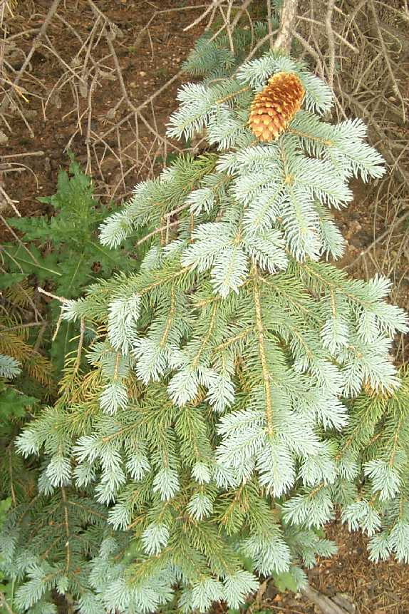

© J. Scott Peterson

USDA, NRCS, NPDC

@ PLANTS

Colorado blue spruce, white spruce, silver spruce, Parry spruce, water spruce, *Picea parryana* Sargent

### Uses

Blue spruce has been little used for lumber or wood products because it is rarely abundant in nature and the wood is brittle and often full of knots. It sometimes is cut with Engelmann spruce. Because of its cold hardiness, symmetrical pyramidal form, and waxy, blue-hued foliage, blue spruce is widely planted in ornamental and general landscape settings. Numerous horticultural cultivars have been developed, based on needle color and crown form. It is used considerably for Christmas trees and blue spruce plantations have been established in the northeastern US – these probably the source of

escapes reported for several states far from its native range (Maine, Massachusetts, New York, Pennsylvania, Maryland). Blue spruce is the state tree of Colorado and of Utah.

### Status

Please consult the PLANTS Web site and your State Department of Natural Resources for this plant’s current status, such as, state noxious status and wetland indicator values.

### Description

*General*: Pine Family (Pinaceae). Native trees growing to 50 meters tall, the crown long-conic; branches whorled, ascending to slightly to strongly drooping; twigs not pendent, stout, yellow-brown, usually without hair; many small twigs produced on the main trunk and between the main whorls of branches; bark relatively thick, gray-brown, breaking into furrows and rounded ridges, only slightly scaly. Needles are evergreen, borne singly and at right angles from all sides of the twig, 1.6-3 cm long, 4-angled, stiff and sharply spine-tipped, silvery to blue-green. Seed cones are green or violet, ripening pale buff, (5) 6-11 (12) cm long, ellipsoid, pendent, the scales elliptic to diamond-shaped, widest below middle, stiff at the base, the tip flexible, unevenly toothed, and extending 8-10 mm beyond seed-wing impression. The common name is based upon the blue foliage color of some races.

*Variation within the species*: trees with similar color tend to occur in small, local populations, suggesting that color traits are under genetic control. The color variation does not conform to a clinal pattern. Most other variable features in blue spruce (e.g., physiology, early survival, growth rate) similarly do not follow geographical parameters; date of bud set follows a local altitudinal pattern.

Besides features of habit, leaf color, and habitat, blue spruce is distinguished from Engelmann spruce by its cones and cone scales that average larger in size, but these characteristics are often partially or completely overlapping. Blue spruce also differs in its glabrous twigs.

### Distribution

The native range of blue spruce is the central and southern Rocky Mountains of the USA – in Idaho, Wyoming, Utah, Colorado, New Mexico and Arizona. For current distribution, please consult the Plant Profile page for this species on the PLANTS Web site.

### Adaptation

Blue spruce commonly occurs on stream banks in moist canyon bottoms (hence one of its common names, water spruce) but may grow on gentle to steep mountain slopes in Douglas fir or spruce-fir woods up to timberline; at 1800-3000 meters elevation in mid-montane forests. It often grows with subalpine fir, white fir, and Engelmann spruce. It is cultivated on a wide variety of soils, except those that are very moist.

### Establishment

Blue spruce begins to produce seed at about 20 years; maximum seed production occurs between 50-150 years. Good cone years occur at intervals of 2-3 years. Seed germination is mostly confined to exposed mineral soil with side shade and overhead light, but natural reproduction is scanty, probably because the light seeds are prevented from coming into contact with mineral soil by the dense herbage, grass, or other ground-cover vegetation that is usually abundant in the habitat of the species. Seedling establishment is probably benefited by moisture availability and shading, which prolong snow and soil moisture in late spring.

Blue spruce is a slow-growing tree and some individuals have been reported to live for more than 600 years. Reproduction by layering has not been reported for this species.

### Management

Western spruce budworm larvae feed on old needles in late April, then mine developing buds and defoliate new tree growth. Heavy repeated attacks kill the tree.

### Cultivars, Improved and Selected Materials (and area of origin)

These plant materials are readily available from commercial sources. Contact your local Natural Resources Conservation Service (formerly Soil Conservation Service) office for more information. Look in the phone book under ”United States Government.” The Natural Resources Conservation Service will be listed under the subheading “Department of Agriculture.”

### References

Daubenmire, R. 1972. *On the relation between Picea pungens and Picea engelmannii in the Rocky Mountains*. Canad. J. Bot. 50:733-742.

Fechner, G.H. 1990. *Picea pungens*. Pp. 238-249, IN R.M. Burns and B.H. Honkala. *Silvics of North America*. *Volume 1.* *Conifers*. USDA Forest Service Agric. Handbook 654, Washington, D.C. <http://willow.ncfes.umn.edu/silvics_manual/Table_of_contents.htm>

Taylor, R.J. 1993. *Picea*. Pp. 369-373, IN *Flora of North America, north of Mexico*. Vol. 2, *Pteridophytes and gymnosperms*. Oxford Univ. Press, New York, New York. <http://hua.huh.harvard.edu/cgi-bin/Flora/flora.pl?FLORA_ID=12395>

### Prepared By

*Guy Nesom*

Formerly BONAP, North Carolina Botanical Garden, University of North Carolina, Chapel Hill, North Carolina

### Species Coordinator

## *Gerald Guala*

USDA, NRCS, National Plant Data Center, Baton Rouge, Louisiana

Edited 05dec00 jsp; 13feb03 ahv; 060802 jsp

For more information about this and other plants, please contact your local NRCS field office or Conservation District, and visit the PLANTS Web site<<http://plants.usda.gov>> or the Plant Materials Program Web site <<http://Plant-Materials.nrcs.usda.gov>>

*The U.S. Department of Agriculture (USDA) prohibits discrimination in all its programs and activities on the basis of race, color, national origin, sex, religion, age, disability, political beliefs, sexual orientation, and marital or family status. (Not all prohibited bases apply to all programs.) Persons with disabilities who require alternative means for communication of program information (Braille, large print, audiotape, etc.) should contact USDA's* [*TARGET Center*](http://www.usda.gov/oo/target.htm) *at 202-720-2600 (voice and TDD).*

*To file a complaint of discrimination write USDA, Director, Office of Civil Rights, Room 326-W, Whitten Building, 14th and Independence Avenue, SW, Washington, DC 20250-9410 or call 202-720-5964 (voice or TDD). USDA is an equal opportunity provider and employer.*

*Read about* [*Civil Rights at the Natural Resources Convervation Service*](http://www.nrcs.usda.gov/about/civilrights/)*.*