

Plant Guide

# CLASPINGleaf pondweed

## Potamogeton perfoliatus L.

Plant Symbol = POPE7

*Contributed by*: USDA NRCS Norman A. Berg National Plant Materials Center

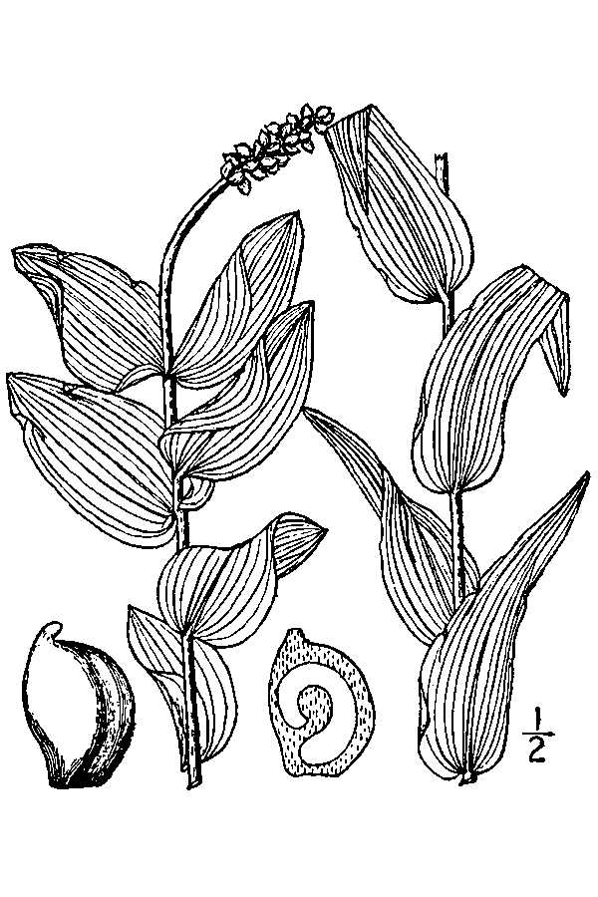

USDA-NRCS PLANTS Database / Britton, N.L., and A. Brown. 1913. An illustrated flora of the northern United States, Canada and the British Possessions. 3 vols. Charles Scribner's Sons, New York. Vol. 1: 80.

### Alternate Names

redhead grass

clasping-leaved pondweed

### Uses

Claspingleaf pondweed beds stabilize sediments, reduce shoreline erosion, and provide valuable habitat and food source for a variety of fish, macroinvertebrates, crustaceans and waterfowl (Thayer et al 1975, Lubbers 1990). They provide protection from predators, as well as attracting epiphytes and zooplankton upon which other species graze, providing an important link in the food web. During the breeding season up to 80 percent of waterfowl’s diet is plant material, much of it aquatic (Kenow and Rusch 1996). Migratory waterfowl dive and scavenge for rhizomes buried in sediments of claspingleaf pondweed beds. Another potentially important feature of claspingleaf pondweed is its antibacterial properties. Bushman and Ailstock (2006), found claspingleaf pondweed exhibited antibacterial activity against a number of different strains of bacteria. This could be critical for the health of the organisms dwelling in the grass beds such as the blue crab, the waterfowl that consume it, as well as any plant community dynamics affected by this trait.

### Status

Please consult the PLANTS Web site and your State Department of Natural Resources for this plant’s current status (e.g., threatened or endangered species, state noxious status, and wetland indicator values).

### Description

*General*:

Claspingleaf pondweed is a submerged, rooted, flowering aquatic plant that grows in alkaline, brackish, and freshwater lakes, streams and estuaries. Substrate conditions are often low in organic content forming a firm muddy bottom or a sand-based sediment in reasonably slow moving waters. The plant has a well-developed rhizomatous network (horizontally branching roots). At the end of the vegetative season rhizomes overwinter in the form of resting buds. These buds develop at the tips of rhizomes and are the source of the next year’s shoots (Hutchinson 1975). Resting bud depth is variable from just below the sediment surface to depths of more than 8 inches into the sediment. Plants tend to be darker green colored in shallow waters and are a paler green in deeper water (Bergstrom et al. 2006).

Stems are light beige to reddish brown or green-yellow in color typically consisting of one straight main stem at the base of the plant. Sometimes two or three (rarely more) stems may branching from the main stem. The parallel-veined leaves are almost perfoliate (stem through the leaves), cordate (heart shaped) clasping the stem by curving around it.

Leaves measure 0.4-2.75 inches long and are from 0.4 to 1 inch wide. They typically start no more than about 2 inches from the base of the plant and extend regularly along the stem in an alternate or slightly opposite pattern. Leaves extend to either the top of the stem or to the flowering end (terminal inflorescence) of the plant. Stem densities in the wild are highly variable. Due to its rhizomatous nature, it is quite rare to find just a single plant.

Flowers are borne on spiked inflorescences (clusters of flowers arranged on stems) measuring approximately 0.5-1.25 inches in length and about 0.25-0.50 inches wide (Gleason and Cronquist 1991). The number of inflorescences per stem ranges from 1-3. Each inflorescence contains about 5-12 (four carpel) flowers producing 20-48 seeds each, for a total of about 48-115 seeds per flowering stem (STAC 2007).

*Distribution*:

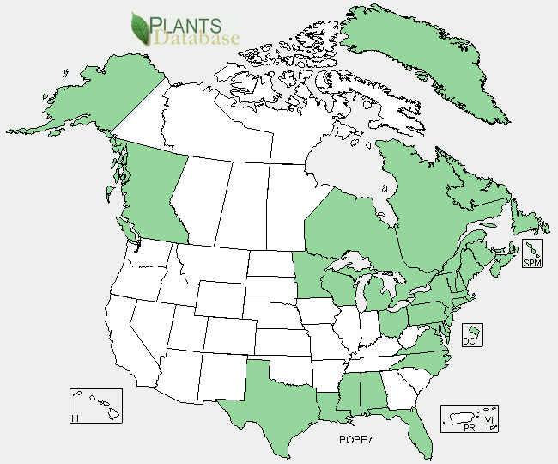

Claspinleaf pondweed distribution from USDA-NRCS PLANTS Database.

For current distribution, please consult the Plant Profile page for this species on the PLANTS Web site.

*Habitat*: *Insert text here*

**Adaptation**

Claspingleaf pondweed can be found throughout the eastern half of North America, Central America (Guatemala), Eurasia, Africa, and Australia (Bergstrom et al. 2006).

### Establishment

Claspingleaf pondweed is propagated through cuttings, rootstocks, and seeds. When starting new populations, using cuttings and rootstocks is the least time consuming method. Cuttings can be taken and immediately planted to create new ones. Use of the appropriate planting substrate is important. Sediments may be removed from a claspingleaf pondweed bed in the field or a better solution has been to develop a substrate combining oyster shell and peat. This combination is easily obtainable from nursery and agricultural suppliers, and balances the plants’ need for an alkaline substrate and includes a coarse addition of organic material (Zinecker et al., 2007). Zinecker et al. (2007) found that the planting substrate should have low organic content, but provide some nutrients, making a sand-only substrate a poor choice. A combination of sand and soil is also a poor choice due to the high organic content with added fertilizers that are much higher than the ideal environment. These factors encourage growth in the aboveground shoots rather than encouraging a robust rootstock. An adequate root system is important when propagating plants, in particular for restoration. When rootstocks are available for planting directly, time is saved because no energy is expended on aboveground shoot development until the underground parts are more developed. When shoots are planted without roots, the shoots typically senesce allowing the plants to develop underground biomass. This underground system supports the plant vegetatively, nutritionally, and provides an anchor guarding against currents or storm events.

Seed propagation may result in a much higher yield of plants than asexual propagation. Seeds must be harvested from plants at the right time of year. Germination rates under ideal conditions are variable from 16-60% (STAC 2007). Ailstock et al. (STAC 2007) found reproductive potential and harvest time highly correlated. Seed collections occur from late July to August at the Baltimore, MD latitude. Due to the large geographic range of this plant the timing of harvest will vary with location. Seed harvesting of the upper third of the water column includes the plant stems and florescence (i.e. 1 foot down in 3 feet of water, or 10 inches down in a 30 inch tank). Harvested seeds quickly degrade and require cold treatment almost immediately. Seed processing should occur soon after harvest and before cold storage. Best germination results require seed to be stratified six to nine months in cold storage (at 40 deg F) and submerged in 15 parts per thousand (ppt) saline water with aeration. To encourage fast, high rates of seed germination, after the 6-9 month stratification,transfer the seed to a warm, freshwater environment.

Plants in outdoor tank storage may be left for seeds to fall near parent plants and allowed to overwinter and germinate. This may not result in the highest germination success because the plants are harder to monitor and the environment is less controlled. The issues affecting germination rates here would be inconsistent temperature, lack of aeration, and controlled salinity. Seeds from the outdoor tank may be collected and put into a climate controlled refrigerator with or without aeration and/or salinity. If not aerated or place in 15ppt saline water, some germination (usually no more than 20%) will occur. Seed in cold, dark storage, will germinate within 2 to 4 months of harvest.

In natural propagation and restoration areas, the plants must be protected by exclosure from natural predators of the plants, such as crabs or cownose rays. There are few prescriptions for the spacing of plants. Restoration in the field, is composed of propagules typically planted in a grid comprising an entire grass bed. Ailstock (2007) recommends seeding 16 seeds per sq ft (696,960 seed/acre), while restoration plantings of winter bud or individual plant densities might be half that number at 5 to 10 units per sq. ft.

### Management

In a domestic tank or experimental setting, one of the major concerns in the aquatic environment is ensuring that algae or invasive vegetation do not overwhelm desired stock plants. Keeping nutrients and organic matter low, as well as the use of herbivores such as snails, fish or tadpoles will help reduce algae. Skimming and removal of algae with nets similar to those used cleaning pools will removed entrained nutrients and temporarily reduce completion. Large tanks with substrate filled bottoms may be more difficult to maintain than in tanks where plants are grown in removable trays filled with substrate. Greater control of invasive plants can be maintained by limiting the spread and eliminating the invasive from just one tray rather than a whole tank. Aeration of the tanks with a biological or other filter can help maintain water quality as well as provide aeration for improved growth. Holding tanks may be more susceptible to invasion from other plants if they are near other holding tanks with other species, or if there is a variety of bird life visiting the tanks.

Extensive harvesting or digging in tanks filled with sediments also gives invaders the opportunity to exploit a disturbed environment. When a tank becomes overwhelmed by an invading species the substrate may need to be changed completely, additional desired plants added to increase density, and/or the entire tank replanted.

Herbivory in outdoor tanks from waterfowl, particularly Canada geese, may be a problem. It can be discouraged with shadecloth or strings criss-crossed over the top and on the sides of the tanks.

### Pests and Potential Problems

While there are species of insects that use claspingleaf pondweed as part of their life cycle, either for egg laying or herbivory in adulthood, most of the species native to the areas where these beds are found do not seem to have a marked negative effect on the plants (Stevenson 1988). Non-migrating Canada geese graze extensively on the vegetation. Theworst herbivores of submerged aquatic vegetation (SAV) are the non-native mute swans and native cownose rays. While it is unlikely they will wipe out the entire SAV population in a given water body, they do reduce above and belowground plant material, and they may destroy restoration plantings in a single visit.

### Environmental Concerns

There are no known issues with respect to claspingleaf pondweed and environmental concerns. Man made activities such as boating, dredging and coastal development pose major challenges to grass bed longevity.

### Control

Mechanized cutting is effective for controlling claspingleaf pondweed, and the least harmful to other species.

### Seeds and Plant Production

Claspingleaf pondweed seeds are available through wild collection, requiring a permit. Seed weight and viability is dependent upon time of collection. Mature wild seed per pound can range from 3,839 seeds up to 11,088 seeds per pound (Ailstock and Shafer 2004).

### Cultivars, Improved, and Selected Materials (and area of origin)

There are no known cultivars, improved, and/or selected materials for claspingleaf pondweed. This plant is commercially available from specialized coastal and wetland plant nurseries.

### References

#### **References**

Ailstock S. and D. Schafer. 2004. Restoration

potential of *Ruppia maritime* and *Potamogeton*

*perfoliatus* by seed in the Mid-Chesapeake Bay. US Army Corps of Engineers Publication

ERDC/TN EL-04-02.

Bergstrom, Peter W., Robert F. Murphy, Michael D.

Naylor, Ryan C. Davis, and Justin T. Reel. 2006. Underwater grasses in Chesapeake Bay and Mid-Atlantic coastal waters: guide to identifying submerged aquatic vegetation. Maryland Sea Grant Publication Number UM-SG-PI-2006-01. College Park, MD.

Bushman, Paul J. and M. Stephen Ailstock. 2006.

Antibacterial compounds in estuarine

submersed aquatic plants. Journal of Experimental Marine Biology and Ecology. Vol. 331. Pp 41-50.

Gleason, Henry A. and Arthur Cronquist. 1993.

Manual of Vascular Plants of Northeastern

United States and Adjacent Canada. Second Edition. New York Botanical Garden.

Hutchinson, Evelyn G. 1975. A Treatise on

Limnology. Volume III. John Wiley and Sons. New York, London, Sydney.

Kenow, Kevin P. and Donald H. Rusch. 1996. Food

Habits of Redheads at the Horicon Marsh, Wisconsin. J. Field Ornithol. Vol. 67 Issue 4. Pp. 649-659.

Lubbers, L., W.R. Boynton, and W.M. Kemp. 1990.

Variations in structure of estuarine fish communities in relation to abundance of submersed vascular plants. Marine Ecology Progress Series. Vol. 65, No. 1. Pp. 1-14.

STAC. 2007. Submerged Aquatic Vegetation (SAV)

Reproductive Ecology in the Chesapeake Bay: Evaluating the State of the Knowledge and Assessing Future Research Needs. Report of the STAC Workshop March 6-7, 2007. STAC Publication 07-006.

Stevenson, J. C. 1988. Comparative ecology of

submersed grass beds in freshwater, estuarine,

and marine environments. Limnological Oceanography. Vol. 33, No. 4 part 2. Pp 867-893.

Thayer, G.W., S.M Adams, and M.W. LaCroix.

1975. Structural and functional aspects of a recently established *Zostera marina* community, p. 518-540. *In* L.E. Cronin (ed.), Estuarine Research. Academic, New York.

Zinecker, E., S. Hunter, P. Kangas, J. Englert. 2007.

Growth of *Potamogeton perfoliatus* (L.) on different substrates. Conference Presentation, ERF, Providence, RI. November 2007.

**Prepared By**:

*Elizabeth Zinecker*, PhD candiadate, University of Maryland

*Jeremy West*, Manager, Norman A. Berg National Plant Materials Center

### Citation

Zinecker, E and J. West. 2010. Plant guide for claspingleaf pondweed (*Potamogaton perfoliatus* L.). USDA-Natural Resources Conservation Service, National Plant Materials Center. Beltsville,MD 20705.

Published January, 2011

Edited: 1SEPTEMBER2010JW

For more information about this and other plants, please contact your local NRCS field office or Conservation District <<http://www.nrcs.usda.gov/>>, and visit the PLANTS Web site <[http://plants.usda.gov](http://plants.usda.gov/)> or the Plant Materials Program Web site <[http://Plant-Materials.nrcs.usda.gov](http://plant-materials.nrcs.usda.gov/)>

**USDA IS AN EQUAL OPPORTUNITY PROVIDER AND EMPLOYER**