

Plant Guide

# sandberg bluegrass

*Poa secunda* J. Presl

including:

*P. ampla* Merr. (POAM)

*P. canbyi* (Scribn.) Howell (POCA)

*P. gracillima* Vasey (POGR)

*P. juncifolia* Scribn. (POJU)

*P. nevadensis* Vasey (PONE3)

*P. sandbergii* Vasey (POSA12)

*P. scabrella* (Thurb.) Benth (POSC)

**Plant Symbol = POSE**

Contributed by: USDA – NRCS, Boise, Idaho

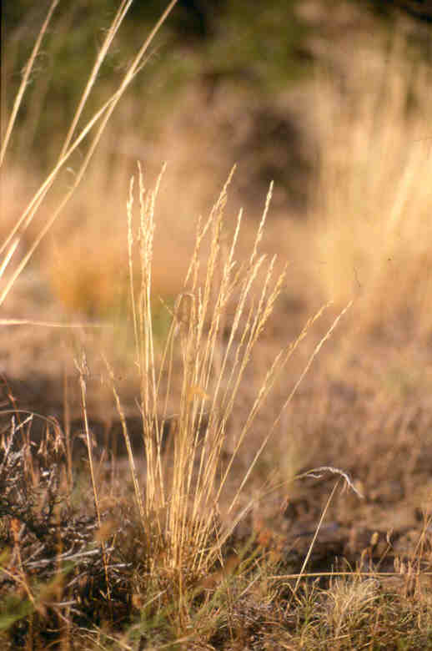

Photo by Mark Majerus. Bridger, MT Plant Materials Center

Alternate Names

*P. ampla* = Big bluegrass

*P. canbyi* = Canby’s bluegrass

*P. gracillima* = Pacific or Slender bluegrass

*P. juncifolia* = Alkali bluegrass

*P. nevadensis* = Nevada bluegrass

*P. sandbergii* = Sandberg bluegrass

*P. scabrella* = Pine bluegrass

Description

*General*: The Sandberg bluegrass complex is composed of cool-season (with some summer active ecotypes) perennial bunchgrasses that mature early in the growing season. This grass is one of the first to green up in the spring, but is cured and dormant by early summer. The plant usually occurs as small tufts, with soft basal leaves and few to many flowering stalks that are naked except for one or two small leaves. The leaves have the typical bluegrass characteristics of prow-shaped tip and double groove down the center of the leaf surface. Sandberg bluegrass has a prominent membranaceous, acute ligule. The seeds are glabrous except for short crisp hairs on the lower portion of the lemmas. The flowers are in narrow panicles that are somewhat spreading during anthesis. Plants seldom exceed 60 cm (24 in) in height. Plants of the Sandberg bluegrass complex have extensive, deep penetrating, coarse, fibrous roots that make them quite drought tolerant and resistant to grazing and trampling. Species within the complex have approximately 2,000,000 seeds per kilogram (925,000 seeds per pound).

*Distribution*: Plants occur throughout Western North America with disjunct populations in Quebec and Chile. For current distribution, consult the Plant Profile page for this species on the PLANTS Web site.

**Taxonomy**

The type specimen for *Poa secunda* was collected between 1790 and 1794 in “cordilleras Chilensibus” by Thaddeus Haenke and was described by Presl in 1830. In 1892, Sandberg collected a plant near Lewiston, Idaho which was described the following year by Vasey as *Poa sandbergii*. Presl’s work is recognized as having taxonomic priority due to its earlier date (Arnow 1981).

The Sandberg bluegrass complex has included up to 45 named species including eight species recognized by Hitchcock (1935): Canby’s bluegrass (*P. canbyi),* big bluegrass(*P. ampla*)*,* little mountain bluegrass (*P. curtifolia*), Pacific bluegrass (*P. gracillima*)*,* alkali bluegrass (*P. juncifolia*)*,* Nevada bluegrass (*P. nevadensis*),Pine bluegrass(*P. scabrella)* and the traditional Sandberg bluegrass (*P. sandbergii*) (Arnow 1981). Kellogg (1985a, 1985b) however, demonstrated that for all species except *P. curtifolia*, the characters used to separate the species were unreliable. Many were often environmentally determined, for example plants turning red when dry, leaf rolling and leaf glaucusness. Research has shown that under garden and greenhouse conditions these characters don’t exhibit themselves as in field conditions (Kellogg 1985b). Other characters vary so widely within a population that they are also unusable to delineate groups within the complex.

Based on these findings, Kellogg (1985a) synonomized the entire complex with the exception of *P. curtifolia*, a well-defined species endemic to serpentine outcrops in the Wenatchee Mountains in Kittitas and Chelan Counties, Washington (Hitchcock and others 1971).

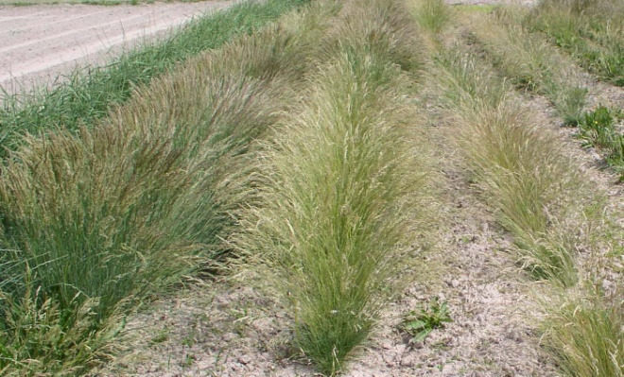Variation in Sandberg bluegrass releases; left to right: Sherman big bluegrass, High Plains and Mountain Home Sandberg bluegrass. Photo by Derek J. Tilley, Aberdeen, ID Plant Materials Center.

Although evidence currently points to a large, highly variable suite of forms making up the Sandberg bluegrass complex, the authors of this paper believe that unique phenotypes exist and the separation of these forms is still useful in describing ecological sites, predicting revegetation performance and in making land management decisions. In this light, the authors have decided to provide descriptions here of the seven separate forms of Sandberg bluegrass recognized by Hitchcock (1935), minus *P. curtifolia*, as an aid to land managers.

The following taxonomic key taken from Cronquist and others (1977) should be useful in separating the seven species of the Sandberg bluegrass complex.

1. Lemmas crisp puberulent to nearly glabrous, the

pubescence sometimes confined to the very base.

2. Panicles open, the lower branches nearly at

right angles to the axis; culms often decumbent

at the base; plants summer flowering

……………………………………*P. gracillima*

2. Panicles contracted or somewhat open; culms

usually erect.

3. Plants relatively small, culms mostly less

than 30 cm tall; basal leaves forming a short

dense tuft, 3-10 cm high; panicles 2-7 cm

long; mostly spring flowering...*P. sandbergii*

3. Plants larger, mostly more than 30 cm

tall; basal leaves looser, the tuft 5-30 cm

high; panicles 6-16 cm long; mostly summer

flowering

4. Basal tuft of leaves 3-15 cm high;

panicles 4-12 cm long…........*P. scabrella*

4. Basal tuft of leaves 15-30 cm high;

panicles 9-16 cm long………....*P. canbyi*

1. Lemmas usually glabrous, sometimes minutely

scaberulous

5. Ligules decurrent, long, 1.5-6.5 mm long,

acuminate or sharply acute……*.P. nevadensis*

5. Ligules not obviously decurrent, short, 1-2 mm

long, rounded or obtuse to truncate.

6. Blades involute, mostly less than 1.5 mm

broad, greenish; plants 20-70 cm tall;

usually growing in alkaline soils

...................................................*P. juncifolia*

6. Blades mostly flat, 1.5-3.5 mm broad, often

glaucous; plants robust, 60-180 cm tall;

growing in non-alkaline soils……...*P. ampla*

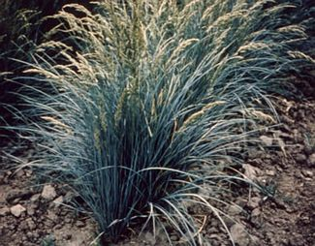‘Sherman’ big bluegrass. Photo from USDA-NRCS.

Big bluegrass (*Poa ampla*)

This is the most robust species within the Sandberg bluegrass complex. Culms reach 60 to 130 cm (24 to 48 in) tall, with basal leaves growing to 40 cm (16 in) long and 1.5 to 3.5 mm (1/16 to 1/8 in) wide. The leaves are typically bluish-green and somewhat glaucus. Panicles range from 10 to 18 cm (4 to 7 in) long and are narrow with densely arranged spikelets. This species occupies sagebrush slopes, mid-elevation meadows and openings in aspen stands. Big bluegrass is notable for early green-up, greater forage production and its importance to range management.

Canby’s bluegrass (*Poa canbyi*)

Canby’s bluegrass bears green to glaucus leaves with culms to 80 cm (31 in) tall. The basal leaves are typically 15 to 30 cm (6 to 12 in) long and 1 to 3 mm (1/16 to 3/32 in) wide. The panicles are loose to compact with erect branches growing to a length of 16 cm (6 ¼ in). Plants of Canby’s bluegrass grow on open grassy or sagebrush slopes at middle elevations. In its native habitat this species actively grows during the late spring and matures by early July as opposed to *P. sandbergii* (Cronquist and others 1977).

Pacific or Slender bluegrass (*Poa gracillima*)

This is another summer active species. Culms range from 20 to 50 cm (8 to 20 in) tall. Leaf blades are flat and lax from 5 to 15 cm (2 to 5 in) long and 0.7 to 2 mm (1/32 to 1/16 in) wide. The panicles are open and pyramidal. Lemmas of Pacific bluegrass have longer hairs on the keel than *P. sandbergii*. This species can be found in meadows, stream banks and rocky slopes from British Columbia to the California Sierras, with populations also in northern Nevada, northern Utah and Colorado.

Nevada bluegrass (*Poa nevadensis*)

This species is a perennial bunchgrass with culms as much as 100 cm (39 in) tall. Basal leaves typically reach a length of 25 cm (10 in) with a width of 1 to 3 mm (1/16 to 3/32 in). Nevada bluegrass has distinctive long acuminate ligules from 1.5 to as much as 6 mm (1/16 to ¼ in) long. The narrow panicles are 10 to 18 cm (4 to 7 in) long with yellowish-green to purplish-tinged spikelets. Nevada bluegrass can be found in relatively moist areas in sagebrush communities including mountain foothills and meadows from Alaska to southern California, through Nevada to Arizona and Colorado.

Alkali bluegrass (*Poa juncifolia*)

This species is regarded as being closely related to *P. ampla* (Cronquist and others 1977) and it has been shown that when grown under garden conditions the differences between the two species are lost (Hitchcock and others 1969). Typically the plants are smaller with culms growing 30 to 70 cm (12 to 26 in) tall. Leaf blades are tightly rolled and less than 2 mm (1/16 in) wide. Panicles are narrow, 7 to 15 cm (2 ¾ to 6 in) long with short, ascending branches. This species prefers moist or dry alkaline meadows from the sagebrush zone to mountain communities from British Columbia to South Dakota and south to Nevada, Utah and New Mexico.

Sandberg bluegrass (*Poa sandbergii*)

This is probably the most common bluegrass species in the Intermountain West, at least in the drier portions of the region, and is an important forage species for small animals in spring and fall (Cronquist and others 1977). Plants are relatively small with culms reaching 20 to 35 cm (8 to 14 in) tall and basal leaves 3 to 5 cm (1 to 2 in) long. Plants occur in dry areas in sagebrush and mountain shrub communities, and occasionally in alpine sites.

Pine bluegrass (*Poa scabrella*)

This species can be tentatively separated from Canby’s bluegrass by its being a spring flowering species as opposed to summer, and from Sandberg bluegrass by its smaller size. However; it is admittedly very closely related to both and extremely difficult to separate when the species are found in close proximity to one another. Typically this species is found on relatively dry sites on sagebrush hills and woodlands at low to mid-elevations from British Columbia to Baja California, Nevada Utah and Colorado, and east to Minnesota.

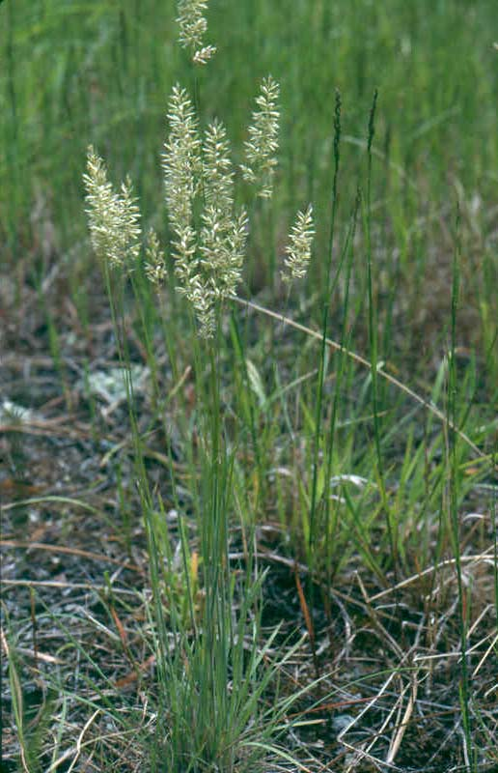

Pine bluegrass. http://www.tarleton.edu/~range/Home/home.htm

Uses

Sandberg bluegrass and the other spring ecotypes are palatable to livestock early in the growing season, becoming less preferred during the summer when cured. Summer growing ecotypes are palatable longer into the season. By autumn Sandberg bluegrass is frequently selected again as available alternatives diminish. Deer, pronghorn antelope, and bighorn sheep utilize Sandberg bluegrass forage and birds and small mammals utilize the seed (Johnson and Larson 1999).

Because of the small stature and early maturity, most of the species of Sandberg bluegrass do not provide much usable forage; however, big bluegrass and Nevada bluegrass can be important forage producers for larger animals. Sandberg bluegrass is usually a minor component of many grassland communities, but is still considered one of the six most important rangeland grasses of the Intermountain and Pacific Northwest regions (USDA Forest Service 1937).

The anticipated use of commercially available Sandberg bluegrass seed is for inclusion in native mixtures for wildlife habitat, reclamation of disturbed sites, restoration of native rangeland, and conservation plantings.

Status

Consult the PLANTS Web site and your State Department of Natural Resources for this plant’s current status (e.g. threatened or endangered species, state noxious status, and wetland indicator values).

Adaptation

Sandberg bluegrass is considered an increaser in mid and short-grass prairies, mountain meadows, and foothills of south-central Canada and western United States (Dakotas west to Washington), south to Mexico (Hitchcock 1935) (Hitchcock & Cronquist 1976). It is found at elevations ranging from 100 to 3,650 meters (300 to 12,000 ft). It grows well on medium texture soils but is also common on badlands, ridge tops, and dry, stony, or sandy soils. It is a pioneer species, one of the first grasses to colonize on disturbed sites. Plants of the Sandberg bluegrass complex occupy a niche in bunchgrass plant communities. The primary area of use would include the northern Great Plains (Montana, Wyoming, North Dakota, South Dakota, Colorado), the Intermountain West including the Great Basin (Idaho, Nevada, Oregon, Washington, Utah), and the Palouse country (Idaho, Oregon, Washington).

Sandberg bluegrass is considered to be a facultative apomyct, reproducing primarily (but not limited to) agamospermy, or asexual seed production (Kellogg 1987). Larson and others (2001) showed that genetic diversity within natural populations of Sandberg bluegrass was much greater than that in the releases Sherman or Canbar. Accordingly, releases, such as Reliable Sandberg bluegrass germplasm, have been developed from multiple plant populations to ensure higher amounts of genetic diversity and greater adaptation (Waldron and others 2006).

Establishment

For best results, seed should be planted into a firm, weed-free seedbed, preferably with a drill that will ensure a uniform seed placement of about 6 mm (1/8 to 1/4 inch). The small seed can be broadcast seeded, harrowed, and packed for good seed-soil contact; however, in dryland situations good precipitation at the time of germination is critical for emergence and survival. The full seeding rate is 1.7 kg/ha PLS (2.0 lb/ac PLS), but this species would seldom be seeded in a pure stand. This species would normally be included in native seed mixtures at a rate of 0.3 to 0.6 kg/ha PLS (1/4 to 1/2 lb/ac PLS). Seeding in early spring is favored in areas that have summer moisture patterns such as the Northern Great Plains, while fall dormant seedings are preferred in winter rainfall areas such as the Columbia Basin and most of the Intermountain West. Sandberg bluegrass is considered a pioneer species and is often one of the first grasses to respond to surface manipulation of deteriorated rangeland. Sandberg bluegrass is a relatively short-lived grass, but often perpetuates itself through prolific seed set and shatter.

Management

Sandberg bluegrass will withstand heavy grazing and trampling, in part, because of its early maturity and apparent dormancy during the summer and fall grazing period. When planted in a native reclamation mix, it will be a minor component of the establishing plant community; therefore management should be based on other key species in the mixture. Any new planting should be deferred from livestock grazing until it is well established which may require 1 to 3 years (Schwendiman 1971).

Pests and Potential Problems

Sandberg bluegrass is susceptible to stem and leaf rusts which can significantly decrease seed production (Mosman 2005). Rust outbreaks can be prevented and controlled by applying a 14 oz rate of systemic fungicides such as Propiconazole and Azoxystrobin (‘Quilt’ tm). Always follow the label in any pesticide application.

Environmental Concerns

Sandberg bluegrass is a native perennial grass that is considered an increaser under heavy grazing conditions and is a pioneer (early colonizing species) on rangeland disturbances or surface manipulated sites. This species is a bunchgrass and seed shatter does not travel far from the parent plant. It occupies space in bunchgrass plant communities and assists with deterring invasive species encroachment due to its extensive root system.

It is recommended in mixtures on sites needing an early spring perennial grass to compete against annual weeds. Sandberg bluegrass is known to fill in interspaces between larger bunchgrasses and effectively impedes the spreading of cheatgrass (Monsen and others 2004). Seed may be consumed by songbirds, upland game birds, and small mammals and spread through feces. Sandberg bluegrass is not aggressive, and therefore is not considered to be invasive.

**Seed Production**

Seed should be planted in rows using a drill that will ensure a uniform 6 mm (1/4 inch) planting depth. Seeding is best in early spring (April 1 to May 15). Seed in rows with at least 45-60 cm (18-24 in) spacing on irrigated sites and 75-90 cm (30-36 in) on dryland sites.

Seed production should not be attempted on dryland sites receiving less than 380 mm (15 inches) of annual precipitation. Seed of this species matures early, so a long growing season is not necessary. However, seed production should not be attempted in areas that have a high probability of a killing frost past May 15th. Commercial seed production fields of Sandberg bluegrass will not produce seed the first (establishment) year. Seed production fields should be established using a rate of 150 to 250 seeds per linear meter of row (50-80 PLS/ linear foot). This will equate to 0.6 to 1.2 kg/ha (0.5 to 1 lb/ac) of pure live seed. Because of the extremely small seed size, seeding rates are often in the neighborhood of 2.2 kg/ha (2 lb/ac) because of the difficulty in metering such a small volume of seed through a drill.

Seeding in wide-spaced rows facilitates weed control and allows for more robust plant development resulting in optimum seed production. Close cultivation should occur only during the establishment year. As the stand matures, cultivation should be further away from the row, allowing tillering from the edges and preventing damage to surface roots. There are several broadleaf herbicides that are registered for use in grass seed production fields, however, options are limited for chemical control of annual grassy weeds.

The average harvest date in south-central Montana ranges from June 24 to August 19; the harvest date varying with spring and early summer climatic conditions. Good seed production can be expected during the second and third year of production with seed production dropping off drastically the fourth year. Expected seed production is 85-175 kg/ha (75-150 lbs/ac) on dryland and 110-445 kg/ha (100-400 lbs/ac) on irrigated sites. Seed ripening is uniform enough that seed can be direct combined, but swathing and combining from a cured windrow is the preferred method of harvest.

Cultivars, Improved, and Selected Materials (and area of origin)

Various "ecotypes" should be utilized within a reasonable geographic range from the original source, since available releases are primarily source identified or selected germplasm releases and have not been progeny tested to determine their range of adaptation and performance.

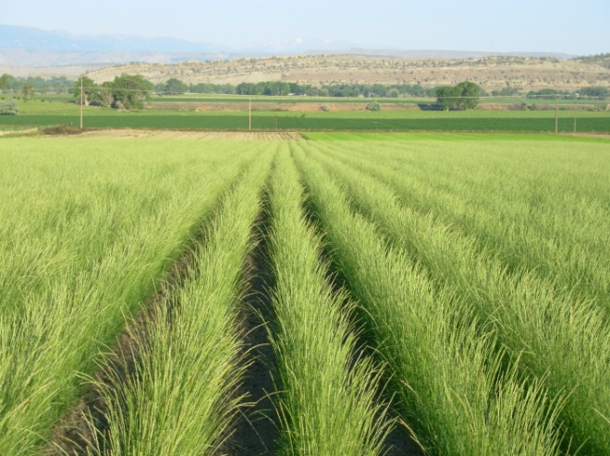

Seed production field of High Plains Sandberg bluegrass at the Bridger, MT PMC. Photo by Susan Winslow.

*High Plains* Selected Class Germplasm of Sandberg bluegrass *(Poa sandbergii)* was released in 2000 from the Bridger Plant Materials Center. This is the first release of the *Poa sandbergii* type to the commercial seed industry. This release is a composite of three accessions originating from the high plains of Wyoming; one each from Natrona (300-350 mm precip., elev. 1,590 m), Campbell (250-300 mm precip., elev. 1,430 m), and Uinta (175-225 mm precip., elev. 1,920 m) counties. G1 (equivalent to Foundation) seed is available to commercial growers through the Foundation Seed Program at Montana State University and the University of Wyoming. The Montana and Wyoming Seed Certification Programs will recognize G2 (equivalent to Registered) and G3 (equivalent to Certified) classes of germplasm.

*Mountain Home Germplasm* (*Poa sandbergii)* is test material from the USDA Forest Service Rocky Mountain Research Station in Boise, ID. Mountain Home Germplasm is not a release at this point, but is under commercial production and being utilized in seed mixes in the Intermountain West.

*Hanford Source* Sandberg bluegrass (*Poa sandbergii*) is a source identified release from L&H Seeds in Connell, Washington. The original material was collected from Hanford, Washington from an area receiving an average 6 inches of annual precipitation. It is adapted to droughty regions in the west and/or locations with well drained sandy soils.

*Duffy Creek and Wallowa* (*Poa sandbergii)* are source identified releases from Benson Farms Inc. Both are intended for use in arid sites throughout the western states.

*Reliable* Sandberg bluegrass (*Poa sandbergii)* was released by the USDA-ARS and the Utah Agricultural Experiment Station in 2004 as a Selected Class germplasm. This is a multi-origin germplasm stemming from 28 collections representing seven USDA-NRCS ecological sites. Reliable was developed for its high genetic diversity and to provide adaptation over a broad ecological range (Waldron and others 2006). G1 and G2 seed is maintained by the USDA-ARS Forage and Range Research Laboratory, Logan, UT. G3 seed is available through the Utah Crop Improvement Association. Seed through the G5 generation will be eligible for certification as Selected Class germplasm.

*Canbar* canby’s bluegrass (*Poa canbyi)* is a cultivar release and was selected from a single collection made in the Blue Mountains, Columbia County, Washington. It is adapted to sites receiving 8 to 24 inches annual precipitation and is intended for use in basin, Wyoming and mountain big sagebrush plant communities in western states. Canbar should be used in a mixture on sites needing an early spring perennial grass to compete against annual weeds. Canbar is known to fill in interspaces between larger bunchgrasses and effectively impedes the spreading of cheatgrass (Monsen and others 2004). Foundation seed is available through the Washington State Crop Improvement Association. Breeder seed is maintained by the Pullman, Washington Plant Materials Center.

*Service* Sandberg bluegrass (*Poa ampla)* comes from a collection made east of Whitehorse, Yukon Territory, Canada. It is intended for use in reclamation, native habitat restoration and erosion control throughout most of Alaska (Alderson and Sharp 1994). Breeder seed is available through the Alaska Plant Materials Center, Palmer, Alaska.

*Sherman* big bluegrass was collected from a native population near Moro, Sherman County, Oregon in 1932 and this cultivar was released in 1945 by the Washington, Idaho and Oregon Agricultural Experiment Stations and the Pullman Washington Plant Materials Center. This is a large stature bunchgrass growing to nearly 1 meter tall (Alderson and Sharp 1994). It is intended for use in range reseeding, cropland retirement plantings, and revegetation of disturbed lands in mountain brush communities and openings in aspen and conifer forests. It is best adapted to areas that receive 10-24 inches of annual precipitation. Plants of Sherman are readily eaten by livestock and large game. Foundation seed is available through Washington State Crop Improvement Association, and breeder seed is maintained by the Pullman, Washington Plant Materials Center.

References

Alderson, J. and W.C. Sharp. 1994. Grass Varieties in the United States. Rev. ed. Agricultural Handbook 170. Washington, DC: U.S. Department of Agriculture, Soil Conservation Service. 296 p.

Arnow, L.A. 1981. *Poa secunda* Presl. Versus *P. sandbergii* Vasey (Poaceae). Systmatic Botany 6:412-421.

Cronquist, A., A.H. Holmgren, N.H. Holmgren and J.L. Reveal. 1977. *Intermountain Flora: Vascular Plants of the Intermountain West*, U.S.A. The New York Botanical Garden.

Hitchcock, A.S. 1935. Manual of the Grasses of the United States. Miscellaneous Publication No. 200. US Printing Office, Washington D.C.

Hitchcock, C.L., A. Cronquist, M. Owenby and J.W. Thompson. 1969. Vascular Plants of the Pacific Northwest. University of Washington Press. Seattle, WA.

Hitchcock, C.L. and A. Cronquist. 1976. Flora of the Pacific Northwest-An Illustrated Manual. University of Washington Press. Seattle, WA.

Johnson, R.J. and G.E. Larson. 1999. Grassland Plants of South Dakota and the Northern Great Plains. B- 566, South Dakota State University, Brookings, SD.

Kellogg, E.A. 1985a. A biosystematic study of the *Poa secunda* complex. J. Arnold Arboretum 66:201-242.

Kellogg, E.A. 1985b. Variation and names in the *Poa secunda* complex. J. Range Management. 38:516- 521.

Kellogg, E.A. 1987. Apomixis in the *Poa secunda* complex. American Journal of Botany 74: 1431- 1437.

Monsen, S.B., Stevens, R. and N. Shaw. 2004. Grasses. In: S.B. Monsen, R. Stevens, and N.L. Shaw [compilers]. Restoring western ranges and wildlands. Fort Collins, CO: USDA Forest Service, Rocky Mountain Research Station. General Technical Report RMRS-GTR-136-vol-2. p. 295-424.

Mosman, D. 2005. Personal communication. Mosman Seed Ranch. Craigmont, ID.

Schwendiman, J.L. 1971. Culture and uses of ‘Sherman’ big bluegrass. USDA SCS Plant Science Handbook. Spokane, WA.

USDA Forest Service. 1937. Range Plant Handbook. U.S Government Printing Office, Washington D.C.

Waldron, B.L., S.R. Larson, K.B. Jensen, R.D. Harrison, A.J. Palazzo and T.J. Cary. 2006. Registration of Reliable Sandberg Bluegrass Germplasm. Crop Science 46: 487-488.

Prepared By

Mark Majerus, Plant Materials Center Manager, USDA, NRCS, Bridger, MT

Larry Holzworth, Plant Materials Specialist, USDA, NRCS, Bozeman, MT

Derek Tilley, Range Conservationist (Plants) USDA NRCS Plant Materials Center, Aberdeen, ID

Dan Ogle, Plant Materials Specialist

USDA NRCS Idaho State Office, Boise, ID

Mark Stannard, Plant Materials Center Manger, USDA Plant Materials Center, Pullman, WA

Species Coordinator

Larry Holzworth, Plant Materials Specialist, USDA, NRCS, Bozeman, MT

### Citation

Majerus, M., Holzworth, L., Tilley, D., Ogle, D., Stannard, M. 2009. Plant Guide for Sandberg bluegrass (*Poa secunda* J. Presl*)*. USDA-Natural Resources Conservation Service, Idaho Plant Materials Center, Aberdeen, ID 83210.

Published October, 2009

Edited: djt010407; dgo010407; lkh110706; ms120706

For more information about this and other plants, please contact your local NRCS field office or Conservation District at <http://www.nrcs.usda.gov/> and visit the PLANTS Web site at <http://plants.usda.gov/> or the Plant Materials Program Web site <http://plant-materials.nrcs.usda.gov>.

PLANTS is not responsible for the content or availability of other Web sites.

**USDA IS AN EQUAL OPPORTUNITY PROVIDER AND EMPLOYER**