

Plant Guide

|  |
| --- |
| narrowleaf mountainmint |
| Pycnanthemum tenuifolium Schrad. |
| Plant Symbol = PYTE |

Contributed by: USDA NRCS Cape May Plant Materials Center

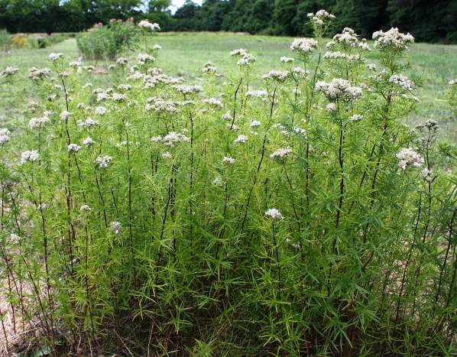

Narrowleaf mountainmint *(Pycnanthemum tenuifolium)* (Photo by, Jolie Dollar, Xerces Society)

**Alternate Names**

*Common Alternate Names:*

Virginia thyme

slender mountain mint

common horsemint

**Uses**

*Wildlife Use:* *Pycnanthemum. tenuifolium* provides a nectar source for pollinators and is well suited for use in pollinator restoration habitat. Preliminary observation found that *P. tenuifolium* attracted 20 different species of Hymenoptera and Lepidoptera in Cape May, New Jersey. The sweat bees *Lasioglossum vierecki*, *Halictus confusus*, and *Halictus ligatus* were most frequently observed visiting the flower. Both *Lasioglossum* sp. and *Halictus confuses* in particularare important pollinators of pepper , watermelon, strawberry, and tomato plants.

Robertson (1928) collected 29 species of Lepidoptera from *P. tenuifolium* in Central Illinois. This is one of the greatest numbers of species to visit a flower from the 244 species of flowering plants in his study. In Tooker et al. (2006), 9 species of fly were found on P. tenuifolium; and Robertson (1929) captured 31 species of fly.

Deer may browse the leaves and a variety of animals will eat the seeds. It is reported that the seeds are too small to attract birds (Hilty, 2012).

*Erosion Control: P. tenuifolium* spreads quickly through rhizomes and so would make a good soil stabilizer.

**Ethnobotany**

*P. tenuifolium* has been used in herbal teas and by many native tribes as a seasoning in food to improve flavor. Members of the genus *Pycnanthemum* were once referred to as American wild basil; so widespread was its use as a food additive (Austin and Honychurch, 2004).

**Status**

Please consult the PLANTS Web site and your State Department of Natural Resources for this plant’s current status (e.g., threatened or endangered species, state noxious status, and wetland indicator values).

**Description**

*General*: *P. tenuifolium* is a native, warm season, perennial forb that grows 2–3 ft tall and spreads equally wide. It is a member of the Lamiaceae (mint) family and the crushed flowers or leaves emit a minty scent. Like other mints, it has a four angled stem and small opposite leaves. The stem is smooth, without hairs, and is slender and stiff. The plant has a taproot and rhizomes.

The pale green leaves are approximately 0.15–0.6 in wide and 0.5–2 in long. They are smooth or minutely hairy on the uppermost leaves. The upper leaves are stalkless while the lowest leaves have short stems. There are short leafy branches in the axils.

The plant has profuse clusters of small, tubular, white flowers which bloom in the middle of summer; July through August. The flower petals have an upper lip, and three-lobed lower lip. Clusters stagger their bloom period over a long period of time. It is thought that pollinators prefer this species because the florets are tightly clustered, have short corolla tubes, and are white (Tooker et al., 2002).

*Distribution*: The plant grows from Canada south to Florida, west to Texas, and northwest to Minnesota. For current distribution, please consult the Plant Profile page for this species on the PLANTS Web site.

*Habitat*: *P. tenuifolium* grows in dry to medium wet soils and in full sun to partial shade. It is found in rocky ground in open prairies and upland woods, as well as in low areas, wet thickets, pine barrens, oak woods, and on the edges of wooded areas. Gleason and Cronquist (1963) observe that it is most often found in dry soils of upland woods and prairies.

The wetland indicator status of this plant is both facultative (FAC) and facultative wetland (FACW) depending on the region under consideration. Facultative species are equally likely to occur in wetlands as non-wetlands. Facultative wetland plants usually occur in wetlands (estimated probability 67%–99%). Please consult the PLANTS Web site to determine the wetland status for your region.

**Establishment**

*P. tenuifolium* should begrown in full sun in moist to slightly dry soils. Although seeds are small and difficult to use, it can be propagated by seed. Seeds germinate without pretreatment. It may also be propagated by cuttings or division. Cuttings should be made in June and divisions should be done during dormancy (from late fall to early spring).

**Pests and Potential Problems**

There are no major pests or problems known for this plant, although it may be vulnerable to rust.

**Environmental Concerns**

It forms colonies by spreading through rhizomes and can show aggressive growth.

**Seeds and Plant Production**

Seeds mature in late September and should be collected when the black seeds can be shaken out of old blooms. The seeds do not have hairs but can still be easily carried by the wind. One ounce of seed contains roughly 375,000- 378,000 seeds. The seeds have low protein content.

**References**

Austin, D.F., and P.N. Honychurch. 2004. Florida ethnobotany. CRC Press. Boca Raton, FL. p. 941.

Carr, M.E. 1985. Plant species evaluated for new crop potential. Econ. Bot. 39(3):336-345.

Gleason, H.A., and A. Cronquist. 1963. Manual of vascular plants of Northeastern United States and adjacent Canada. Van Nostrand Reinhold Company. New York, NY.

Hilty, J. 2012. Illinois wildflowers: Pycnanthemum tenuifolium (slender mountain mint). http://www.wildflower.org/plants/result.php?id_plant=PYTE (accessed 17 Apr. 2012).

Missouri Botanic Garden. 2012. Pycnanthemum tenuifolium (slender mountain mint) http://www.missouribotanicalgarden.org/gardens-gardening/your-garden/plant-finder/plant-details/kc/r690/pycnanthemum-tenuifolium.aspx (accessed 17 Apr. 2012).

Robertson, C. 1928. Flowers and insects: lists of visitors of four hundred and fifty-three flowers. The Science Press Printing Company, Lancaster, PA.

Stone, W. 1973.The plants of Southern New Jersey. Quarterman Publications, Inc. Boston, Mass.

The University of Texas at Austin Wildflower Center. 2012. *Pycnanthemum tenuifolium* http://www.wildflower.org/plants/result.php?id_plant=PYTE (accessed 17 Apr. 2012). Native Plant Database, Austin, Texas.

Tooker, J.F., M. Hauser, and L. M. Hanks. 2006. Floral host plants of Syrphidae and Tachinidae (Diptera) of Central Illinois. Ann. Entomol. Soc. AM. 99 (1): 96-112.

Tooker, J.F., P. F. Reagel, and L.M. Hanks. 2002. Nectar sources of day-flying Lepidoptera of Central Illinois. Anal. Entomol. Soc. of Am., 95 (1): 84-96.

Toupal, R.S. 2006. An ethnobotany of Indiana Dunes National Lakeshore: A baseline study emphasizing plant relationships of the Miami and Potawatomi Peoples. Bureau of Applied Research in Anthropology. University of Arizona. http://www.csu.edu/cerc/documents/EthnobotanyINDunesNationalLakeshore2006.pdf (accessed 17 Apr. 2012)

**Prepared By**: Christopher M. Sheahan. USDA-NRCS, Cape May Plant Materials Center, Cape May, NJ.

**Citation:** Sheahan, C.M. 2012. Plant guide fornarrowleaf mountainmint (*Pycnanthemum. tenuifolium*). USDA-NRCS, Cape May Plant Materials Center. Cape May, NJ.

Edited:

For more information about this and other plants, please contact your local NRCS field office or Conservation District at

<http://www.nrcs.usda.gov/> and visit the PLANTS Web site at <http://plants.usda.gov/> or the Plant Materials Program Web site <http://plant-materials.nrcs.usda.gov>.

PLANTS is not responsible for the content or availability of other Web sites.

**USDA IS AN EQUAL OPPORTUNITY PROVIDER AND EMPLOYER**