|  |
| --- |
| Oregon oak |
| *Quercus garryana* Dougl. ex Hook. |
| Plant Symbol = QUGA4 |

Contributed by: Santa Barbara Botanic Garden and USDA NRCS National Plant Data Center

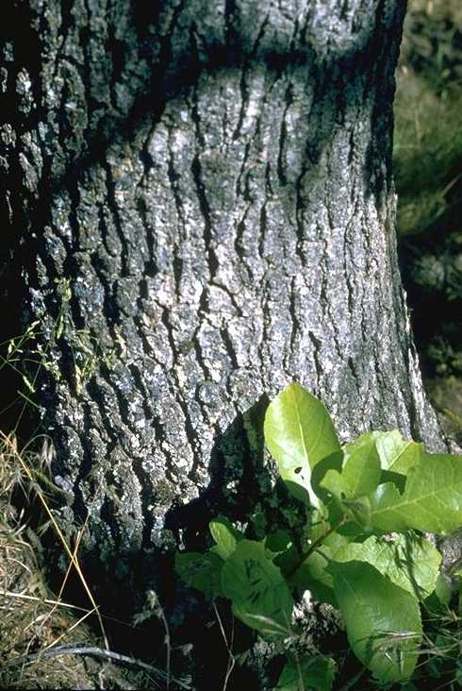

Brother Alfred Brousseau

© Brother Eric Vogel, St. Mary’s College

@ CalPhotos

# Alternate Names

Oregon white oak, Garry oak, Brewer’s oak, chêne de Garry; three varieties are recognized for this species: *Quercus garryana* var. *garryana*, *Quercus garryana* var. *breweri*, and *Quercus garryana* var. *semota*

# Uses

*Wildlife*: Oregon oak is a valuable source of food and cover for wildlife. Gray squirrels, deer, and livestock eat acorns and the leaves of young shoots and sprouts.

*Ethnobotanic*: Native Americans used Acorns as a food staple.

*Construction*: In the Pacific Northwest, large trees were preferred for shipbuilding, railroad ties, and construction. Resistance to decay also contributed to its use as fence posts. The wood continues to be important to cottage furniture and cabinet industries.

# Status

Please consult the PLANTS Web site and your State Department of Natural Resources for this plant’s current status, such as, state noxious status and wetland indicator values.

# Description

General: Oak Family (Fagaceae). *Quercus garryana*, a native deciduous tree up to 30 m tall throughout much of its range in the Pacific Northwest, has an open, rounded crown. However, in the southern part of its range, including interior California, it also is a shrub up to 5 m tall, which is treated as var. *breweri* (Engelm.) Jepson. The mature bark is brownish gray and shallowly fissured in a checker-like pattern. Leaves are oblong to obovate, 8-15 cm long, and deeply lobed (5-7 rounded lobes). The upper surfaces are shiny and dark green, but the lower surfaces are pale green. Like all oaks, Oregon oak is monoecious and wind-pollinated. The acorn cups are composed of thick, tubercled scales. The one-seeded nuts are 2-3 cm long, ovoid, and mature in one year. Flowering takes place from March to May. Fruits mature between August and November. Color images, line drawings, and a description can be found in Farrar (1995).

# Distribution

This species is known from California, Washington, Oregon, and British Columbia. For current distribution, please consult the Plant Profile page for this species on the PLANTS Web site.

# Establishment

*Adaptation*: Oregon oak is best developed as a tree on slopes and valleys below 1500 m where annual rainfall exceeds 30 inches. The range in climate is considerable, extending from the relatively cool, moist Fraser Valley of British Columbia to the summer-dry Coast Ranges north of San Francisco and the foothills of the Sierra Nevada in California. Oregon oak takes the form of a shrub on nutrient-poor soils (e.g., serpentine) and drier sites, often forming clonal thickets. It is tolerant of freezing conditions and also has a broad tolerance of substrates, which vary from rocky, thin soils of ridges to the deep loams and clays of valley bottoms. Common associates in mixed forests include madrone, Douglas fir, tanbark oak, and yellow pines. In the coastal mountains and in the absence of fire, Douglas fir gradually replaces Oregon oak. Throughout much of its range, Oregon oak reproduces extensively by basal sprouts, which often develop after fires. Thus, Oregon Oak is often associated with local grasslands maintained by fire. In some areas seedlings develop into multi-stemmed plants, which may live up to 10 years, until a single shoot becomes dominant. Like most oaks, Oregon oak has an obligate relationship with mycorrhizal fungi, which provide additional moisture and nutrients.

*Seed Preparation*: Oak seeds do not store well and consequently seeds should be planted soon after maturity. Nuts are considered ripe when they separate freely from the acorn cap and fall from the tree. Care should be taken to collect local fruits, because they may be adapted to local environmental conditions. Viable nuts may be green to brown, and have unblemished walls. Nuts with discoloration or sticky exudates, and small holes caused by insect larvae, should be discarded.

*Direct Seeding*: Seeds may be planted at the beginning of the winter. Once the site is chosen, prepare holes that are 10 inches in diameter and 4-5 inches deep. One gram of a slow-release fertilizer should be placed in the bottom and covered by a small amount of soil. Place 6-10 acorns in each hole at a depth of 1-2 inches. Rodents or birds should use temporary enclosures to minimize herbivory. A simple enclosure can be constructed from a one-quart plastic dairy container with the bottom removed and a metal screen attached. Towards the end of the first season, seedlings should be thinned to 2 or 3 per hole and to one seedling by the second season. Supplemental watering may be necessary if a drought of 6 weeks or more occurs during the spring.

*Container Planting*: Seeds may be planted in one-gallon containers, using well-drained potting soil that includes slow-release fertilizer. Tapered plastic planting tubes, with a volume of 10 cubic inches, may also be used. Seeds should be planted 1-2 inches deep and the soil kept moist and aerated. Seedlings should be transplanted as soon as the first leaves open and become firm, which generally occurs in spring. Planting holes should be at least twice as wide and deep as the container. Seedlings may require watering every 2-3 weeks during the first season. Care should be taken to weed and mulch around young plants until they are 6-10 inches tall.

# Management

Natural regeneration, through sprouting and seed germination, is promoted by fire, which contributes to expansion and persistence of Oregon oak stands. Continued disturbance by fire may result in pure stands that are often associated with an understory of grasses or scattered shrubs. Oregon oak is not as susceptible to oak crown and root rot fungi (e.g., *Inonotus*, *Ganoderma*, and *Laetiporus*) as other oaks, unless disturbed by changes that include irrigation. Activities that disturb or compact soil around large trees, especially in urban settings, should be avoided.

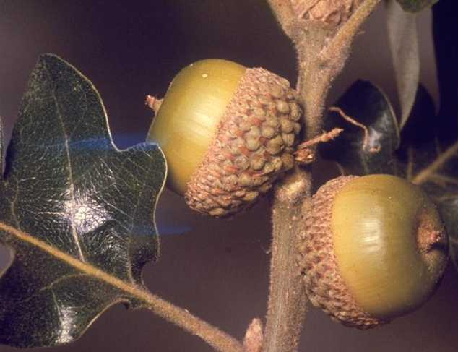

Charles Webber

© California Academy of Sciences

@ CalPhotos

# Cultivars, Improved and Selected Materials (and area of origin)

This species can be acquired from nurseries throughout its range that deal in native plants. Contact your local Natural Resources Conservation Service (formerly Soil Conservation Service) office for more information. Look in the phone book under ”United States Government.” The Natural Resources Conservation Service will be listed under the subheading “Department of Agriculture.”

# References

CalPhotos 2000. *Quercus garryana*. Version: 000502. <http://www.calflora.org>. CalFlora, Inc., Berkeley, California.

Farrar, J.L. 1995*. Trees of the northern United States and Canada*. Iowa State University Press, Ames, Iowa. 502 pp.

Franklin, J. & C. Dyrness 1973. *Natural vegetation of Oregon and Washington*. USDA, Forest Service, General Technical Report PNW 8. 417 pp.

Griffin, J. 1977. *Oak woodland*. pp. 383-415. IN M. Barbour and J. Major (eds.). *Terrestrial vegetation of California*. Wiley Interscience, New York, New York. 1002 pp.

Olson, D. 1974. *Quercus L. oak*. pp. 692-703. IN C. Schopmeyer (ed.). *Seeds of woody plants in the United States*. Agriculture Handbook No. 450. USDA, Forest Service, Washington, D.C.

Thilenius, J. 1968. The *Quercus garryana* forests of the Willamette Valley, Oregon. Ecology 49: 1124-1133.

USDA, NRCS 2000. *The PLANTS database*. Version: 000502. <http://plants.usda.gov>. National Plant Data Center, Baton Rouge, Louisiana.

# Prepared By

*Dieter Wilken & Julie Burgher*

Santa Barbara Botanic Garden, Santa Barbara, California

# Species Coordinator

*Dieter Wilken*

Santa Barbara Botanic Garden, Santa Barbara, California

Email: dwilken@sbbg.org

Edited 02may00 jsp; 13feb03 ahv; 060809 jsp

For more information about this and other plants, please contact your local NRCS field office or Conservation District, and visit the PLANTS Web site<<http://plants.usda.gov>> or the Plant Materials Program Web site <<http://Plant-Materials.nrcs.usda.gov>>

*The U.S. Department of Agriculture (USDA) prohibits discrimination in all its programs and activities on the basis of race, color, national origin, sex, religion, age, disability, political beliefs, sexual orientation, and marital or family status. (Not all prohibited bases apply to all programs.) Persons with disabilities who require alternative means for communication of program information (Braille, large print, audiotape, etc.) should contact USDA's* [*TARGET Center*](http://www.usda.gov/oo/target.htm) *at 202-720-2600 (voice and TDD).*

*To file a complaint of discrimination write USDA, Director, Office of Civil Rights, Room 326-W, Whitten Building, 14th and Independence Avenue, SW, Washington, DC 20250-9410 or call 202-720-5964 (voice or TDD). USDA is an equal opportunity provider and employer.*

*Read about* [*Civil Rights at the Natural Resources Convervation Service*](http://www.nrcs.usda.gov/about/civilrights/)*.*