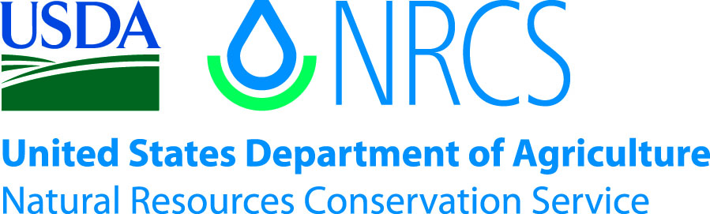

Plant Guide

# Autumn Buttercup

## Ranunculus aestivalis (L.S. Benson) Van Buren & Harper

### Plant Symbol = RAAE

#### Contributed by: USDA NRCS Idaho Plant Materials Program

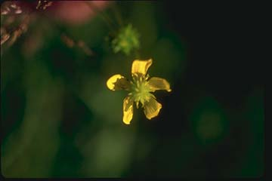

Figure . Fall buttercup (Ranunculus aestivalis). Photo from UTDNR (2010).

#### **Alternate Names**

Fall buttercup

R. *acriformis* var. *aestivalis*

R. *acris* var. *aestivalis*

#### **Uses**

There are no known human uses associated with autumn buttercup. It is grazed by cattle and eaten by small mammals.

#### **Status**

Autumn buttercup was first collected in 1894 by Marcus E. Jones in Garfield County, UT. It was later recollected and described as a new species by Benson in 1948. Surveys made in the 1970s could not locate any plants at the original localities and the species was believed to have gone extinct until 1982 when a small population was discovered 1.6 km (1 mi) from the original collection location. Monitoring from 1983 through 1989 showed a 90 percent decrease in individuals, going from over 400 individuals to approximately 20 as a result of continued grazing and habitat modification. Autumn buttercup was listed endangered by the USDI Fish and Wildlife Service (1989) when it was known from a single 0.004 ha (0.01 ac) population which numbered approximately 20 individuals.

The species has been assigned a recovery priority of 6 indicating it as a subspecies with a high degree of threat and low recovery potential (USDI-FWS 1991). In 1989 The Nature Conservancy purchased a 44 acre tract of land encompassing the existing population and excluding domestic livestock grazing. Since that time, two additional small populations have been discovered within the Nature Conservancy’s parcel. As of 1991 there were an estimated 200 individual plants (USDI FWS 1991).

Consult the PLANTS Web site and your State Department of Natural Resources for this plant’s current status (e.g., threatened or endangered species, state noxious status, and wetland indicator values).

#### **Description**

*General*: Buttercup family (Ranunculaceae). Autumn buttercup is a short-lived perennial forb from 0.2 to 0.5 m tall. Basal leaf blades are simple with three main lobes which are notched or lobed at the tips. The petioles (leaf stalks) are 3 to 15 cm (1.8 to 5.9 in) long. The plant bears yellow flowers with 5 petals which are approximately 1 cm long (Welsh et al. 2003).

*Distribution*:

Autumn buttercup is known from a small area along the Sevier River north of Panguitch, Utah at 1950 m (6400 ft) in elevation. Other similar habitats in surrounding areas are held by private land owners and have not been thoroughly investigated botanically (Welsh et al. 2003). For current distribution, consult the Plant Profile page for this species on the PLANTS Web site.

*Habitat*:

The known populations exist in wet saline meadows consisting of sedges, rushes and grasses. Dominant species in the community include wiregrass (*Juncus arcticus*), sea milkwort (*Glaux maritima*) and Nebraska sedge (*Carex nebrascensis*). The site was historically grazed by livestock until 1988 (Spence 1996).

#### **Adaptation**

This species is adapted to wet meadows at the transition zone between *Carex* dominated communities and dry upland meadows.

#### **Management**

Early researchers assumed that grazing by domestic livestock was a major threat to autumn buttercup and contributed to its decline (USDI FWS 1989; USDI FWS 1991). However; since the exclusion of livestock to autumn buttercup population sites, numbers have continued to drop (Spence 1996). From these observations, Spence (1996) developed two hypotheses for the decrease in individuals at the Nature Conservancy Preserve: 1) decrease in moisture levels and 2) the ABSENCE of grazing. Diversion of springs that sub-irrigate the monitored stand and nearby prospective reintroduction sites may have caused a plant community shift which favors other plant species over autumn buttercup. Additionally, disturbance caused by cattle grazing may have opened sites for autumn buttercup to grow large enough to flower and spread. In the absence of disturbance, other quickly spreading species such as wiregrass would have a competitive advantage.

USDI FWS goals for the species include developing a habitat management plan, and conducting population monitoring studies (1991). There are also plans to inventory potential habitat to find unknown populations and suitable habitat for beginning new populations. Plant reproduction and establishment studies are also indicated.

#### **Pests and Potential Problems**

There are no known pests or potential problems associated with autumn buttercup.

#### **Environmental Concerns**

There are no known environmental concerns associated with autumn buttercup.

#### **Seeds and Plant Production**

Methods for propagating Autumn buttercup have been developed, using tissue cultures started from seedlings.  Plants produced in this project have been used to augment a declining population of this species in Utah (CREW 2010).

#### **References**

Center for Conservation of Endangered Wildlife. 2010. Autumn buttercup [Online]. Available at http://www.cincinnatizoo.org/earth/CREW/AutuAutumnButte.html. (accessed 20 Apr 2010). Cincinnati Zoo and Botanical Gardens. Cincinnati, OH.

USDI-Fish and Wildlife Service. 1989. Endangered and threatened wildlife and plants: final rule to determine a “*Ranunculus acriformis*” var. “*aestivalis*” (autumn buttercup)to be endangered. Federal Register. 54 (139): 30550-30554.

USDI-Fish and Wildlife Service. 1991. Autumn buttercup (*Ranunculus acriformis* var. *aestivalis*) recovery plan. U.S. Fish and Wildlife Service, Denver, CO. 20p.

Utah Division of Natural Resources. 2010. Autumn buttercup [Online]. Available at <http://dwrcdc.nr.utah.gov/rsgis2/Search/Display.asp?FlNm=ranuaest>/ (accessed 20 Apr 2010). UTDWR, Salt Lake City, UT.

Welsh, S.L., N.D. Atwood, S. Goodrich, and L.C. Higgins. 2003. A Utah Flora. Third Edition, revised. Brigham Young University, Provo, UT.

#### **Prepared By**

*Derek Tilley*; USDA NRCS Plant Materials Center, Aberdeen, Idaho.

*Loren St. John*, USDA NRCS Plant Materials Center, Aberdeen, Idaho.

*Dan Ogle*, USDA NRCS State Office, Boise, Idaho.

#### **Citation**

Tilley, D., St. John, L. and D. Ogle. 2010. Plant guide for autumn buttercup (*Ranunculus aestivalis*). USDA-Natural Resources Conservation Service, Idaho Plant Materials Center. Aberdeen, ID.

Published: November 2010

Edited: 20Apr2010djt

For more information about this and other plants, please contact your local NRCS field office or Conservation District at <http://www.nrcs.usda.gov/> and visit the PLANTS Web site at <http://plants.usda.gov/> or the Plant Materials Program Web site <http://plant-materials.nrcs.usda.gov>.

PLANTS is not responsible for the content or availability of other Web sites.

**USDA IS AN EQUAL OPPORTUNITY PROVIDER AND EMPLOYER**