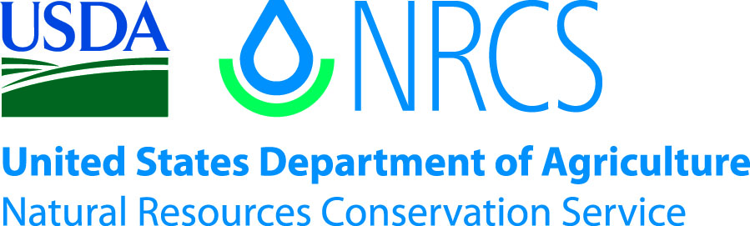

Plant Guide

## Western Buttercup Ranunculus occidentalis Nutt.

Plant Symbol = RAOC

*Contributed by*: *USDA NRCS Corvallis Plant Materials Center, Oregon*

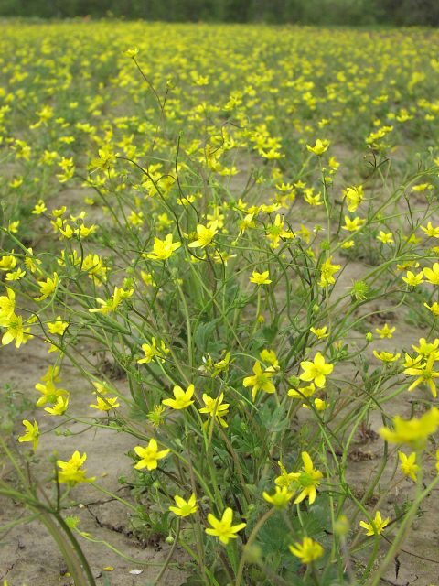

Photo by Amy Bartow, NRCS Corvallis Plant Materials Center, 2008

### Alternate Names

*Alternate Common Names:* western field buttercup

*Alternate Scientific Names:* none

### Uses

*Pollinator habitat:* Western buttercup is an early blooming plant making it a suitable pollen and nectar source for early season pollinators. Attracting pollinators is not just advantageous for crop productivity, it is essential for many food crops. Bees especially are attracted to the bright yellow blooms that are one of the first to appear in the spring (Ley et al., 2012).

*Restoration:* This plant is a great choice for wetland prairie restoration throughout its range. Its versatility enables it to thrive in moist upland or lowland sites as a quickly establishing native (Stanley et al., 2010).

*Ornamental:* Gardeners may like to add this early-blooming pollinator plant to their garden to draw beneficial insects and add diversity to their landscape.

**Ethnobotany**

Western buttercup has been noted as an important species to tribes throughout its range. In northern California and southern Oregon, its blooms are said to mark the coming of the summer salmon runs. Many tribes ground the seeds of the buttercup and mixed them with other seeds to make pinole (a flour-like staple), and the Aleut noted the juices of its blooms are poisonous (Moermon, 2012).

### Status

*Ranunculus occidentalis* is a facultative wetland species, meaning throughout most of its native range it occurs in moist wetland areas or vernal pools, but also sometimes occurs in uplands. Please consult the PLANTS Web site and your State Department of Natural Resources for this plant’s current status (e.g., threatened or endangered species, state noxious status, and wetland indicator values).

### Description

*General:* Western buttercup is a common, perennial, native forb/herb in the crowfoot or buttercup family (Ranunculaceae). Its traits are fairly variable and its many varieties are easily mistaken for other native and non-native buttercups. Plant stems are erect and grow to be from 6 inches to 2.5 feet tall, and have wedge-like, three-lobed leaves at the base. Basal leaves typically range from ¾ to 2 inches (2–5 cm) long by ¾ to 3 inches (2–8 cm) wide, and stem leaves stay low to the base of the plant, are few, lobed, and branched (Whittemore, 2012). They mature and bloom as early as March, continuing through July or August depending on variety, latitude, and elevation, with yellow flowers having 5 to 14 short, broad petals that are 1/16 to 5/16 inch (2–8 mm) wide by 3/16 to 1/2 inch (5–13 mm) in length. Flower petals are fewer and shorter when compared to the 9–16 longer petals of other species. Seeds are 1/16 to 1/8 inch (2–3 mm) in circumference, flat, disc-shaped, and have a small protruding beak from one edge (Figure 3).

There are several varieties of western buttercup, some of which intergrade or overlap in their distribution, and which are sometimes difficult to distinguish due to the large geographical distribution of the species, and slight variations within and among varieties. Botanists currently recognize between four (USDA-NRCS, 2012) and seven (Torrey and Gray, 1997) varieties of *R. occidentalis*.

*R. occidentalis* is very closely related to California buttercup (*R. californicus*), and in early phases can also be confused with the invasive creeping buttercup (*R.*

[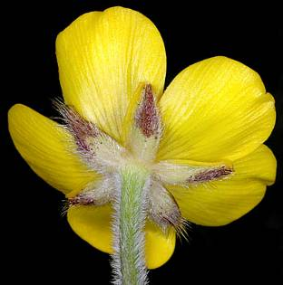](http://www.botany.hawaii.edu/faculty/carr/ofp/images2/ran_rep_0689b.jpg)[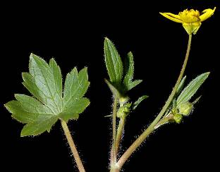](http://www.botany.hawaii.edu/faculty/carr/ofp/images2/ran_occ_occ_8760b.jpg)

Figure 1. R. repens (left) and R. occidentalis (right) receptacle views. Photo courtesy of G.D. Carr, Oregon Flora Image Project. 2007, 2008.

*repens*). The non-native creeping buttercup (*R. repens*) frequents similar habitats and is undesirable due to its invasive status and weediness (Ball et al., 2006). Because this species has such a broad distribution and multiple varieties, it is commonly misidentified. Generally, *R.* *repens* tends to stay close to the ground, bunch together, and “creep,” but this characteristic alone is not a reliable way to differentiate, since *R.* *occidentalis* can also keep a low profile under certain environmental conditions. If the plants are in bloom, petals of the western buttercup are more pointed and not so overlapped as the rounder and fuller petals of the creeping buttercup, and the receptacle (stem and base under the flower) of the creeping buttercup is fuzzy or hairy while the western is smooth (Figure 2). When not in bloom the dark green leaves of *R. repens* have light patches or spots that *R. occidentalis* leaves do not.

*Distribution*: This species is found from sea level to 7,000 ft elevations in western North America, from California and western Nevada north through western Canada and into Alaska. For current distribution, please consult the Plant Profile page for this species on the PLANTS Web site.

*Habitat*: *R. occidentalis* prefers seasonally moist soilsin a variety of habitats from coastal prairies and bluffs to disturbed areas, meadows, and forested areas (Turner and Gustafson, 2006). It is generally associated with wetland areas, although it will tolerate seasonal drought and is also found in non-wetland sites.

**Adaptation**

While western buttercup prefers vernal pools and wetland sites, it will also tolerate drier upland sites away from the coast that retain seasonally moist soils. It also does quite well in plant and seed production fields, tolerating all soil types and a range of pH values.

### Establishment

Seeds germinate best at cool temperatures (50–60°F) and stands are best established by directly sowing in the fall; alternately, plugs can be transplanted in the fall. Broadcast at a single species application rate of 6 to 7 pounds pure live seed (pls) per acre. Western buttercup has approximately 200,000 seeds per pound, so applying seed at a rate of one pound per acre will result in about 5 seeds per square foot. Germination begins 5 to 6 weeks after fall sowing. The plants will grow throughout winter,

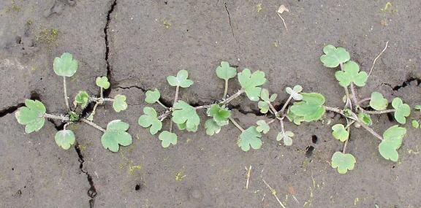

Figure 2. Western buttercup seedlings sprouting at the Corvallis Plant Materials Center. Photo by Amy Bartow, NRCS, 2008.

flowering and producing seed the first spring. Western buttercup goes dormant in the summer after setting seed, and re-emerges in the fall after the first rains.

### Management

Once established in an appropriate environment, this species is relatively low-maintenance. On a restoration site, it is not aggressive and unlikely to dominate and become weedy like some other *Ranunculus* species. It can tolerate herbicide application during its late summer dormancy, and would likely benefit from mowing in late summer (Bartow, 2012) to reduce non-native competition on a restoration site (Stanley et al., 2010).

### Pests and Potential Problems

This is a hardy plant with few, if any, susceptibilities to disease or pests.

### Environmental Concerns

The fresh leaves, stems, and flower sap of other members of the *Ranunculus* genus have been found to cause digestive or nervous system problems for livestock grazing in buttercup-dominated areas (Youngen, 2012). However, due to its bitter taste most animals avoid eating it, especially when other feed sources are available, making it unlikely to be ingested (Goetz et al., 2012). There is no indication that the consumption of dried plants (such as in hay) cause problems because as it dries, the toxic residue evaporates (Youngen, 2012). No specific studies have been done on the toxicity of *R. occidentalis*.

### Seeds and Plant Production

*Field Establishment & Management:* There are limited labeled herbicides appropriate for forb species in seed production; therefore, a weed free seedbed is very important. At the Corvallis PMC, fields are drill planted at a rate of 6 to 7 lb pls/acre at a depth of 1/8 to 1/4 inch with row spacing of 10 to 14 inches. When establishing a field with transplants, plugs can be planted as close as 1ft centers as plants do not take up much space, but row spacing should be planned to accommodate cultivation and harvest equipment. It is beneficial to fertilize a well-established field in the early spring, Western buttercup has tolerated a broadleaf herbicide spray during its summer dormancy, allowing a window of time for weed management before the plants resume growth in the fall. Otherwise, glyphosate spot-spraying or hand weeding methods are most effective. This species is very prolific and will bloom and produce seed the first year. Depending on site conditions, fields can last from 3 to 5 years.

*Seed Harvest:* A flail vacuum type seed stripper works well to harvest all green and mature seed from the stem, but the fragile nature of the stems only allows a single harvest of the field. Due to uneven field maturation and seed-shatter, the highest yields may be seen on plots grown on weed fabric. This technique allows for the latest possible field harvest as the fabric will catch earlier shattering seed, which can then be vacuumed or swept post-harvest.

*Seed Conditioning:* Harvested materials should be thoroughly dried before beginning the cleaning process. An air-screen machine will easily separate seed from other organic debris in the harvested lot. Average seed yields at the Corvallis Plant Materials Center are between 60 and 80 pounds per acre using weed fabric*.*

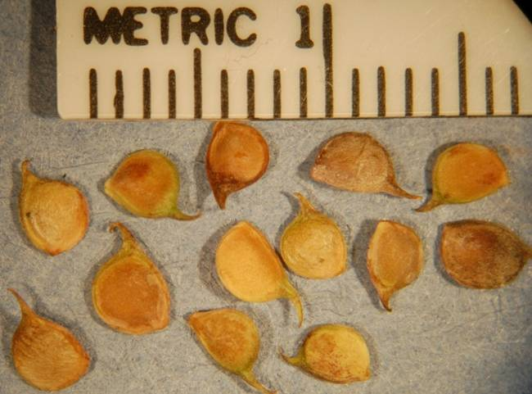

Figure 3. Western buttercup seeds at the Corvallis PMC, 2012.

### Cultivars, Improved, and Selected Materials (and area of origin)

There are no improved cultivars of western buttercup, but seed is sometimes available from commercial growers in the Pacific Northwest.

### References

Ball, D.A., et al. 2006. Weeds of the west. Western Soc. of Weed Science, Univ. of Wyoming, Jackson.

Bartow, A. 2012. The 2011 US Fish and Wildlife Service annual report. USDA-NRCS, Plant Materials Center, Corvallis, OR.

Carr, G.D. *Ranunculus* *occidentalis* and *Ranunculus repens*. Oregon Flora Image Project. http://www.botany.hawaii.edu/faculty/carr/ofp/ofp_inind.htm (accessed 30 Aug. 2012).

Goetz, J., T.N. Jordan, J.W. McCain, and N.Y. Su. 2012. Indiana plants poisonous to livestock and pets: buttercups. Cooperative Extension Service, Purdue Univ., West Lafayette, IN. http://www.vet.purdue.edu/toxic/plant30.htm (accessed 30 Mar. 2012).

Ley, E.L., S. Buchmann, K. McGuire, and R. Holmes. 2012. Selecting plants for pollinators: a regional guide for farmers, land managers, and gardeners in the Pacific Lowland Mixed Forest Province. Pollinator Partnership and the North American Pollinator Protection Campaign, San Francisco. http://pollinator.org/PDFs/Guides/PacificLowlandrx9FINAL.pdf (accessed 30 Mar. 2012).

Moerman, D. 2012. *Ranunculus occidentalis*. In: Native American Ethnobotany Database [Online]. Univ. of Michigan, Dearborn. http://herb.umd.umich.edu/ herb/search.pl (accessed 1 May 2012).

Stanley, A.G., T.N. Kaye, and P.W. Dunwiddie. 2010. Regional strategies for restoring invaded prairies, final technical report. Institute for Applied Ecology, Corvallis, OR and The Nature Conservancy, Seattle, WA. http://appliedeco.org/reports/default-page#rare-plant-species-research (accessed 3 May 2012).

Torrey, J., and A. Gray. 2012. *Ranunculus occidentalis*. Flora of North America. http://www.efloras.org/florataxon.aspx?flora_id=1&taxon_id=233501179 (accessed May 2012).

Turner, M., and P. Gustafson. 2006. Wildflowers of the Pacific Northwest. Timber Press, Portland, OR.

USDA-NRCS. 2012. The PLANTS Database. National Plant Data Team, Greensboro, NC. http://plants.usda.gov (3 May 2012).

Whittemore, A.T. 2012 (v. 1.0). Jepson eFlora, *Ranunculus occidentalis*, Jepson Flora Project. http://ucjeps.berkeley.edu/IJM.html (accessed 3 May 2012).

Youngen, G. 2012. Plants toxic to animals: buttercup. Veterinary Medicine Library, Univ. of Illinois, Urbana-Champaign. http://www.library.illinois.edu/vex/toxic/butcup/butcup.htm (accessed 30 Mar. 2012).

**Prepared By**: *Mary Beuthin,* USDA-NRCS Corvallis Plant Materials Center, Oregon

### Citation

Beuthin, M. 2012. Plant Guide for western buttercup (*Ranunculus occidentalis*). USDA-Natural Resources Conservation Service, Plant Mat.Center, Corvallis, OR.

Published October 2012

Edited: 03May2012 aym; 06Nov2012jab

For more information about this and other plants, please contact your local NRCS field office or Conservation District at <http://www.nrcs.usda.gov/> and visit the PLANTS Web site at <http://plants.usda.gov/> or the Plant Materials Program Web site <http://plant-materials.nrcs.usda.gov>.

PLANTS is not responsible for the content or availability of other Web sites.

**USDA IS AN EQUAL OPPORTUNITY PROVIDER AND EMPLOYER**