

Plant Guide

# Nootka rose

## Rosa nutkana C. Presl

Plant Symbol = RONU

*Contributed by*: NRCS Plant Materials Center, Pullman, Washington

### Photo of Rosa nutkana flower by Ben Legler, University of Washington Burke Herbarium

*Rosa nutkana* flower. Ben Legler, University of Washington Burke Museum of Natural History and Culture

### Alternate Names

*Alternate Common Names:* bristly Nootka rose, Spalding’s rose

*Alternate Scientific Names*: *R. anatonensis* St. John, *R. caeruleomontana* St. John, *R. columbiana* Rybd., *R. durandii* Crepin, *R. jonesii* St. John, *R. macdougali* Holz., *R. megalantha* G.N. Jones, *R. muriculata* Greene, *R. rainierensis* G.N. Jones, *R. spaldingii* Crepin (Hitchcock et al., 1969; USDA ARS, 2012)

### Uses

*Ornamental:* Nootka rose is an attractive shrub that can be incorporated into landscaped areas. It should be planted where its spread by rhizomes and suckers will not be a problem.

*Pollinators and Beneficial Insects:* Roses produce small amounts of nectar, so the primary insect pollinators of roses are bees gathering pollen (Mader et al., 2011). The open-faced flowers of native roses are more attractive to pollinators than non-native cultivars with double flowers (Mader et al., 2011).

*Wildlife:* Nootka rose fruits (hips) remain on the plant throughout the winter, and are eaten by small mammals, birds and insects. *Rosa* species are important browse for Rocky Mountain elk in summer, but the use is lower in fall and winter (Kufeld, 1973). Deer also browse leaves and young shoots (Parish et al., 1996).

*Livestock*: Livestock browse Nootka rose leaves and young shoots (Parish et al., 1996).

*Ethnobotanical:* Native Americans throughout the Pacific Northwest and Rocky Mountain region used Nootka rose as food, medicine, and for ceremonial purposes (Moerman, 2012). Hips of all wild roses are high in vitamin C and are made into jams, jellies, syrups and teas.

*Revegetation:*  Nootka rose produces extensive rhizomes and grows rapidly, making it an ideal plant for revegetation projects. It is used to control soil erosion on hillsides, road cuts and streambanks.

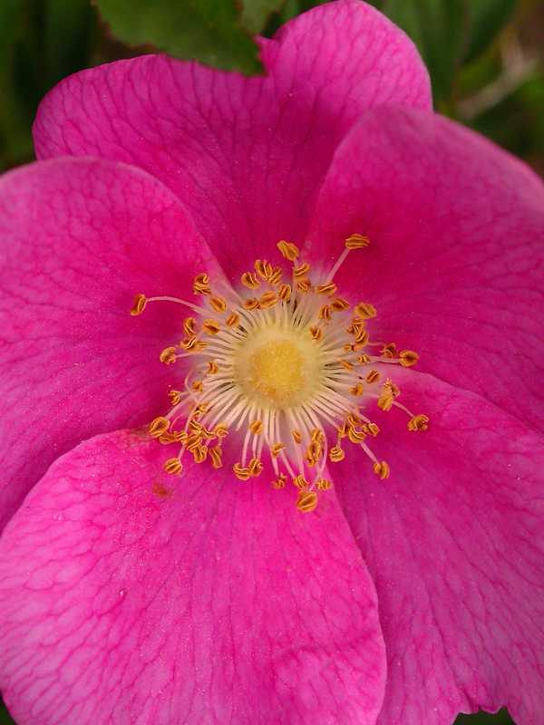

*Rosa nutkana* flower. Ben Legler, University of Washington Burke Museum of Natural History and Culture

### Status

Consult the PLANTS Web site and your State Department of Natural Resources for this plant’s current status (e.g., threatened or endangered species, state noxious status, and wetland indicator values).

### Description

*General*: Rose family (Rosaceae). *Rosa nutkana* is an erect to spreading, long-lived shrub native to the western U.S. and Canada. It grows 1 to 9 feet tall and forms loose thickets. Stems are slender, often very dark brown to black. All subspecies except subsp. *melina* typically have straight thorns, or are sometimes unarmed. Subsp. *melina* typically has curved thorns. The thorns are often in pairs at the base of each leaf. Leaves are alternate, deciduous, and odd-pinnate with 5 to 9 leaflets. Leaflets are elliptic to elliptic-ovate with serrated to multi-serrated margins. Flowers occur at the ends of branches, bloom May through July, and are usually solitary and large. Petals are 1 to 1.6 inches long, light to dark pink, and have broad notches. Sepals are restricted in the middle, then expanded toward the tip and are nearly as long as the petals. Flowers have numerous stamens and pistils, and the styles are deciduous as the fruit matures. The fruit is a round to pear-shaped hypanthium (hip) 0.5 to 0.8 inch wide. It matures in August to September, is bright red to reddish purple, and has persistent sepals. The fruit contains numerous seeds that are angled achenes. The plant reproduces sexually by seed and vegetatively by sprouts, rhizomes and layering. (Hitchcock and Cronquist, 1973; Young and Young, 1992; Parish et al., 1996; Lewis and Ertter, 2007; Burke Museum of Natural History and Culture, 2012; Turner, 2012).

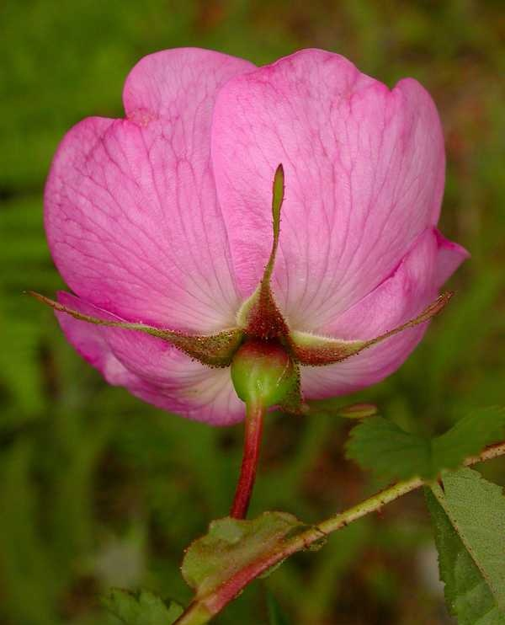

*Rosa nutkana* pedicel and sepals. Ben Legler, University of Washington Burke Museum of Natural History and Culture

*Rosa* is a complex and variable genus which hybridizes freely and sometimes exhibits polyploidy and/or apomixis (Hitchcock, et al., 1969). Hybridization may occur between *Rosa nutkana* and other native roses, *R. woodsii* (Woods’ rose) and *R. gymnocarpa* (baldhip rose)(Turner, 2012).

The genus name *Rosa* is an ancient Latin name for rose (St. John, 1963). The species name *nutkana* refers to the Nootka Sound on the west coast of Vancouver Island, BC (Charters, 2012).

*Distribution: Rosa nutkana* grows in the western U.S., from the Rocky Mountain states to the Pacific Coast, and in British Columbia and Alaska. The genus is divided into three subspecies: subsp. *melina* grows at high elevations (7500 to 11,400 feet) in the southern Rocky Mountains of Colorado, New Mexico and Utah and is rare in Montana, Wyoming and southern Idaho; subsp. *macdougalii* grows at elevations below 7,500 feet in the intermontane area between the Rocky Mountains and Cascade Mountains from Colorado and Utah to central British Columbia; and subsp. *nutkana* grows at elevations below 7,500 feet west of the Cascade Mountains, along the Pacific Coast from northern California to Alaska (Lewis and Ertter, 2007). For current distribution, consult the Plant Profile page for this species on the PLANTS Web site.

*Habitat*: *Rosa nutkana* is an understory plant in dry and moist forest communities, including Douglas-fir (*Pseudotsuga menziesii*), ponderosa pine (*Pinus ponderosa*), mountain hemlock (*Tsuga mertensiana*), Sitka spruce (*Picea sitchensis*), lodgepole pine (*Pinus contorta*), redwood (*Sequoia sempervirens*) and western hardwoods (Reed, 1993). It also grows in sagebrush (*Artemisia* spp.), and in mountain and plains grasslands (Reed, 1993). It is often found in association with red-osier dogwood (*Cornus sericea*), quaking aspen (*Populus tremuloides*), black cottonwood (*Populus trichocarpa*) and snowberry (*Symphoricarpos albus*) (Aller et al., 1981; Bell et al., 1992).

**Adaptation**

This plant is adapted to medium and fine textured soils with neutral pH (USDA NRCS, 2012). It can tolerate low levels of fertility but does not tolerate drought (USDA NRCS, 2012). It grows in open and shaded areas receiving 18 to 125 inches of annual precipitation. The subspecies *macdougalii* and *nutkana* grow at low to moderate elevations up to 7,500 feet, and the subspecies *melina* grows at high elevations, 7,500 to 11,400 feet (Lewis and Ertter, 2007). The plant will recover after a fire, however multiple fires will significantly reduce a population (Reed, 1993).

### Establishment

Freshly cleaned Nootka rose seed can be broadcast or drilled and covered with firm soil and mulch (Young and Young, 1992). Dried seed needs a cold stratification period of 90 days for optimal germination. Plants can also be established by transplanting seedlings or cuttings (see the Seeds and Plant Production section, below).

### Pests and Potential Problems

None known

### Environmental Concerns

None

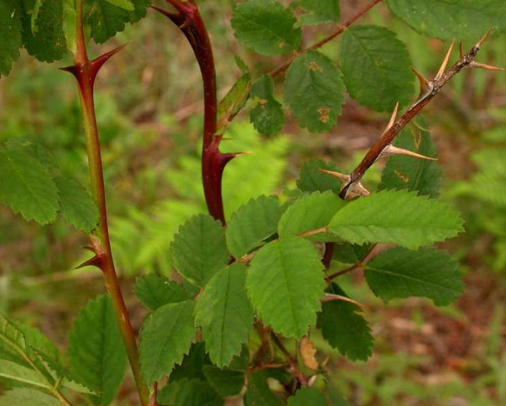

*Rosa nutkana* thorns. Ben Legler, University of Washington Burke Museum of Natural History and Culture

### Seeds and Plant Production

*Rosa nutkana* plants are sexually reproductive after 2 to 5 years of growth (Reed, 1993). Seed is obtained by collecting rose hips after they turn a bright red color (Gill and Pogge, 1974). The seeds can be removed from the hip flesh by macerating the hips in water and allowing the debris to float to the surface. Seeds collected soon after ripening and not allowed to dry will be less dormant than dried seeds (Gill and Pogge, 1974; Young and Young, 1992). Dried seeds require a cold stratification period of 90 days to improve germination (Gill and Pogge, 1974; USDA NRCS, 2012). Dried seeds stored in air-tight containers will remain viable for 2 to 4 years (Young and Young, 1992). There are about 45,000 seeds per pound (USDA NRCS, 2012).

Plants can be produced by sowing seed into pots or flats in October or November, then moving into a greenhouse in January or February. Seedlings should be moved to a lath house or other structure in the spring and grown for one year to develop an adequate root system before transplanting.

Nootka rosecan also be reproduced by cuttings, root suckers or layering. All seedlings and propagated plants should be hardened off for two to four weeks prior to transplanting in the desired field location.

### Cultivars, Improved, and Selected Materials (and area of origin)

None, but seeds and seedlings are commercially available.

### References

**Aller, A.R., M.A. Fosberg, M.C. LaZelle, and A.L. Falen. 1981. Plant communities and soils of north slopes in the Palouse region of eastern Washington and northern Idaho. Northwest Sci. 55(4):248-262.**

**Bell, J.H., J.L. Lauer, and J.M. Peek. 1992. Habitat use patterns of white-tailed deer, Umatilla River, Oregon. Northwest Sci. 66(3):160-171.**

**Burke Museum of Natural History and Culture. [Online]. Available at http://biology.burke.washington.edu/herbarium/imagecollection.php (accessed 15 Nov 2012). University of Washington, Seattle, WA.**

Charters, M.L. 2012. California Plant Names: Latin and Greek Meanings and Derivations. Available at http://www.calflora.net/botanicalnames/ (accessed 27 Nov 2012) Michael L. Charters, Sierra Madre, CA.

Gill, J.D. and F.L. Pogge. 1974. *Rosa* L. Rose. In: Seeds of Woody Plants of the United States. Agriculture Handbook No. 450. USDA Forest Service, Washington, D.C.

Hitchcock, C.L., A. Cronquist, M. Ownbey, and J.W. Thompson. 1969. Vascular Plants of the Pacific Northwest. University of Washington Press, Seattle and London.

Hitchcock, C.L. and A. Cronquist. 1973. Flora of the Pacific Northwest. University of Washington Press, Seattle and London.

Kufeld, R. 1973. Foods eaten by the Rocky Mountain elk. J. of Range Mgmt. 26:106-113.

Lewis, W.H. and B.E. Ertter. 2007. Subspecies of *Rosa nutkana* and *R. woodsii* (Rosaceae) in Western North America. Novon 17:341-353.

Mader, E., M. Shepherd., M. Vaughan, S.H. Black, and G. LeBuhn. 2011. Attracting Native Pollinators. The Xerces Society. Storey Publishing, North Adams, MA.

Moerman, D. 2012. Native American Ethnobotany Database. Available at http://herb.umd.umich.edu/

(accessed 29 Nov 2012) University of Michigan-Dearborn, Dearborn, MI.

Parish, R., R. Coupe, and D. Lloyd (eds.) 1996. Plants of Southern Interior British Columbia and the Inland Northwest. Lone Pine Publishing, Vancouver, BC.

Reed, W.R. 1993. *Rosa nutkana*. In: Fire Effects Information System. Available at http://www.fs.fed.us/database/feis/ (accessed 28 Nov 2012) U.S. Department of Agriculture, Forest Service, Rocky Mountain Research Station, Fire Sciences Laboratory.

St. John, H. 1963. Flora of Southeastern Washington and of Adjacent Idaho (3rd ed.). Outdoor Pictures, Escondido, CA.

Turner, M. 2012. Pacific Northwest Wildflowers. Available at <http://www.pnwflowers.com/flower/rosa-nutkana> (accessed 30 Nov 2012) Turner Photographics, Bellingham, WA.

USDA ARS, National Genetic Resources Program,  
Germplasm Resources Information Network (GRIN). 2012. Available at http://www.ars-grin.gov/cgi-bin/npgs/html/taxon.pl?5309 (accessed 28 Nov 2012). National Germplasm Resources Laboratory, Beltsville, Maryland.

USDA NRCS. 2012. The PLANTS Database (http://plants.usda.gov, 15 Nov 2012). National Plant Data Team, Greensboro, NC.

Young, J.A. and C.G. Young. 1992. Seeds of Woody Plants of North America. Dioscorides Press, Portland, OR.

**Prepared By**

*Pamela L.S. Pavek*, USDA NRCS Plant Materials Center, Pullman, Washington

*David M. Skinner,* USDA NRCS Plant Materials Center, Pullman, Washington (*retired*)

### Citation

Pavek, P.L.S. and D.M. Skinner. 2013. Plant guide for Nootka rose (*Rosa nutkana* C. Presl). USDA Natural Resources Conservation Service, Pullman, WA.

Published March 2013

Edited: 17Dec2012 dms; 14Jan2013 plsp; 26Feb2013 jab

For more information about this and other plants, please contact your local NRCS field office or Conservation District at <http://www.nrcs.usda.gov/> and visit the PLANTS Web site at <http://plants.usda.gov/> or the Plant Materials Program Web site <http://plant-materials.nrcs.usda.gov>.

PLANTS is not responsible for the content or availability of other Web sites.

**USDA IS AN EQUAL OPPORTUNITY PROVIDER AND EMPLOYER**