|  |  |
| --- | --- |
| **Natural Resources Conservation Service** | Plant Guide |

# HIMALAYAN BLACKBERRY

***Rubus armeniacus* Focke**

Plant Symbol = RUAR9

#### Close up of berries, leaves and underside of leaves.

### Alternate Names

*Common Names:* , Himalaya-berry, Armenian Blackberry

*Scientific Names: Rubus discolor* Weihe & Nees

**Uses**

Himalaya blackberry fruits are highly edible and commonly collected by berry pickers. The fruit can be canned, frozen, or eaten fresh (Francis 2003). Wildlife readily consumes the fruit as well. It was used in the development of the hybrid marionberry cultivar, ‘Marion’ (Waldo 1957).

Blackberry thickets create highly effective barriers that can control human, wildlife, and domestic livestock access (Francis 2003).

**Status**

Himalaya blackberry is an introduced, perennial, spreading shrub. It is very weedy and is listed as a noxious weed in numerous states. It is widely distributed but there are states where it does not occur. Please consult the PLANTS Web site and your State Department of Natural Resources for this plant’s current status (e.g., threatened or endangered species, state noxious status, and wetland indicator values).

**Weediness**

Riparian areas are especially prone to Himalayan Blackberry invasion because riparian areas are generally composed of many plant species and blackberryfrequently goes unnoticed until it has become firmly established. It is less of a problem on actively managed agricultural areas because most practices such as disking impedes its ability to flourish.

Please consult with your local NRCS Field Office, Cooperative Extension Service office, state natural resource, or state agriculture department regarding its status and use. Weed information is also available from the PLANTS Web site at <http://plants.usda.gov/>. Please consult the Related Web Sites on the Plant Profile for this species for further information.

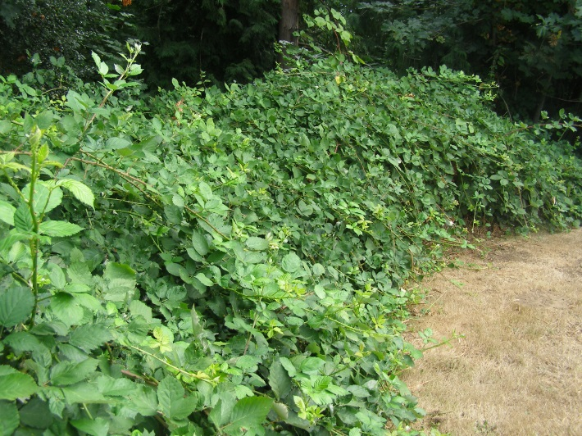

Blackberry thickets can create almost impenetrable barriers.

**Description**

*General*: Himalayan Blackberry is an arching woody shrub. Its leaves remain on the plant for a long period of time and sometimes persist all winter long in mild climates. The leaflets occur in groups of three or five and each resembles a large rose leaf. The underside of the leaves is white.

The canes are thorny and may be as long as 10 meters. The canes are biennial: first year canes, primocanes, are non-fruit bearing, and second year canes, floricanes, are fruit bearing (Clark and Finn 2007). The thorns typically have a reddish color later in the summer and may be as long as 20 mm. The canes will root (layer) upon touching the ground (Willoughby and Davilla 1984). The canes can create an impenetrable intertwined thicket that may be as tall as 2 meters tall or taller if the canes are supported by a fence or other structure.

The flowers are 5-peteled and vary from white to light-pink in color. The flowers occur in loose clusters and give rise to black fruits. Each fruit is comprised of multiple drupelets.

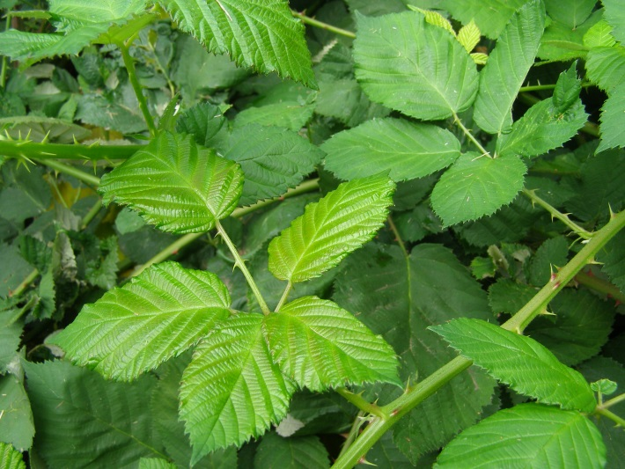

Blackberry leaves are typically comprised of 5 leaflets and sometimes 3 leaflets.

**Ethnobotany**

Himalayan blackberry is a bit of a misnomer because it isn’t even from the Himalayas. Himalayan blackberry originates from the Armenia region, hence its scientific name, *Rubus armeniacus*. Luther Burbank purportedly imported it to North America; the same Luther Burbank whom Burbank potatoes are named after.

Himalayan blackberry has become part of the Pacific Northwest rural culture. Locals collect berries each year and many small businesses incorporate ‘blackberry’ into their business names.

*Distribution*: Himalayan Blackberry originates from Eurasia but it is currently distributed worldwide (Francis 2003). It is well distributed in the western USA and Hawaii. It occurs in eastern USA as well.

For current distribution, please consult the Plant Profile page for this species on the PLANTS Web site.

*Habitat*: Vacant lots, railroad right of ways, degraded riparian areas, fence lines, and electricity power transmission lines are common Himalayan Blackberry sites. Degraded soils do not limit this plant’s ability to flourish (Brinkman 1974).

**Adaptation**

It grows best in full sun but will tolerate partial shading. It can be found from coastal estuaries to inland upland sites as high as 1500 m (Willoughby and Davilla 1984).

**Control**

Controlling Himalayan Blackberry requires persistence because it frequently requires 2 or more years of intense effort to rid a stand (Stannard and Dobrowolski 2004). Clipping the plant to the ground is relatively ineffective unless the clippings are routinely made whenever the canes reach 2 feet. Clipping when the canes are shorter will reduce the vigor of the stand but does not deplete the energy reserves as fast.

Plastic and woven barrier fabrics fail to provide much control after the first year they are installed. Once the barrier begins to breakdown or tear, the canes grow through. Newer heavy-duty fabrics are better but require proper installation.

Burning a thicket, while visually pleasing, is not very effective. The temperatures rarely are hot enough to destroy the rhizomes. Burning can be a good initial treatment because it reduces the top growth and makes application of other treatments far easier.

Digging can be very effective. Removing the rhizomes and crowns to a 6-inch depth will greatly reduce the amount of regrowth. The regrowth can be easily handled. It is imperative to plant desirable vegetation on the site or blackberry (or another weed) will simply reinvade.

Disking and/or cultivating need to be practiced routinely to rid a stand. This practice can spread rhizomes and aggravate the situation. More than one operation is needed and these additional operations should be planned into the next year.

Several herbicides provide excellent control of blackberry (Prather et al. 2013). Please contact your local agricultural extension specialist or county weed specialist to learn what works best in your area and how to use it safely. Always read label and safety instructions for each control method.

Several other control techniques circulate in conversation, and we touch on them. Treating the foliage with vinegar can cause leaf burn but is largely ineffective. Stripping the foliage can reduce the vigor of small canes, but leaf stripping is far more labor intensive and less effective than digging.

Please contact your local agricultural extension specialist or county weed specialist to learn what works best in your area and how to use it safely. Always read label and safety instructions for each control method. Trade names and control measures appear in this document only to provide specific information. USDA NRCS does not guarantee or warranty the products and control methods named, and other products may be equally effective.

**Literature Cited**

Brinkman, K.A. 1974. Rubus L. blackberry, raspberry.

In: Seeds of woody plants in the Unitsed States. Agric. Handbook No. 450. Wa D.C. USDA, Forest Service: 738-743.

Clark, J.R. and C.E. Finn. 2011. Blackberry breeding and

genetics. Fruit, Vegetable, and Cereal Science and Biotechnology. p. 27-43. Global Science Books, 2011

Francis, J.K. 2003. *Rubus discolor* Weihe & Nees.

http://fs.fed.us/global/iitf/pdf/shrubs/Rubus discolor.pdf. (accessed 12/09/13)

Stannard, M.E. and J. Dobrowolski. 2004. Himalayan

blackberry in the Pacific Northwest: Attack of the canes. Forest Stewardship Notes: 13: 11-12.

Waldo, G.F. 1957. The Marion blackberry. Circ. 571.

Agric. Exp. Sta. Oregon State Univ. Corvallis OR.

Willoughby, J.W. and W. Davilla. 1984. Plant species

composition and life form spectra of tidal streambanks and adjacent riparian woodlands along the lower Sacromento River. In: Proc. California riparian systems: ecology, conservation, and productive management.

### Citation

Stannard, M.E. 2014. Plant guide for Himalayan *Blackberry (Rubus armeniacus). USDA-Natural* Resources Conservation Service, Plant Materials *Center, Pullman, Washington 99164-6211.*

Published January 2014

Edited: [08Jan2014 jab]

For more information about this and other plants, please contact your local NRCS field office or Conservation District at <http://www.nrcs.usda.gov/> and visit the PLANTS Web site at <http://plants.usda.gov/> or the Plant Materials Program Web site <http://plant-materials.nrcs.usda.gov>.

PLANTS is not responsible for the content or availability of other Web sites.

***Helping People Help the Land***

**USDA IS AN EQUAL OPPORTUNITY PROVIDER AND EMPLOYER**