

Plant Guide

# pitcher sage

*Salvia azurea* Michx. ex Lam. var. *grandiflora* Benth.

Plant Symbol = SAAZG

Contributed by: USDA NRCS Plant Materials Center, Manhattan, Kansas

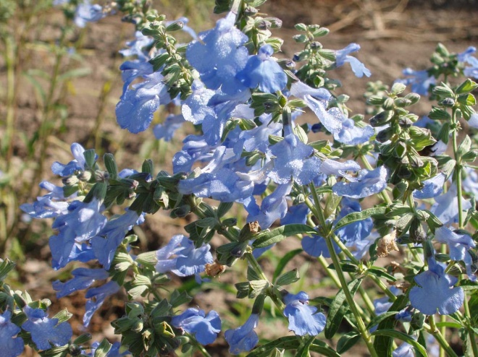

Alan Shadow, East Texas PMC, Nacogdoches, TX

Alternate Names azure blue sage, blue salvia, blue sage, pitcher salvia, and wild blue sage.

Uses

Wildlife: Pitcher sage is readily eaten by livestock and wildlife (Bare, 1979). This palatable forb is especially sought out by livestock in the early spring due to its high level of protein. Pitcher sage decreases in native pastures that are over grazed or over stocked with livestock. The flowers are pollinated by bumble bees and may be visited by hummingbirds. The plant is attractive to migrating monarch butterflies (Lepidoptera: Danaidae, *Danaus plexippus*) and other insects (Thomas and Schrock, 2004).

Landscape potential: Thomas and Schrock (2004) described *Salvia azurea* as a sometimes disorderly plant that is spectacular for its profuse, deep blue flowers. The bloom period persists over a long period of time in the fall when little else is blooming.

Status

Please consult the PLANTS Web site and your State Department of Natural Resources for this plant’s current status (e.g. threatened or endangered species, state noxious status, and wetland indicator values).

Description

*General*: The Mint family (Lamiaceae). Pitcher Sage is a warm-season, long-lived, herbaceous, native perennial species. The common name Pitcher Sage is derived from the name of Doctor Zina Pitcher, a 19th century U.S. Army surgeon and botanist. “*Salvia*” Latin for safe and well since some of the plants of this genus have medicinal properties; *“azurea*” and “*grandiflora*” Latin for blue and large flowers, respectively. Stem number single to several, sparingly branched, arising from a thick caudex with deep branched roots to 2.5 meters (m). Weaver (1968) indicated that this species and others doubled their rooting depth in response to extreme drought. The stems are .6 to 1.5 m in height, square in cross section and have leaves attached opposite. The narrow, linear to lanceolate, gray greens leaves extend out from all four sides of the stem, and are produced from the bottom to the terminal spike inflorescence. Although it has a fragrance, the odor of the foliage is not nearly as strong as some members of the mint family. Lower leaves are sometimes shed early in the growing season. Pitcher sage usually begins blooming in July and can bloom until early October. The light blue flowers are attached by short pedicels on terminal spikes or in the axils of the upper leaves. The greatly enlarged, drooping lower lip of the flower is covered at the base by a short, stiff, upper lip or hood. A bee will land on the lower lip and force its way under the hood to reach the nectar gland at the base of the flower tube. As in some other species the anthers of the flower mature before the stigma is ready to accept pollen, thus ensuring cross pollination. The pollen bearing anther is on one end of a slender filament and a sterile anther on the other end. When the bee enters the flower tube, its head pushes on the sterile anther, and the filament, like a seesaw, pivots to dust the bee’s back with pollen from the fertile anther (Farrar, 1990). The fruits consist of one or two light brown resin-dotted nutlets borne at the bottom of the persistent calyx tube (Platt and Harder, 1991). The nutlets are elliptical, flattened and approximately 3 millimeters (mm) long.

*Distribution*: For current distribution, please consult the Plant Profile page for this species on the PLANTS Web site. Pitcher sage grows in the eastern ¾ of Kansas. This species is also found in parts of Oklahoma, Nebraska, Missouri, and the panhandle of Texas. The species ranges east to South Carolina and Florida.

*Habitat*: *Salvia azurea* grows on open sunny sites in well drained upland prairies. It can be found along roadsides and in moderately disturbed sites (Platt and Harder, 1991). Barkley et al. (1986) reported that it grows on rocky and sandy sites.

Adaptation

This perennial forb is adapted to dry, sunny sites and is quite drought resistant. Thomas and Schrock (2004) indicated that *Salvia azurea* was a drought tolerant plant that will occasionally wilt under extreme heat. They also indicated that it was an excellent long-term survivor. Lindgren and Schaaf (2005) conducted a ten year study and found that *Ratibida pinnata* and *Salvia azurea* had the highest survival rate of 16 wildflowers planted in buffalo grass or blue grama grass plots in central Nebraska.

Establishment

Unstratified seed can be planted in the fall or stratified seed can be planted in the spring (Platt and Harder, 1991). Without pretreatment approximately 40 percent of the seed will germinate. Moist stratification for 4 to 8 weeks will increase germination to around 80 percent (Platt and Harder, 1991).

Management

When *Salvia azurea* is grown without competition it tends to become too tall and sprawl or lodge. This will lead to what Thomas and Schrock (2004) considered a disorderly plant as they mentioned in their article. However, moderate clipping early in the growing season will allow the plant to maintain a better more upright form. The plant flowers over an extended period of time and this makes time of harvest hard to judge since you have flowers and fruit in all stages of maturation.

Pests and Potential Problems

There are no serious insect or disease problems of any consequence with this member of the Lamiaceae family (Kahtz, 2006).

Environmental Concerns

No real environmental concerns regarding this plant species. It is used in prairie revegetation plantings where it is not considered weedy. Pitcher sage may volunteer from seed, but will not spread aggressively (Platt and Harder, 1991).

Seeds and Plant Production

Seed can be planted in the field for plant establishment or in flats in a greenhouse situation as potted stock with proper stratification. The two cotyledons are heart-shaped, rounded at the tip, wide at the base and attached to a moderately long stalk. True seedling leaves arise in pairs on the upright stem. The true leaves are elongated and have a toothed margin (Platt and Harder, 1991).

Salac et al. (1978) indicated that *Salvia azurea* could be propagated vegetatively by stem cuttings.

Cultivars, Improved, and Selected Materials (and area of origin)

Contact your local Natural Resources Conservation Service (formerly Soil Conservation Service) office for more information. Look in the phone book under “United States Government.” The Natural Resources Conservation Service will be listed under the subheading “Department of Agriculture.”

‘Nekan’, Pitcher Sage is a cooperative release by the USDA-NRCS, Manhattan Plant Materials Center in Manhattan, KS and the Nebraska Agriculture Experiment Station in Lincoln, NE. The release was made in 1977 after evaluation of accessions from Nebraska, Kansas and South Dakota. The Kansas accession from Marion County, Kansas designated as PMK-1408 was selected for additional testing in 1972, because of overall better performance and was rated excellent for vigor and stand. Growth of PMK- 1408 was uniform with respect to plant height and spread.

References

Bare, J.E. 1979. Wildflowers and Weeds of Kansas. The Regents Press of Kansas. Lawrence, KS.

Barkley, T.M., R.L. McGregor, R.E. Brooks and E.K. Schofield (eds.) 1986. Flora of the Great Plains. University of Kansas Press. Lawrence, KS.

Farrar, J. 1990. A Wildflower Year. NEBRASKAland Magazine. Published by the Nebraska Game and Park Commission. Lincoln, NE.

Kahtz, A.M. 2006. Field Notes: *Salvia azurea.* American Nurseryman. August 1, 2006: Vol. 66.

Lindgren, D.T. and D. Schaaf. 2005. Survival and growth of wildflowers with bufflo grass or blue grama grass. HortScience. 40(6): 1787-1789.

Platt, D.R. and L.H. Harder. 1991. Growing Native Wildflowers. The Kauffman Museum, Bethel College. N. Newton, KS.

Salac, S.S., P.M. Jensen, J.A. Dickerson, and R.W. Gray Jr. 1978. Wildflowers for Nebraska Landscapes. The Agriculture Experiment Station Bulletin (PM 35) University of Nebraska. Lincoln, NE.

Thomas, A.L. and D. Schrock. 2004. Performance of 67 Native Midwestern U.S. Perennials in Low- maintenance Landscape. HortTechnology. 14(3); 381-388.

Weaver, J.E. 1968. Prairie Plants and their Environment. University of Nebraska Press. Lincoln, NE.

Prepared By and Species Coordinator:

*Richard Wynia*, USDA NRCS Manhattan Plant Materials Center, Manhattan, KS

### Citation

Wynia, R., 2009. Plant Guide for pitcher sage (*Salvia* *azurea* Michx. ex Lam. var. *grandiflora* Benth.*)*. USDA-Natural Resources Conservation Service, Kansas Plant Materials Center, Manhattan, Kansas 66502

Published October, 2009

Edited: 090226 jsp

For more information about this and other plants, please contact your local NRCS field office or Conservation District at <http://www.nrcs.usda.gov/> and visit the PLANTS Web site at <http://plants.usda.gov/> or the Plant Materials Program Web site <http://plant-materials.nrcs.usda.gov>.

PLANTS is not responsible for the content or availability of other Web sites.

**USDA IS AN EQUAL OPPORTUNITY PROVIDER AND EMPLOYER**