

Plant Guide

# PURPLE SAGE

## Salvia dorrii (Kellogg) Abrams Plant Symbol = SADO4

#### Contributed by: NRCS Plant Materials Center, Pullman, WA

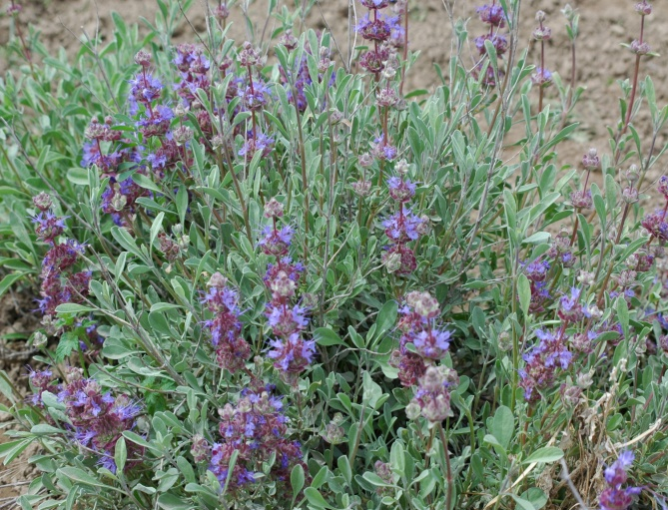

*Salvia dorrii*. Pamela Pavek, Pullman Plant Materials Center

### Alternate Names

### Dorr sage, Grayball sage, desert sage, tobacco sage Uses

*Ornamental:* Purple sage is an attractive, low-maintenance, drought-tolerant shrub that can be used as an accent plant or small hedge in landscaped areas (Mee et al. 2003). It will maintain its rounded shape without pruning (Mee et al. 2003) and is resistant to browsing by deer and rabbits (High Country Gardens 2010).  
  
*Pollinators:* Purple sage provides nectar and pollen for bees, butterflies and moths.

*Range revegetation*: This plant can be used for revegetation and diversification of rangeland, particularly in harsh, rocky sites.

### *Forage:* Purple sage is undesirable as forage to both livestock and wildlife. *Ethnobotanical:* This plant was used for multiple medicinal and cultural purposes by tribes throughout its range. People of the Kawasiiu, Paiute, Shoshoni, Washoe and Okanagan-Colville tribes made infusions and decoctions of the leaves and stems of purple sage for a cold remedy. They also made poultices of the leaves to apply to the chest, smoked dried leaves and made steam baths with the leaves to ease congestion. Infusions, decoctions, washes and poultices of this plant were also used to treat headaches, stomachaches, fever, influenza, pneumonia, gonorrhea, swollen leg veins, eye problems and general illness (Native American Ethnobotany Database 2010). The Hopi used smoke and an infusion of the plant to alleviate epilepsy and faintness and the Kawaiisu threw the plant into fire to keep away spirits and ghosts (Native American Ethnobotany Database 2010). The Hopi, Kumiai, and Paipai also used the plant to treat stomachaches, headaches and other medical conditions (Huisinga 2001). Status

*Salvia dorrii* ssp. *mearnsii* is listed by the United States Forest Service as a sensitive species in Arizona due to its limited distribution and threats to its survival (Huisinga 2001). Consult the PLANTS Web site and your State Department of Natural Resources for this plant’s current status (e.g., threatened or endangered species, state noxious status, and wetland indicator values).  
  
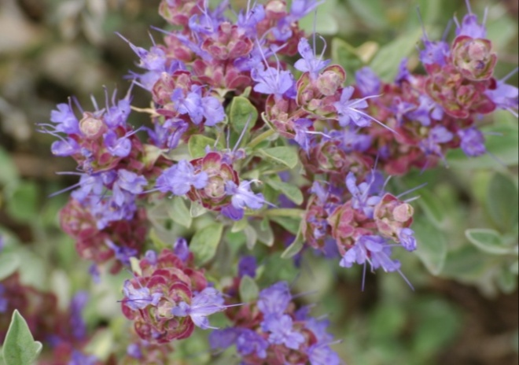 ***Salvia dorrii* flowers. Pamela Pavek, Pullman Plant Materials Center**

### Description

*General*: Mint family (Lamiaceae). *Salvia dorrii* is a woody perennial shrub that grows to 20 to 80 cm (8 to 32 in) tall and 20 to 150 cm (24 to 36 in) wide. It has an upright to spreading form, with the exception of *S. dorrii* ssp. *dorrii* var. *clokeyi*  which forms mats and occasionally roots at the nodes (Strachan 1982). The plant has rough bark that peels off the mature woody branches. Leaves are opposite, oval, 1.5 to 4 cm (0.6 to 1.6 in) long, 0.5 to 1.5 cm (0.2 to 0.6 in) wide, are widest at the tip and taper to the stem. Leaves have a smooth margin, are silver-gray, aromatic, and are retained on the plant throughout the winter months. The plant blooms in spring through early summer (May through July). Flower bracts are broad, about 1 cm (0.4 in) wide and are reddish purple. Flowers are pale blue to purple, 1 to 1.3 cm (0.4 to 0.5 in) long, and occur in a series of showy, terminal clusters. The corolla is two-lipped, with the three-lobed bottom lip longer than the flat, two-lobed upper lip. The two stamens extend beyond the corolla. The style is narrow, long and two-parted. The ovary is two-celled and superior. Four seeds are produced per flower, and they are thick-walled achenes (Hitchcock and Cronquist 1973; Strachan 1982; Knopf 2001; Mee et al. 2003; Burke Museum of Natural History and Culture 2010).

#### **photo of hummingbird hawk moth extracting nectar from a salvia dorrii flower. Pamela Pavek**

White-lined sphinx moth (*Hyles lineata*) extracting nectar from a *Salvia dorrii* flower. Pamela Pavek, Pullman Plant Materials Center

The first recorded collections of *Salvia dorrii* were made by David Douglas in Washington state “… on the banks of the Columbia, near the Priest’s Rapid, and on the clayey banks near the Big Birch, in 1826” (Lindley 1831, as referenced by Strachan 1982). Doulgas named the plant “*Salvia carnosa”* at that time, but never published the name. The first published name of the plant was *Audibertia incana* Benth., in 1831. The name later transitioned to *Audibertia dorri* Kellogg in 1863, and to *Salvia dorri (*Kellogg) Abrams in 1951 (Strachan 1982).

The genus name *Salvia* is derived from the Latin *salveo* which means “I am well” (Charters 2010). The species name *dorrii* refers to Clarendon Herbert Dorr (1816 – 1887) who was a poet, inventor, and son of the captain of the first American ship to anchor in a California port (Charters 2010). C.H. Dorr purportedly made collections of this plant near Virginia City, Nevada in the mid 1800s (Strachan 1982).

*Distribution*: *Salvia dorrii* is found throughout the western United States (Utah, Nevada, Idaho, Washington, Oregon, California, and Arizona). The taxonis currently divided into two subspecies: *S. dorrii* ssp. *dorrii* and *S. dorrii* ssp. *mearnsii*. Within *S. dorrii* ssp. *dorrii* there are four varieties (ecotypes): *clokeyi* (found in Nevada), *dorrii* (found in Idaho, Oregon, Utah, Nevada, California, and Arizona)*, incana* (found in California, Oregon, Washington and Idaho)*,* and *pilosa* (found in California, Nevada and Arizona)*.* *S. dorrii* ssp. *mearnsii* is endemic to Arizona. For current distribution, consult the Plant Profile page for this species on the PLANTS Web site.

*Habitat*: Purple sage grows in sandy, rocky or limestone soil on dry open slopes, on flats or foothills (Burke Museum of Natural History and Cutlure 2010; Huisinga 2001). It is often associated with pinyon-juniper, sagebrush, chaparral, and cool desert shrub habitats (Knopf 2001; Mee et al. 2003; Huisinga 2001).

**Adaptation**Purple sage is adapted to areas receiving 18 to 38 cm (7 to 15 in) of annual precipitation, at elevations ranging from 300 to 3,050 m (960 to 9,800 ft).

#### **Establishment** Purple sage can be established by seed or transplanted seedlings. Seeds should be planted in a late fall dormant planting (November or December) with a drill into a weed-free seedbed at a rate of 5.6 kilograms PLS (pure live seed) per hectare (5 pounds PLS per acre) and at a depth of 1.3 – 0.6 cm (0.5 – 0.25 in). If included in a mix the seeding rate should be adjusted accordingly, and if the seed is broadcast the rate should be doubled. Stratification in cold and moist conditions will enhance germination (Love 1994).

#### Seedlings can be started by seed or semi-hardwood cuttings during the fall to winter months, grown out in greenhouse and transplanted in the early spring (March – May depending on frost risk). Semi-hardwood cuttings are from leafy, matured annual or secondary growth (Everett 1978). Transplanted seedlings should be spaced 0.6 – 0.9 m (2 to 3 ft) apart.

### Management

*Salvia dorrii* produces new branches each season throughout the spring, summer and early fall. Most of the new growth dies back in the winter, though some persists and becomes woody (Strachan 1982). For this reason pruning of *Salvia dorrii* is not necessary in order to increase the number of flowering branches. Pruning the lateral branches, however, may encourage a more upright form to facilitate machine harvesting. This method has not been tested.

#### Salvia dorrii may not be suitable for sprinkler-irrigated production. Only 60% of transplanted seedlings under solid-set irrigation at the Washington State University Experiment Station in Othello, WA, survived into their second year. The plants received a maximum of 2.5 cm (1 in) of water per week during the months of May, June and July. Excessive moisture in combination with an unsuitable soil type (silt loam) may have caused the plant mortality.

#### **Pests and Potential Problems**

#### The Pullman Plant Materials Center has found a large portion (>50%) of harvested seed damaged by insect predation. The damaged seed can be separated from intact seed with the use of a forced air column following screen cleaning.

#### **Environmental Concerns** None.

### Seeds and Plant Production

#### Salvia dorrii has about 530,000 seeds per kilogram (240,000 seeds per pound) (Royal Botanic Gardens Kew, Seed Information Database 2008). Seeds can be easily separated from plant material with use of a hammer mill and screen cleaner. As mentioned above, the Pullman Plant Materials Center has found a large portion of harvested seed damaged by insects. A forced air column following screen cleaning can remove the damaged seed.

Germination of *Salvia dorrii* seed is enhanced with 1 to 6 weeks of cold-moist stratification or treatment with gibberellic acid (GA3) (Love 1994). Germination rates are also higher with fluctuating diurnal temperatures as opposed to constant temperatures (Love 1994) and low water levels (10 ml per day) as opposed to high (50 ml per day) (Huisinga 2001). Scarification does not enhance germination of *Salvia dorrii* ssp. *dorrii* (Love 1989) or *Salvia dorri* ssp. *mearnsii* (Huisinga 2001). Kay et al. (1988) evaluated seed stored in open warehouse and hermetically sealed conditions over a period of 7 years. They found viability declined immediately when stored in an open warehouse, declined after 2 years when stored sealed at -15C, and remained constant or improved when stored sealed at 4C and at room temperature.

#### Plants of Salvia dorrii establish and grow quickly.

#### The Pullman Plant Materials Center has observed transplanted one-year-old seedlings under irrigation produced seed during the first year, and of the 60% of plants that survived into the second year, seed production increased.

### Cultivars, Improved, and Selected Materials (and area of origin)

#### None. However seedlings are commercially available from several nurseries in western

#### states. Seed availability is extremely limited.

#### **References**

**Burke Museum of Natural History and Culture. [Online]. Available at: http://biology.burke.washington.edu/herbarium/imagecollection.php (accessed 30 Nov 2010). University of Washington, Seattle, WA.**

Charters, M.L. 2010. California Plant Names: Latin and Greek Meanings and Derivations. [Online] Available at: http://www.calflora.net/botanicalnames/ (accessed 30 Nov 2010).

Everett, R.L., R.O. Meeuwig, and J.H. Robertson. 1978. Propagation of Nevada shrubs by stem cuttings. J. Range Manage. 31:426-429.

High Country Gardens. 2010. Salvia dorrii. [Online] Available at: http://www.highcountrygardens.com/catalog/product/84712/ (accessed 10 Dec 2010).

Hitchcock, C.L. and A. Cronquist. 1973. Flora of the Pacific Northwest. University of Washington Press, Seattle and London.

Huisinga, K.D. 2001. Cultural influence as a factor in determining the distribution of a rare sage, *Salvia dorrii* ssp. *mearnsii*. USDA Forest Service Proceedings RMRS 23:165-175.

Huisinga, K.D. 2001. Seed ecology of a rare sage, *Salvia dorrii* ssp. *mearnsii*. USDA Forest Service Proceedings RMRS 23:228-237.

Kay, B.L., W.L. Graves, and J.A. Young. 1988. Long-term storage of desert shrub seed. Mojave Revegetation Notes 23. University of California, Davis.

Knopf, A. A. 2001. National Audubon Society Field Guide to Wildflowers, Western Region. Chanticleer Press, New York, NY.

Love, B.K. 1989. Propagation of *Salvia dorrii* (Kellogg) Abrams. Master’s thesis, University of Reno, Nevada.

Love, B.K. 1994. A germination study of purple sage. Hort Technology 4:244-247.

Mee, W., J. Barnes, R. Kjelgren, R. Sutton, T. Cerny, C. Johnson. 2003. Waterwise: Native Plants for Intermountain Landscapes. Utah State University Press, Logan, UT.

Native American Ethnobotany Database. 2010. [Online] Available at http://herb.umd.umich.edu/ (Accessed 29 Nov 2010). University of Michigan, Dearborn, MI.

Royal Botanic Gardens Kew, Seed Information Database (SID). 2008. Version 7.1. [Online] Available at: http://data.kew.org/sid/ (accessed 30 Nov 2010).

Strachan, J.L. 1982. A revision of the Salvia dorrii complex (Lamiaceae). Brittonia 34: 151 – 169.

#### **Prepared By**

*Pamela L.S. Pavek*, USDA NRCS Plant Materials Center, Pullman, Washington

#### **Citation**

Pavek, P.L.S. 2010. Plant guide for purple sage (*Salvia dorrii*). USDA-Natural Resources Conservation Service. Pullman, WA.

Edited: 04Jan2011jb; 05Jan2011plsp

For more information about this and other plants, please contact your local NRCS field office or Conservation District at <http://www.nrcs.usda.gov/> and visit the PLANTS Web site at <http://plants.usda.gov/> or the Plant Materials Program Web site <http://plant-materials.nrcs.usda.gov>.

PLANTS is not responsible for the content or availability of other Web sites.

**USDA IS AN EQUAL OPPORTUNITY PROVIDER AND EMPLOYER**