|  |
| --- |
| drummond willow |
| *Salix drummondiana* Barratt ex Hook. |
| Plant Symbol = SADR |

Contributed by: USDA NRCS Pullman Plant Materials Center, Pullman, Washington

##### Alternate Names

##### beautiful willow, blue willow, handsome willow

##### Uses

##### Native Americans and other have long used willows for basket making. Willows are also a well-known source of salacin, which is chemically closely related to aspirin. Willows have also been used by Native Americans for bows, arrows, scoops, fish traps and other items.

##### Drummond willow is used for revegetation of riparian areas, native plant community restoration, and wildlife food, cover, and browse.

##### Status

##### Please consult the PLANTS Web site and your State Department of Natural Resources for this plant’s current status (e.g. threatened or endangered species, state noxious status, and wetland indicator values).

##### Description

##### *General*: Drummond willow is a multi-stemmed native shrub. It reaches a mature height of 12 feet. Flowers appear before or with new leaves. Twigs are glabrous or glaucous. Leaves are entire with revolute margins and are dense persistent white-hairy beneath.

*Distribution*: Drummond willow occurs in the Yukon Territory, Alberta, British Columbia, east of the Cascades in Washington, Montana, Wallowa and Steens Mountains in Oregon, Idaho, California, Nevada, Utah, Colorado, Wyoming and New Mexico.

*Habitat*: Drummond willow commonly dominates or co-dominates shrubby communities along middle elevation mountain streams. It frequently mixes with ecologically similar Booth willow (*S. boothii*). It occurs on streambanks and in moist meadows, less often on open slopes, from foothills to moderate or high elevations in the mountains, descending to the Palouse prairie in eastern Washington.

USDA NRCS Pullman Plant Materials Center

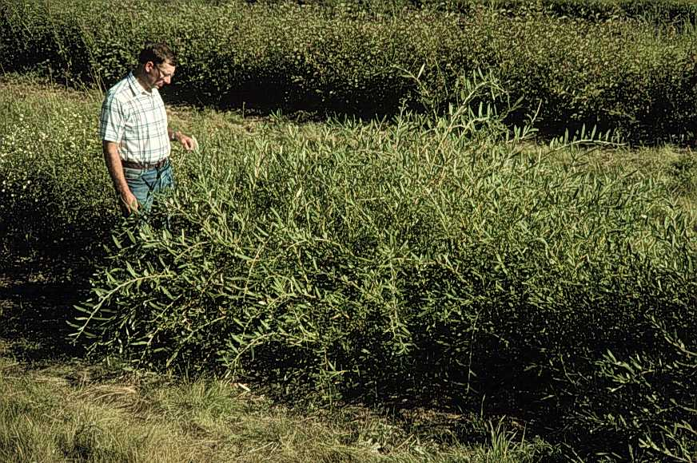

*Associated Species*: Associated shrubs include Booth, Barclay (*S. barclayi*), Geyer (*S. geyeriana*), mountain (*S. eastwoodii*), and Wolf willow (*S. wolfii*); mountain gooseberry (*Ribes montigenum*); whitestem currant (*Ribes rubrum*); thinleaf alder (*Alnus incana* ssp. *tenuifolia*); red-osier dogwood (*Cornus sericea*); alder buckthorn (*Frangula alnus*) and marsh cinquefoil (*Potentilla* ). Understory species include bluejoint reedgrass (*Calamagrostis canadensis*), beaked sedge (*Carex rostrata*), water sedge (*C. aquatilis*), tufted hairgrass (*Deschampsia caespitosa*), Kentucky bluegrass (*Poa pratensis*), and field mint (*Mentha arvensis*).

##### Importance to Livestock and Wildlife

##### All classes of livestock eat willows in the West, but cattle consume more than others because they frequent riparian areas. Drummond willow is palatable to livestock, but its importance in their diets is not reported.

Moose consume large amounts of Drummond willow during the winter, while use by other ungulates is generally light. It is used by elk and white-tailed deer.

Beaver prefer willows as food and building material. Ducks and grouse, other birds, and small mammals eat willow shoots, catkins, buds and leaves. Red-naped sapsuckers, warblers, humming birds, chipmunks, and red squirrels also use Drummond willow.

Drummond willow often forms thickets that provide good cover for a variety of wildlife species including moose, and good nesting and foraging habitat for ducks, shore birds, vireos, warblers, and sparrows. Dense overhanging branches provide shade for salmonids.

##### Adaptation

##### Drummond willow is adapted to fine, medium, and coarse-textured soils with a pH of 5.2 to 7.4 and annual precipitation from 16 to 40 inches. It typically grows on moist, well-aerated mineral soils. Textures vary from cobbles and gravels immediately adjacent to waterways to sandy or clay loams in broad valleys. Shade tolerance is intermediate.

##### Establishment

##### Drummond willow may be propagated via seed or cuttings. Seed is used to produce containerized plants. Cuttings may either be planted directly at the site or planted to produce bareroot plants or containerized plants. Drummond willow should be established in the capillary zone in riparian revegetation plantings. Much information is available for willow establishment, primarily in riparian zones. See reference section.

##### Management

##### Drummond willow provides important streambank protection by effectively stabilizing soils. Heavy grazing in moist Drummond willow communities can lead to soil compaction, streambank sloughing and damage to willow plants. Cattle or wild ungulate overgrazing of Drummond willow causes it to become decadent or stunted. Plants recover rapidly when browsing is excluded. Grazing is particularly detrimental to the establishment of willows.

##### Seed and Plant Production

##### Drummond willow is easily propagated by use of hardwood cuttings without use of rooting hormone. It can also be propagated with seed but seed must be collected as soon as the fruits ripen. Mature seed loses germination ability rapidly, so planting soon after collection is necessary. Moistened seed may be stored for up to a month if refrigerated in sealed containers. Seeds of willow are not known to exhibit dormancy. Some native plant propagators prefer seed propagation for added diversity of genetic material and less labor requirement for handling of materials during collection, storage and propagation. (See reference section for production of hardwood cuttings in cutting blocks or stooling beds.)

##### Pests and Potential Problems

##### Poplar/willow borers are potential problems in stands of Drummond willow maintained for cutting production. Borers must be controlled prior to entering the stems. Decadent stems with borer infestation should be pruned from commercial cutting production sites. Consult local/state pesticide recommendations for further control.

Willow plantings, especially during establishment, can be damaged by rodents including beaver, muskrat, mice, voles, etc. either cutting off stems or girdling.

##### Weediness

##### This plant is not considered a weed in its native habitat. It spreads slowly by seed and does not spread vegetatively by rootstock.

##### Control

##### Mechanical or chemical control methods seem to adequately control Drummond willow. Contact your local agricultural extension specialist or county weed specialist to learn what works best in your area and how to use it safely. Always read label and safety instructions for each control method.

##### Cultivars

##### The NRCS Pullman, WA Plant Materials Center released as a cultivar 'Curlew' Drummond willow in 1993. 'Curlew' originated from a riparian site near the Curlew River in Ferry County, Washington at an elevation of 2135 feet. Mature height is 9 feet and canopy width is 15 feet at Pullman, WA. 'Curlew' is relatively low-growing with striking yellow to yellow-orange stems which may provide appeal for ornamental use, especially when contrasted with material such as red-osier dogwood. 'Curlew' has outstanding foliage density when grown on good sites in silt loam soils. It easily roots from hardwood cuttings without use of rooting hormone treatment. 'Curlew' is available commercially.

Contact your local Natural Resources Conservation Service (formerly Soil Conservation Service) office for more information. Look in the phone book under ”United States Government.” The Natural Resources Conservation Service will be listed under the subheading “Department of Agriculture.”

##### References

Brinkman, K. A. 1974. Salix L. willow. *In*: Schopmeyer, C. S. *Seeds of woody plants in the United States*. Agriculture Handbook 450. Washington, DC. USDA, Forest Service, p. 746-750.

Crowder, W.A. and D.C.Darris. 1999. *Producing Pacific Northwest native trees and shrubs in hardwood cutting blocks or stooling beds*. Plant Materials Technical Note 38. USDA, NRCS. Spokane, WA.

Hayes, D.W. and G.A Garrison. 1960. *Key to important woody plants of eastern Oregon and Washington.* Agriculture Handbook 148. USDA. US Gov't. Printing Office. Washington, D.C.

Hitchcock, C.L. and A. Cronquist 1964. *Vascular plants of the Pacific Northwest*. Part 2: Salicaceae to Saxifragaceae. Seattle, WA: Univ. of Washington Press.

Hoag, J.C. September, 1993. *How to plant willows and cottonwoods for riparian rehabilitation.* Plant Materials Technical Note 23. USDA, SCS. Boise, ID.

Lambert, S.M. January, 1989. *Streamside revegetation*. Plant Materials Technical Note 12 (Revised). USDA, NRCS. Spokane, WA.

U.S. Department of Agriculture, Forest Service, Rocky Mountain Research Station, Fire Sciences Laboratory (2003, January). Fire Effects Information System, [Online]. Available: <<http://www.fs.fed.us/database/feis>> [January 6, 2003].

Uchytil, R.J. 1991 *Salix drummondiana*. *In*: USDA, Forest Service Fire Effects Information System Database. <[http://www.fs.fed.us/database/feis](http://www.fs.fed.us/database/feis/plants/shrub/saldru/all.html)> [January 6, 2003]. Rocky Mountain Research Station, Fire Sciences Laboratory, Missoula, Montana

USDA, NRCS. 2003. The PLANTS Database, Version 3.5 <[http://plants.usda.gov](http://plants.usda.gov/)>. National Plant Data Center, Baton Rouge, LA 70874-4490

##### Prepared By

##### *Wayne Crowder*, USDA, NRCS, Plant Materials Center, Pullman, Washington

##### Species Coordinator:

##### *Wayne Crowder*, USDA NRCS, Plant Materials Center, Pullman, Washington

Drafted 14jan03 wac; Edited 15jan03 jlk; 060817 jsp

For more information about this and other plants, please contact your local NRCS field office or Conservation District, and visit the PLANTS Web site<<http://plants.usda.gov>> or the Plant Materials Program Web site <<http://Plant-Materials.nrcs.usda.gov>>

*The U.S. Department of Agriculture (USDA) prohibits discrimination in all its programs and activities on the basis of race, color, national origin, sex, religion, age, disability, political beliefs, sexual orientation, and marital or family status. (Not all prohibited bases apply to all programs.) Persons with disabilities who require alternative means for communication of program information (Braille, large print, audiotape, etc.) should contact USDA's* [*TARGET Center*](http://www.usda.gov/oo/target.htm) *at 202-720-2600 (voice and TDD).*

*To file a complaint of discrimination write USDA, Director, Office of Civil Rights, Room 326-W, Whitten Building, 14th and Independence Avenue, SW, Washington, DC 20250-9410 or call 202-720-5964 (voice or TDD). USDA is an equal opportunity provider and employer.*

*Read about* [*Civil Rights at the Natural Resources Convervation Service*](http://www.nrcs.usda.gov/about/civilrights/)*.*