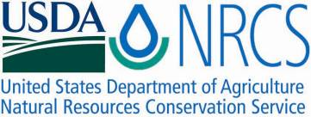

Plant Guide

# Barneby reed-mustard

***Schoenocrambe barnebyi* (S.L. Welsh & N.D. Atwood) Rollins** Plant Symbol = SCBA80

*Contributed by*: USDA NRCS Idaho and Utah Plant Materials Program

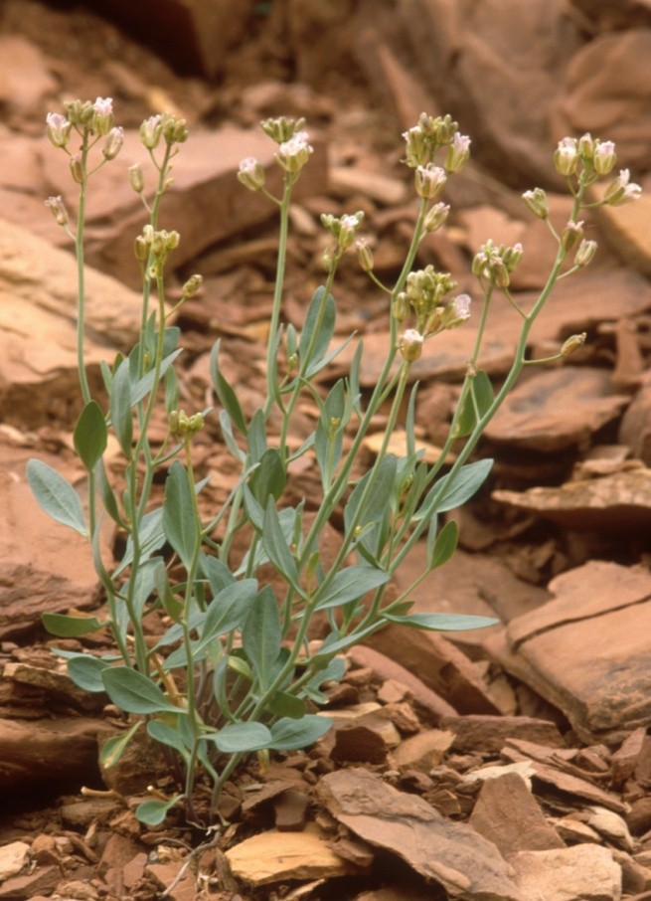

**Barneby reed-mustard (Schoenocrambe barnebyi). Photo by C.R. Delmatier**

### Alternate Names

Syes Butte Plainsmustard

*Thelypodiopsis barnebyi*

### Uses

There are no known human or wildlife uses of Barneby reed-mustard.

### Status

Barneby reed-mustard was determined by the USDI-Fish and Wildlife Service to be an endangered species warranting protection in 1992 (USDI-FWS,

1992). There are an estimated 2,000 individual plants in existence (USDI-FWS, 1994).

Consult the PLANTS Web site and your State Department of Natural Resources for this plant’s current status (e.g., threatened or endangered species, state noxious status, and wetland indicator values).

### Description

*General*: Mustard family (Brassicaceae). Barneby reed-mustard is a perennial forb with multiple stems arising from a branching woody caudex and taproot. The stems grow 10 to 35 cm (4 to 14 in) tall, and bear elliptical, entire leaves which can be hairy to glabrous and glaucus. The leaves are 13 to 51 mm (0.50 to 2.0 in) long and 4 to 24 mm (0.16 to 0.94 in) wide with 0.4 to 10 mm (0.02 to 0.40 in) long petioles. The flowers have four white to lavender petals, 10 to 12 mm (0.40 to 0.47 in) long, with conspicuous purple veins. The fruit is a silique (a lengthened pod), 34 to 65 mm (1.34 to 2.56 in) long and 1 to 2 m (0.04 to 0.08 in) wide (Welsh, et al., 2003).

*Distribution*:

There are two known populations of Barneby reed-mustard. One population is within the boundary of Capitol Reef National Park in the Fremont River drainage west of Fruita, Utah in Wayne County, and the other population is in the southern portion of the San Rafael Swell in Emery County, Utah. The two populations are separated by a distance of approximately 40 km (25 mi).

For current distribution, consult the Plant Profile page for this species on the PLANTS Web site.

*Habitat*:

Barneby reed-mustard inhabits semi arid canyonlands on steep slopes, generally with northern exposures. The plants grow in mixed shadscale (*Atriplex confertifolia*), buckwheat (*Eriogonum* *corymbosum* ) and ephedra (*Ephedra torreyana* and *E. viridis*) plant communities (Welsh et al., 2003). Other plant associates include Utah serviceberry (*Amelanchier utahensis*), galleta grass (*Hilaria* *jamesii*), tarragon (*Artemisia* *dracunculus*) and rubber rabbitbrush (*Ericameria* *nauseosa*) (USDI-FWS, 1994).

**Adaptation**

This species is endemic to red clay soils derived from the Moenkopi and Chinle Formations overlain with sandstone talus. These soils are rich in selenium and gypsum (USDI-FWS, 1994). Both populations are found in a 15 to 23 cm (6 to 9 in) mean annual precipitation zone (WRCC, 2011).

### Management

Existing threats to the survival of Barneby reed-mustard include oil and gas exploration, oil-shale mining, stone quarrying, and off-road vehicle (ORV) use. An additional potential threat is habitat destruction due to uranium mining activity. A large portion of the San Rafael Swell population lies within existing mining claims. The Capitol Reef National Park population is at risk of habitat destruction from foot traffic caused by park visitors (USDI-FWS, 1994).

Management goals include the establishment of a minimum of 5 separate populations consisting of 2,000 or more individuals per population. This is to be accomplished by controlling the habitat threatening activities listed above, and by identifying suitable habitat for additional populations and introducing propagated materials. Life history, reproduction and ecological studies for the species are also indicated (USDI-FWS, 1994).

### Pests and Potential Problems

Historical sheep and cattle grazing use may have impacted Barneby reed-mustard on USDI-BLM lands. However current grazing levels are not believed to pose a serious threat.

### Environmental Concerns

### There are no known environmental concerns associated with Barneby reed-mustard.

### Seed and Plant Production

Reproduction of Barneby reed-mustard is sexual. Flowering occurs from April to May with fruit ripening in May to June. Specific pollination vectors are unknown (USDI-FWS, 1994).

### References

USDI-Fish and Wildlife Service. 1992. Endangered and threatened wildlife and plants; final rule to determine the plant *Schoenocrambe argillacea* (Clay reed-mustard) to be a threatened species, and the plant *Schoenocrambe barnebyi* (Barneby reed-mustard) to be an endangered species. In: Federal Register. 57(9): 1398-1403.

USDI-Fish and Wildlife Service. 1994. Utah reed-mustards; clay reed-mustard (*Schoenocrambe* *argillacea*), Barneby reed-mustard (*Schoenocrambe barnebyi*), shrubby reed-mustard (*Schoenocrambe suffrutescens*) recovery plan. Denver, Colorado. 22p.

Welsh, S.L., N.D. Atwood, S. Goodrich, and L.C. Higgins. 2003. A Utah Flora. Third Edition, revised. Brigham Young University, Provo, UT.

Western Regional Climate Center. 2011. Online. http://www.wrcc.dri.edu/index.html. Accessed January 13, 2011.

**Prepared By**:

*Derek Tilley*; USDA NRCS Plant Materials Center, Aberdeen, Idaho.

*Loren St. John*, USDA NRCS Plant Materials Center, Aberdeen, Idaho.

*Dan Ogle*, USDA NRCS, Boise, Idaho.

### Citation

Tilley, D., L. St. John and D. Ogle. 2011. Plant guide for Barneby reed-mustard (*Schoenocrambe barnebyi*). USDA-Natural Resources Conservation Service, Idaho Plant Materials Center. Aberdeen, ID.

Published Jan 2011

Edited: 13Jan2011djt; 13jan2011dgo; 13Jan2011ls

For more information about this and other plants, please contact your local NRCS field office or Conservation District at http://www.nrcs.usda.gov/ and visit the PLANTS Web site at http://plants.usda.gov/ or the Plant Materials Program Web site http://plant-materials.nrcs.usda.gov.

PLANTS is not responsible for the content or availability of other Web sites.

**USDA IS AN EQUAL OPPORTUNITY PROVIDER AND EMPLOYER**