

Plant Guide

# uinta basin hookless cactus complex

Including

**Sclerocactus *brevispinus* K.D. Heil and J.M. Porter**

***S.* glaucus (K. Schumann) L.D. Benson**

**and**

***S. wetlandicus* Hochstätter**

Plant Symbol = SCGL3

*Contributed by*: USDA NRCS Idaho and Utah Plant Materials Program

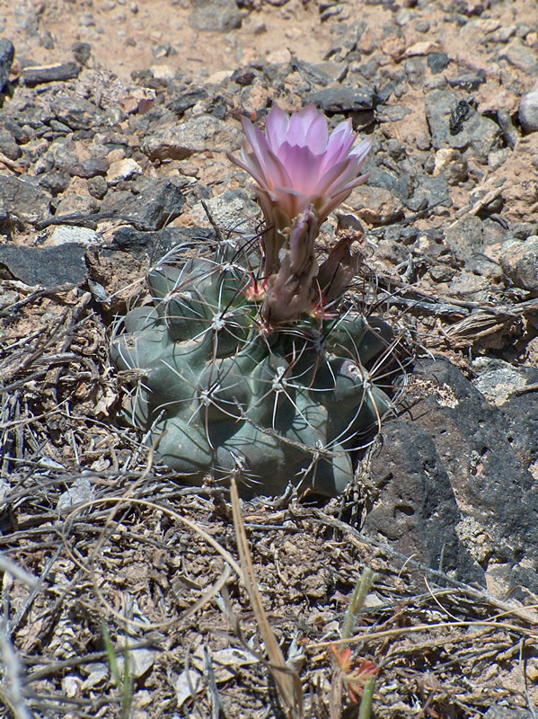**Uinta Basin hookless cactus (Sclerocactus glaucus). Photo by Barry C. Johnston**

### Alternate Names

### Colorado hookless cactus

Pariette cactus

### Uses

Uinta Basin cactus and other rare cacti are targeted by cactus collectors. These species have no known human uses. The flowers are visited by numerous insects including bees, ants and beetles (USDI-FWS, 2007).

### Status

Uinta Basin hookless cactus (*Sclerocactus glaucus*) was listed as a threatened species by the USDI Fish and Wildlife Service in 1979 (USDI-FWS, 1979). Since that time, the species has undergone numerous taxonomic changes, being described as up to three distinct taxa. In 2009, the USDI-Fish and Wildlife Service followed Hochstätter’s treatment of the genus (1997) and the taxonomic nomenclature accepted by the Flora of North America (Heil and Porter, 2004), and relisted three species as threatened: Pariette cactus (*S*. *brevispinus*), Colorado hookless cactus (*S. glaucus*) and Uinta Basin hookless cactus (*S. wetlandicus*) (USDI-FWs, 2009).

USDI-FWS has further stated their intent to propose reclassification of Pariette cactus from threatened to endangered (USDI-FWS, 2006).

Consult the PLANTS Web site and your State Department of Natural Resources for this plant’s current status (e.g., threatened or endangered species, state noxious status, and wetland indicator values).

### Description

*General*: Cactus family (Cactaceae). Plants of all three species grow as unbranched spheres or cylinders with tubercles on the ribs. The above ground portion of the spheres reaches 4 to 18 cm (2 to 7 in) tall and 2.5 to 12 cm (1 to 4.5 in) in diameter. There are 6 to 14 radial spines and 1 to 5 central spines per areole. The flowers are funnel or bell-shaped, 5 cm long (2 in) and 2 to 3 cm (0.8 to 1.2 in) across. The inner tepals are pink or violet, 2 to 3 cm (0.8 to 1.2 in) long and 3 to 6 mm (0.1 to 0.2 in) wide. The fruit is an indehiscent oval shaped berry. The seed is black, 1.5 to 2.5 mm (0.06 to 0.1 in) long (Heil and Porter, 2004).

The three species can be tentatively separated as follows (Heil and Porter, 2004):

1. Seed surface composed of convex cells; plants of Colorado *S. glaucus*

1. Seed surface composed of flattened cells; plants of Utah

2. Abaxial central spines usually not hooked; flowers funnel shaped; outer and inner tepals brownish lavender, violet, or pink, 2.5 to 5 cm diameter *S. wetlandicus*

2. Abaxial central spines often absent, or if present, then all curved or hooked; flowers bell shaped; outer tepals greenish to purple, inner tepals purple, 1.1 to 3 cm diameter *S. brevispinus*

*Distribution*:

Colorado hookless cactus is known from populations in Montrose, Mesa, Delta and Garfield Counties, Colorado.

Uintah Basin hookless cactus is endemic to the Uinta Basin in northeastern Utah. Its range covers an area approximately 96 km long by 40 km wide (60 mi by 25 mi) wide containing approximately 30,000 individuals.

Pariette cactus is restricted to the Pariette Draw of the central Uinta Basin (USDI-FWS, 2006b). There is a single known population covering an area of approximately 16 km (10 mi) long by 8 km (5 mi) wide. The total species population is estimated at 8,000 individuals (USDI-FWS, 2007).

For current distribution, consult the Plant Profile page for this species on the PLANTS Web site.

*Habitat*:

These three cactus species grow on sparsely vegetated arid desert shrubland in association with shadscale (*Atriplex* *confertifolia*), rabbitbrush (*Ericameria nauseosa*) and horsebrush (*Tetradymia* spp.).

**Adaptation**

Colorado hookless and Uinta Basin hookless cactus are found on coarse soils derived from stream terrace deposits, or on rocky surfaces on mesa slopes at 1,350 to 1,900 m (4,400 to 6,200 ft) in elevation. Pariette cactus is found on fine clay soils in the badlands derived from the Uinta Formation (USDI-FWS, 2006b). The range of all three species lies in an area receiving 15 to 22 cm (6 to 9 in) of mean annual precipitation.

### Management

### Habitat of all three cactus species is threatened by oil and gas production and development. Most of the range of Uinta Basin cactus lies within existing oil and gas fields or within undeveloped oil and gas lease areas (USDI-FWS, 2006a). Additional threats come from illegal collection from succulent plant enthusiasts. Illegal collection rates continue to increase as oil and gas related roads are created in the species’ range. Livestock trampling and recreational off highway vehicle (OHV) use are also considered threats.

### Pests and Potential Problems

### Parasitism is known to occur with other members of the genus; however, specific threats are as yet unknown for these three species.

### Environmental Concerns

### There are no known environmental concerns associated with these three *Sclerocactus* species.

### Seed and Plant Production

### These cactus species flowers April to May and are pollinated by native bees, and possibly ants and beetles (USDI-FWS, 2007).

### References

Heil, K.D., and J.M. Porter. 2004. *Sclerocactus* in: Flora of North America, north of Mexico Volume 4, Magnoliophyta: Caryophyllidae, part 1. Edited by: Flora of North America Editorial Committee. Oxford University Press. New York. Pp. 197-207.

USDI-FWS. 1979. Endangerd and threatened wildlife and plants; determination that *Sclerocactus* *glaucus* is a threatened species. In: Federal Register 44(198).

USDI-FWS. 2006. 5-year review of Uinta Basin hookless cactus (*Sclerocactus glaucus*). Denver, Colorado.

USDI-FWS. 2006. Endangered and threatened wildlife and plants; 90-day finding on a petition to remove the Uinta Basin Hookless Cactus from the list of endangered and threatened plants; 90-day finding on a petition to list the Pariette cactus as threatened or endangered. In: Federal Register 71(240): 75215-75220.

USDI-FWS. 2007. Endangered and threatened wildlife and plants; 12-month finding on a petition to list *Sclerocactus brevispinus* (Pariette cactus) as an endangered or threatened species; taxonomic change from *Sclerocactus glaucus* to *Sclerocactus brevispinus*, S. glaucus, and S. wetlandicus. In: Federal Register 72(180): 53211-53222.

USDI-FWS. 2009. Endangerd and threatened wildlife and plants; taxonomic change of *Sclerocactus* *glaucus* to three separate species. In: Federal Register 74(177): 47112-47117.

**Prepared By**:

*Derek Tilley*; USDA NRCS Plant Materials Center, Aberdeen, Idaho.

*Loren St. John*, USDA NRCS Plant Materials Center, Aberdeen, Idaho.

*Dan Ogle*, USDA NRCS, Boise, Idaho.

### Citation

Tilley, D., L. St. John and D. Ogle. 2010. Plant guide for Uinta Basin hookless cactus (*Sclerocactus glaucus*). USDA-Natural Resources Conservation Service, Idaho Plant Materials Center. Aberdeen, ID.

Published Jan 2011

Edited: 05Jan2011 djt, 06Jan2011lsj; 05jan2011dgo

For more information about this and other plants, please contact your local NRCS field office or Conservation District at http://www.nrcs.usda.gov/ and visit the PLANTS Web site at http://plants.usda.gov/ or the Plant Materials Program Web site http://plant-materials.nrcs.usda.gov.

PLANTS is not responsible for the content or availability of other Web sites.

**USDA IS AN EQUAL OPPORTUNITY PROVIDER AND EMPLOYER**