|  |
| --- |
| sturdy bulrush |
| *Schoenoplectus robustus* (Pursh) M.T. Strong |
| Plant Symbol = SCRO5 |

# *Contributed by: USDA NRCS National Plant Data Center*

# Alternative Names

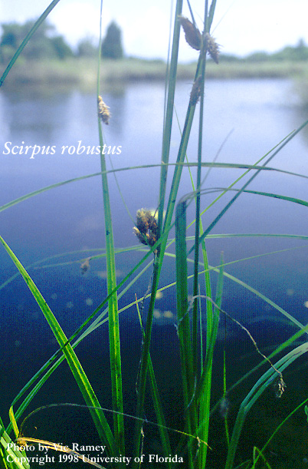

Vic Ramey

© University of Florida

@ Aquatic Plant Information Retrieval System

bulrush, alkali bulrush, three cornered rush, leafy three-cornered sedge, stout bulrush

# Uses

*Wildlife*: Sturdy bulrush seeds are an important food source to muskrat, waterfall, ducks, geese, and other water birds. This species also provide cover for nesting birds.

# Status

# Please consult the Plants Web site and your State Department of Natural Resources for this plant’s current status, such as, state noxious status, and wetland indicator values.

# Description

*General*: Sedge family (Cyperaceae). Sturdy bulrush is native, perennial sedge that grows up to three and a half feet tall. The leaves are grasslike, long and narrow, up to twenty-four inches long. The flowers are born in three or more spiklets that are covered by brown scales (Tiner 1987), flowering between April and August. The fruit is a dark brown or black achene with pits that fruit between July and October.

*Distribution*: Sturdy bulrush grows from Maine, south to Florida and west to Texas. For current distribution, please consult the Plant profile page for this species on the PLANTS Web site.

# Adaptation

Sturdy bulrush occurs in swampy meadows, along streams, swamps, sloughs, and borders of oxbow lakes in river flood plains. This is a wetland species that grows best in *Schoenoplectus* communities with water levels between –6 and +5 inches with a soil pH ranging from 4.3 to 6.4.

# Establishment

*Propagation by Seed*: Sturdy bulrush seeds should be sown in a cold frame as soon as they are ripe in a pot standing in three centimeters of water. The seeds germinate quickly. When they are large enough to handle, out-plant into their permanent positions in early summer.

Large divisions can be planted directly into their permanent positions. It is best to pot smaller divisions and grow them in a cold frame and out-planting when they are well established in the summer.

# Management

After seed planting, water level over sturdy bulrush seeds should be maintained at one foot for two weeks. Periodic flooding up to three feet should occur until the seedlings are established.

# Cultivars, Improved and Selected Materials (and area of origin)

Available through commercial nurseries dealing with wetland plants. Contact your local Natural Resources Conservation Service (formerly Soil Conservation Service) office for more information. Look in the phone book under ”United States Government.” The Natural Resources Conservation Service will be listed under the subheading “Department of Agriculture.”

# References

Gleason, H.A. 1952. *The new Britton and Brown: illustrated flora of the northeastern United States and adjacent Canada*. Vol 1. The New York Botanical Garden, Bronx, New York.

Godfrey, R.K. & J.W. Wooten 1979. *Aquatic and wetland plants of southeastern United States: monocotyledons*. The University of Georgia Press, Athens, Georgia.

Hitchock, L.C. & A. Cronquist 1973. *Flora of the Pacific Northwest*. University of Washington Press, Seattle, Washington.

Howell, J.T. 1949. *Marin Flora: manual of the flowering plants and ferns of Marin County, California*. University of California Press, Berkeley & Los Angeles, California.

Munz, P.A. 1965. *A California flora*. University of California Press, Berkeley & Los Angeles, California.

Munz, P.A. 1973. *A California flora and supplement*. University of California Press, Berkeley, California.

Radford, A.E., H.E. Ahles, & C.R. Bell 1968. *Manual of the vascular flora of the Carolinas*. The University of North Carolina Press, Chapel Hill, North Carolina.

Small, J.K. 1933. *Manual of the southeastern flora*. The University of North Carolina Press, Chapel Hill, North Carolina.

Strausbaugh, P. D. & E. L. Core 1977. *Flora of West Virginia*. 2nd ed. Seneca Books, Inc., Morgantown, West Virginia.

Tiner, R.W. Jr. 1987. *A field guide to coastal wetland plants of the northeastern United States*. The University of Massachusetts Press, Amherst, Massachusetts.

University of Florida 2002. Center for Aquatic and Invasive Plants, Gainsville, Florida. Accessed: 11jan02. <http://aquat1.ifas.ufl.edu/welcome.html>

# Prepared By

#### *Jammie Favorite*

formerly USDA, NRCS, National Plant Data Center

# Baton Rouge, Louisiana

# Species Coordinator

*Lincoln M. Moore*

USDA, NRCS, National Plant Data Center, Baton Rouge, Louisiana

Edited: 10jan02 jsp; 24feb03 ahv; 060817 jsp

For more information about this and other plants, please contact your local NRCS field office or Conservation District, and visit the PLANTS Web site<<http://plants.usda.gov>> or the Plant Materials Program Web site <<http://Plant-Materials.nrcs.usda.gov>>

*The U.S. Department of Agriculture (USDA) prohibits discrimination in all its programs and activities on the basis of race, color, national origin, sex, religion, age, disability, political beliefs, sexual orientation, and marital or family status. (Not all prohibited bases apply to all programs.) Persons with disabilities who require alternative means for communication of program information (Braille, large print, audiotape, etc.) should contact USDA's* [*TARGET Center*](http://www.usda.gov/oo/target.htm) *at 202-720-2600 (voice and TDD).*

*To file a complaint of discrimination write USDA, Director, Office of Civil Rights, Room 326-W, Whitten Building, 14th and Independence Avenue, SW, Washington, DC 20250-9410 or call 202-720-5964 (voice or TDD). USDA is an equal opportunity provider and employer.*

*Read about* [*Civil Rights at the Natural Resources Convervation Service*](http://www.nrcs.usda.gov/about/civilrights/)*.*