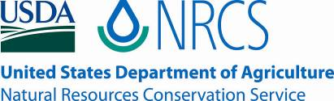

Plant Guide

# idaho

# blue-eyed grass

## Sisyrinchium idahoense E.P. Bicknell

Plant Symbol = SIID

*Contributed by*: USDA NRCS Corvallis Plant Materials Center, Oregon

Photo by Amy Bartow, NRCS Corvallis Plant Materials Center, 2011

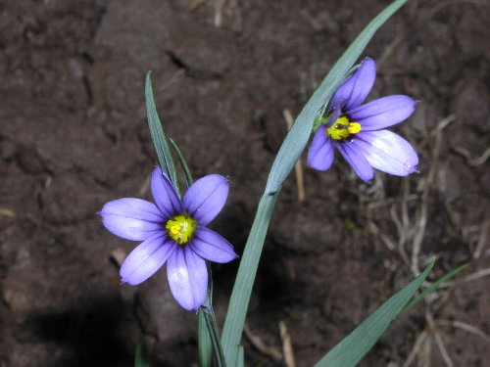

### Alternate Names

There are at least four varieties of Idaho blue-eyed grass occurring throughout the species’ range

(var. *idahoense*, var. *macounii*, var. *occidentale*, var. *segetum*).

### Uses

*Restoration*: *Sisyrinchium idahoense* is a prime candidate for wetland or riparian zone restoration sites, such as for Wetland Reserve Program (WRP) and Wetland Reserve Enhancement Program (WREP) projects. It attracts multiple pollinators and beneficial insects, provides cover for small animals, and its clumpy root structure provides soil stability. It grows in full sun to shaded areas and is highly desirable because of its productive versatility.

*Pollinator habitat*: This plant is a highly attractive nectar and pollen plant for native bees and other beneficial insects. It is also reported as a nectar source for the mardon skipper (*Polites mardon*), a butterfly listed as endangered in the state of Washington, and a candidate species for enlistment on the Federal endangered species list (Black & Vaughan, 2005).

*Ornamental*: Idaho blue-eyed grass makes a pleasing addition to any garden landscape. The plant is evergreen and, due to a short stature, is a suitable border highlight for all seasons. Small but attractive bluish flowers bloom mid-spring to mid-summer and compliment other floral variety. Once established in a seasonally moist or well-watered area, it is relatively low maintenance and will add plant and insect biodiversity.

### Status

This forb has facultative wetland indicator status in Oregon, Idaho, Washington, western Montana and western Wyoming (region 9), and obligate wetland indicator status in Nevada, Utah, western Colorado, California, Arizona and New Mexico (regions 7,8, and 9), meaning that it almost always naturally occurs in wetlands throughout its native range. Please consult the PLANTS Web site and your State Department of Natural Resources for this plant’s current status (e.g., threatened or endangered species, state noxious status, and wetland indicator values).

### Description

*General*: Idaho blue-eyed grass is a perennial forb/herb, not a grass as the common name suggests. Part of the iris family (Iridaceae), it is a monocot and has thin, erect, grass-like leaves growing from the base. As it matures it will grow to be 6 to 18 inches tall, and its small blooms are light blue to deep blue or purple, six-petaled, star-shaped flowers with a yellow center (Cholewa, 2012). Flowers will begin to bloom late spring through mid-summer (Turner & Gustafson, 2006). Seeds will form in round capsules and, when ripe, pods turn tan to dark brown or black and begin to split.

*Distribution*: The four varieties of this plant are found throughout the western half of the United States, from northern California and Nevada throughout Oregon and Washington into British Columbia, east across northern Idaho into western Montana and south into western Wyoming and Colorado, eastern Utah, Arizona and northern New Mexico. For current distribution, please consult the Plant Profile page for this species on the PLANTS Web site.

*Habitat*: Plants are common in moist meadows and on the edges of wetlands or stream banks, in a range of mid to lower elevations, but mostly in open meadows and mountainous forests (Turner & Gustafson, 2006). This species prefers subalpine climates and seasonally moist soils like those of the Pacific Northwest.

**Adaptation**

Idaho blue-eyed grass can adapt to fine to coarse soils, loamy to clay in texture. The limiting factor for this species is drought. It will do well in any area where it has moist to saturated winter and spring soils.

### Establishment

Be sure to choose areas that are at least seasonally moist, if not swampy, or employ irrigation and the plants will grow well. *S. idahoense* seeds are dormant and need to experience warm, early fall temperatures followed by cold winter temperatures to initiate germination in early spring as soils warm. Seeds can be shallowly drill planted (surface to 1/8 inch) or broadcast at a single species rate of 6 to 7 pounds pure live seed (pls) per acre in the fall if there is good site preparation and weed control for at least the previous year. There are approximately 380,000 seeds per pound, so a rate of one pound per acre will result in about 9 seeds per square foot. However, the preferred establishment method for this species is to plant plugs in the early spring to establish a competitive advantage over aggressive weed species.

### Management

Once established in appropriate areas, there is little maintenance required to keep these plants growing. While Idaho blue-eyed grass will self-sow and be prolific, it is not aggressive and is unlikely to become dominant in most areas.

### Pests and Potential Problems

No known pests or problems are associated with *S. idahoense*.

### Environmental Concerns

None.

### Seeds and Plant Production

*Plug Propagation and Field Establishment:* It is recommended to establish fields from plugs to avoid competition from weeds and the need for dry-season irrigation during the first years. Production work done at the Corvallis Plant Materials Center indicates that transplanting plugs into weed fabric creates cleaner fields and results in an established, productive field in the first growing season. To overcome seed dormancy, sow seeds in containers and place in a warm location (65°F) for 2-4 weeks then move containers to a cold location (45°F or lower) for at least eight weeks. Alternately, containers can be left outside from early September through December. Move containers to a greenhouse set between 50-60°F in late December. Temperatures warmer than 65°F can halt germination, but greenhouse temperatures can be raised after seeds have germinated. Expect seeds to germinate within 2-4 weeks. Grow in a greenhouse and transplant out into fields covered with weed fabric in spring on 1 x 1 foot spacing. Plants are small and do not require a large planting distance, so spacing may be tailored to the individual producer’s equipment. It may be beneficial to plant on wider row spacing for weed control purposes, especially if weed fabric is not used (not recommended).

This species can also be established by direct sowing methods in early fall, but this is not recommended for seed production fields. For direct seeding into a field, seeds should be sown at a rate of 60 pls seeds per square foot, or 6-7 pounds pls per acre. Sow as shallowly as possible (surface to 1/8 inch) in rows 10-14 inches apart.

*Field Management:* The recommended use of weed fabric for Idaho blue-eyed grass optimizes two production objectives: weed exclusion and yield increase. There are no labeled herbicides for use on this forb when in seed production, so other methods of weed control become very important. Weed fabric excludes most weeds, but hand weeding may be necessary where the soil is exposed within the holes in the fabric. Hand weeding and spot spraying are effective weed management tools, and are more beneficial when coupled with a carefully selected pre-emergent herbicide to create a weed free seed bed. Production field borders need to be kept clean using herbicides or tillage methods. Reducing weeds from the seed production area will help prevent weed seeds from contaminating the seed crop. A spring application of a balanced fertilizer (15-15-15) is recommended for this species. The weed fabric may need to be cut in year two to allow for expansion of the plant crowns as they grow in the spring. The field may be mowed again following harvest to remove residual material and allow for ease of weed treatments.

*Harvest Methods:* Idaho blue-eyed grass begins flowering in May and will continue through July. Harvest maturity may be uneven, but for each plant it is reached when the round seed capsules turn light to dark brown and begin to split open. There is a narrow window of time to collect seed between capsule ripening and shattering. As capsules open, seed will fall out. For this reason, it is recommended to plant small plots that can be managed by hand and harvested daily, or use weed fabric to catch shattering seed. Harvest using a modified swather that is able to collect harvested stems and seeds as they are cut, instead of leaving it on the ground. When weed fabric is used, fallen seed may be swept or vacuumed after the plants are harvested, increasing yields. If using weed fabric, harvest stems as the latest seeds are maturing. Seeds that have shattered onto the weed fabric may be swept up using a flail-vac seed stripper or vacuumed from the fabric. If weed fabric is not used, harvest the field when most seeds are mature, but have not shattered. Harvested materials should be laid out to dry completely before cleaning.

*Seed Cleaning*: Blue-eyed grass seeds are round and heavy, and cleaning them to purity is relatively easy. A stationary combine or thresher works well to separate seed from pods. Follow with an air-screen machine to sort seed from chaff and other organic debris.

This little plant can be very prolific, averaging a seed yield of 620 pounds per acre for a mature, solidly-planted stand. Although the plants will flower during the first season, first year harvests are usually minimal at around 10 pounds per acre. Yields steadily increase in years two and three, reaching up to 700 pounds per acre depending on harvest method and use of weed fabric. Plants are long-lived and maintain high production beyond five years.

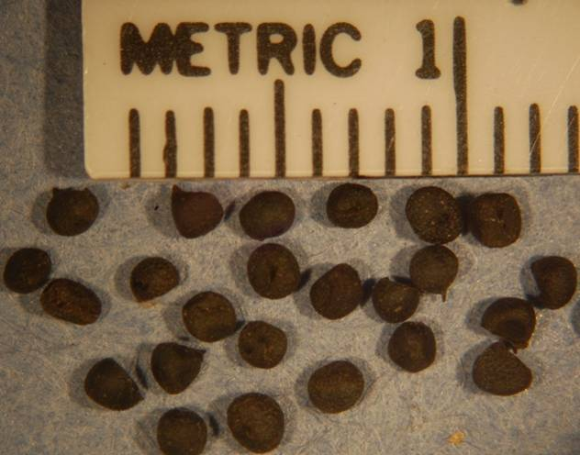

### *Sisyrinchium sp.* seeds at the Corvallis Plant Materials Center, Oregon, 2012. *Photo by Robert C Hoffman*.

### Cultivars, Improved, and Selected Materials (and area of origin)

None, but seed is readily available from commercial dealers in the Pacific Northwest.

### References

Bartow, A. 2012. The 2011 Bureau of Land Management

annual report: Roseburg district. USDA NRCS Plant Materials Center, Corvallis, OR.

Black, S.H., and D.M. Vaughan. 2005. Species profile:

*Polites mardon*. Red list of pollinator insects of North America. CD-ROM Version 1 (May 2005). The Xerces Society for Invertebrate Conservation, Portland, OR.

Carr, G.D. *Sisyrinchium idahoense.* Oregon flora project.

Available at <http://www.botany.hawaii.edu/faculty/carr/ofp/ofp_index.htm> (accessed 3 May 2012)

Cholewa, A. 2012. Jepson eFlora (v. 1.0), *Sisyrinchium*.

Available at http://ucjeps.berkeley.edu/IJM.html (accessed 29 Mar. 2012). Jepson Flora Project, Berkeley.

Turner, M., and P. Gustafson. 2006. Wildflowers of the

Pacific Northwest. Timber Press, Portland, OR.

**Prepared By**

*Mary Beuthin*

Corvallis Plant Materials Center, Oregon

### Citation

Beuthin, M. 2012. Plant guide for Idaho blue-eyed grass (*Sisyrinchium idahoense*). USDA-Natural Resources Conservation Service, Plant Materials Center, Corvallis, OR.

Published May 2012

Edited: 2Apr2012 aym;06Nov2012jab

For more information about this and other plants, please contact your local NRCS field office or Conservation District at <http://www.nrcs.usda.gov/> and visit the PLANTS Web site at <http://plants.usda.gov/> or the Plant Materials Program Web site <http://plant-materials.nrcs.usda.gov>.

PLANTS is not responsible for the content or availability of other Web sites.

**USDA IS AN EQUAL OPPORTUNITY PROVIDER AND EMPLOYER**