

Plant Guide

# Rose checker-Mallow

## Sidalcea virgata Howell

Plant Symbol = SIVI3

*Contributed by*: USDA NRCS Corvallis Plant Materials Center, Oregon

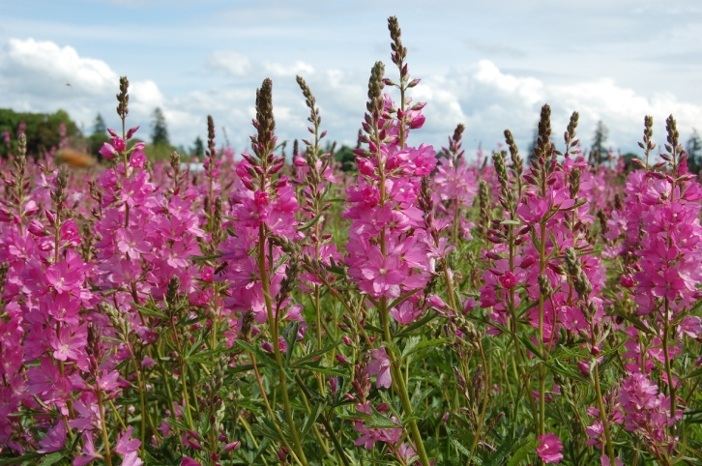

Photo by Amy Bartow, Corvallis Plant Materials Center, 2011.

### Alternate Names

*Alternate Common Names:* wild hollyhock, showy wild hollyhock, virgate checkerbloom, rosy checkermallow, dwarf checkerbloom

*Alternate Scientific Names: Sidalcea malviflora* (DC.) A. Gray ex Benth. ssp. *virgata* (Howell) C.L. Hitchc., *Sidalcea malviflora* (DC.) A. Gray ex Benth. var. *virgata* (Howell) Dimling, *Sidalcea malviflora* (DC.) A. Gray ex Benth. ssp. *asprella* (Greene) C.L. Hitchc. var. *virgata*

### Uses

*Prairie restoration:* Rose checker-mallow is a native wildflower used in prairie restoration plantings as an important member of a diverse native plant community.

*Pollinator habitat:* Rose checker-mallow flowers are one of the primary nectar sources for the federally endangered Fender’s blue butterfly, *Icaricia icarioides fenderi* (Wilson et al., 1997). It is also a suspected host plant for the West Coast painted lady *Vanessa annabella*, common checkered skipper *Pyrgus communis*, and two-banded checkered skipper *Pyrgus ruralis* (Newhouse, 2001). Flowers of *Sidalcea* species are a source of pollen and nectar for European honeybees (LCBA, 2012), as well as native bees and other beneficial insects (Newhouse, 2009). There is one native bee (*Diadasia* *nigrifrons*) that is a specialist pollinator of *Sidalcea* species (Leong, 2006).

### Status

*Sidalcea virgata* is listed as an endangered species in the state of Washington (WDNR, 2003). Please consult the PLANTS Web site and your State Department of Natural Resources for this plant’s current status (e.g., threatened or endangered species, state noxious status, and wetland indicator values).

### Description

*General*: Rose checker-mallow is a member of the mallow family (Malvaceae). It is an herbaceous perennial that typically grows 8 to 40 inches tall (Hitchcock and Cronquist, 1961). Plants have a strong taproot and short to trailing rhizomes (horizontal underground stems). The aboveground stems are often trailing or reclining on the ground, freely root at the base, are generally not hollow, and are covered in soft, branched (stellate), fairly long hairs. Leaf stems (petioles) are covered in dense, stellate hairs, and the upper surface of basal leaves is densely covered in short simple or forked hairs. Basal leaves are generally palmate, while leaves along the stem are deeply divided. Flower stalks are generally loose, often one-sided, rarely branched (from 1-3 side branches), and have relatively few flowers (5-30) compared to other *Sidalcea* species in western Oregon (Gisler, 2003).

This species is gynodioecious, meaning populations contain plants with hermaphrodite flowers (outcrossing and self-compatible), as well as plants that have only female flowers (obligate outcrossing) (Halse et al., 1989). Flowers have five petals that are rounded with a shallow notch at the tip, 5/8-1 inch (15-25 mm) long on perfect (bisexual) flowers and 3/8-1/2 inch (9-13 mm) on female flowers, and are pink to magenta (or sometimes white around Eugene, Oregon). Carpels containing individual seeds are relatively large for checker-mallows (1/7-1/6 inch, or 3.5-4 mm) and have a very rough, deeply net-

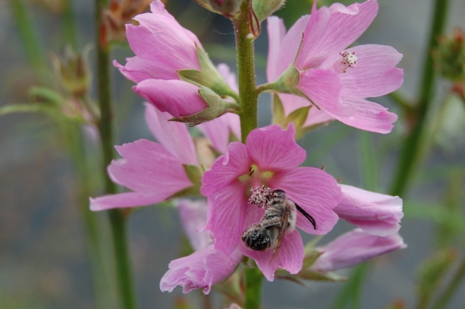

*Native Eucerine bee visiting rose checker-mallow flowers. Photo by A. Bartow, Corvallis Plant Materials Center, 2009.*

veined surface. Seeds are dispersed by water, wind and gravity. Plants flower May to June and seed generally ripens by late June to mid-July.

Rose checker-mallow has the same geographic distribution and pollinators as three other checker-mallows (*S. campestris*, *S. cusickii,* and *S. nelsoniana*), but hybridization with these species is generally discouraged in the wild by different flowering times, as *S. virgata* starts earlier and usually finishes flowering by the time the other three begin (Gisler, 2004). Differences in chromosome numbers may also help discourage inter-species crossing, although tetraploid populations of *S. virgata* in its northern range are thought to be hybrids of diploid *S. virgata* (currently found in its southern range) and hexaploid *S. campestris* (Whittall et al., 2000). Both *S. cusickii* and *S. nelsoniana* are diploids.

*Distribution*: Rose checker-mallow is found throughout the inland valleys and foothills of western Oregon, especially in the Willamette Valley, and north into southwestern Washington. For current distribution, please consult the Plant Profile page for this species on the PLANTS Web site.

*Habitat*: This species grows in moderately wet to very dry and upland (usually sloping) habitats including moist meadows, fields and lower mountains, as well as along roadsides and on grassy hillsides (Gisler, 2004; Hitchcock and Cronquist, 1961).

**Ethnobotany**

There are no known ethnobotanic uses of this plant.

**Adaptation**

Rose checker-mallow is adapted to sites that are seasonally saturated in the winter to early spring, but the species is also fairly drought-tolerant.

### Establishment

For restoration plantings, proper weed control and site preparation (tilling to create a clean, firm seed bed) are critical for good establishment and long-term survival (Schultz, 2001). Seeds are not dormant but appear to benefit from scarification prior to sowing based on observations at the Corvallis Plant Materials Center. Seeds sown in the fall will germinate naturally in late fall to late winter. Seed can be broadcast at a single-species rate of 4 to 6 lb/ac, but should be proportionally reduced in a prairie restoration mix depending on the other species used, site conditions, and desired outcome. There are 75,000-150,000 seeds per pound, so one pound of pure live seed spread over one acre will result in approximately 0.3 to 0.6 seeds per square foot, depending on seed size. Experimental seedings with 50% forb and 50% grass seed (*S. virgata* density of 15 seeds/ft2) showed better establishment than mixes composed of 10% forb and 90% grass seed (*S. virgata* density of 8 seeds/ft2) (Schultz, 2001). This species can also be established from transplanted plugs or rhizomes in the fall or spring.

### Management

Rose checker-mallow occurs in prairie and meadow habitats that were historically maintained by fire, so fire may be an important tool in managing appropriate habitat for this species (WDNR, 2003). Conifer and non-native shrub encroachment can displace native prairie forbs from their historical distribution.

### Pests and Potential Problems

Seed weevil larvae (*Macrorhoptus* spp.) have decimated yields some years in seed production fields at the Corvallis Plant Materials Center. Vole, mouse, and rabbit predation and leaf rust can also be detrimental to seed production of this species.

### Environmental Concerns

When collecting/growing out seed and planning restoration projects, care should be taken to avoid introducing *S. virgata* outside of its naturally occurring geographic range, as this may increase the likelihood of inter-specific hybridization with other Willamette Valley checker-mallows. It is also recommended to avoid combining populations of rose checker-mallow with different chromosome numbers in a single grow-out (populations can be either diploid [2n=20] or tetraploid [2n=40]; Alverson, 2006; Hitchcock and Kruckeberg, 1957).

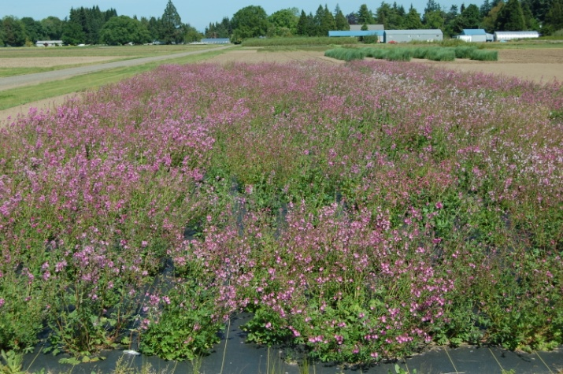

*Seed production field of rose checker-mallow on weed fabric at the Corvallis Plant Materials Center. Photo by A. Bartow, 2009.*

### Seeds and Plant Production

*Field Establishment & Maintenance*: For seed production, this species is best established from transplanted plugs in the fall or spring. Transplanting plugs creates cleaner fields and results in an established productive field in the first growing season. If direct seeding, sow in the fall or spring at a depth of ¼ to ½ inch and a rate of 4 to 6 lb/ac on 24- to 36-inch row spacing (approximately 30 seeds per square foot). For smaller plots, it is beneficial to plant into weed fabric for easier harvest and weed control. Larger plots may be grown without fabric, but yields may suffer. Plants respond well to additional nitrogen. Plants that were fertilized with 50 lb N/ac in spring at the Corvallis PMC had a longer bloom time and higher rates of filled seed. Fields established from plugs can be harvested the first year, but yields usually peak between years two and three, and are maintained for many years. Field longevity is over five years.

*Seed Harvest*: Plants typically have highly variable seed maturation. It is common to find single plants that simultaneously have flower buds, open flowers, immature seed, and shattered seed pods. It can be difficult to determine an optimal harvest time if harvesting a field that does not have weed fabric. For highest yields, direct combine fields with weed fabric when latest maturing seed is in hard dough stage. Catch debris as it comes out of the back of the combine on a tarp and dump offsite. After combining, use a flail-vac harvester (seed stripper) to sweep up all the seed remaining on the weed fabric. If weed fabric is not used, direct combine field when most seed is between soft dough and hard dough stage. Dry all material on tarps after harvest.

*Seed Conditioning*: Harvesting with a combine will separate seed from most other plant material. For smaller plots where a combine cannot be used, a thresher would provide the same service. Seeds are then sent through an air-screen machine to separate remaining plant debris from seed. Some seed lots contain a high amount of unfilled seed, so be sure to check inside the hulls for seed fill. Yields range from 130 to 270 pounds per acre at the Corvallis PMC.

*Container Production*: At the Corvallis Plant Materials Center, seeds are sown into 7-cubic-inch Ray Leach “Cone-tainers” filled with Sunshine Mix #1 (a soil less peat-based media) amended with micro-nutrients (Micromax) and a slow-release fertilizer (Osmocote 14-14-14). Flats are placed in a greenhouse set at moderate temperatures (70°F days/50°F nights). Seeds generally germinate within one to two weeks, with germination rates around 60%. Plugs are usually ready to harden off and plant out in about 4 to 6 months.

### Cultivars, Improved, and Selected Materials (and area of origin)

There are no developed cultivars of rose checker-mallow, but seed and plant materials are sometimes available from commercial sources in Oregon.

### References

Alverson, E. 2006. Taxonomy and variation of some Willamette Valley prairie plants: a plant taxonomist’s perspective on seed collection. Presentation for the workshop “Addressing Seed Transfer Issues in the Willamette Valley” on 22 Mar 2006 in Corvallis, OR. Available at http://www.nativeseednetwork.org/ article_view?id=33 (accessed 23 Mar 2012). The Nature Conservancy, Eugene, OR.

Gisler, S.D. 2003. Reproductive isolation and interspecific hybridization in the threatened species, Sidalcea nelsoniana. Unpublished Master’s thesis. Dept. of Botany and Plant Pathology, Oregon State Univ., Corvallis.

Gisler, S.D. 2004. Developing biogeographically based population introduction protocols for at-risk Willamette Valley plant species. Report to US Fish and Wildlife Service, Portland, OR. Available at http://www.fws.gov/oregonfwo/Species/Data/NelsonNelsonsChecker/Documents/ODA2004ReportSidalcReportSid.pdf (accessed 15 Mar 2012). Native Plant Conservation Program, Oregon Dept. of Agriculture, Salem.

Halse, R.R., B.A. Rottink, and R. Mishaga. 1989. Studies in Sidalcea taxonomy. Northwest Science 63(4):154-161.

Hitchcock, C.L., and A. Cronquist. 1961. Vascular plants of the Pacific Northwest, Part 3: Saxifragaceae to Ericaceae. Univ. of Washington Press, Seattle.

Hitchcock, C.L., and A.R. Kruckeberg. 1957. A study of the perennial species of Sidalcea. Univ. of Washington Publ. Biol. 18:1-96.

LBCA (Lane County Beekeepers Association). 2012. Native plants attractive to honeybees. Available at http://www.lcbaor.org/Supportfiles/nativeplants_for_honeybees.pdf (accessed 23 Mar 2012). LCBA, Eugene, OR.

Leong, J. 2006. Bird-foot checkerbloom (Sidalcea pedata) reserve design criteria: reproductive potential in a fragmented environment. Section 6 project final report to California Dept. of Fish and Game. Available at nrm.dfg.ca.gov/FileHandler.ashx? DocumentVersionID=40672 (accessed 26 Mar 2012). Biological Sciences Dept., California State Polytechnic University, Pomona.

Newhouse, B. 2009. Native plants frequented by native bees in the Willamette Valley Ecoregion, Oregon. Available at http://salixassociates.com/pdf/NativeBee Plants.pdf (accessed 24 Mar 2012). Salix Associates, Eugene, OR.

Newhouse, B. 2001. Willamette Valley butterflies and native host plants. Available at http://www.naba.org/chapters/nabaes/btrfly-gdng2.html (accessed 23 Mar 2012). NABA Eugene-Springfield Chapter, Eugene, OR.

Schultz, C.B. 2001. Restoring resources for an endangered butterfly. Journal of Applied Ecology 38:1007–1019.

WDNR (Washington Dept. of Natural Resources). 2003. Sidalcea malviflora ssp. virgata rose checker mallow. Available at http://www1.dnr.wa.gov/nhp/refdesk/ fguide/pdf/sidmsi.pdf (accessed 26 Mar 2012). WDNR, Washington Natural Heritage Program and BLM, Olympia.

Whittall, J., A. Liston, S. Gisler, and R.J. Meinke. 2000. Detecting nucleotide additivity from direct sequences is a SNAP: an example from Sidalcea (Malvaceae). Plant Biology 2:211-217.

Wilson, M.V., P.C. Hammond, and C.B. Schultz. 1997. The interdependence of native plants and Fender’s blue butterfly. Pp. 83-87 in T.N. Kaye, A. Liston, R.M. Love, D. Luomo, R.J. Meinke, and M.V. Wilson (ed.) Conservation and management of native flora and fungi. Native Plant Society of Oregon, Corvallis.

### Prepared By:

*Annie Young-Mathews,* Conservation Agronomist

USDA NRCS Corvallis Plant Materials Center, Oregon

### Citation

Young-Mathews, A. 2012. Plant guide for rose checker-mallow (*Sidalcea virgata)*. USDA-Natural Resources Conservation Service, Plant Materials Center, Corvallis, OR.

Published May 2012

Edited: 26Mar2012 dcd; 27Mar2012 ab; 17Apr2012 jab; 27Apr2012 gm

For more information about this and other plants, please contact your local NRCS field office or Conservation District at <http://www.nrcs.usda.gov/> and visit the PLANTS Web site at <http://plants.usda.gov/> or the Plant Materials Program Web site <http://plant-materials.nrcs.usda.gov>.

PLANTS is not responsible for the content or availability of other Web sites.

**USDA IS AN EQUAL OPPORTUNITY PROVIDER AND EMPLOYER**