|  |
| --- |
| silverleaf nightshade |
| *Solanum elaeagnifolium* Cav. |
| Plant Symbol = SOEL |

Contributed by: USDA NRCS Nacogdoches (TX) Technical Office and the National Plant Data Center

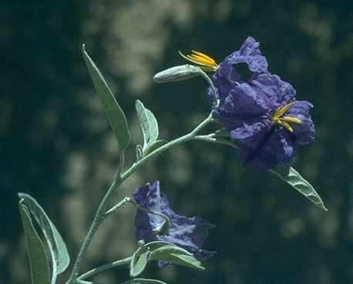

Brother Alfred Brousseau

© St. Mary’s College

@ CalPhotos

## Alternate Names

whiteweed, trompillo, white horsenettle

## Uses

Caution: Poisonous plant. Like most plants in the nightshade genus, silver-leaf nightshade is poisonous to cattle, but rarely consumed. *Solanum* is a huge genus with 1,200-1,800 species worldwide, but only 20 are found in Texas (all poisonous). The green portions of its domestic cousin, the potato, are also poisonous. Wildlife value of this plant is minimal.

## Status

Please consult the PLANTS Web site and your State Department of Natural Resources for this plant’s current status (e.g. threatened or endangered species, state noxious status, and wetland indicator values).

**Description***General*: Nightshade Family (Solanaceae). *Solanum elaeagnifolium,* is a deep-rooted, native perennial, which rarely reaches a height of more than 3 feet. Silver-leaf nightshade gets its name from the short, white or silvery pubescence (hairs or fuzz) on the leaves and stems. This plant is found throughout Texas. Plants growing in humid regions do not normally have spines or prickles, while those found in arid regions are more commonly prickly. Leaves are alternate and entire. Leaf margins are normally wavy. Flowers are typical of the nightshade family (potatoes, peppers, and tomatoes). *Solanum* is the genus of the domestic potato.

*Solanum dimidiatum* (western horse-nettle) is somewhat similar, but does not have the velvety appearance. Vegetatively, *Croton capitatus* (wooly croton, doveweed, goatweed), resembles silverleaf nightshade, though *Croton* is never armed. Unlike nightshade, *Croton* is very intolerant of shade.

## Distribution

This species is known from Washington and California to Maryland and Florida. For current distribution, please consult the Plant Profile page for this species on the PLANTS Web site.

**Establishment***Adaptation*: Silver-leaf nightshade is found on upland sites and appears to prefer loamy, droughty soils, but is found on virtually all soil types, except for deep sands. It is shade tolerant, becoming quite abundant under trees and beside farm buildings. Because the plant is poisonous and avoided by livestock, it tends to become more prevalent in overgrazed areas.

## Cultivars, Improved and Selected Materials (and area of origin)

These plant materials are readily available from commercial sources. Contact your local Natural Resources Conservation Service (formerly Soil Conservation Service) office for more information. Look in the phone book under ”United States Government.” The Natural Resources Conservation Service will be listed under the subheading “Department of Agriculture.”

**References**Davis, L. 2000. *Texas plant fact sheet: Solanum elaeagnifolium*. USDA, NRCS, Nacogdoches Technical Office #2, Nacogdoches, Texas.

USDA, NRCS 2000. *The PLANTS database*. <http://plants.usda.gov>. 001206. National Plant Data Center, Baton Rouge, Louisiana.

## Prepared By

# *Lee Davis*

USDA, NRCS, Nacogdoches Technical Office #2, Nacogdoches, Texas

## Species Coordinator

# *Lee Davis*

USDA, NRCS, Nacogdoches Technical Office #2, Nacogdoches, Texas

Edited 21may01 jsp; 14feb03 ahv; 060817 jsp

For more information about this and other plants, please contact your local NRCS field office or Conservation District, and visit the PLANTS Web site<<http://plants.usda.gov>> or the Plant Materials Program Web site <<http://Plant-Materials.nrcs.usda.gov>>

*The U.S. Department of Agriculture (USDA) prohibits discrimination in all its programs and activities on the basis of race, color, national origin, sex, religion, age, disability, political beliefs, sexual orientation, and marital or family status. (Not all prohibited bases apply to all programs.) Persons with disabilities who require alternative means for communication of program information (Braille, large print, audiotape, etc.) should contact USDA's* [*TARGET Center*](http://www.usda.gov/oo/target.htm) *at 202-720-2600 (voice and TDD).*

*To file a complaint of discrimination write USDA, Director, Office of Civil Rights, Room 326-W, Whitten Building, 14th and Independence Avenue, SW, Washington, DC 20250-9410 or call 202-720-5964 (voice or TDD). USDA is an equal opportunity provider and employer.*

*Read about* [*Civil Rights at the Natural Resources Convervation Service*](http://www.nrcs.usda.gov/about/civilrights/)*.*