

Plant Guide

# scarlet globemallow

***Sphaeralcea coccinea* (Nutt.) Rydb.**

Symbol = SPCO

Contributed by: Aberdeen Plant Materials Center and Idaho NRCS State Office

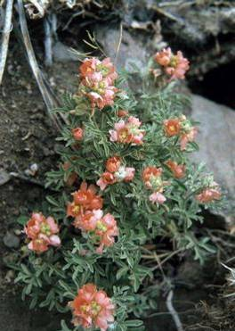

**Scarlet globemallow (Joy Viola, Northeastern University, Bugwood.org)**

**Alternate Names**

Red false mallow, copper mallow, cowboy’s delight

Uses

Scarlet globemallow provides good ground cover on disturbed sites. Although its value for erosion control is low to moderate, it is used in low rainfall area native seed mixtures to stabilize roadsides and other disturbed sites. Livestock commonly eat scarlet globemallow particularly when grasses are dormant. It provides important forage for pronghorn antelope; is rated as excellent forage for domestic sheep, deer, and bighorn sheep. Bison, prairie dogs, jack rabbits, and other small mammals utilize this species for forage. Some small birds eat scarlet globemallow fruits. Palatability is rated poor to good depending on the animal species, location, and season of use. Palatability is generally rated fair for cattle and elk and poor for horses.

Status

Consult the PLANTS Website and your State Department of Natural Resources for this plant’s current status (e.g. state noxious status).

Description

*General*: Mallow Family (Malvaceae).

Scarlet globemallow is a low-spreading, warm season, long-lived perennial forb to half-shrub. Stems emerge from a woody caudex located just under the soil surface and reach a height of 10-40 cm (4-16 inches). Plants are densely covered with stellate hairs. Leaves are alternate, palmately lobed, 1-3.7 cm long and 1-5cm wide. The deep orange to pinkish colored flowers are clustered in dense, short racemes. There are 5 distinct petals, 5 united sepals, and 5 to numerous styles. Stamens are joined by their stalks into a tube and several pistils united in a ring. The fruit is an indehiscent schizocarp with 1-seeded carpels. Plants are rhizomatous. The main taproot is woody and stout and may remain un-branched for 3 feet (90cm) before it divides into lateral roots. Growth begins in March and April, flowering in May to July and seed matures unevenly between July and August throughout much of its range. There are approximately 500,000 seeds per pound. The seed has a hard seed coat.

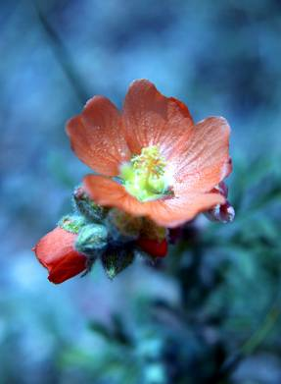**National Park Service photo by Jim Pisarowicz**

**Distribution**

Scarlet globemallow is most commonly found in the low rainfall areas of the Intermountain West, Great Basin, Rocky Mountains and Great Plains regions of the United States and Canada.

**Habitat**

Scarlet globemallow grows in desert, semi-desert, prairies, grasslands, scrub, pinyon-juniper, and sagebrush plant communities and also often on dry roadsides, disturbed areas and dry slopes. It is adapted to a wide range of soil types from sandy to clay loams to gravelly to alkaline and moderately saline soils, but it is not generally found on sodic soils. It is extremely drought tolerant and does not tolerate shady conditions. It grows at elevations from 3,500 to 9,000 feet (1,067-2,743 m).

Adaptation

This species is adapted to well-drained soils with a pH range of 5.0 to 8.0. For xeriscaping and low water-use gardening, the species is recommended for use in USDA hardiness zones 6-8 in areas receiving 6 to 10 inches or more annual precipitation.

Management

When planted in a native reclamation mix, scarlet globemallow should be a minor component of the mixture and establishing plant community. Therefore, management should be based on other key species in the established plant community. Grazing on seeded lands should be deferred for at least two growing seasons to allow full stand establishment.

Pests and Potential Problems

Information on pests and potential problems of scarlet globemallow is limited. Grasshoppers will eat scarlet globemallow but it is unpalatable to mormon crickets and appears to not be affected by army cutworm infestations on rangeland. In seed increase fields in western Colorado, two species of weevils were identified in the field. *Anthonomus sphaeralcea* (*Sphaeralcea* weevil) was the dominant species of weevil and an unidentified *Apion* sp. was also present. Weevils feed on developing seed pods and the potential for damage is high. Any insecticide applications should be carefully considered and precautions taken to protect pollinators. There are no known diseases that affect scarlet globemallow.

**Seed and Plant Production**

Fields for seed production can be established by transplanting greenhouse-grown containerized stock or from direct seeding. Direct seeding should take place in the fall to allow for natural stratification of the seed. Seed germination can be increased by acid or mechanical scarification. The pure stand seeding rate is 2 pounds PLS per acre. When planting as part of a seed mix, adjust the rate to the percentage desired in the mix. Seed should not be planted approximately 1/8 inch deep and no deeper than 1/4 inch.

For seed production, the seeding rate is 20 to 50 PLS per linear foot of row. Row spacing should be 28-36 inches. Irrigation may be needed if planting in areas with less than 16 inches of annual precipitation. Two irrigation applications are usually needed; once in the spring and then during the seed ripening phase. Scarlet globemallow is pollinated by insects, so the use of insecticides should be limited especially during flowering. Bees of the genus *Diadaysia* have been observed pollinating scarlet globemallow. Seed may be harvested mechanically or by hand stripping and seed yields range from 75-100 pounds per acre (34-45 kg/ha). Harvest seed when the lower capsules begin to dry. Care should be used when handling seed because the stellate hairs on the seed can be a severe eye irritant.

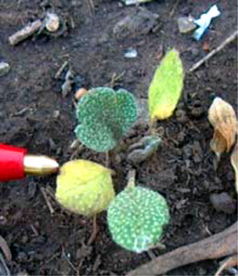

**Scarlet globemallow seedling (National Park Service)**

Cultivars, Improved, and Selected Materials (and area of origin)

Wildland harvested seed is available through commercial sources. The Agricultural Research Service released Pre-variety Selected Class ARS-2936 Scarlet Globemallow in 1993. The original collection was made in northern Idaho in 1987 and was selected for forage yield, spread from rhizomes and relatively high palatability. Small seed samples are available for seed increase or research.

References

Arches National Park. Scarlet Globemallow. National Park Service. http://www.nps.gov/arch/naturescience/htm

(accessed 4 Feb 2009).

Davis, R.J. 1952. Flora of Idaho. WM. C. Brown Company. Dubuque, Iowa. 828 p.

Hammon, B. Western Colorado Entomology. Pests Affecting Native Plant Seed Production. The Sphaeralcea Weevil. http://wci.colostate.edu/Assests/html/Spco.html

(accessed 4 Feb 2009).

Page, R., D. Goodwin and N. West. 1966. Germination requirements of Scarlet Globemallow. Journal of Range Management (19) p145-146.

Range Plants of Utah. Scarlet Globemallow. Utah State University. http://extension.usu.edu/range/forbs/scarletglobemall ow.htm (accessed 15 Jan 2009).

Rumbaugh, M., B. Pendery, H. Mayland and G. Shewmaker. 1993. Registration of ARS-2936 Scarlet Globemallow. Crop Science (33) 1106-1107.

Stevens, R., K. Jorgensen, S. Young, S. Monsen. 1996. Forb and Shrub Seed Production Guide for Utah. Utah State University Extension. 51p.

USA National Phenology Network. *Sphaeralcea coccinea*. http://www.usanpn.org

(accessed 20 Jan 2009).

Tollefson, J. 2006. Sphaeralcea coccinea. In: Fire Effects Information System. USDA-FS-RMRS, FSL. http://www.fed/us/database/feis/plants.html

(accessed 15 Jan 2009).

USDA Natural Resources Conservation Service. 2008. The PLANTS database, version 3.5. URL: http://plants.usda.gov

(accessed 04 Feb 2009). Baton Rouge, LA. National Plant Data Center.

Prepared By

Loren St. John, USDA NRCS Plant Materials Center, Aberdeen, ID

Dan Ogle, USDA NRCS Idaho State Office, Boise, ID

Species Coordinator

Dan Ogle, USDA NRCS Idaho State Office, Boise, ID

### Citation

St. John, L., D.G. Ogle, D. Tilley. 2010. Plant Guide for Strawberry Clover (*Trifolium fragiferum*). USDA-Natural Resources Conservation Service, ID Plant Materials Center, Aberdeen, ID 83210.

Published March, 2009

Edited: 020609lws; 020609dgo

For more information about this and other plants, please contact your local NRCS field office or Conservation District at <http://www.nrcs.usda.gov/> and visit the PLANTS Web site at <http://plants.usda.gov/> or the Plant Materials Program Web site <http://plant-materials.nrcs.usda.gov>.

PLANTS is not responsible for the content or availability of other Web sites.

**USDA IS AN EQUAL OPPORTUNITY PROVIDER AND EMPLOYER**