

Plant Guide

# Gierisch’s globeMallow

***Sphaeralcea gierischii* N.D. Atwood and S. Welsh**

Plant Symbol = SPGI2

*Contributed by*: USDA NRCS Idaho and Utah Plant Materials Program

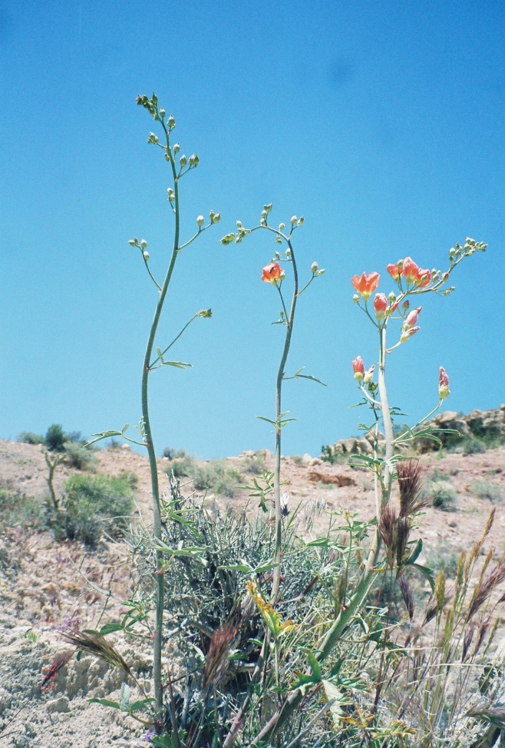**Gierisch globemallow (*Sphaeralcea gierischii*). Photo courtesy of USID-FWS**

### Alternate Names

Gierisch’s globemallow

### Uses

There are no known human uses of Gierisch globemallow. It is palatable to livestock and wildlife, especially in drought years when other forages are reduced or unavailable (USDI-FWS, 2010).

### Status

Gierisch globemallow became a candidate for federal protection in 2008 (USID-FWS, 2008). Listing is considered warranted; however, higher priority

listing actions have precluded the proposed and final listing rules for the species (USDI-FWS, 2010). The species has a listing priority of 2 (high magnitude with imminent threat).

Consult the PLANTS Web site and your State Department of Natural Resources for this plant’s current status (e.g., threatened or endangered species, state noxious status, and wetland indicator values).

### Description

*General*: Mallow family (Malvaceae). Gierisch globemallow is a perennial forb growing from a woody caudex, with the inflorescence reaching 40 to 100 cm (16 to 39 in) tall. The stems are often dark reddish purple. The leaves are 3 to 5 lobed, bright green, and oval shaped in outline. The leaf base is often heart shaped. The blades are 1.2 to 4 cm (0.5 to 1.6 in) long and 1 to 5 cm (0.4 to 2.0 in) wide. The flowers are large with orange petals, 15 to 25 mm (0.6 to 1.0 in) long (Welsh et al., 2003).

*Distribution*:

Gierisch globemallow is known from nine populations totaling approximately 60 acres. Eight populations are located in northern Mohave County, Arizona, and one population is in Washington County, Utah. There are between 7,000 and 12,000 individuals in Arizona, and the Utah population is believed to be approximately 5,000 to 8,000 individuals (USDI-FWS, 2010).

For current distribution, consult the Plant Profile page for this species on the PLANTS Web site.

*Habitat*:

Gierisch globemallow is found in warm desert shrub plant communities of the northern Mohave Desert at approximately 1,090 m (3,576 ft) (Welsh et al., 2003).

**Adaptation**

Gierisch globemallow is an obligate gypsophile (a plant limited to gypsum based soils) restricted to outcrops of the Harrisburg Member of the Kaibab Formation. The area receives approximately 13 to 20 cm (5 to 8 in) of annual precipitation (WRCC, 2011).

### Management

Gierisch globemallow is threatened by habitat destruction due to gypsum mining, and habitat degradation from off road vehicle (ORV) use and livestock grazing. Habitat for Gierisch globemallow continues to be destroyed by gypsum mining, and reclaimed sites following mining activities may not provide suitable habitat.

### Pests and Potential Problems

Gierisch globemallow is palatable to wildlife and livestock. The flowering stems are grazed primarily in drought years, reducing seed production and recruitment opportunities (USDI-FWS, 2010).

### Environmental Concerns

Climate change could negatively impact this and other species with restricted distributions.

### Seed and Plant Production

Life history and germination studies are needed for this species. Reproduction, pollination systems and seed dispersal mechanisms are unknown.

### References

U.S. Fish and Wildlife Service. 2008. Endangered and threatened wildlife and plants; review of native species that are candidates for listing as endangered or threatened; annual notice of findings on resubmitted petitions; annual descriptions of progress on listing actions. In: Federal Register. 73(238): 75176-75178.

U.S. Fish and Wildlife Service. 2010. Species assessment and listing priority assignment for Gierisch globemallow (*Sphaeralcea gierischii*). U.S. Fish and Wildlife Service. Albuquerque, New Mexico. 12p.

Welsh, S.L., N.D. Atwood, S. Goodrich, and L.C. Higgins. 2003. A Utah Flora. Third Edition, revised. Brigham Young University, Provo, UT.

Western Regional Climate Center. 2011. Online. http://www.wrcc.dri.edu/index.html. Accessed January 13, 2011.

**Prepared By**:

*Derek Tilley*; USDA NRCS Plant Materials Center, Aberdeen, Idaho.

*Loren St. John*, USDA NRCS Plant Materials Center, Aberdeen, Idaho.

*Dan Ogle*, USDA NRCS, Boise, Idaho.

### Citation

Tilley, D., L. St. John and D. Ogle. 2011. Plant guide for Gierisch globemallow (*Sphaeralcea gierischii)*. USDA-Natural Resources Conservation Service, Idaho Plant Materials Center. Aberdeen, ID.

Published Jan 2011

Edited: 18Jan2011djt; 18jan2011ls; 18jan2011dgo

For more information about this and other plants, please contact your local NRCS field office or Conservation District at http://www.nrcs.usda.gov/ and visit the PLANTS Web site at http://plants.usda.gov/ or the Plant Materials Program Web site http://plant-materials.nrcs.usda.gov.

PLANTS is not responsible for the content or availability of other Web sites.

**USDA IS AN EQUAL OPPORTUNITY PROVIDER AND EMPLOYER**