

Plant Guide

# Last chance townsendia

## Townsendia aprica S.L. Welsh & Reveal

### Plant Symbol = TOAP

#### Contributed by: USDA NRCS Idaho Plant Materials Program

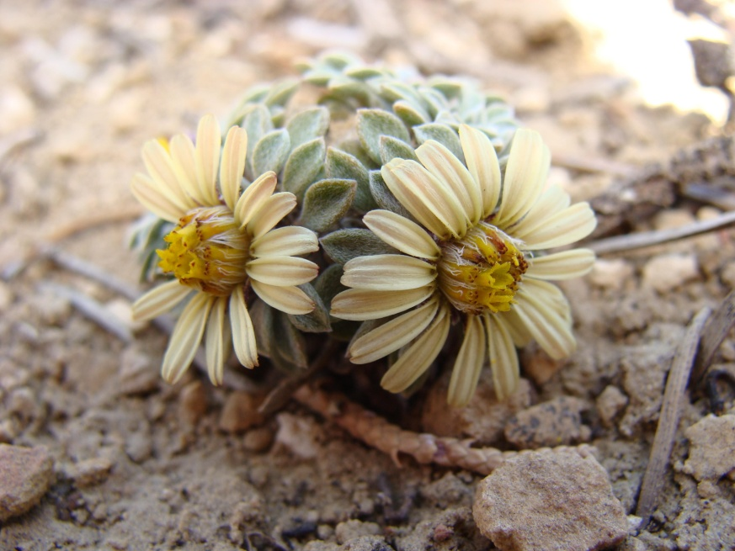

Figure . Last Chance Townsendia (Townsendia aprica). Photo by Megan Robinson. Used with permission.

#### **Alternate Names**

Last Chance Townsend daisy

#### **Uses**

Last Chance Townsendia is a recently discovered forb of extremely limited distribution. It has no known human or wildlife associated uses.

#### **Status**

Last Chance Townsendia was listed as a threatened species on August 21, 1985 (USDI FWS 1985). It has been given a recovery priority of 5C indicating a high degree of threat and a low recovery potential (USDI FWS 1993).

Consult the PLANTS Web site and your State Department of Natural Resources for this plant’s current status (e.g., threatened or endangered species, state noxious status, and wetland indicator values).

#### **Description**

*General*: Sunflower family (Asteraceae). Last Chance Townsendia is a small mound forming perennial forb. The plant arises from an underground base and branches to form a dense mat from 5 to 10 cm (2 to 4 in) across with the flowering heads formed tight against the leafy mound. The ray flowers (petals) are yellow to golden on the upper surface and purplish and glandular below. The disk flowers are yellow. Achenes are small and hairy with a short pappus of barbed capillary bristles (Welsh et al. 2003). The leaves are hairy, 7 to 13 mm (0.25 to 0.43 in) long and 1 to 3.5 mm (0.04 to 0.14 in) wide and broadest near the tip.

*Distribution*:

This species is endemic to a small band about 8 km (5 mi) wide and 48 km (30 mi) long in South Central Utah. Populations are known from the western edge of the San Rafael Swell, west to near Fremont Junction in extreme eastern Sevier county and south to Hartnet Draw in Wayne County. Small isolated populations are known outside of this area of but in close proximity to the main population group. In 1993 there were 15 known populations with an estimated 6,000 individual plants (USDI FWS 1993). Clark and Groebner (2000) reported an additional 11 new populations with approximately 650 total individuals. For current distribution, consult the Plant Profile page for this species on the PLANTS Web site.

*Habitat*:

Last Chance Townsendia is known to inhabit saltbush and pinyon-juniper plant communities on clay or clay-silt exposures of the Mancos, Morrison, Summerville and Entrada Formations (USFWS 1993). Species known growing in association with Last Chance Townsendia include galleta (*Hilaria jamesii*), blue grama (*Bouteloua gracillis*), black sagebrush (*Artemisia nova*), shadscale (*Atriplex confertifolia*) and Indian ricegrass (*Achnatherum hymenoides*). Populations occur between 1,800 and 2,400 m (6,000 to 8,000 ft) in elevation (Clark and Groebner 2000).

#### **Adaptation**

Last Chance Townsendia grows in soils derived from shale lens of the Mancos and other formation with a very fine silt texture that are highly saline or sodic. The unique soil characteristics create small islands of habitable space in vast areas of otherwise uninhabitable soils. These soil conditions have produced habitat for several other endemic plant species growing in the same range as Last Chance Townsendia including *Pediocactus despainii, Sclerocactus wrightiae, Schoenocrambe barnebyi, Pediocactus winkleri, Gilia caespitosa* and *Gilia tenuis*. All of these species are either listed as federally endangered or as candidate species (USFWS 1993).

#### **Establishment**

Last Chance Townsendia has been propagated and grown to flower and seed under greenhouse conditions (CPC 2010); however no propagation protocols are available.

#### **Management**

The severely limited distribution and range of Last Chance Townsendia make it highly vulnerable to a variety of threats. Genetic analysis revealed bottlenecks in more than half of the populations of Last Chance Townsendia (Jennings, 2000). The loss of any population would thus be severely detrimental to the overall health of the species. The greatest current threats come from mineral and energy development, road building and livestock trampling (USFWS 1993). Most of the federally owned habitat of Last Chance Townsendia is or has been under lease for coal or oil and gas production (USFWS 1993).

Current management strategies for Last Chance Townsendia focus on regulating and managing mineral development activities, developing off-road vehicle use plans and managing livestock use of currently occupied Townsendia habitat (USFWS 1993).

#### **Pests and Potential Problems**

There are no known pests or potential problems associated with Last Chance Townsendia.

#### **Environmental Concerns**

There are no known environmental concerns associated with Last Chance Townsendia.

#### **Seed and Plant Production**

Flowering takes place from April to May with fruit and seed ripening occurring from May to June. This species is primarily self-incompatible with outcrossing being the primary means of reproduction (Tepedino et al. 2004). Several native solitary bees have been found to be important pollinators. Multiple species of bees in the genus *Osmia* and the ground-nesting *Synhalonia fulvitarsis* were observed as the primary visitors to Last Chance Townsendia flowers (Tepedino et al. 2004).

#### **References**

##### Center for Plant Conservation. 2010. *Townsendia aprica*, plant profile. [Online]. Available at http://www.centerforplantconservation.org/collection/cpc_viewprofile.asp?CPCNum=4300 (accessed 8 Apr 2010). Missouri Botanical Garden, St. Louis (MO.

Clark, D.J., Groebner, C.M. 2000. Determining Habitat Potential and Surveying for Nine Rare Plant Species in South-Central Utah. Southwestern rare and endangered plants: proceedings of the third conference; September 25-28; Flagstaff, AZ. In: Maschinski, Joyce; Holter, Louella, editors. 2000. U.S. Department of Agriculture, Forest Service, Rocky Mountain Research Station. Fort Collins, CO (Proceedings RMRS-P-23). p 38-43.

##### Jennings, L. 2000. Genetic variation and ecological differentiation between two southern Utah endemics: U.S. federally threatened *Townsendia* *aprica* and a closely related congener, *T. jonesii* var. *lutea*. Master’s Thesis. University of British Columbia, Canada.

##### Tepedino, V.J., Sipes, S.D., Griswold, T.L. 2004. Reproductive biology of a rare spring composite of the Colorado Plateau: Townsendia aprica. Western North American Naturalist. 64(4): 465-470.

##### USDI Fish and Wildlife Service. 1985. Endangered and threatened wildlife and plants: rule to determine *Townsendia aprica* (Last Chance Townsendia) to be a threatened species. Federal Register. 50 (162): 33734-33737.

USDI Fish and Wildlife Service. 1993. Last Chance Townsendia (*Townsendia aprica*) recovery plan. U.S. Fish and Wildlife Service, Denver, CO. 18 pp.

Welsh, S.L., N.D. Atwood, S. Goodrich, and L.C. Higgins. 2003. A Utah Flora. Third Edition, revised. Brigham Young University, Provo, UT.

#### **Prepared By**

*Derek Tilley*; USDA NRCS Plant Materials Center, Aberdeen, Idaho.

*Loren St. John*, USDA NRCS Plant Materials Center, Aberdeen, Idaho.

*Dan Ogle*, USDA NRCS State Office, Boise, Idaho.

#### **Citation**

Tilley, D., St. John, L. and D. Ogle. 2010. Plant guide for Last Chance Townsendia (*Townsendia aprica*). USDA-Natural Resources Conservation Service, Idaho Plant Materials Center. Aberdeen, ID.

Published: November 2010

Edited: 12Apr2010 djt; 12Apr2010dgo; 12Apr2010lsj

For more information about this and other plants, please contact your local NRCS field office or Conservation District at <http://www.nrcs.usda.gov/> and visit the PLANTS Web site at <http://plants.usda.gov/> or the Plant Materials Program Web site <http://plant-materials.nrcs.usda.gov>.

PLANTS is not responsible for the content or availability of other Web sites.

**USDA IS AN EQUAL OPPORTUNITY PROVIDER AND EMPLOYER**