|  |  |
| --- | --- |
| **Natural Resources Conservation Service** | Plant Guide |

## American Vetch

Vicia americana

Muhl. ex Willd.

Symbol =VIAM

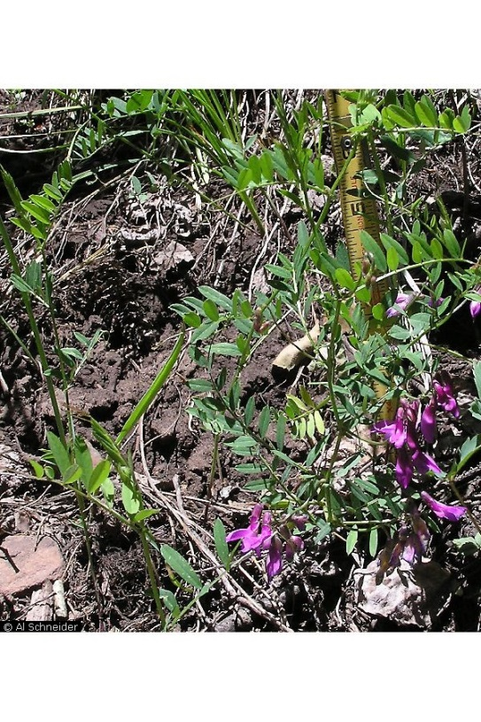

American vetch. Photo ©Al Schneider, www.swcoloradowildflowers.com, used with permission.

### Alternate Names:

Purple vetch

American deer vetch

Stiff-leaf vetch

**Scientific Names:**

*Vicia americana* var. *americana*

## *Vicia americana* var. *minor* Hook

### Description

American vetch is a native rhizomatous, single-stemmed, climbing perennial forb that measurers up to 16 inches tall. The 8 to 16 leaflets are broadly elliptical to linear measuring 0.4 to 1.5 inches in length. The lower stipules are deeply lacerated, often appearing star-like (Isley 1998). The inflorescence is a raceme with up to 10 purple flowers approximately 0.5 to 1.5 inches long. Flowering occurs from May to August with the seeds maturing around one month after pollination (Voss, 1985; Wasser, 1982). The fruit is a 1 to 1.5 inch long pod bearing two to several pea-like seeds. There are approximately 33,000 seeds/lb (USDA-NRCS, 2015). American vetch has a moderate to deeply-branched taproot which reaches a maximum depth of 40 inches. The deep tap root allows for the plant to exhibit characteristics of severe drought tolerance.

PLANTS currently recognizes three subspecies of American vetch: ssp. *americana*, ssp. *minor*, and ssp. *mexicana* (USDA-NRCS, 2015). *V. a.* ssp*. americana* bears more flowers, (5-9) per inflorescence, and is more sprawling with prehensile, often branched, tendrils. *V. a. minor* has 3 to 4 flowers per inflorescence, erect stems and non-prehensile tendrils (Isley, 1998). Subspecies mexicana has calyx teeth all equal, differing from *V. a*. ssp. *americana* which has the upper two calyx teeth much shorter than the lower three (Gunn, 1979).

*Distribution*: American vetch is widely distributed west of the Mississippi River, in the northeastern United States, Alaska, and parts of Canada (Stubbendiek and Conard, 1989). Mexican American vetch (*V. a.* ssp*. mexicana*) is restricted to the Sierra Leon Mountains in Mexico and is geographically separated from *V. a.* ssp. *americana* (Gunn, 1979). *V. a.* ssp*. minor* is found primarily in the short grass prairie but extends into the Intermountain region. *V. a.* ssp. *americana* covers the range of the species (Isley, 1998).

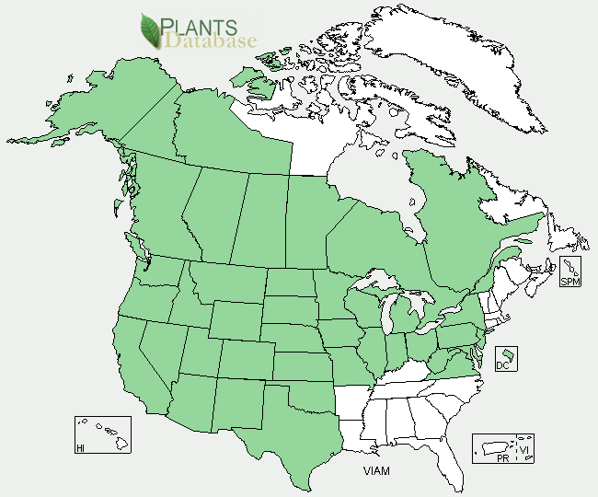

American vetch distribution from USDA-NRCS PLANTS Database.

*Habitat*:

American vetch grows in a wide variety of habitats. It is typically found in moist areas, including swampy woods, mixed forests, sheltered canyons, and clearings, but can also be found in arid locations on hilltops or valley badlands (Cronquist et al, 1989).

**Adaptation**

American vetch is drought tolerant and has the ability to fix nitrogen into the soil (Stubbendiek and Conard, 1989). American vetch occurs frequently on slightly saline to moderately acidic soils of medium to coarse texture, but can also be found on clays. In western mountains, American vetch is usually more abundant in deep porous loams that are rich in organic matter. American vetch is adapted to a wide range of plant communities from arid to mesic. It can be found growing in sites receiving as little as 10 inches mean annual precipitation to as much as 50 or more inches (Tilley et al, 2013).

### Uses

*Restoration*: Relatives of American vetch are often used as cover crops. Planting American vetch in disturbed sites can help remediate the habitat and restore disturbed rangelands by providing a natural source of nitrogen (Kirk, and Belt, 2010). American vetch has been successfully seeded in disturbed alpine rangelands (Brown et al, 1979). American vetch is one of the few non-toxic native legumes adapted to sites receiving less than 12 inches mean annual precipitation, making it a valuable option for native restoration seedings on arid rangeland (Tilley et al, 2013).

*Wildlife*: American vetch provides high quality, although limited, grazing and fodder for game birds, small mammals, black bear, grizzly bear, and mule deer (Coladonato, 1993). Domesticated animals such as horses, sheep, and cattle will browse on the aerial portions of American vetch. It is considered preferred forage in spring and summer and desired in fall and winter for elk, deer, and antelope (Ogle and Brazee 2009).

*Pollinator*: American vetch is an important species for native pollinators. It is a known larval host plant for the western blue tailed butterfly (*Everes amyntula*) (Stout, 2015). American vetch has showy flowers and can be included in wildflower plantings and pollinator gardens.

### *Ethnobotany:*Indigenous peoples used the seed leaves and seeds of American vetch as a source of food (Castetter, 1935). A poultice of the leaves has been used to treat aliments such as spider bites, and an infusion of the plant was used as an eyewash (Vestal, 1952). American vetch has also been used as a panacea, an aphrodisiac, and a good luck charm. Native Americans would get horses to smoke the plant to increase the horses’ endurance (Wyman, 1951).

### Status

*Threatened or Endangered*: American vetch is listed as endangered or extirpated in Maryland (USDA-NRCS, 2015).

### Planting Guidelines

The full stand seeding rate for approximately 25 seeds/ft² is 33 PLS lbs/ac (Tilley et al, 2013). American vetch should be seeded in the fall to a depth of 1 to 2 inches. Unscarified seed will germinate in approximately 14 days. Scarification decreases the overall seed germination time between 3 to 7 days; however the scarification process does not improve the overall germination rate (Rose, 1998). The climbing nature of this plant should be considered when planting. Sowing the plant in combination with more upright growing species will ensure a climbing matrix to support the vetch. Vetch cover crops, including hairy vetch (*V. villosa*) and common vetch (*V. sativa*) are seeded at 20 to 40 pounds per acre.

### Management

American vetch could be used as a minor component of restoration seed mixtures. Management strategies should be based on the key species in the established plant community. Grazing should be deferred on seeded lands for at least two growing seasons to allow for full stand establishment.

### Pests and Potential Problems

*Vicia* spp. are susceptible to several species of *Botrytis* fungus. Vetch seeds are also susceptible to vetch bruchid, or vetch weevil (*Bruchus* sp*.*) injury (Bridwell, 1933).

### Environmental Concerns

American vetch is a natural component of many native plant communities in North America. There are no known environmental concerns regarding American vetch.

### Seeds and Plant Production

Hand harvesting of wildland populations with clippers or shears is the most common means of seed collection. Due to its low and twining growth habit, mechanical and vacuum harvesting are ineffective (Burton, 2015). Seed production fields may be harvested mechanically. It is suggested that a nurse crop such as alfalfa be used to elevate American vetch for easier harvesting. Species selected should have significantly dissimilar seed size and weight for easy separation (Burton, 2015).

### Cultivars, Improved, and Selected Materials (and area of origin)

There are no recommended cultivars or selected materials for American vetch at this time. Seed source should be selected based on the local climate, resistance to local pests, and intended use. Consult with your local land grant university, local extension, or local USDA NRCS office for recommendations on adapted cultivars or germplasms for use in your area.

**Literature Cited**

Bridwell, J.C. (1933). The hairy-vetch bruchid, *Bruchus brachialis* Fahraeus, in the United States. Journal of Agricultural Research, 46, 739−751.

Brown, Ray W.; Johnston, Robert S. 1979. Revegetation of disturbed alpine rangelands. In: Johnson, D. A., ed. Special management needs of alpine ecosystems. Range Science Series No. 5. Denver, CO: Society for Range Management: 76-94.

Burton, C.M., Burton, P.J. 2015. A Manual for Growing and Using Seed from herbaceous Plants Native to the Northern Interior of British Columbia. Symbios Research & Restoration, Smithers, BC. Accessed online: http://www.env.gov.bc.ca/wld/natplant_manual_intropg.htm.

Castetter, Edward F. 1935 Ethnobiological Studies in the American Southwest I. Uncultivated Native Plants Used as Sources of Food. University of New Mexico Bulletin 4(1):1-44.

Coladonato, Milo. 1993. *Vicia americana*. In: Fire Effects Information System, [Online]. U.S. Department of Agriculture, Forest Service, Rocky Mountain Research Station, Fire Sciences Laboratory (Producer). Accessed online: http://www.fs.fed.us/database/feis/ [2015, March 30].

#### Cronquist, A., Holmgren, A.H., Holmgren N.H., Reveal, J.L., and P.K. Holmgren. 1989. Intermountain Flora: Vascular Plants of the Intermountain West, U.S.A. Volume 3, Part B. Fabales. The New York Botanical Garden. Bronx, New York. 279p.

#### Gunn, C.R. 1979. Genus Vicia with notes about tribe Vicieae (Fabaceae) in Mexico and Central America. US Department of Agriculture, Technical Bulletin No. 1601. 41p.

#### Kirk, S. and Belt, S. 2010. Plant fact sheet for American Vetch (Vicia americana), USDA, Natural Resources Conservation Service, Norman A. Berg National Plant Materials Center, Beltsville, MD 20705

Isley, D. 1998. Native and naturalized Leguminosae (Fabaceae) of the United States (exclusive of Alaska and Hawaii) Provo, UT: Brigham Young University. 941-944p.

Ogle, D.G. and B. Brazee. 2009. Technical Note 3. Estimating Initial Stocking Rates. NRCS. Boise, ID. 39p.

Rose, R., Chacuhlski, C. and Haase, D. 1998. Propagation of Pacific Northwest Native Plants. Oregon State University Press. Corvallis, OR. 1998.

Stubbendiek, J. and Conard, E. C. 1989. Common legumes of the Great Plains: an illustrated guide. Lincoln, NE: University of Nebraska Press. 330 p.

Tilley, D., Taliga, C., Burns, C. and L. St. John. 2013. Technical Note 2c. Plant Materials for Pollinators and Other Beneficial Insects in Eastern Utah and Western Colorado. NRCS. Boise, ID. 54p.

USDA-NRCS. 2015. The PLANTS Database (http://plants.usda.gov, 31 March 2015). National Plant Data Team, Greensboro, NC 27401-4901 USA.

Vestal, P. A. 1952. The Ethnobotany of the Ramah Navaho. Papers of the Peabody Museum of American Archaeology and Ethnology 40(4):1-94.

Voss, Edward G. 1985. Michigan flora. Part II. Dicots (Saururaceae--Cornaceae). Bull. 59. Bloomfield Hills, MI: Cranbrook Institute of Science; Ann Arbor, MI: University of Michigan Herbarium. 724p.

Wasser, C. H. 1982. Ecology and culture of selected species useful in revegetating disturbed lands in the West. FWS/OBS-82/56. Washington, DC: U.S. Department of the Interior, Fish and Wildlife Service. 347p.

Welsh, S.L., Atwood, N.D., Goodrich, S., and L.C. Higgins. 2003. A Utah Flora. Brigham Young University. Provo, Utah. 912p.

Wyman, L. C. and S. K. Harris. 1951. The Ethnobotany of the Kayenta Navaho. Albuquerque, NM. The University of New Mexico Press.

### Citation

Allen, J. and D. Tilley. 2014. Plant Guide for American Vetch (Vicia americana). USDA-Natural Resources Conservation Service, Idaho Plant Materials Center. Aberdeen, Idaho 83210.

Published

April 2015

Edited:

For more information about this and other plants, please contact your local NRCS field office or Conservation District at http://www.nrcs.usda.gov/ and visit the PLANTS Web site at http://plants.usda.gov/ or the   
Plant Materials Program Web site:

http://plant-materials.nrcs.usda.gov

PLANTS is not responsible for the content or availability of other Web sites.

***Helping People Help the Land***

**USDA IS AN EQUAL OPPORTUNITY PROVIDER AND EMPLOYER**