|  |  |
| --- | --- |
| **Natural Resources Conservation Service** | Plant Guide |

# Desert Zinnia

## Zinnia acerosa (DC.) A. Gray

Plant Symbol =ZIAC

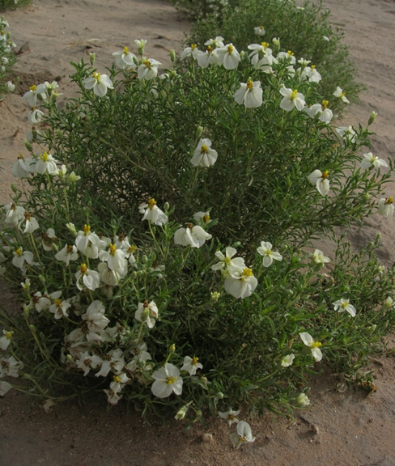Figure 1: Desert zinnia (Photo by Mary Hershdorfer, USDA-NRCS. Tucson Plant Materials Center)

### Alternate Names

*Common Names:* dwarf zinnia, wild zinnia, and spiny leaf zinnia

*Scientific Names: Zinnia pumila*

### Description

*General*: Desert zinnia is a small, shrub-like, native, perennial forb. The flowers consist of 5 to 7 off-white ray flowers and 8 to 13 yellow disc flowers. The ray flowers are lightly dentate (toothed) at the tips. Desert zinnia may flower from spring to fall when moisture is available. It may grow up to 10 inches in height (Shreve and Wiggins, 1964; Kearney and Peebles, 1969; Torres, 1963).

*Distribution*: Desert zinnia is found in Arizona, New Mexico, Texas, Sonora, Chihuahua, Zacatecas, Nuevo Leon and San Luis (Torres, 1963). For current distribution, please consult the Plant Profile page for this species on the PLANTS Web site.

*Habitat*: Desert zinnia is common in dry mesas and arid, rocky slopes at elevations ranging from 2,500 to 6,500 feet (Kearney and Peebles, 1969; Havens et al., 1982).

***Adaptation***

Desert zinnia is adapted to calcareous or alkaline soils with high soil pH (Kearney and Peebles, 1969). It does well on loose slopes. It will endure full sun or part shade.

### Uses

### Desert zinnia may be used in restoration of disturbed areas, wildlife and pollinator habitat improvement, and to increase plant diversity on adapted areas (Garner and Hershdorfer, 2008; USDA-NRCS, 2012).

### Ethnobotany

*Zinnia acerosa* has been reported to have medicinal use as an external antirheumatic aid. A crushed plant paste mixed with salt is used to alleviate swelling or aches (Swank, 1932).

### Status

*Threatened or Endangered*: No

*Wetland indicator:*  Obligate Upland -UPL. (USDA-NRCS, 2014).

Please consult the PLANTS Web site (<http://plants.usda.gov/>) and your State Department of Natural Resources for this plant’s current status (e.g., threatened or endangered species, state noxious status, and wetland indicator values).

### Planting Guidelines

Desert zinnia may be direct seeded by broadcasting or drill seeding. It may also be propagated in plugs or pots and transplanted. Desert zinnia has approximately 760,000 seeds per pound. Seed is produced from summer to fall, but more consistently in the fall. The broadcast seeding rate is 2.2 PLS (pure live seed) pounds per acre. The drill seeding rate is 1.1 PLS pounds per acre (USDA-NRCS, 2012; USDA-NRCS, 2004).

Seed should be planted onto a firm, weed-free seedbed. Broadcast seeding should be followed with a cultipacker or harrow to provide seed with a shallow covering of soil. When used as part of a mix, the seeding rate should be adjusted to the desired percentage of the mixture (USDA-NRCS, 2004; USDA-NRCS, 2012).

Desert zinnia should be propagated in containers filled with a well-drained soil mix. Seed sowed into containers should be covered with approximately ½ inch of soil (USDA-NRCS, 2012).

### Management

Desert zinnia may be mowed, and it seems to tolerate burning. Pre-emergent herbicide such as oryzalin may be used to control weeds in production fields. The plants benefit from light fertilization. Irrigation should be applied sparingly and only when the plants are actively growing. It may be killed by applying glysophate when foliage is actively growing (USDA-NRCS, 2012).

### Pests and Potential Problems

Desert zinnia has no serious pest problems. It may be consumed by rabbits or ants when young. It is adapted to arid conditions and is thus susceptible to root rot if over watered. During periods of high rainfall, it may also be infected by the flower blight*.* (Colbaugh et al., 2001).

### Environmental Concerns

*Zinnia acerosa* does not appear to have any negative impacts that could become an environmental concern.

Please consult with your local NRCS Field Office, Cooperative Extension Service office, state natural resource, or state agriculture department regarding its status and use. Weed information is also available from the PLANTS Web site at http://plants.usda.gov/.

### Seeds and Plant Production

Desert zinnia may be produced under typical crop conditions. When harvesting with a flail-vac brush seed stripper it may be necessary to space rows to allow the flail-vac to get close to the ground. This may be accomplished by skipping a row where the edge of the flail vac will pass or by using wide spacing on beds. Seed loss may be a concern when harvesting with a flail vac. Other harvest methods may prove more efficient (USDA-NRCS, 2012).

Although desert zinnia flowers from spring to fall, the most productive seed harvest is in the fall. Desert zinnia is a prolific seed producer. Seed produced under crop conditions seem to have appreciably higher percent germination than those collected from the wild (Garner and Hershdoerfer, 2008; USDA-NRCS, 2012).

### Cultivars, Improved, and Selected Materials (and area of origin)

Batamote Germplasm desert zinnia was developed by the Tucson Plant Materials Center for use in Major Land Resource Area 41 (EPA Level 3 Ecoregion 79) of southeastern Arizona. It is a composite of 9 accessions collected from native desert zinnia stands in southeastern Arizona (Garner and Hershdoerfer, 2008; USDA-NRCS, 2012).

**Literature Cited**

Colbaugh, W.A., W.A. Mackay and S. George. 2001. Alternaria alternata flower blight of Zinnia acerosa in Texas. Plant Disease. 85: 228.

Garner, E.R., and M. E. Hershdoerfer. 2008. Notice of Release of Batamote Germplasm Desert Zinnia. USDA-NRCS, Tucson Plant Materials Center. Tucson, AZ 85705.

Havens Y. H., J.S. Horton, M.S. James, C.W. Renney, A. P. Thatcher, and E. M. Shmutz. 1982. Landscaping with Native Arizona Plants. Soil Conservation Society of America, Natural Vegetation Committee, Arizona Chapter, the University of Arizona

Kearney, T.H., and R.H. Peebles.1969. Arizona flora. Univ. of California Press, Berkeley. , CA.

Shreve, F., and I. L. Wiggins. 1964. Vegetation and Flora of the Sonoran Desert. Vol. 2. Stanford Univ. Press. Stanford, California.

Swank, George R. 1932. The ethnobotany of the Acoma and Laguna Indians. Master’s Thesis. University of New Mexico. Albuquerque, New Mexico 87131

Torres, A M. 1963. Taxonomy of zinnia. Brittonia. 15(1)1-25.

USDA-NRCS. 2004. Field Office Technical Guide, Section IV: Range Planting - Code550. Conservation Practices Standards and Specifications for Arizona.

USDA-NRCS. 2012. Conservation Plant Release for Batamote Germplasm desert zinnia (*Zinnia acerosa* (D.C.) A. Gray). Tucson Plant Materials Center, Tucson, AZ 85705.

USDA-NRCS. 2014. The PLANTS Database. Available at [http://plants.usda.gov](http://plants.usda.gov/), (verified 9 July 2014). National Plant Data Team, Greensboro, NC 27401-4901 USA.

### Citation

Garner, E.R., and M.E. Hershdorfer. 2014. Plant Guide for desert zinnia (*Zinnia acerosa)*. USDA-Natural Resources Conservation Service, Tucson Plant Materials Center. Tucson, AZ 85705.

Published September 2008

Edited: 10Jul2014 mr

For more information about this and other plants, please contact your local NRCS field office or Conservation District at <http://www.nrcs.usda.gov/> and visit the PLANTS Web site at <http://plants.usda.gov/> or the   
Plant Materials Program Web site:

<http://plant-materials.nrcs.usda.gov>.

PLANTS is not responsible for the content or availability of other Web sites.

***Helping People Help the Land***

**USDA IS AN EQUAL OPPORTUNITY PROVIDER AND EMPLOYER**