|  |
| --- |
| yerba mansa |
| *Anemopsis californica* (Nutt.) Hook. & Arn. |
| Plant Symbol = ANCA10 |

*Contributed By: USDA NRCS National Plant Data Center*

# Alternate Names

Bear root

# Uses

*Ethnobotanic*: The root of the plant was used as a medicine by many tribes in California, Great Basin, and the Southwest including the Wukchumni Yokuts, Kawaiisu, Paiute, Shoshone, and Pima. Some Native Americans still gather the plant today. The Kawaiisu, for example, boiled the root and a decoction was then drunk hot to alleviate colds and coughing. The Tubatulabal of southern California for colds also took a decoction of the plant. The Kamia of Imperial Valley pulverized the seeds of yerba mansa in the mortar and the meal was then cooked as mush in a pot or baked as bread in hot ashes. The Yokuts pounded up the root and soaked it in water. The water was then drunk for a bad stomach. The Costanoan made a decoction from the root, which was used, for menstrual cramps and for general pain remedy. A tea was used to wash sores and the plant, dried and powdered, was sprinkled on wounds as a disinfectant. The Cahuilla peeled, cut up, squeezed, and boiled the roots into a decoction that was drank as a cure for pleurisy. An infusion was also used as a cure for stomach ulcers, chest congestion, and colds.

The bark was also harvested in autumn and boiled into a deep red-wine color and drank to alleviate

ulcers or applied externally to wash open sores. The Moapa Paiute boiled the leaves in a quantity of water and used it as a bath for muscular pains and for sore feet. The Shoshone mashed the roots and boiled them to make a poultice for swellings, or the decoctions used as an antiseptic wash. A tea from the boiled roots can be taken for stomachache or more commonly as a tonic for general debility following colds. The Pima in the Southwest made an infusion of dried roots which was taken for colds. They also chewed the roots and swallowed them or made a decoction of the roots which was taken for coughs. Spanish settlers in California used the plant as a liniment for skin troubles and as a tea for disorders of the blood.

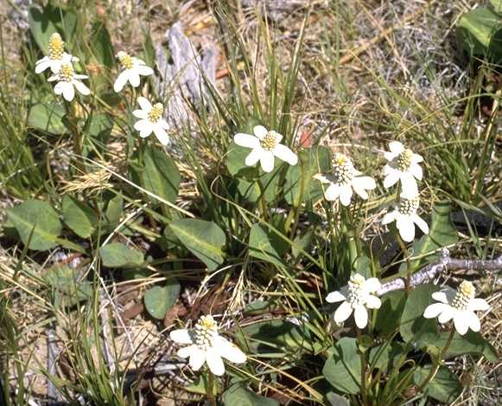

Alfred Brousseau

© Brother Eric Vogel, St. Mary's College

@ CalPhotos

# Status

Please consult the PLANTS Web site and your State Department of Natural Resources for this plant’s current status and wetland indicator values.

# Description

*General*: Lizard’s Tail Family (Saururaceae). This common herbaceous perennial has an aromatic, creeping rhizome, which is thick and woody. The flowers do have not true petals, but rather each flower is subtended by an involucre bract 1-3 cm long that is white, often tinged reddish. There are about one hundred flowers to each conical-shaped flower head. The conical spike is stout, 1-3 cm long and is subtended by 4-8 unequal white petal-like bracts, 1-2 cm long and rounded. The fruit is a capsule. The leaves have a spicy smell and are alternate and simple.

# Distribution

For current distribution, please consult the Plant Profile page for this species on the PLANTS Web site. The plants are found in saline or alkaline soil in damp or wet places in many different plant community types, such as valley grassland, saltgrass flats, and desert fan palm oases. The range of the plant is from the Peninsular Ranges, South Coast Ranges and Mojave Desert of California on the south, and north through the Sacramento, San Joaquin Valleys and San Francisco Bay Area. The plant also inhabits the Channel Islands off the southern California coast. Its range extends into Utah, central Kansas, northcentral Oklahoma, Colorado at the foot of the Front Range, Arizona, northwest New Mexico, and west Texas

# Establishment

This plant is not valued horticulturally, yet its white bracts are quite attractive. This plant is hardy and spreads rapidly, and can become invasive. Start the plant from a fleshy root. Dig up the plants from an already established area and transplant them in the fall or winter. Directly outplant the plants in the ground in full sun, giving them plenty of space. Place the plants one-foot apart. The transplants will fill in quickly, sending 2-3 feet of runners radiating out from each plant. Water the transplants and keep them moist year round. If growing the plants for their roots for medicinal purposes, plant them in a loose soil.

# Management

Weed around the plants periodically. Areas of yerba mansa were burned periodically by the Wukchumni Yokuts to maintain their quality and abundance.

# Cultivars, Improved and Selected Materials (and area of origin)

ANCA is available from native plant nurseries within its range.

# References

Bean L.J. & K.S. Saubel. 1972. *Temalpakh: Cahuilla Indian knowledge and usage of plants*. Malki Museum Press, Morongo Indian Reservation, Banning, CA.

Bocek, B.R. 1984. *Ethnobotany of Costanoan Indians, California, based on collections by John P. Harrington*. Economic Botany 38(2):240-255.

Chalfant, W.A. 1933. *The story of Inyo*. 229 p.

Curtin, L.S.M. 1949. *By the prophet of the earth*. San Vicente Foundation, Santa Fe, New Mexico.

Franco, H. 1993. *That place needs a good fire*. News From Native California 7(2):17-19.

Jepson, W.L. 1925. *A manual of the flowering plants of California*. University of California Press. Berkeley, California.

Kaul, R.B. 1986. *Saururaceae*. p. 79 IN: Flora of the Great Plains. R.L. McGregor, T.M. Barkley, R.E. Brooks, E.K. Schofield (eds). University Press of Kansas, Lawrence, Kansas.

McClintock, E. 1993. *Saururaceae*. pp. 1000-1002 IN: The Jepson Manual: Higher Plants of California. J.C. Hickman (ed.). University of California Press, Berkeley, California.

Powers, S. 1976. *Tribes of California*. University of California Press, Berkeley, California. p. 480.

Train, P., J.R. Henrichs & W.A. Archer 1957. *Contributions toward a Flora of Nevada No. 45*. USDA, ARS, Plant Industry Station Beltsville, Maryland.

Train, P., J.R. Henrichs, & W.A. Archer 1941. *Medicinal uses of plants by Indian tribes of Nevada*. Contributions Toward a Flora of Nevada No. 33. USDA, The Division of Plant Exploration and Introduction, Bureau of Plant Industry, Washington D.C.

USDA, NRCS 1999. *The PLANTS database*. National Plant Data Center, Baton Rouge, Louisiana. <http://plants.usda.gov>. Version: 990405.

Voegelin, E.W. 1938. *Tubatulabal ethnography*. Anthropological Records 2(1):1-84.

Zigmond, M.L. 1981. *Kawaiisu ethnobotany*. University of Utah Press, Salt Lake City, Utah

# Prepared By & Species Coordinators

*M. Kat Anderson*

USDA, NRCS, National Plant Data Center

c/o Plant Science Department, University of California, Davis, California

*Wayne Roderick*

Former Director of the East Bay Regional Parks Botanic Garden, Berkeley, California

Edited 25jul00 jsp; 17mar03 ahv; 30may06jsp

For more information about this and other plants, please contact your local NRCS field office or Conservation District, and visit the PLANTS Web site<<http://plants.usda.gov>> or the Plant Materials Program Web site <<http://Plant-Materials.nrcs.usda.gov>>

*The U.S. Department of Agriculture (USDA) prohibits discrimination in all its programs and activities on the basis of race, color, national origin, sex, religion, age, disability, political beliefs, sexual orientation, and marital or family status. (Not all prohibited bases apply to all programs.) Persons with disabilities who require alternative means for communication of program information (Braille, large print, audiotape, etc.) should contact USDA's* [*TARGET Center*](http://www.usda.gov/oo/target.htm) *at 202-720-2600 (voice and TDD).*

*To file a complaint of discrimination write USDA, Director, Office of Civil Rights, Room 326-W, Whitten Building, 14th and Independence Avenue, SW, Washington, DC 20250-9410 or call 202-720-5964 (voice or TDD). USDA is an equal opportunity provider and employer.*

*Read about* [*Civil Rights at the Natural Resources Convervation Service*](http://www.nrcs.usda.gov/about/civilrights/)*.*