|  |
| --- |
| beach strawberry |
| *Fragaria chiloensis* (L.) P. Mill. |
| Plant Symbol = FRCH |

##### *Contributed By: USDA NRCS National Plant Data Center & East Bay Regional Parks Botanic Garden*

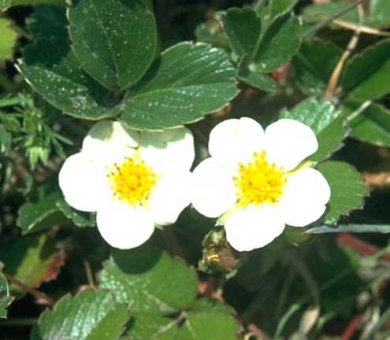

Alfred Brousseau

© Brother Eric Vogel, St. Mary’s College

@ CalPhotos

# Alternative Names

Pacific beach strawberry. This species is recognized as having four subspecies: *chiloensis*, *lucida*, *pacifica*, and *sandwicensis*. *Frageria chiloensis* ssp. *sandwicensis* is known as the Sandwich beach strawberry.

# Use

*Ethnobotanic*: This strawberry produces many more fruits than the wood strawberry and has a great flavor. It was gathered and eaten raw by the Makah, Quileute, and Quinault of western Washington. It was also harvested for its fruit by the native peoples of Alaska and coastal British Columbia. The Wiyot, Pomo, and other tribes in California savored the fruits. The plant is also used medicinally by the Quileute by chewing the leaves and spitting them on burns.

*Wildlife*: The Portola woodrat and the valley quail eat the fruit and leaves of wild strawberries.

# Status

Please consult the PLANTS Web site and your State Department of Natural Resources for this plant’s current status, such as, state noxious status, and wetland indicator values.

# Description

*General*:This herbaceous perennial plant spreads by seed and also by short rhizomes and leafless stolons. The toothed leaves are leathery, basal with a petiole generally 2-20 cm. They appear in leaflets of 3 and are glabrous (not hairy) above. The flowers have 5 white petals that are 10-18 mm, with numerous pistils and 20-35 stamens. The five bractlets are unlobed. The red fleshy fruit is covered with achenes.

# Distribution

This plant is found below 200 m, in dune and grassland communities of coastal California. It is found from Alaska to coastal South America and Hawaii. For current distribution, please consult the Plant Profile page for this species on the PLANTS Web site.

# Establishment

Dig up plantlets or runners and plant them in pots in summer. Be sure to cover the stems and roots with soil. Place the pots in a hothouse to establish good, strong roots. Water the plants or runners and keep them moist. Plant the plants outdoors in the ground in the fall or winter after the rains have started. They should be planted in full sun in a light, loose soil, about ten inches apart. It will not take long for the plants to make a complete ground cover. Lightly fertilize the plants during the growing season. Note that those plants that have bigger flowers usually have less fruit and those with smaller flowers have more fruit. Protect the plants from gophers, deer, squirrels, raccoons, and other wildlife.

# Management

Keep the runners pruned back because they can be invasive. It is necessary to divide the patch every three to four years and start a new patch for increased vigor. Younger plants are more vigorous and produce more berries.

# Cultivars, Improved and Selected Materials (and area of origin)

Seeds and plants of selected *Fragaria* cultivars are available from many nurseries. It is best to plant species from your local area, adapted to the specific site conditions where the plants are to be grown.

Contact your local Natural Resources Conservation Service (formerly Soil Conservation Service) office for more information. Look in the phone book under ”United States Government.” The Natural Resources Conservation Service will be listed under the subheading “Department of Agriculture.”

# References

Ertter, B. 1993. *Fragaria.* Page 952 IN: *The Jepson manual: Higher plants of California*. J.C. Hickman(ed.). University of California Press, Berkeley, California.

Goodrich, J., C. Lawson, & V. P.Lawson 1980. *Kashaya Pomo plants*. American Indian Studies Center, University of California, Los Angeles, California.

Gunther, E. 1992. *Ethnobotany of western Washington: The knowledge and use of indigenous plants by Native Americans*. University of Washington Press, Seattle, Washington.

Kuhnlein, H.V. & N.J. Turner 1991. *Traditional plant foods of Canadian indigenous peoples: nutrition, botany, and use*. Gordon and Breach Science Publishers, Philadelphia, Pennsylvania.

Loud, L.L. 1918. *Ethnogeography and archaeology of the Wiyot territory*. University of California Publications in American Archaeology and Ethnology. 14(3):221-436.

Martin, A.C., H.S. Zim, & A.L. Nelson 1951. *American wildlife and plants: A guide to wildlife food habits*. Dover Publications, Inc., New York, New York.

# Prepared By

##### *M. Kat Anderson*

USDA, NRCS, National Plant Data Center

*Wayne Roderick*

Former Director of the East Bay Regional Parks Botanic Garden, Berkeley, California

# Species Coordinator

##### *M. Kat Anderson*

USDA, NRCS, National Plant Data Center, c/o Plant Science Department, University of California, Davis, California

Edited 05dec00 jsp; 19may03 ahv; 07jun06 jsp

For more information about this and other plants, please contact your local NRCS field office or Conservation District, and visit the PLANTS Web site<<http://plants.usda.gov>> or the Plant Materials Program Web site <<http://Plant-Materials.nrcs.usda.gov>>

*The U.S. Department of Agriculture (USDA) prohibits discrimination in all its programs and activities on the basis of race, color, national origin, sex, religion, age, disability, political beliefs, sexual orientation, and marital or family status. (Not all prohibited bases apply to all programs.) Persons with disabilities who require alternative means for communication of program information (Braille, large print, audiotape, etc.) should contact USDA's* [*TARGET Center*](http://www.usda.gov/oo/target.htm) *at 202-720-2600 (voice and TDD).*

*To file a complaint of discrimination write USDA, Director, Office of Civil Rights, Room 326-W, Whitten Building, 14th and Independence Avenue, SW, Washington, DC 20250-9410 or call 202-720-5964 (voice or TDD). USDA is an equal opportunity provider and employer.*

*Read about* [*Civil Rights at the Natural Resources Convervation Service*](http://www.nrcs.usda.gov/about/civilrights/)*.*