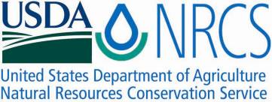

Plant Guide

# bog labrador

# tea

## Ledum groenlandicum Oeder

Plant Symbol = LEGR

*Contributed by*: USDA NRCS National Plant Data Team, Greensboro, NC

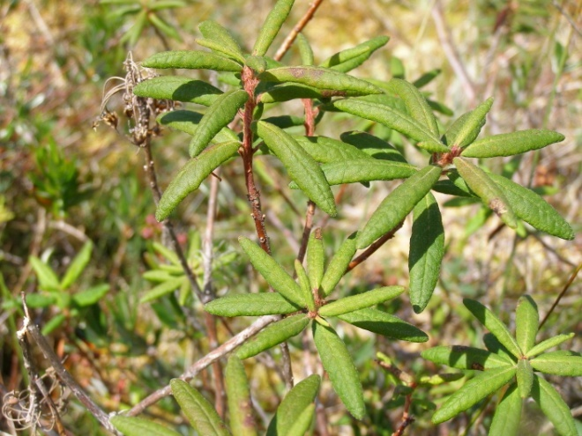

Bog Labrador tea in Ahlstrom's Prairie, Olympic National Park. Photograph by M. Kat Anderson, 2007.

### Alternate Names

*Rhododendron groenlandicum* (Oeder) Kron & Judd

Labrador tea, Indian tea, Hudson Bay tea, James tea, marsh tea, swamp tea

### Uses

Bog Labrador tea leaves are fragrant and were used as a beverage and medicine by many tribes such as the Quinault and Makah in western Washington, the Potawatomi in the Great Lakes region, and the Iroquois in the Northeast. This tea was as popular among tribes as green tea, chai and black teas are to Western culture today (Gunther 1973; Smith 1933; Hedrick 1933). First Nations in Canada also picked the leaves for a warm drink and medicine (Turner 2004).

**CAUTION: Bog Labrador tea may be toxic in concentrated doses. It contains toxic alkaloids known to be poisonous to livestock, especially sheep (Pojar and MacKinnon 1994).**

The beverage was quickly adopted by Europeans because of its pleasant flavor, aroma and salutary effects (Franklin 1823; Umfreville 1954). It warmed the insides of many a non-Indian explorer, trapper, and early settler. The Indians graciously taught them how to use it and it was called “Indian tea plant” by some non-Indians. The leaves were even used as a substitute for tea during the Revolutionary War (Hedrick 1972). Today there is a demand for the plant’s essential oil for aromatherapy (Rogers 1997) and the plant is planted in gardens as an ornamental shrub.

Large quantities of leaves were picked in spring before flowering by some native families while others picked them year round (Anderson 2009). The Ojibwa gathered the leaves from spring to autumn for a beverage tea (Smith 1932). The leaves were used either fresh or dried for future use. There were a number of ways to prepare tea, including adding a handful of leaves to boiling water and letting it simmer for several minutes or adding a handful of leaves to cold water, bringing it to a boil and simmering it for much longer (Stewart 2002). The Ojibwa, for example, tied fresh or dried leaves in a packet using a thin strip of basswood bark before placing in water to boil. The quantity was a large handful to a quart of water. It was drunk while hot and sweetened with maple sugar (Buttree 1932).

Re-enacting an ancient custom, the Hoh, Quinault, Quileute, Klallam, and Makah still gather and steep the leaves and drink the resulting tea as a refreshing beverage (Anderson 2009; Gill 1984). Today, different Native American families keep a pot of this tea on the stove, ready for serving anytime (Stewart 2002). Pat Boachup, Makah, (pers. comm.) says: “I still gather the leaves of the Indian tea every year. We pick off the leaves that have molded or spoiled. We collect the good leaves and put them in a warm place to dry. If the leaves stay in a plastic bag they will turn black. They are put in a paper bag next to a wood stove to dry. Then after they are dry you can put them in a plastic bag. I take a handful of leaves—enough to cover the top of the pot—and put them in the pan or pot with water. Take a fork and push down the leaves. When it starts boiling turn it down and steam it for 15 to 20 minutes. When it turns a rich orange it’s ready. If steamed too long, it turns dark. I drink it most of the time hot with sugar. I gather four or five grocery bags of dried leaves from two sites every year. You can pick it all year round, but I usually go in the fall in September and October. I make sure I leave some leaves so as not to kill the plant.”

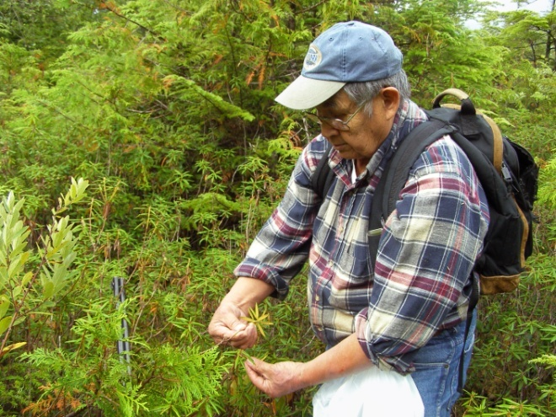

Pat Boachup, Makah, collecting bog Labrador tea on Ts'oo-yuhs Prairie, late September 2009. Photograph by M. Kat Anderson, 2009.

*Medicinal Use:* The sophistication and complexity of bog Labrador tea’s medicinal use is demonstrated by the wide variety of ailments that were treated with this plant. Hudson Bay Company writer Edward Umfrewille (1954) wrote in 1790 about the Indians and Europeans of Canada and how they used the tea medicinally: “Its virtues are many; it is an aromatic, very serviceable in rheumatic cases, strengthens the stomach, relieves the head, and also promotes perspiration. Outwardly, it is applied to gangrenes, contusions, and excoriations; in the latter case the powder is made use of.”

Tribes used the leaves to treat inflammatory pathologies such as asthma, rheumatism, and burns; diseases of the liver and kidney and many other sicknesses (U’mista Cultural Society et al. 1998; Gunther 1973). The Makah, for example used a strong infusion for a blood purifier (Gunther 1973). The leaves were used by the Ojibwa as a medicine for treating ulcers (Densmore 1974). Cree and the Metis of Canada continue to use it, drunk as a tea or leaves chewed and the juice swallowed, to treat stomach flu, diarrhea, chills and bad breath, pneumonia and difficulty urinating (Marles et al. 2000). The Innu (formerly the Montagnais-Naskapi) of Labrador still treat sore throats and headaches by chewing the leaves, but not swallowing (Olsson n.d.). The Denyaavee of Alaska still use a tea of the leaves for settling upset stomachs, easing heartburn, and helping to ease arthritis pain. A tea made from the flowers is good for combating a cold. The cooled tea is a wash for skin problems and works well for sore throats when gargled (Tanana Chiefs Conference, Inc. 1999).

Recent studies support its ethnopharmacological use, showing significant anti-inflammatory and antioxidant activities from methanol extracts of leaves and twigs. Bog Labrador tea twig extracts were found to be active against lung and colon carcinoma cell lines (Dufour et al. 2007).

*Wildlife Use:*The flowers of bog Labrador tea provide nectar for butterflies (Pettinger and Costanzo 2002). The palm warbler (*Dendroica palmarum*) and Connecticut warbler (*Oporornis agilis*) nest in *Sphagnum* in bogs with bog Labrador tea and open conifer cover (Walkinshaw and Wolf 1957; Huff 1929). Bog Labrador tea leaves and twigs are browsed by caribou and moose.

### Status

Please consult the PLANTS Web site and your State Department of Natural Resources for this plant’s current status (e.g., threatened or endangered species, state noxious status, and wetland indicator values).

### Description

*General:* Heath family (Ericaceae). An erect, aromatic shrub that grows to one meter with twigs densely covered with long, soft hairs (villous). The narrow, leathery leaves are 2-5 cm long, alternate, and evergreen. The leaves are dark green above with edges that curl under along the margins, and there is a dense mat of orange-brown hairs on the underside. Numerous white flowers in tight clusters bloom from May to July. Each flower has a small five-toothed sepal tube with five separate petals, and 5-7 stamens. The fruit is a small, fuzzy capsule tipped with a persistent style (Marles et al. 2000; Pettinger and Costanzo 2002; Pojar and MacKinnon 1994).

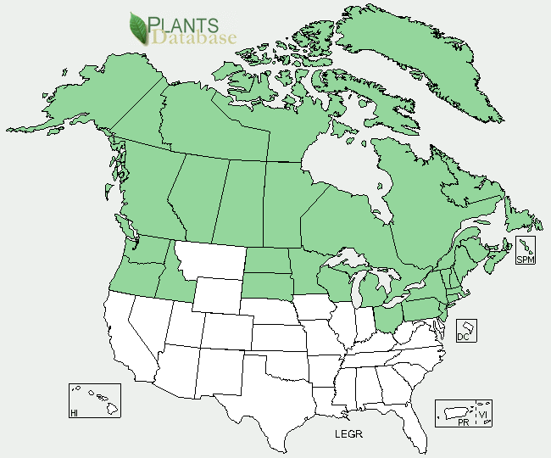

Bog Labrador tea distribution from USDA-NRCS PLANTS Database.

Found in low to middle elevations across Alaska, Canada, and Greenland, south through the New England States, northern New Jersey, mountains of Pennsylvania, the northern Great Lake States, North and South Dakota, Idaho, Washington, and Oregon (Gleason and Cronquist 1991; Pettinger and Costanzo 2002; Strong 2002; Fernald et al. 1958). For current distribution, please consult the Plant Profile page for this species on the PLANTS Web site.

*Habitat*: Bog Labrador tea grows in bogs, fens, muskegs, open tundra, and dwarf shrub communities. It covers significant areas in bogs with black and white spruce (*Picea mariana* and *Picea glauca*), and tamarack (*Larix laricina*) in the boreal forests of Canada and high-elevation northeastern United States; eastern hemlock (*Tsuga canadensis*), pitch pine (*Pinus rigida*), eastern white pine (*Pinus strobus*), sugar maple (*Acer saccharum*), white ash (*Fraxinus americana*), and paper birch (*Betula papyrifera*) in the Northeast and Great Lakes region; as an understory shrub in open or closed moist forests in association with lodgepole pine (*Pinus contorta* var. *contorta*), Sitka spruce (*Picea sitchensis*) and western hemlock (*Tsuga heterophylla*) in the Pacific coastal forests of Oregon, Washington, Canada, and Alaska; and shrub birch (*Betula glandulosa*) in the Yukon (Gleason and Cronquist 1991; Pettinger and Costanzo 2002; Strong 2002; Tiner 1991).

### Establishment

Plants can be started from seed or root-crown division. Collect the seeds from dry capsules and plant them in fall or spring in a moist peaty soil, in a sunny spot. Water them thoroughly after planting and keep moist. Suckers with roots can be split off from the base of the plant in mid-December and transplanted during spring (Pettinger and Costanzo 2002; MacKenzie 1997; Young and Young 1992; Dirr and Heuser 1987).

### Management

Many of the fens and bogs that provide important habitat for bog Labrador tea in North America were created by glaciation. These wetlands have been disappearing over thousands of years, due to a decrease in native ungulates that graze the bogs, and encroachment by conifers and hardwoods. Indians in different regions burned these wetlands periodically (Anderson 2009; Day 1953; Patterson and Sassaman 1988). The primary role of fire was to maintain open habitats such as prairies, bogs, and forest clearings. Forest encroachment would have reduced sunlight that the bog Labrador tea plants needed, increased competition for nutrients, and made the plants more difficult to get to and harvest. Burning also had a directly beneficial effect on individual plants, maintaining vigor and stimulating new growth. Bog Labrador tea is fire tolerant (Mallik and Mallik 1997), responding to low-intensity fires by resprouting from stems. If completely top-killed, the plant regenerates from root crowns and rhizomes (Calmes and Zasada 1982; Parminter 1984). Regeneration is typically rapid (Scotter 1972). Indian tea can even survive severe fires because the rhizomes lie as deep as 50 cm in the soil (Flinn and Wein 1977). The young leaves can become infected with a fungal disease, spruce needle rust, leaving powdery orange spores (Hiratsuka et al. 1995).

Kate McCarty, a non-Indian woman married to a Makah, described bog Labrador tea on the Ts’oo-yuhs prairie as producing better crops after the Makah burned it: “The Labrador tea can just keep growing and growing and growing until it gets real leggy. And all that you have is just a few little leaves on top. But after it’s been burned then it starts all over again. It’s just like pinching flowers off of the chrysanthemum to make them bush out” (Kate McCarty pers. comm.).

**Environmental Concerns**

“People burned in the cranberry marsh to promote a better crop of cranberries and Indian tea. Our people have been drinking the Indian tea for thousands of years. But you can never drink enough. A lot of people like the Indian tea. Another reason to burn was to keep the brush and trees from growing. Otherwise it would be a loss. The marsh behind the school [on the Makah Reservation], unless someone burns it, it will be history. It is being encroached by trees and shrubs. Unless they’re cut down and burned, they’ll eventually take over the cranberry marsh just like at Ozette” (Pat Boachup, Makah, pers. comm.).

### Control

Please contact your local agricultural extension specialist or county weed specialist to learn what works best in your area and how to use it safely. Always read label and safety instructions for each control method. Trade names and control measures appear in this document only to provide specific information. USDA NRCS does not guarantee or warranty the products and control methods named, and other products may be equally effective.

### Cultivars, Improved, and Selected Materials (and area of origin)

This plant is available from native plant nurseries (Damrosch 2008).

### References

Anderson, M.K. 2009. The Ozette Prairies of

Olympic National Park: their former indigenous uses and management. Final report to Olympic National Park. Winter 2009.

Buttree, J.M. 1932. Foods of the Omaha and

Chippewa. The Totem Board 11(11):443-454. The Woodcraft League of America, Inc. Santa Fe. University of New Mexico Press, Albuquerque.

Calmes, M.A. and J.C. Zasada. 1982. Some

reproductive traits of four shrub species in the black spruce forest type of Alaska. Canadian Field-Naturalist 96(1):35-40.

Damrosch, B. 2008. The Garden Primer: The

Completely Revised Gardener’s Bible. Workman Publishing Co., Inc. New York, N.Y.

Day, G. 1953. The Indian as an ecological factor in

the northeastern forests. Ecology 34:329-346.

Densmore, F. 1974. How Indians Use Wild Plants for

Food, Medicine, & Crafts. 1974. Dover Publications, Inc. New York, N.Y. Originally published in 1928 in the *Forty-fourth Annual Report of the Bureau of American Ethnology, 1926-1927*, pages 275-397.

Dirr, M.A. and C.W. Heuser, Jr. 1987. The Reference

Manual of Woody Plant Propagation. Varsity Press, Athens, GA.

Dufour, D., A. Pichette, V. Mshvildadze, M.

Bradette-Hébert, S. Lavoie, A. Longtin, C. Laprise, and J. Legault. 2007. Antioxidant, anti-inflammatory and anticancer activities of methanolic extracts from *Ledum groenlandicum* Retzius. Journal of Ethnopharmacology 111:22-28.

Fernald, M.L., A.C. Kinsey, and R.C. Rollins. 1958.

Edible Wild Plants of Eastern North America. Harper and Row, Publishers. New York, N.Y.

Flinn, M.A. and R.W. Wein. 1977. Depth of

underground plant organs and theoretical survival during fire. Canadian Journal of Botany 55:2550-2554.

Franklin, Capt. J. 1823. Narrative of a Journey to the

Shores of the Polar Sea in the Years 1819-22. London, England.

Gill, S. 1984. Ethnobotany of the Makah People,

Olympic Peninsula, Washington. Makah Language Program, Neah Bay, Washington and Marion Ownbey Herbarium Wasington State University, Pullman, WA.

Gleason, H.A. and A. Cronquist. 1991. Manual of

Vascular Plants of Northeastern United States and Adjacent Canada. The New York Botanical Garden. Bronx, N.Y.

Gunther, E.. 1973. Ethnobotany of Western

Washington: The Knowledge and Use of Indigenous Plants by Native Americans. Seattle: University of Washington Press.

Hedrick, U.P. 1933. A History of Agriculture in the

State of New York. New York State Agricultural Society, Albany, N.Y.

___________. 1972. Sturtevant’s Edible Plants of the

World. Dover Publications, Inc. N.Y., N.Y. Originally published by J.B. Lyon Company, Albany, in 1919 for the State of New York as the Department of Agriculture’s Twenty-seventh Annual Report, Volume 2, Part II [Report of the New York Agricultural Experiment Station for the Year 1919.]

Hiratsuka, Y., D.W. Langor, and P.E. Crane 1995. A

Field Guide to Forest Insects and Diseases of the Prairie Provinces. Nat. Resour. Can., Canadian Forest Service Special Report 3. Edmonton, Alberta.

Huff, N.L. 1929. The nest and habits of the

Connecticut warbler in Minneosota. The Auk 46(4):455-465.

MacKenzie, D.S. 1997. Perennial Ground Covers.

Timber Press, Portland, OR.

Mallik, I. and A.U. Mallik. 1997. Effects of *Ledum*

*groenlandicum* amendments on soil characteristics and black spruce seedling growth. Plant Ecology 133(1)29-36.

Marles, R.J., C. Clavelle, L. Monteleone, N. Tays,

and D. Burns. 2000. Aboriginal Plant Use in Canada’s Northwest Boreal Forest. UBC Press, Vancouver, B.C.

Olsson, K. n.d. Caribou bones and Labrador tea:

traditional health care practices and their implications for nursing. Unpublished paper.

Parminter, J. 1984. Fire-ecological Relationships for

the Biogeoclimatic Zones of the Northern Portion of the Mackenzie Timber Supply Area Summary Report. Ministry of Forests, Province of British Columbia, Victoria, BC.

Patterson, W.A. and K. E. Sassaman. 1988. Indian

fires in the prehistory of New England. Pages 107-135 in: Holocene Human Ecology in Northeastern North America. G.P. Nicholas (ed.). Plenum Press, New York, N.Y.

Pettinger, A. and B. Costanzo. 2002. Native Plants in

the Coastal Garden: A Guide for Gardeners in the Pacific Northwest. Timber Press. Portland, OR.

Pojar, J. and A. MacKinnon (eds.) 1994. Plants of

the Pacific Northwest Coast: Washington, Oregon, British Columbia & Alaska. Lone Pine Publishing, Vancouver, British Columbia.

Rogers, R. 1997. Aromatics and their use as

medicine. Pages 53-54 In Proceedings of the Prairie Medicinal and Aromatic Plants Conference 1997, Brandon, MB.

Scotter, G.W. 1972. Fire as an ecological factor in

boreal forest ecosystems of Canada. Pages 15-25 In: Fire in the Environment. Symposium Proceedings May 1-5, 1972. U.S. Department of Agriculture, Forest Service. Denver, CO. FS-276.

Smith, H.H. 1932. Ethnobotany of the Ojibwe

Indians. Bulletin of the Public Museum of the City of Milwaukee 4(3):327-525.

___________. 1933. Ethnobotany of the Forest

Potawatomi Indians. Bulletin of the Public Museum of the City of Milwaukee 7:1(1-230).

Stewart, H. 2002. Drink in the Wild: Teas, Cordials,

Jams and More. Douglas & McIntyre. Vancouver, B.C.

Strong, W.L. 2002. Lodgepole pine/Labrador tea type

communities of western Canada. Can. J. Bot. 80:151-165.

Tanana Chiefs Conference, Inc. 1999. Denyaavee

Medicine Plants of the Tanana Chiefs Conference Region. Fairbanks, Alaska.

Tiner, R.W. 1991. The concept of a hydrophyte for

wetland identification. BioScience 41(4):236-247.

Turner, N. J. 2004. Plants of Haida Gwaii. Sononis

Press, Winlaw, B.C.

Umfreville, E. 1954. The Present State of Hudson’s

Bay Containing a Full Description of that Settlement, and the Adjacent Country; and Likewise of the Fur Trade. The Ryerson Press, Toronto, Canada.U’mista Cultural Society, J.

Walkinshaw, L.H. and M.A. Wolf. 1957. Distribution

of the palm warbler and its status in Michigan. The Wilson Bulletin 69(4):338-351.

Young, J.A. and C.G. Young. 1992. Seeds of Woody

Plants in North America. Dioscorides Press. Portland, OR.

**Prepared By**: *M. Kat Anderson,* USDA NRCS National Plant Data Team, Greensboro, NC

### Citation

Anderson, M., 2011. Plant Guide for bog Labrador tea (*Ledum groenlandicum)*. USDA-Natural Resources Conservation Service, National Plant Data Team. Greensboro, NC.

**Acknowledgements**

The author would like to thank Doug Goldman and Roger Latham for editing this Plant Guide and providing citations.

Published February 2012

Edited: 15Feb2011jw

For more information about this and other plants, please contact your local NRCS field office or Conservation District at <http://www.nrcs.usda.gov/> and visit the PLANTS Web site at <http://plants.usda.gov/> or the Plant Materials Program Web site <http://plant-materials.nrcs.usda.gov>.

PLANTS is not responsible for the content or availability of other Web sites.

**USDA IS AN EQUAL OPPORTUNITY PROVIDER AND EMPLOYER**