|  |
| --- |
| Pacific waxmyrtle |
| *Morella californica* (Cham. & Schlecht.) Wilbur |
| Plant Symbol = MOCA6 |

Contributed by: USDA NRCS National Plant Data Center

# Alternative Names

California bayberry, California wax myrtle, bayberry, pacific bayberry, western bayberry, *Myrica californica* (MYCA13)

# Uses

*Ethnobotanic*: Wax from the pulp of the fruit was used to make aromatic candles. The wax was also used in making soups. A gray-brown and a maroon-purple dye was obtained from the fresh or dried berries (Grae 1974). This species was easily grown and valued especially on the Pacific Coast for its berries and evergreen leaves (Wyman 1965).

*Agroforestry*: *Myrica californica* is used in tree strips for windbreaks. They are planted and managed to protect livestock, enhance production, and control soil erosion. Windbreaks can help communities with harsh winter conditions better handle the impact of winter storms and reduce home heating costs during the winter months. They also provide shade and wind protection during the summer, which aids in the reduction of cooling bills.

# Status

# Please consult the PLANTS Web site and your State Department of Natural Resources for this plant’s current status, such as, state noxious status, and wetland indicator values.

# Description

*General*: Pacific waxmyrtle (*Myrica californica*) is a large evergreen shrub or small tree, ten to thirty-five feet high. The leaves are alternate, simple, five to ten centimeters long with resin dots, and are slightly sticky and fragrant when crushed. The fruit are purplish, single seeded berries, coated with a white wax, ripening in the early autumn and usually falling during the winter. The bark is smooth, compact, dark gray or light brown on the surface and dark red-brown internally (Sargent 1961).

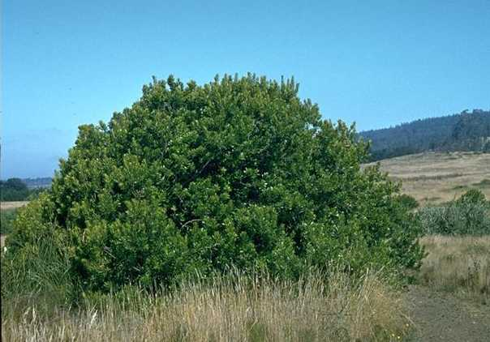

Brother Alfred Brousseau

© St. Mary’s College

@ Calflora

*Distribution*: Pacific waxmyrtle occurs in canyons and hill slopes of the coastal region from the Santa Monica Mountains of Los Angeles County northward to Del Norte County, and north to Washington (McMinn 1939). For current distribution, please consult the Plant profile page for this species on the PLANTS Web site.

# Adaptation

*Myrica californica* thrives in wet soil conditions and is drought tolerant. It grows best in full sun in an open position and can tolerate light shaded areas. This species prefers a peaty soil or lime free loamy soil.

# Establishment

*Propagation from Seed*: Seeds are best sown as soon as ripe in the autumn in a cold frame. Stored seeds will germinate faster if they go through a three-month period of cold stratification and then are sown in a cold frame. As soon as the seeds are ripe, place them in seed trays or containers. When seedlings are large enough to handle, place them in individual pots and grow them in a cold frame for the first winter. Plants should be planted into their permanent positions in the late spring or early summer.

# Management

In exposed situations, the wax myrtle forms a little more than a bushy arborescent shrub but in protected areas it becomes a medium sized tree, much branched and densely leafy, with a gray warty unfissured bark (Howell 1949). Plants injured by fire sprout from the heavy root crown (Ibid.).

# Cultivars, Improved and Selected Materials (and area of origin)

Available through native plant nurseries within its range. Contact your local Natural Resources Conservation Service (formerly Soil Conservation Service) office for more information. Look in the phone book under ”United States Government.” The Natural Resources Conservation Service will be listed under the subheading “Department of Agriculture.”

# References

Britton, N.L. 1908. *North American trees*. Henry Holt & Company, New York, New York

Farrar, J.L. 1995. *Trees of the northern United States and Canada*. Iowa State University Press, Ames, Iowa.

Grae, I. 1974. *Nature’s colors-dyes from plants*. MacMillan Publishing Company, New York, New York.

Howell, J.T. 1949. *Marin Flora: manual of the flowering plants and ferns of Marin County, California*. University of California Press, Berkeley & Los Angeles, California.

McMinn, H.E. 1939. *An illustrated manual of California shrubs*. University of California Press, London, England.

McMinn, H.E. & E. Maino 1963. *An illustrated manual of Pacific Coast trees*. University of California Press, Berkeley, California.

Pojar, J & A. MacKinnon 1994. *Plants of the Pacific Northwest coast: Washington, Oregon, British Columbia, and Alaska*. Lone Pine Publishing, Redmond, Washington.

Preston, R.J., Jr., 1989. *North American trees*. 4th ed. Iowa State University Press, Ames, Iowa.

Rehder, A. 1990. *Manual of cultivated trees and shrubs: hardy in North America*. 2nd ed. Dioscorides Press, Portland, Oregon.

Sargent, C.S. 1961. *Manual of the trees of North America*. Vol. 1. Dover Publications, Inc., New York, New York.

Thomas, J.H. 1961. *Flora of the Santa Cruz Mountains of California*. Stanford University Press, Stanford, California.

Wyman, D. 1965. *Trees for American gardens*. The MacMillan Company, New York, New York.

# Prepared By:

## *Jammie Favorite*

formerly USDA, NRCS, National Plant Data Center

Baton Rouge, Louisiana

# Species Coordinator

## *M. Kat Anderson*

USDA, NRCS, National Plant Data Center, c/o Plant Sciences Dept., University of California, Davis, California

Edited: 19jun02 jsp; 060802 jsp

For more information about this and other plants, please contact your local NRCS field office or Conservation District, and visit the PLANTS Web site<<http://plants.usda.gov>> or the Plant Materials Program Web site <<http://Plant-Materials.nrcs.usda.gov>>

*The U.S. Department of Agriculture (USDA) prohibits discrimination in all its programs and activities on the basis of race, color, national origin, sex, religion, age, disability, political beliefs, sexual orientation, and marital or family status. (Not all prohibited bases apply to all programs.) Persons with disabilities who require alternative means for communication of program information (Braille, large print, audiotape, etc.) should contact USDA's* [*TARGET Center*](http://www.usda.gov/oo/target.htm) *at 202-720-2600 (voice and TDD).*

*To file a complaint of discrimination write USDA, Director, Office of Civil Rights, Room 326-W, Whitten Building, 14th and Independence Avenue, SW, Washington, DC 20250-9410 or call 202-720-5964 (voice or TDD). USDA is an equal opportunity provider and employer.*

*Read about* [*Civil Rights at the Natural Resources Convervation Service*](http://www.nrcs.usda.gov/about/civilrights/)*.*