|  |
| --- |
| american ginseng |
| *Panax quinquefolius* L. |
| Plant Symbol = PAQU |

Contributed by: USDA NRCS National Plant Data Center

### Alternate Names

wild ginseng, sang

### Uses

*Ethnobotanic:* American ginseng was used by Menominee hunters, who chewed the root to impart a lure to the breath and to attract deer. The plant was used by Meskwaki women to obtain a husband. A mixture consisted of ground ginseng, mica, gelatin, and snake meat. The Pawnee also used ginseng roots in combination with certain other substances as a love charm. The Ojibwe considered the root a good-luck charm if carried in the pocket. Huron Smith (1932) recorded a potentially sustainable way to harvest the roots among the Ojibwe. “They only gathered the root when the red berries were mature, but before they were ready to drop. Into the hole from whence the root came, they would thrust the whole fruiting top, and carefully firm the soil upon it. Knowing the location well, they would revisit the place in three to five years and find more roots than they harvested in the first instance.” The roots were used in eyewash by the Iroquois to treat the sore eyes of two-year-old children. The root could also be steeped in warm water and drunk for alleviating sores on the body. The pulverized root was smoked to treat asthma. Women of the Penobscot tribe took an infusion of the root to increase fertility. The Delaware used the roots and other plant parts as a general tonic. American ginseng is in high demand in the United States and China as an herbal remedy. It is used for stress and to increase energy and mental acuity in the United States. In China, it is a panacea for sexual impotency, nervousness, vomiting, and dyspepsia.

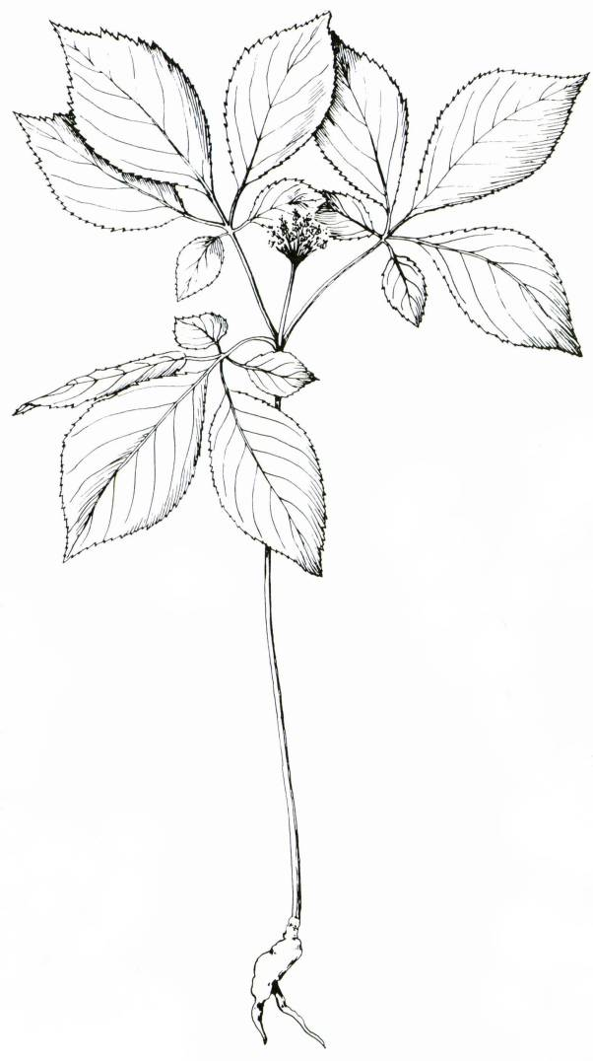

from Voss (1985)

### Status

In general, this species has been depleted by over-collecting for commercial purposes. Many states, such as Maryland, have a permit process instituted for collectors in the wild. Certain U.S. ports have been designated by the USDA, APHIS as ports through which ginseng can be exported. The Canadian Museum of Nature (2000) considers it a species at risk. Please consult the PLANTS web site and your State Department of Natural Resources for this plant’s current status.

### Description

*General:* Ginseng Family (Araliaceae). This aromatic herbaceous perennial has once palmately compound leaves arranged in a single whorl. The leaves are oblong-obovate to obovate, 6-15 cm, and conspicuously serrate. The stems are solitary, 2-6 dm, and with one flower umbel per stem. The flowers are greenish-white, all or mostly perfect. There are two styles and five stamens. The fruits are berry-like, bright red drupes, 1 cm thick.

### Distribution

For current distribution, please consult the Plant Profile page for this species on the PLANTS Web site. This plant is now considered rare and collection in the wild is either prohibited or strictly regulated in the states in which it is found. Most regulations allow digging only in autumn, after ginseng seeds have dropped. It is found in rich woods from Quebec to Minnesota and South Dakota to Georgia and occurs in Louisiana and Oklahoma. It grows in full shade underneath deciduous hardwood species.

### Establishment

Ginseng is widely cultivated in the U.S., Canada, and China. In natural conditions, the seed may take two or three years to germinate and the plant three to four years to produce seed. The root takes at least three to four years before it is ready to harvest (Sadler 1999). Detailed growing instructions are available from Michigan State University Extension (1996).

*Propagation by seeds*: Fruits should be collected when they are red, usually August or September. Seeds can be separated from the pulp and sown fresh in the fall in flats. If stored, they should be stored moist. If buying seed, soak it in a 10 percent bleach solution for 20 minutes and rinse before sowing to kill any fungus spores that may have come along with them. After a 3-fingered leaf emerges in the spring, transplant each of these in bunches of 3 to deep pots. They will be ready to plant outside the following fall. Plant the plants in full shade under deciduous trees in a well-drained soil and keep them moist. Wild American ginseng is typically found in calcium rich forest soils well supplied with organic matter.

### Management

If American ginseng has been planted in an acid soil, apply dolomite every fall to heighten the plant’s vigor and color. Hand weed around the plants.

### Cultivars, Improved and Selected Materials (and area of origin)

This species is generally available from those nurseries that specialize in herbs. Contact your local Natural Resources Conservation Service (formerly Soil Conservation Service) office for more information. Look in the phone book under ”United States Government.” The Natural Resources Conservation Service will be listed under the subheading “Department of Agriculture.”

### References

Beyfuss, R.L. 1999. *American ginseng production in woodlots*. Agroforestry Notes 14. USDA, Forest Service and USDA, Natural Resources Conservation Service. USDA, National Agroforestry Center, East Campus-UNL, Lincoln, Nebraska.

Bourne, J. 2000. *On the trail of the ‘sang poachers*. Audubon 102:2(84-91).

Canadian Museum of Nature 2000. *Species at risk in Canada: American ginseng*. Version: 000504. <http://www.nature.ca/english/ginseng.htm>. Ottawa, Ontario, Canada.

Crosby, M.R. 2000. *Ginseng*. IN: Microsoft® Encarta® Online Encyclopedia 2000. <http://encarta.msn.com>. Microsoft Corporation, Redmond, Washington.

Cullina, W. 2000. *Growing and propagating wildflowers of the United States and Canada*. The New England Wild Flower Society Guide. Houghton Mifflin Company, New York.

Gilmore, M.R. 1932. *Some Chippewa uses of plants*. Papers of the Michigan Academy of Science, Arts and Letters17:119-143.

Gilmore, M.R. 1977.  *Uses of plants by the Indians of the Missouri River region.* University of Nebraska Press, Lincoln, Nebraska.

Gleason, H.A. & A. Cronquist 1991.  *Manual of vascular plants of northeastern United States and Adjacent Canada.* Second Edition. The New York Botanical Garden, Bronx, New York.

Gupton, O.W. & F.C. Swope 1982. *Wildflowers of Tidewater Virginia*. University Press of Virginia, Charlottesville, Virginia. 208 pp.

Herrick, J.W. 1995. *Iroquois medical botany.* Syracuse University Press, Syracuse, New York.

Michigan State University Extension 1996. *Growning ginseng*. Home Horticulture. <http://www.msue.msu.edu/msue/imp/mod03/03900053.html>. East Lansing, Michigan.

Moerman, D.E. 1998 *Native American ethnobotany.*  Timber Press, Portland, Oregon.

Phillips, H.R. 1985 *Growing and propagating wild flowers.*  The University of North Carolina Press, Chapel Hill, North Carolina.

Sadler, T. 1999. *Ginseng in Australia*. The Australian New Crops Newsletter, No. 11. <http://www.newcrops.uq.edu.au/newslett/ncn11167.htm >.

Smith, H.H. 1923. *Ethnobotany of the Menomini*. Bulletin of the Public Museum of the City of Milwaukee4:1(8-175).

Smith, H.H. 1928*. Ethnobotany of the Meskwaki*. Bulletin of the Public Museum of the City of Milwaukee 4:2(175-326).

Smith, H.H. 1928*. Ethnobotany of the Meskwaki*. Bulletin of the Public Museum of the City of Milwaukee 4:2(175-326).

Smith, H.H. 1932*. Ethnobotany of the Ojibwe*. Bulletin of the Public Museum of the City of Milwaukee4:3(327-525).

Speck, F.G. 1917*. Medicine practices of the Northeastern Algonquians.* Proceedings of the 19th International Congress of Americanists*,* pp. 303-321.

Tantaquidgeon, G. 1972.  *Folk medicine of the Delaware and related Algonkian Indians.* Pennsylvania Historical Commission Anthropological Papers, Number 3. Harrisburg, Pennsylvania.

USDA, NRCS 2000. *The PLANTS database*. Version: 000504. <http://plants.usda.gov>. National Plant Data Center, Baton Rouge, Louisiana.

Vestal, P.A. & R.E. Schultes. 1939.  *The economic botany of the Kiowa Indians as it relates to the history of the tribe.* Botanical Museum, Cambridge, Massachusetts.

Voss, E. 1985. *Michigan flora. Part II. Dicots (Saururaceae-Cornaceae)*. Bulletin 59. Cranbrook Institute of Science and University of Michigan Herbarium, Ann Arbor, Michigan. 724 pp.

Williams, L. & J.A. Duke 1978. *Growing ginseng*. Farmers' Bulletin No. 2201. USDA, Science and Education Administration, Washington, D.C.

### Prepared By

*M. Kat Anderson & J. Scott Peterson*

USDA, NRCS, National Plant Data Center

### Species Coordinator

*M. Kat Anderson*

USDA, NRCS, National Plant Data Center

c/o Department of Environmental Horticulture, University of California, Davis, California

Edited 05dec00 jsp; 29may03 ahv; 060802 jsp

For more information about this and other plants, please contact your local NRCS field office or Conservation District, and visit the PLANTS Web site<<http://plants.usda.gov>> or the Plant Materials Program Web site <<http://Plant-Materials.nrcs.usda.gov>>

*The U.S. Department of Agriculture (USDA) prohibits discrimination in all its programs and activities on the basis of race, color, national origin, sex, religion, age, disability, political beliefs, sexual orientation, and marital or family status. (Not all prohibited bases apply to all programs.) Persons with disabilities who require alternative means for communication of program information (Braille, large print, audiotape, etc.) should contact USDA's* [*TARGET Center*](http://www.usda.gov/oo/target.htm) *at 202-720-2600 (voice and TDD).*

*To file a complaint of discrimination write USDA, Director, Office of Civil Rights, Room 326-W, Whitten Building, 14th and Independence Avenue, SW, Washington, DC 20250-9410 or call 202-720-5964 (voice or TDD). USDA is an equal opportunity provider and employer.*

*Read about* [*Civil Rights at the Natural Resources Convervation Service*](http://www.nrcs.usda.gov/about/civilrights/)*.*