|  |
| --- |
| red pine |
| *Pinus resinosa* Soland. |
| Plant Symbol = PIRE |

Contributed by: USDA NRCS National Plant Data Center

# Alternate Names

Norway pine, eastern red pine, pin rouge

# Uses

*Economic*: Red pine wood is moderately hard and straight grained. It is grown primarily for the production of wood used for poles, lumber, cabin logs, railway ties, post, pulpwood, and fuel. The bark is occasionally used for tanning leather (Sargent 1961). This species is also planted and used as Christmas trees.

*Ethnobotanic*: The inner bark of *Pinus resinosa* was pounded as a poultice for any kind of inflamed wound, sore, or ulcer when white pine bark was not available (Fielder 1975).

*Landscaping & Wildlife*: Red pine is an attractive tree that is used in recreational areas because of its colorful bark. This species provides cover for many species of mammals and birds. Deer, cottontails, and snowshoe hares browse songbirds, mice and chipmunks feed on the seed while seedlings.

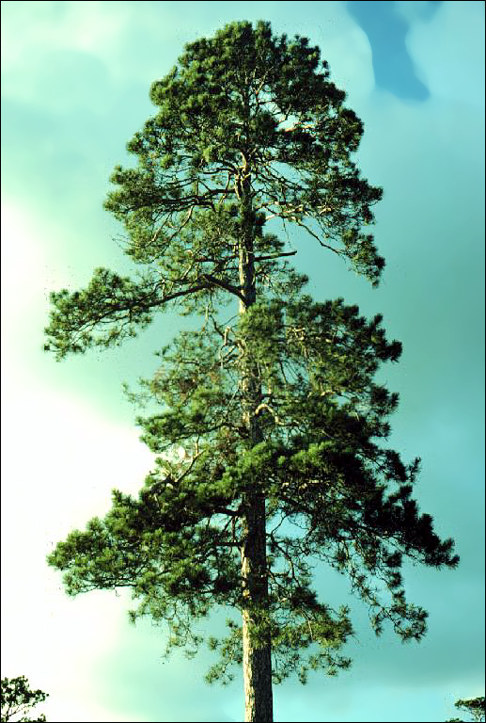

© Joseph O’Brien

USDA, Forest Service, St. Paul Field Office

*Agroforestry*: *Pinus resinosa* is used in tree strips for windbreaks. They are planted and managed to protect livestock, enhance crop production, and control soil erosion. Windbreaks can help communities with harsh winter conditions better handle the impact of winter storms and reduce home heating costs during the winter months and cooling cost in the summer.

# Status

# Please consult the PLANTS Web site and your State Department of Natural Resources for this plant’s current status, such as, state noxious status and wetland indicator values.

# Description

*General*: Red pine (*Pinus resinosa*) is a medium sized tree, up to twenty-five meters high and seventy-five centimeters in diameter (Farar 1995). The leaves are soft and flexible evergreen needles, in clusters of two, slender, 4”-6” long, dark green borne in dense tufts at the ends of branchlets. The fruit is ovoid-conic, with thin scales, becoming light chestnut-brown at maturity. The bark is thick and slightly divided by shallow fissures into broad flat ridges covered by thin loose red-brown scales (Sargent 1961). The root system is moderately deep, wide spreading, and very wind firm.

# *Distribution*: Red pine is native to northeastern United States. This species ranges from Newfoundland and Manitoba, south to the mountains of Pennsylvania, west to Minnesota (Dirr 1990). For current distribution, please consult the Plant profile page for this species on the PLANTS Web site.

# Adaptation

Red pine occurs most often on well drained, dry, highly acid, sandy soils of outwash plains, and gravelly ridges (Barnes & Wagner 1981). It is frequently found where the soil fertility is low, in pure stands or mixed with species such as jack pine, white pine, aspens, oaks, and white birch. This species prefers full sun and is shade intolerant and extremely cold tolerant. *Pinus resinosa* is easily cultivated in nurseries and easily raised in plantations (Ibid.).

# Establishment

*Propagation by Seed*: Cones ripen from August to October with natural seed dispersal occurring between October and November. However, seeds can be artificially harvested by kiln drying ripe cones for nine hours at 130ºF (Dirr & Heuser 1987). Fresh seed has no dormancy and will germinate immediately upon sowing. Stored seed requires two months cold stratification. Optimum temperature for germination is 77ºF (Ibid.).

# Management

Most red pine natural stands originate after a forest fire. Fire is necessary for regeneration because it prepares a seedbed by reducing much of the humus, and competition from other trees and shrubs, decreases the number of cone-destroying insects, and thins out the overstory (Farrar 1995). Once established, red pine requires little care. Tip and shoot moths sometime attack it.

# Cultivars, Improved and Selected Materials (and area of origin)

Materials are available through nurseries within its range. Contact your local Natural Resources Conservation Service (formerly Soil Conservation Service) office for more information. Look in the phone book under ”United States Government.” The Natural Resources Conservation Service will be listed under the subheading “Department of Agriculture.”

# References

Barnes, B.V. & W.H. Wagner, Jr. 1981. *Michigan trees*. The University of Michigan Press, Ann Arbor, Michigan.

Britton, N.L. 1908. *North American trees*. Henry Holt & Company, New York, New York.

Dirr, M.A. 1990. *Manual of woody landscape plants: their identification, ornamental characteristics, culture, propagation, and uses*. 4th ed. Stipes Publishing Co., Champaigne, Illinois.

Dirr, M.A. 1997 *Dirr’s hardy trees and shrubs: an illustrated encyclopedia*. Timber Press, Portland, Oregon.

Farrar, J.L. 1995. *Trees of the northern United States and Canada*. Iowa State University Press, Ames, Iowa.

Graves, A.H. 1956. *Illustrated guide to trees and shrubs*. Harper & Brothers, Publishers, New York, New York.

Grimm, W.C. 1967. *Familiar trees of America*. Harper & Row, Publishers, New York, New York.

O’Brien, J. 2002*. Images of Northern Forests-red pine*. USDA, Forest Service, St. Paul Field Office, St. Paul, Minnesota. Accessed: 10jan02. <http://www.na.fs.fed.us/spfo/for_images/miscimage.htm>

Peattie, D.C. 1950. *A natural history of trees of eastern and central North America*. Houghton Mifflin Company, Boston, Massachusetts.

Preston, R.J., Jr., 1989. *North American trees*. 4th ed. Iowa State University Press, Ames, Iowa.

Rehder, A. 1990. *Manual of cultivated trees and shrubs: hardy in North America*. 2nd ed. Dioscorides Press, Portland, Oregon.

Sargent, C.S. 1961. *Manual of the trees of North America*. Vol. 1. Dover Publications, Inc., New York, New York.

# Prepared By:

## *Lincoln M. Moore*

USDA, NRCS, National Plant Data Center

Baton Rouge, Louisiana

# Species Coordinator

## *M. Kat Anderson*

USDA, NRCS, National Plant Data Center, c/o Environmental Horticulture Dept., Davis, California

Edited: 19jun02 jsp; 29may03 ahv; 060803 jsp

For more information about this and other plants, please contact your local NRCS field office or Conservation District, and visit the PLANTS Web site<<http://plants.usda.gov>> or the Plant Materials Program Web site <<http://Plant-Materials.nrcs.usda.gov>>

*The U.S. Department of Agriculture (USDA) prohibits discrimination in all its programs and activities on the basis of race, color, national origin, sex, religion, age, disability, political beliefs, sexual orientation, and marital or family status. (Not all prohibited bases apply to all programs.) Persons with disabilities who require alternative means for communication of program information (Braille, large print, audiotape, etc.) should contact USDA's* [*TARGET Center*](http://www.usda.gov/oo/target.htm) *at 202-720-2600 (voice and TDD).*

*To file a complaint of discrimination write USDA, Director, Office of Civil Rights, Room 326-W, Whitten Building, 14th and Independence Avenue, SW, Washington, DC 20250-9410 or call 202-720-5964 (voice or TDD). USDA is an equal opportunity provider and employer.*

*Read about* [*Civil Rights at the Natural Resources Convervation Service*](http://www.nrcs.usda.gov/about/civilrights/)*.*