|  |
| --- |
| douglas fir |
| *Pseudotsuga menziesii* (Mirbel) Franco |
| Plant Symbol = PSME |

Contributed by: USDA NRCS National Plant Data Center

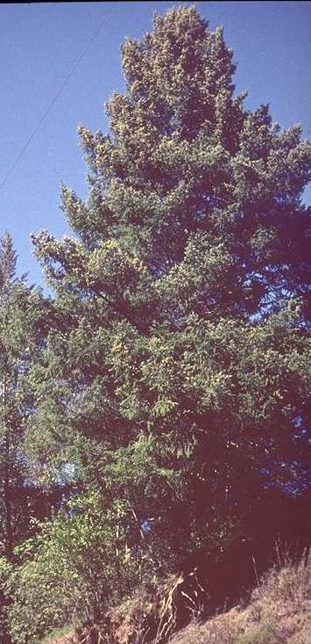

Brother Alfred Brousseau

© Brother Eric Vogel, St. Mary's College

@ CalPhotos

###### Alternative Names

Two varieties of this species are currently recognized: Rocky Mountain Douglas-fir (*Pseudotsuga menziesii* (Mirbel) Franco var. *glauca* (Beissn.) Franco and Douglas-fir (*Pseudotsuga menziesii* (Mirbel) Franco var. *menziesii*).

###### Uses

*Ethnobotanic*: Douglas-fir needles were made into a tea and drank by Isleta Puebloans in New Mexico to cure rheumatism. Douglas-fir resin was used by the Shasta in northern California to poultice cuts and the Yuki along the California coast used a decoction from spring buds to treat venereal diseases. The Sinkyone of California made Douglas-fir bark tea which eased colds and stomach ailments. The Kayenta Navaho of Arizona used the tree to treat stomach disease and headaches, although what part of the plant was used is not known. Also, historically the Kayenta Navajo ground part of tree with a certain rock and mixed it with corn seeds to insure a good crop. The Pueblo people used the wood to construction dwellings while the twigs were worn on various parts of dancers' costumes. Prayer sticks made of Douglas-fir wood were excavated from archeological sites in New Mexico dating back to the Anasazi. The White Mountain Apache used the pitch of this conifer as gum and applied it to water jugs to make them watertight. Douglas-fir roots were used in California Indian basketry.

*Commercial*: The tree is one of the world's most important and valuable timber trees and historically it was used by Westerners for telephone poles and railway ties among many other uses. Today Douglas-fir is also grown for Christmas trees.

*Wildlife*: The winged seeds are eaten by western squirrels, the red tree mouse, and the dusky-foot woodrat. The foliage and twigs are browsed by antelope, mule and white-tailed deer, elk, and mountain sheep. The staminate cones and needles of Douglas-fir provide a significant winter food of the blue grouse.

###### Status

Please consult the PLANTS Web site and your State Department of Natural Resources for this plant’s current status, such as, state noxious status and wetland indicator values.

###### Description

*General*: Pine Family (Pinaceae). This native, evergreen tree has a round crown when mature and a conic crown when young. It reaches up to 67 m tall and 4.4 m wide. The bark on mature trunks is dark brown, thick, and deeply furrowed. The flat leaves are 2-4 cm in length, taper to a short petiole, with two whitish bands on the lower surface. The deciduous seed cones are 5-9 cm and mature the first season. The seeds have wings that are less than 25 mm.

###### Distribution

For current distribution, please consult the Plant Profile page for this species on the PLANTS Web site. This tree is common in the northern and central parts of Arizona, southward to northern Mexico, and eastward to western Texas. Douglas-fir is also widespread in mixed evergreen and mixed conifer forests in California below 2200 m. It is found in the Klamath Ranges, the outer North Coast Ranges, high Cascade Range, high Sierra Nevada, San Francisco Bay Area, Central Coast, outer South Coast Ranges, and northward to British Columbia.

###### Establishment

*Adaptation*: Douglas-fir needs excellent drainage. In the higher elevations of the West that receive snow and in the lower foothills that have moderately cold winters and hot summers, Douglas-fir requires moderate summer watering, generally 1-4 times per month depending upon the absorption rate and water retention capacity of the soil. It does best in full or part-shade and may tolerate morning and winter sun in ocean-influenced areas of northern and central California.

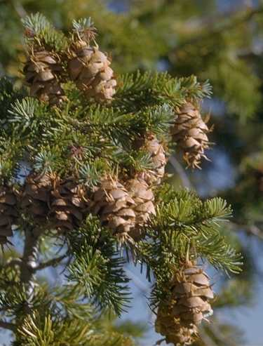

Charles Webber

© California Academy of Sciences

@CalPhotos

If establishing the tree by seed, remove the seeds from the cones, gently rub the wings off, and soak them in water for 24 hours, drain them, and thoroughly surface-dry them. Put them in a plastic bag, without any medium, seal the bag and place them in refrigerated conditions until their chilling treatment begins. Allow three times the air space as seed space in the bag. It is best to sow the seeds in late February to early March. Expose the seeds to a chilling treatment of at least four weeks prior to sowing. After cold stratification, plant the seeds in a well-drained coarse potting mix in leach tubes that are narrow but deep with two seeds per tube. These containers should allow roots to reach the air and stop growing and be at least 6 inches deep. Fertilize the containers with a starter formulation of fertilizer with low or zero nitrogen. These containers can be kept in a greenhouse for the first 4 to 6 weeks, receiving 70-degree temperatures during the day. Keep the surface of the soil moist during the germination phase. Next, after the first set of cotyledons, water the plants with a deep, thorough soaking and let the plants dry in between watering. Thin the plants down to one per container and move the pots into a shade-house with 30 percent shade after 4 to 6 weeks. Protect the plants from wind and wildlife. During the main summer growing season use a balanced fertilizer applied to each container. At the end of the growing season, use a finisher formulation of fertilizer. Plant the plants in the ground outside in the late winter or early spring in moist soil. Conduct supplemental hand watering or irrigation if the rains are insufficient. Clear weeds in a 3 feet by 3 feet area around the plants to encourage better survival and growth rate. Make sure a protective barrier is placed around the conifers such as Vexar tubing to shield them from jack rabbits, deer, and other wildlife that may feed on the leaves, stems, and roots.

###### Cultivars, Improved and Selected Materials (and area of origin)

Available from most nurseries specializing in native plants within its range. Contact your local Natural Resources Conservation Service (formerly Soil Conservation Service) office for more information. Look in the phone book under ”United States Government.” The Natural Resources Conservation Service will be listed under the subheading “Department of Agriculture.”

###### References

Dunmire, W.W. & G.D. Tierney 1995. *Wild plants of the Pueblo Province exploring ancient and enduring uses*. Museum of New Mexico Press, Santa Fe, New Mexico.

CalPhotos 2000. *Pseudotsuga menziesii*. <http://elib.cs.berkeley.edu/cgi/img_query?seq_num=11920&one=T> Version: 000229. CalFlora, Berkeley, California.

Griffin, J.R. 1993. *Pinaceae*. Pages 115-121 IN: The Jepson Manual: Higher plants of California*. J.C. Hickman* (ed.)*.* University of California Press, Berkeley.

Hermann, R.K. & D.P. Lavender 1990*.* *Pseudotsuga menziesii (Mirb.) Franco Douglas-Fir.* Pages 527-540 IN: Silvics of North America Vol. 1: Conifers. R. M. Burns and B.H. Honkala (tech. coordinators). USDA, Forest Service Agriculture Handbook 654.

Kearney, T.H. & R.H. Peebles 1960. *Arizona flora*. University of California Press, Berkeley, California

Martin, A.C., H.S. Zim, & A.L. Nelson 1951*.* *American wildlife and plants: A guide to wildlife food habits*. Dover Publications, New York, New York.

Reagan, A.B. 1929. *Plants used by the White Mountain Apache Indians of Arizona.* Wisconsin Archeologist 8(4):143-160.

Strike, S.S. & E.D. Roeder 1994. *Ethnobotany of the California Indians-volume 2*. *Aboriginal uses of Claifornia's indigenous plants*. Koeltz Scientific Books, Champaign, Illinois.

USDA, NRCS 2000. *The PLANTS database*. <http://plants.usda.gov>. Version: 000229. National Plant Data Center, Baton Rouge, Louisiana.

Wyman, L.C. & S.K. Harris 1951. *The Ethnobotany of the Kayenta Navaho*. University of New Mexico Publications in Biology 5. University of New Mexico Press, Albuquerque, New Mexico.

###### Prepared By and Species Coordinator

*M. Kat Anderson*

USDA, NRCS, National Plant Data Center

Department of Plant Sciences, University of California, Davis, California

Edited 0500dec jsp; 29may03 ahv; 060808 jsp

For more information about this and other plants, please contact your local NRCS field office or Conservation District, and visit the PLANTS Web site<<http://plants.usda.gov>> or the Plant Materials Program Web site <<http://Plant-Materials.nrcs.usda.gov>>

*The U.S. Department of Agriculture (USDA) prohibits discrimination in all its programs and activities on the basis of race, color, national origin, sex, religion, age, disability, political beliefs, sexual orientation, and marital or family status. (Not all prohibited bases apply to all programs.) Persons with disabilities who require alternative means for communication of program information (Braille, large print, audiotape, etc.) should contact USDA's* [*TARGET Center*](http://www.usda.gov/oo/target.htm) *at 202-720-2600 (voice and TDD).*

*To file a complaint of discrimination write USDA, Director, Office of Civil Rights, Room 326-W, Whitten Building, 14th and Independence Avenue, SW, Washington, DC 20250-9410 or call 202-720-5964 (voice or TDD). USDA is an equal opportunity provider and employer.*

*Read about* [*Civil Rights at the Natural Resources Convervation Service*](http://www.nrcs.usda.gov/about/civilrights/)*.*