|  |
| --- |
| blue oak |
| *Quercus douglasii* Hook. & Arn. |
| Plant Symbol = QUDO |

Contributed by: USDA NRCS National Plant Data Center

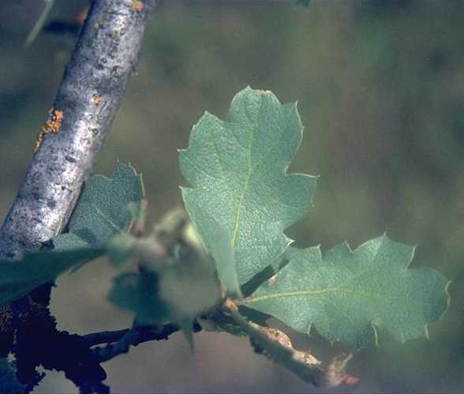

Brother Alfred Brousseau

© Brother Eric Vogel, St. Mary's College

@ CalPhotos

# Uses

*Ethnobotanic*: Blue oaks had and continue to have significant meaning to native cultures. The most significant use of blue oak was for its highly desirable acorns for food. Acorns were shelled, dried, pounded into flour, sifted for fineness, leached of bitter tannins, and mixed with other acorn types such as black oak (*Quercus kelloggii*) and prepared as mush, soup, paddies, or bread. Called "acorn" by contemporary gatherers, this food is still relished for ceremonies, festivals, dances, and family gatherings.

California's blue oak provided many resources to California Indian people including medicine, dyes, utensils, games, toys, and construction materials. The inner bark of the blue oak was boiled and the brew drank for relief of arthritis by the Kawaiisu. Acorns served as bait in traps and snares to catch pigeons, flickers, quail, and jays by the Gabrielino, Sierra Miwok and other tribes. California blue oaks grow new sprouts vigorously after a fire and these young shoots exhibit highly desirable qualities for manufacturing products. These characteristics include flexibility, length, no lateral branching, easily split, and straightness. These shoots were used for basketry and oak sprouts were reputed to have great strength. Types of baskets included Miwok, Pomo, and Maidu cradleboards with frameworks of oak shoots, and Kawaiisu twined work-baskets made with rims of blue oak branches. The Salinan along the central coast made seed-beaters with a looped stick of oak. The Yana used an oak paddle in cooking and the Achomawi made spoons of oak. The Kawaiisu made a ladle about a foot long that was carved from the wood of blue oak. Forked oak sticks, darkened by charring, were used as fake antlers on deer masks of the Sierra Miwok for hunting purposes. The Maidu of Chico Rancheria constructed their houses with posts of oak. The Western Mono also used young oak switches as construction materials for certain structures such as acorn granary frameworks. Digging sticks were made of blue oak by the Western Mono for roasting yucca bulbs, blue oak was preferred as firewood by the Kawaiisu and the pith of the oak was used for starting fires. Fallen oak limbs make excellent firewood, because the coals retain heat and the Shasta, Sierra Miwok, and many other tribes used the wood. Acorns were utilized by many tribes in the manufacture of toys including acorn buzzers and acorn tops. Split acorns often formed dice, which could be rolled upon a flat, coiled basketry tray. The Miwok, the Western Mono, Pomo, Sinkyone, and other cultural groups used these.

*Wildlife*: It is well known that bears (*Ursus americanus*), ground squirrels (*Spermophilus scrofa*), jays (*Cyanocitta steller*i), band-tailed pigeons (*Columba fasciata*), acorn woodpeckers (*Melanerpes formicivorus*), pocket gophers (*Thomomys bottae*), deer mice (*Peromyscus* spp.) and black-tailed deer (*Odocileus hemionus*), among many other animals find acorns a favorite food source.

# Status

Please consult the PLANTS Web site and your State Department of Natural Resources for this plant’s current status, such as, state noxious status and wetland indicator values.

# Description

*General*: Oak Family (Fagaceae). Blue oak is a deciduous tree that is endemic to California. It has a rounded crown and grows from 6-20 m. high. The gray bark is shallowly checked into small thin scales. The leaves are shallowly lobed and blue-green above. The acorns mature in one year, are oval, and have slightly tubercled scales.

# Distribution

For current distribution, please consult the Plant Profile page for this species on the PLANTS Web site.

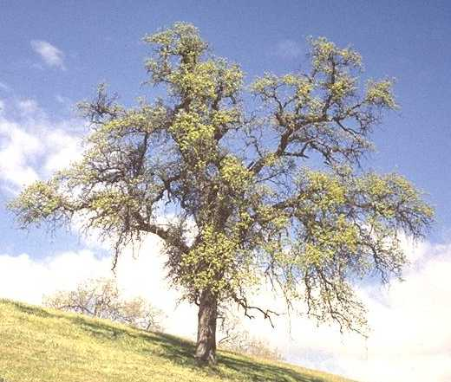

Brother Alfred Brousseau

© Brother Eric Vogel, St. Mary's College

@ CalPhotos

# Establishment

*Adaptation*: Blue oak woodlands cover 3 million acres in California, one-half of all oak covered lands. It is the most abundant hardwood forest type in the state. Blue oak may occur in near pure stands in dense woodland or savanna. It may also occur as a dominant in mixed stands that include foothill pine (*Pinus sabiniana*), interior live oak (*Quercus wislizenii*), valley oak (*Quercus lobata*), and/or coast live oak (*Quercus agrifolia*), or as a minor component in mixed stands of oaks and other hardwoods.

If possible, gather acorns from many different trees locally, to maintain genetic diversity of blue oak and to ensure that the plants are adapted to the site. The seeds of most oaks are short-lived and must be sown or refrigerated quickly, otherwise they lose their ability to germinate. They are best gathered directly from the tree or from the ground within a short time of their dropping, usually within several days. To test their ripeness, select an acorn that is still in its cap and twist it lightly. If it pops out of the cap, the acorn is ripe. Store the seeds without their caps in a grocery sack until ready to plant. The seeds can be sown in autumn outdoors (see under direct seeding), or if the seeds are started in pots in the greenhouse in the early spring, they should be stratified for one and one-half months between 33 and 40 degrees in a refrigerator in a mix.

Fill a gallon Ziploc™ bag about half full with acorns, and then add about a cup of dry perlite and a little bit of vermiculite (3:1 mixture). Shake the bag to distribute the perlite around the acorns, label the bag, and place it in the refrigerator. Check the bag weekly and discard moldy acorns. Any acorns that have germinated need to be taken out of the bag and sown. Plant the seeds on their sides directly in long, deep pots (2 in. in diameter by 10 inches long) with potting soil and a slow release fertilizer. Water the tubes and place them in diffused light in the nursery or outside, making sure to keep each tube suspended off the ground or bench so the large air holes at the bottom of the tube are exposed. When the tree roots hit the air, they'll stop growing. Water the pots when the surface of the soil is dry to the touch. Do not over-water.

Plant the seedlings the following winter in a sunny location and water the transplants to ensure sufficient moisture and eliminate air pockets. Be careful to keep the soil from falling off of the roots. Place the seedlings in the ground such that the top of the soil from the container is even with the ground line. Use a pick mattock for planting, which has a pick on one surface and a triangular wedge on the other surface. Break up the soil, which will foster root growth. Protect the seedlings from weeds, drying winds, grasshoppers, and small and large mammals that might feed on the roots, leaves, or trunks. Also, water the seedlings deeply the first summer. A good seedling protector is essential and can be a simple wire window screen mesh and wooden stake. Bend the mesh into a cylinder that is about 6-8 inches in diameter and 3 feet tall. Attach the mesh cylinder onto the wooden stake with staples or carpet tacks. Place the tube over the seedling and pound the stake into the ground. Seedlings should be kept free of vegetation for 2 to 3 feet surrounding each seedling.

*Direct Seeding*: Pick acorns without insect exit holes or diseases. Store acorns for one and one half months in a sealed plastic bag in the refrigerator. Dig a hole with the trowel, shovel, or hoe and be sure to break up the soil much deeper (one to two feet) than the acorn is planted and backfill with loosened soil to accommodate the growing of roots. Plant the acorns on their sides, one to two inches deep in the fall of the year. Plant several acorns in each hole and thin multiple seedlings down to a single most vigorous plant. Water the acorns deeply the first summer. Weed several feet around each seedling for several years. Protect the seedlings from animals until well established.

# Management

Keep lawns and plants that require a lot of moisture away from the oaks. Blue oak should not be irrigated accept in years of unusually low rainfall. If a drought year, supplemental watering can take place in the spring to complement natural rainfall. Water the soil from halfway between the trunk and the drip line to 10-15 feet beyond, allowing water to penetrate the soil to a depth of 18 to 24 inches. It may be necessary to water for 4 to 6 hours to get water to this depth. Keep water at least 10 feet away from the trunk. Native plants that are drought-tolerant and shade-tolerant and require no summer water can be planted under the oaks, such as California brome (*Bromus carinatus*), deergrass (*Muhlenbergia rigens*), sego lily (*Calochortus* spp.), and bluedicks (*Dichelostemma* spp.), among others. Light pruning can be done in the winter on mature oaks to remove weak, diseased, and dead branches, but never top oaks.

Once established, blue oak is quite fire-tolerant. Many tribes in California set frequent light-surface fires in areas of blue oak to ensure continual yields of high-quality acorn. Major reasons for their burning included the following: 1) facilitating acorn collection; (2) increasing the quality and quantity of acorn production through decreasing diseases; (3) increasing the quality and quantity of acorn production through decreasing acorn pests; 4) stimulating the production of straight shoots (epicormic) for the making of cultural items; 5) decreasing the likelihood of major conflagrations that would destroy the oaks; 6) burning for mushrooms; and 7) increasing edible grasses and other seed-bearing herbaceous plants under the oaks and within the surrounding woodlands.

# Cultivars, Improved and Selected Materials (and area of origin)

Readily available from most native plant nurseries within its range. Contact your local Natural Resources Conservation Service (formerly Soil Conservation Service) office for more information. Look in the phone book under ”United States Government.” The Natural Resources Conservation Service will be listed under the subheading “Department of Agriculture.”

# References

Barrett, S.A. & E.W. Gifford 1933. *Miwok material culture*. Bulletin of the Public Museum of the City of Milwaukee 2(4):117-376.

CalPhotos 2000. *Quercus douglasii*. Version: 000229. CalFlora, Inc., Berkeley, California.

<http://elib.cs.berkeley.edu/cgi/img_query?seq_num=11938&one=T>.

Dagit, R. 1998. *Transplanting oak trees*. Growing Native 9(6):1-24. Editor, L. Lacy. The Newsletter of the Growing Native Research Institute.

Hagen, B.W. 1990. *Keeping native California oaks healthy*. Tree Notes #7. California Department of Forestry and Fire Protection.

Hagen, B.W., B.D. Coate, & K. Oldham 1991. *Compatible plants under and around oaks*.

Hill, D. 1978. *The Indians of Chico Rancheria*. State of California, the Resources Agency. Department of Parks and Recreation, Sacramento, California. 108 pp.

Keator, G. 1998. *The life of an oak: an intimate portrait*. Heyday Books and California Oak Foundation. Berkeley, California.

Martin, A.C., H.S. Zim, &A.L. Nelson 1951. *American wildlife and plants: A guide to wildlife food habits.* Dover Publications, New York, New York.

Mason, J.A. 1912. *The ethnology of the Salinan Indians*. University of California Publications in American Archaeology and Ethnology. Vol. 10(4). pp. 97-240.

McDonald, P.M. 1990. *Silvics of North America*. Volume 2, Hardwoods. Burns, R.M. and B.H. Honkala, tech. coords. Agriculture Handbook 654. U.S. Department of Agriculture, Washington, DC.

Schulz, P.E. 1988. *Indians of Lassen Volcanic National Park and vicinity*. Loomis Museum Association. Lassen Volcanic National Park, Mineral, California. 160 pp.

USDA, NRCS 2000. *The PLANTS database*. <http://plants.usda.gov>. Version: 000229. National Plant Data Center, Baton Rouge, Louisiana.

Zigmond, M.L. 1981. *Kawaiisu ethnobotany*. University of Utah Press, Salt Lake City, Utah.

# Prepared By and Species Coordinator

*M. Kat Anderson*

USDA, NRCS, National Plant Data Center

Department of Plant Sciences, University of California, Davis, California

Edited 05dec00 jsp; 29may03 ahv; 060809 jsp

For more information about this and other plants, please contact your local NRCS field office or Conservation District, and visit the PLANTS Web site<<http://plants.usda.gov>> or the Plant Materials Program Web site <<http://Plant-Materials.nrcs.usda.gov>>

*The U.S. Department of Agriculture (USDA) prohibits discrimination in all its programs and activities on the basis of race, color, national origin, sex, religion, age, disability, political beliefs, sexual orientation, and marital or family status. (Not all prohibited bases apply to all programs.) Persons with disabilities who require alternative means for communication of program information (Braille, large print, audiotape, etc.) should contact USDA's* [*TARGET Center*](http://www.usda.gov/oo/target.htm) *at 202-720-2600 (voice and TDD).*

*To file a complaint of discrimination write USDA, Director, Office of Civil Rights, Room 326-W, Whitten Building, 14th and Independence Avenue, SW, Washington, DC 20250-9410 or call 202-720-5964 (voice or TDD). USDA is an equal opportunity provider and employer.*

*Read about* [*Civil Rights at the Natural Resources Convervation Service*](http://www.nrcs.usda.gov/about/civilrights/)*.*