|  |
| --- |
| yellow coneflower |
| *Ratibida pinnata* (Vent.) Barnh. |
| Plant Symbol = RAPI |

Contributed by: USDA NRCS National Plant Data Center

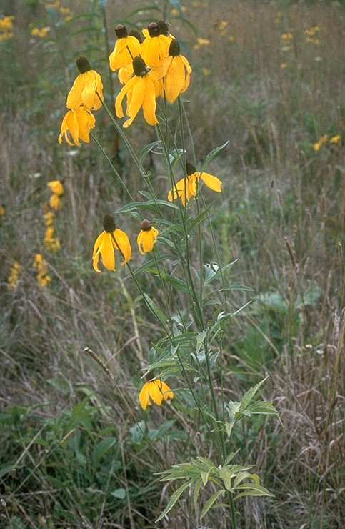

Division of Natural Areas and Preserves

Ohio Department of Natural Resources

# Alternative Names

gray-head prairie coneflower, drooping coneflower, pinnate prairie coneflower

# Uses

*Ethnobotanic*: *Ratibida pinnata* root was used to cure toothache (Fielder 1975).

*Landscaping &Wildlife*: Yellow coneflower is a strong survivor of former prairies where the majority of the original plants have perished. This is a long live species and is best to plant where there is competition from other plants. The seed heads are eaten by birds in the late fall. The flowers attract several different butterfly species.

# Status

# Please consult the Plants Web site and your State Department of Natural Resources for this plant’s current status, such as, state noxious status and wetland indicator values.

# Description

*General*: Sunflower family (Asteraceae). Yellow coneflower is a native perennial herb growing from a woody caudex up to one meter or taller. The leaves are pinnantely compound, mostly with five to seven lanceolate segments, with harsh and scurfy surfaces (Bruggen 1976). The disk flowers are usually gray at first becoming brown with age. When the disk heads are crushed, an odor of anise is emitted. Each flower has its own stalk and five to eight yellow, drooping petals arranged in a cone shape.

# *Distribution*: Yellow coneflower ranges from Ontario and New York to Minnesota, South Dakota, and Nebraska, south to Georgia, Arkansas and Oklahoma (Steyermark 1963). For current distribution, please consult the Plant profile page for this species on the PLANTS Web site.

# Adaptation

This species occurs in prairies, thickets, and borders of woods. It is often found along roadsides and railroad right-of-ways. Yellow coneflower grows best on loam, clay, and sandy soil types that are from medium moisture to dry. It prefers calcareous soils that are neutral pH 6-7, but will grow in sunny locations with well-drained soils, and is often found in wet mesic, mesic and dry mesic sites.

# Establishment

*Propagation by Seed*: *Ratibida pinnata* seeds are best planted in the spring or fall. Generally the seeds does not need any pre-treatment. They can be stratified at 33 to 38ºF for thirty days.

# Management

Harvesting of seeds should be done from October through November. The cones should be clipped form the stem and placed into a bucket to rub the seeds off the cone to be used for propagation.

# Cultivars, Improved and Selected Materials (and area of origin)

Somewhat available through native plant seed sources within its range. Contact your local Natural Resources Conservation Service (formerly Soil Conservation Service) office for more information. Look in the phone book under ”United States Government.” The Natural Resources Conservation Service will be listed under the subheading “Department of Agriculture.”

# References

Bruggen, T. V. 1976. *The vascular plants of South Dakota*. The Iowa State University Press, Ames, Iowa.

Fielder, M. 1975. *Plant medicine and folklore*. Winchester Press, New York, New York.

Gleason, H. A. 1952. *The new Britton and Brown illustrated flora of the northeastern United States and adjacent Canada*. 3 vols. The New York Botanical Garden, New York, New York.

Grimm, W.C. 1993. *The Illustrated book of wildflowers and shrubs*. Stackpole Books, Mechanicsburg, PA.

Mohlenbrock, R.H., ed. 1975. *Guide to the vascular flora of Illinois*. Southern Illinois University Press, Carbondale, Illinois.

Mohlenbrock, R. H. & J.W. Voight 1959. *A flora of southern Illinois*. Southern Illinois University Press, Carbondale, Illinois.

Ohio Department of Natural Resources 2000. *Ohio prairies*. Division of Natural Areas and Preserves. Accessed: 11jan02. <http://www.dnr.state.oh.us/dnap/prairies/OhioPrairies.htm>

Small, J. K. 1933. *Manual of the southeastern flora*. The University of North Carolina Press, Chapel Hill, North Carolina.

Steyermark, J. A. 1963. *Flora of Missouri*. The Iowa State University Press, Ames Iowa.

Swink, F. & G. S. Wilhelm 1979. *Plants of the Chicago region*. 3rd ed. The Morton Arboretum, Lisle, Illinois.

The Great Plains Flora Association 1986. *Flora of the Great Plains*. University Press of Kansas, Lawrence, Kansas.

# Prepared By

#### *Jammie Favorite*

formerly USDA, NRCS, National Plant Data Center

# Baton Rouge, Louisiana

# Species Coordinator

*M. Kat Anderson*

USDA, NRCS, National Plant Data Center, c/o Plant Sciences Dept., Davis, California

Edited: 19jun02 jsp; 30may03 jsp; 060809 jsp

For more information about this and other plants, please contact your local NRCS field office or Conservation District, and visit the PLANTS Web site<<http://plants.usda.gov>> or the Plant Materials Program Web site <<http://Plant-Materials.nrcs.usda.gov>>

*The U.S. Department of Agriculture (USDA) prohibits discrimination in all its programs and activities on the basis of race, color, national origin, sex, religion, age, disability, political beliefs, sexual orientation, and marital or family status. (Not all prohibited bases apply to all programs.) Persons with disabilities who require alternative means for communication of program information (Braille, large print, audiotape, etc.) should contact USDA's* [*TARGET Center*](http://www.usda.gov/oo/target.htm) *at 202-720-2600 (voice and TDD).*

*To file a complaint of discrimination write USDA, Director, Office of Civil Rights, Room 326-W, Whitten Building, 14th and Independence Avenue, SW, Washington, DC 20250-9410 or call 202-720-5964 (voice or TDD). USDA is an equal opportunity provider and employer.*

*Read about* [*Civil Rights at the Natural Resources Convervation Service*](http://www.nrcs.usda.gov/about/civilrights/)*.*