|  |
| --- |
| tehachapi Rose |
| *Rosa woodsii* Lindl. var. *gratissima* (Greene) Cole |
| Plant Symbol = ROWOG2 |

Contributed by: USDA NRCS National Plant Data Center & the Biota of North America Program

## Alternate Names

Common wild rose, wild rose, mountain rose

## Uses

*Wildlife*: Fruits of Woods’ rose are a good source of energy and protein and are eaten by many animals, including squirrels, deer, coyotes, and bears. Many birds and mammals are sustained by the persistent dry hips when the ground is covered with snow. The plants are browsed by livestock and big game from spring through fall, but the young spring leaves are especially palatable. Porcupines and beavers also browse the leaves. Thickets formed by Woods’ rose provide nesting and escape cover for many birds and small mammals.

*Conservation*: The rhizome system makes Woods’ rose effective in erosion control, and the species has been used to revegetate disturbed sites along road cuts, streambanks, and seeps. Plants are used as ornamentals near homes to attract birds and other wildlife.

*Ethnobotanic*: Native Americans used the roots, stems, leaves, flowers, and fruits of Woods’ rose for foods and therapeutic materials. The hips are a source of vitamin C and are dried for use in flavoring teas, jellies, fruitcakes, and puddings. The inner bark and roots were boiled to treat diarrhea and stomach aliments and a tea was made from the bark to treat muscles.

## Status

Please consult the PLANTS Web site and your State Department of Natural Resources for this plant’s current status, such as, state noxious status and wetland indicator values.

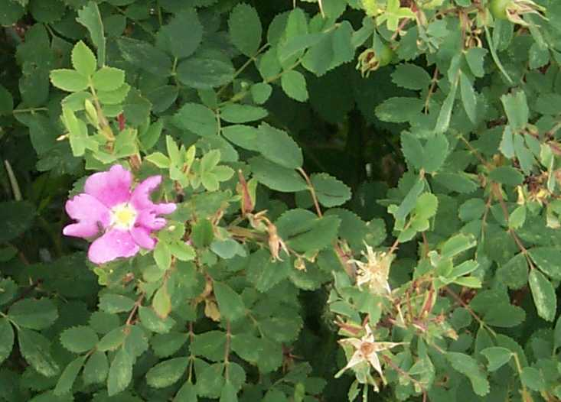

© J. Scott Peterson

USDA, NRCS, NPDC

@ PLANTS

## Description

Rose family (Rosaceae). Native subshrubs or shrubs growing 0.2-2(-3) m high, rhizomatous, with shallow, frequently branching fibrous roots, sometimes forming nearly impenetrable thickets; stems reddish-brown to gray, with straight or slightly curved prickles. Leaves are deciduous, alternate, odd-pinnately compound, leaflets 5-7(-11), obovate to ovate or elliptic, ca. 1.5-3(-4) cm long, finely toothed toward the tip. Flowers occur on branches lateral from the old wood, 10-20 cm long, few in a cluster at the stem tip, less commonly solitary; petals 5, (10-)15-25 mm long, pink to lilac-pink, or lavender; sepals lanceolate, 1-2 cm long, erect and usually persistent, tomentose on the margins and inner surface. Fruit is a fleshy, red, globose to ellipsoid “hip” 5-12 mm wide, derived from the base of the sepals and petals; nutlets 15-35, 3-4 mm long. Named for Joseph Woods, 1776-1864, an early English student of roses.

*Variation within the species*: many variants have been described, and the species now includes many roses previously described as species. The following varieties are sometimes now recognized (Cronquist & Holmgren 1997) but they are combined as a single variable species by others (e.g., Ertter 1993 in The Jepson Manual).

*Rosa woodsii* var. *glabrata* (Parish) Cole – CA

*Rosa woodsii* var. *gratissima* (Greene) Cole – CA and NV

*Rosa woodsii* var. *ultramontana* (S. Wats.) Jepson

*Rosa woodsii* var. *woodsii*

Woods’ rose forms natural hybrids with *R. acicularis* Lindl., *R. arkansana* Porter, *R. blanda* Ait., and probably others.

Woods’ rose is recognized among many similar species of rose by its combination of shrubby, thicket-forming habit, stems with straight prickles, and leaves and sepals without glands.

## Distribution

Widely distributed over western North America, from Ontario and Manitoba, Wisconsin, Minnesota, and Iowa, south to Texas and northern Mexico, west to California and Alaska through every other western state and province. Var. *woodsii* (see below) occurs in Alaska and Yukon but no other provinces or states bordering the Pacific; var. *ultamontana* is the far-western entity, sometimes regarded as including var. *glabrata* (California endemic) and var. *gratissima* (California and Nevada). For current distribution, please consult the Plant Profile page for this species on the PLANTS Web site.

## Adaptation

Woods’ rose is commonly a dominant species on riparian and wetland sites, but it is adapted to a broad range of moisture conditions. It is common in various regions as a pioneer on disturbed sites, especially along roadsides and south-facing cutbanks. It occurs on bluffs, dry grassy slopes, prairie sandhills, and in clearings in boreal and subalpine forests or sometimes as an understory species in stands dominated by cottonwood, ponderosa pine, and Douglas fir. Moderate shade-tolerance allows it to persist as an understory species in mid-seral to climax communities; at elevations of 800-3500 meters. Flowering June-August; fruiting August and into the fall, the hips remaining on the plant through the winter.

## Establishment

Woods’ rose produces flowers and fruits at about 2-5 years of age. Good crops are usually produced every 2 years. Birds and mammals eat the fruits and disperse the seeds in droppings. The seeds remain viable for 2-5 years, and after warm or cold stratification, they germinate within 30 to 40 days. Woods’ rose also reproduces through rhizomes, root crown sprouts, and layering. Establishment for ornament or rehabilitation is from transplants, hardwood cuttings, and direct seeding.

## Management

Fire of low- to moderate-severity typically top-kills Woods’ rose, but sprouts from root crowns and rhizomes enable it to persist or even increase. The shallow root crowns are injured by severe fire and populations consequently may decrease in vitality and abundance. Reproduction from seed is rarely observed after fire, and seedling growth rate in a burned area may be slow.

## Cultivars, Improved and Selected Materials (and area of origin)

These plant materials are readily available from commercial sources. Contact your local Natural Resources Conservation Service (formerly Soil Conservation Service) office for more information. Look in the phone book under ”United States Government.” The Natural Resources Conservation Service will be listed under the subheading “Department of Agriculture.”

## References

Blauer, A.C., A.P. Plummer, E.D. McArthur [and others] 1975. *Characteristics and hybridization of important Intermountain shrubs. I. Rose family*. Res. Pap. INT-169. USDA, Forest Service, Intermountain Forest and Range Experiment Station, Ogden, Utah.

Cronquist, A. and N.H. Holmgren 1997. *Rosa*. Pp. 134-140, IN: *Intermountain flora*. Vol. 3, Part A. Subclass Rosidae (except Fabales). New York Bot. Garden, Bronx, New York.

Tesky, J.L. 1992. *Rosa woodsii*. IN: W.C. Fischer (compiler). *The fire effects information system* [Data base]. USDA, Forest Service, Intermountain Research Station, Intermountain Fire Sciences Laboratory. Missoula, Montana. <http://www.fs.fed.us/database/feis/>

## Prepared By

*Guy Nesom*

Formerly BONAP, North Carolina Botanical Garden, University of North Carolina, Chapel Hill, North Carolina

## Species Coordinator

### *M. Kat Anderson*

USDA, NRCS, National Plant Data Center, Bc/o Plant Sciences Dept., Davis, California

Edited: 19jun02 jsp; 03jun03 ahv; 060816 jsp

For more information about this and other plants, please contact your local NRCS field office or Conservation District, and visit the PLANTS Web site<<http://plants.usda.gov>> or the Plant Materials Program Web site <<http://Plant-Materials.nrcs.usda.gov>>

*The U.S. Department of Agriculture (USDA) prohibits discrimination in all its programs and activities on the basis of race, color, national origin, sex, religion, age, disability, political beliefs, sexual orientation, and marital or family status. (Not all prohibited bases apply to all programs.) Persons with disabilities who require alternative means for communication of program information (Braille, large print, audiotape, etc.) should contact USDA's* [*TARGET Center*](http://www.usda.gov/oo/target.htm) *at 202-720-2600 (voice and TDD).*

*To file a complaint of discrimination write USDA, Director, Office of Civil Rights, Room 326-W, Whitten Building, 14th and Independence Avenue, SW, Washington, DC 20250-9410 or call 202-720-5964 (voice or TDD). USDA is an equal opportunity provider and employer.*

*Read about* [*Civil Rights at the Natural Resources Convervation Service*](http://www.nrcs.usda.gov/about/civilrights/)*.*