|  |
| --- |
| lemmon’s needlegrass |
| *Achnatherum lemmonii* (Vasey) Barkworth |
| Plant Symbol = ACLE8 |

Contributed by: USDA NRCS Plant Materials Center, Corvallis, Oregon

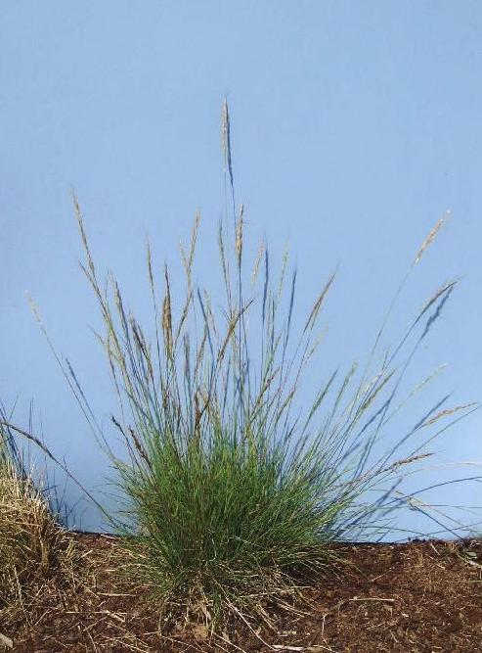

Dale Darris

USDA NRCS Corvallis PMC

##### Alternate Names: Also known as Lemmon’s stipa, *Stipa lemmonii* (Vasey) Scribner. Other scientific names are *Achnatherum lemmonii* subsp. *pubescens* and *Achnatherum lemmonii* var. *jonesii*.

**Uses:** Lemmon’s needlegrass is a desirable cool season bunchgrass for restoration of upland prairies and oak savannas, including sites representing extremes in both drought and soil infertility. In western Oregon and western Washington its best use may be revegetation of hot, sunny, dry, south facing slopes and rocky outcrops with impoverished or weakly developed soils. In drier and nearly semi-arid regions of the western US, the species can be used for rangeland plantings as a component of seed mixtures.

Lemmon's needlegrass is a valuable forage plant and has good palatability for deer, sheep, and cattle. It produces large seeds that are important food for birds and small mammals. The species may have potential in low maintenance lawns or xeric landscaping.

**Description:** Lemmon’s needlegrass is a medium to long lived, relatively short, densely tufted perennial grass with culms (stems) that are 20-80 cm tall and hairy below the nodes (joints). Leaf blades are 10-20 cm long, 1-2 mm wide, flat or rolled inward, and often blue-green in color. The form is spreading to upright and the inflorescence (seed head or panicle) is spike-like, narrow, and pale or purplish in color. Spikelets are one flowered. The subspecies *pubescens* has pubescent or tomentose culms. Lemmon's needlegrass flowers in May and seeds mature by mid June in the foothills of western Oregon.

*Key to Identification:* Lemmon's needlegrass has a distinct spike-like seed head and long awns (linear appendages that are 15-50 mm but typically 20-35 mm) on the seed that are bent twice and twisted at maturity. The species can easily be confused with other grasses in the genus *Stipa* or *Achnatherum.* However, other needlegrasses are less likely to occur at low elevations west of the Cascades from the Willamette Valley northward. Western needlegrass (*Stipa occidentalis*) can co-exist at mid-elevations but its seed is much smaller than Lemmon's needlegrass. Without seed heads the fine textured bluish foliage of Lemmon’s needlegrass may be confused with Roemer’s fescue (*Festuca roemeri*) which has a broader, branching panicle.

**Adaptation:**  Lemmon’s needlegrass is found naturally in northern and western California, including the Sierra Nevada Mountains, north to southern British Columbia and east to Montana, Utah, and Arizona. The species has deep fibrous roots and is very drought tolerant. Stands typically occur on dry sunny slopes, grasslands, savannas, openings within pine woodlands, and upland prairies from sea-level to 7500 ft. elevation. It is adapted to low fertility and moderately acid to slightly alkaline (pH 5.0-7.5), shallow soils derived from basalts. Soil texture ranges from gravelly to medium fine loams and silts. The subspecies *pubescens* is restricted to serpentine soils (soils high in silicates of magnesium and iron as well as other minerals and therefore toxic to many plants).

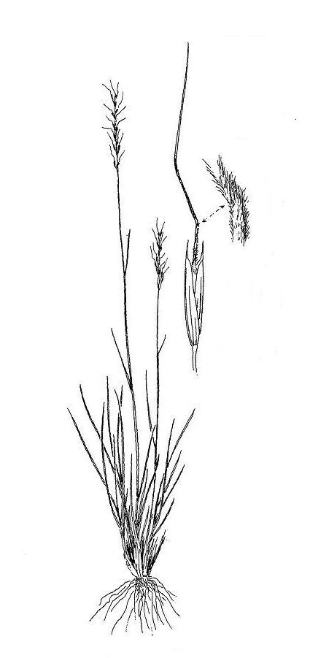

Line drawing reprinted by permission, University of Washington Press

**Commercial availability of seed:** Seed is periodically available in California from vendors. In addition, the Bureau of Land Management and the US Forest Service contract with private growers to produce Lemmon’s needlegrass for their restoration work and growers sometimes sell extra seed. Most of this seed originates from east of the Cascades or southern Oregon. Willamette Valley and western Washington sources may be limited to wild collections.

**Relative abundance in the wild:** This species is infrequent in the Willamette Valley and Puget lowlands where it is often confined to foothills and south slopes. It is more common east of the Cascades as well as in southern Oregon and California.

**Limitations or environmental concerns:** Lemmon’s needlegrass has high seed dormancy and delayed germination which can allow weedy species to establish first. After seedling emergence, establishment is still relatively slow. Plants are shade intolerant. It can be disease prone on winter wet to summer moist sites where it is maladapted or a weak competitor. Like other needlegrasses, the long awned seed can cause injury to the mouth and other facial tissues of livestock.

**Establishment:** The awns on the seed should be removed by a debearder or other device in order to plant using standard seeding equipment. Germination for most seed lots improves substantially with 60-90 days of cold, moist chilling (stratification). Therefore, direct seeding should be in the fall to overcome dormancy. In some cases, light scarification of the seed coat has improved germination as well. There are approximately 95,000 seeds/lb (+/- 15%) with awns removed but hulls intact. One pound of live seed sown per acre is equivalent to about 2.2 live seeds per square foot. For best results and easier management, sow alone at 4-8 lbs/ac or at lower rates in mixes with other species that have similar seed dormancy. Where winters are relatively mild and snow free, seed may germinate outdoors as early as January. Control of fall and winter weeds is essential for initial stand establishment, otherwise results can be poor. Good results can be achieved with the use of a nonselective foliar applied herbicide after sowing but prior to emergence of Lemmon’s needlegrass. The species tolerates light to moderate grazing and fire as natural components of prairie ecosystems.

Prepared By:

Dale Darris, Sonja Johnson, and Amy Bartow. USDA NRCS Plant Materials Center, Corvallis, Oregon.

Species Coordinator:

Dale Darris, USDA NRCS Plant Materials Center, Corvallis, Oregon.

Edited 7/31/07 D. Darris; 070802 jsp

For more information about this and other plants, please contact your local NRCS field office or Conservation District, and visit the PLANTS Web site<<http://plants.usda.gov>> or the Plant Materials Program Web site <<http://Plant-Materials.nrcs.usda.gov>>

*The U.S. Department of Agriculture (USDA) prohibits discrimination in all its programs and activities on the basis of race, color, national origin, sex, religion, age, disability, political beliefs, sexual orientation, and marital or family status. (Not all prohibited bases apply to all programs.) Persons with disabilities who require alternative means for communication of program information (Braille, large print, audiotape, etc.) should contact USDA's* [*TARGET Center*](http://www.usda.gov/oo/target.htm) *at 202-720-2600 (voice and TDD).*

*To file a complaint of discrimination write USDA, Director, Office of Civil Rights, Room 326-W, Whitten Building, 14th and Independence Avenue, SW, Washington, DC 20250-9410 or call 202-720-5964 (voice or TDD). USDA is an equal opportunity provider and employer.*

*Read about* [*Civil Rights at the Natural Resources Conservation Service*](http://www.nrcs.usda.gov/about/civilrights/)*.*