

Plant Fact Sheet

PURPLE GIANT

## HYSSOP

Agastache scrophulariifolia

**(Willd.) Kuntze**

Plant Symbol = AGSC

Contributed by: USDA NRCS Cape May Plant Materials Center

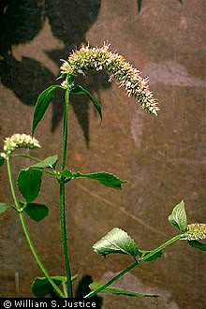

USDA-NRCS PLANTS Database / William S. Justice @ USDA-NRCS PLANTS Database

**Alternative Names**

*Common Alternate Names:*

giant hyssop

prairie hyssop

*Scientific Alternate Names:*

*Hyssopus scrophulariifolia* Willd.

*Agastache scrophulariifolia* var. *mollis* (Fernald) A. Heller

**Uses**

*Wildlife Use:* Purple giant hyssop provides a nectar source for pollinators and is well suited for use in pollinator restoration habitat. Preliminary observation found that purple giant hyssop attracted 14 different species of Hymenoptera and Lepidoptera in Cape May, New Jersey. The halictid bee (*Agapostemon virescens*), leaf-cutter bee (*Megachile mendica*), and *Megachile texana* species were most frequently observed visiting the flower. Other bees known to frequent the flower are the European honey bee (*Apis mellifera*), black and gold bumble bee (*Bombus auricomus*), and *Bombus pensylvanicus*. The flower also attracts goldfinches and hummingbirds.

**Ornamental**

Purple giant hyssop is a popular ornamental plant. The relatively large height of the plant makes it a good choice as a background against fencing.

**Status**

Please consult the PLANTS Web site and your State Department of Natural Resources for this plant’s current status (e.g., threatened or endangered species, state noxious status, and wetland indicator values).

**Description and Adaptation**

*Description:* Purple giant hyssop is a late-flowering, native perennial herb of the mint family. It can grow unusually tall for a mint; up to 6 feet, with diamond-shaped stems, aromatic foliage and flowers, and vigorous stolons. The stems are erect and form clumps. The upper braches may be purplish.

The densely branched inflorescence is a 1–6 in terminal, continuous, or interrupted flower spike, or raceme. The plant usually has several spikes. The tops of the spikes develop into a flower and two lateral branches develop under the flower from a common node; giving the inflorescence a symmetrical appearance. The flower clusters persist throughout the winter.

The individual flowers are ¼ in long, 15-nerved tubes that are lavender to pale pink. The upper lip has 2 lobes and projects forward; and the lower lip curves downwards with 3 lobes. The individual lobes are 3-nerved.

Not all flowers open at the same time. The flowers contain 4 stamens that extend beyond the flower. The two lower stamens curve upwards, while the two upper stamens curve downwards. The pollen sacs are nearly parallel.

*A. scrophulariifolia* is similar to blue giant hyssop (*A. foeniculum*), however purple giant hyssop has a cup-like whorl of green sepals (modified leaf-like bracts under the flower) while *A. foeniculum* has blue-violet sepals. Often the sepals of giant purple hyssop have colored margins.

Nutlets are .05-.07 in (1.5–2 mm), dark brown, rounded, and minutely hairy at the squared-off tip.

The stalked leaves of purple giant hyssop are positioned opposite on either side of the stem. The sharp-pointed leaves are 4 in long and 2 in wide, with a cordate, somewhat heart-shaped or rounded base. The margins of the leaves are coarsely toothed and short hairs cover the leaf stems. The undersides of the leaves are green, and smooth or appear shaggy. Conversely, the underside of the blue giant hyssop (*A. foeniculum*) is whitish. The species name is derived from the Scrophulariaceae or figwort family, for the resemblance of the leaves to the figwort. When crushed, the leaves emit a distinct, anise-like odor.

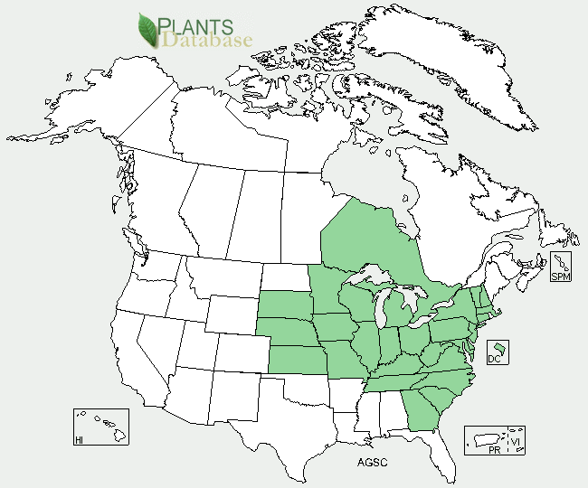

Purple giant hyssop distribution from USDA-NRCS PLANTS Database.

*Adaptation:* Like many members of the mint family, purple giant hyssop grows best in moist soil or wet conditions. It is found in rich woodland sites with dappled shade, woodland borders, meadows, thickets, the upper limits of floodplains, and upland woods. It prefers recently disturbed, sandier soils where competition is limited. Plants will not persist under hot and dry conditions (USDA zone 9 or higher). Threats to its habitat include changes in land use, competition from non-native species, and natural succession. For updated distribution, please consult the Plant Profile page for this species on the PLANTS Web site.

**Establishment**

Purple giant hyssop requires cold stratification and sunlight to germinate. Keep the seed for 8 weeks at 40ºF and move to 68ºF for germination. The seeds will germinate in 30–90 days in containers with good drainage. When planting in the fall, cold stratification is not required. For vegetative propagation, take late spring cuttings from the basal growth that emerges in mid-March. These cuttings can be fertilized for quicker establishment.

Purple giant hyssop propagates rapidly by seed and transplants easy into natural settings. One can use it in dry-site seed mixes for pollinator habitat at 8% of the mix. Sow into open ground and cover with a light layer of mulch or sow into flats and grow to 12 in (30 cm) in height before transplanting. There are 60,000–93,000 seeds/ounce.

**Management**

Because purple giant hyssop requires soil disturbance for successful establishment, regular clearings must be created and maintained through tree-thinning, elimination of competing vegetation, or by delaying natural succession cycles.

Populations of purple giant hyssop tend to be short-lived because they are easily out-competed. Therefore, field plots may need to be re-established every 3–4 years for a fuller look. To encourage more vigorous growth, cut 2–6 in from the plant.

**Pests and Potential Problems**

Little is known about potential pests. Anecdotal evidence suggests it can be affected by mildew and rusts. There are mixed findings on the plant’s susceptibility to browsing deer.

The gradual and continued loss of farmland to either forests or urbanization continues to threaten a species that requires open fields and meadows for habitat.

**Environmental Concerns**

None

**Prepared By**

*Christopher M. Sheahan*; USDA-NRCS, Cape May Plant Materials Center, Cape May, New Jersey.

**Citation**

Sheahan, C.M. 2012. Fact sheet for purple giant hyssop (*Agastache scrophulariifolia)*. USDA-Natural Resources Conservation Service, Cape May Plant Materials Center. Cape May, NJ. 08210.

Published 07/2012

Edited:

For more information about this and other plants, please contact your local NRCS field office or Conservation District <<http://www.nrcs.usda.gov/>>, and visit the PLANTS Web site <[http://plants.usda.gov](http://plants.usda.gov/)> or the Plant Materials Program Web site <<http://plant-materials.nrcs.usda.gov>>

**USDA IS AN EQUAL OPPORTUNITY PROVIDER AND EMPLOYER**