

Plant Fact Sheet

# saskatoon serviceberry

## Amelanchier alnifolia (Nutt.) Nutt. ex M. Roem. var. semiintegrifolia (Hook.)

## C.L. Hitchc.

Plant Symbol = AMALS

*Contributed by*: USDA NRCS Plant Materials Center, Corvallis, OR

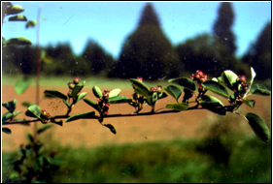

*Photo by Theresa Flessner, Corvallis Plant Materials Center.*

### Alternative Names

*Alternate Common Names:* Pacific serviceberry

*Alternate Scientific Names: Amelanchier alnifolia* (Nutt.) Nutt. ex M. Roem. ssp. *florida* (Lindl.) Hultén, *Amelanchier florida* Lindl.

Uses

*Ethnobotanic*: Saskatoon serviceberry was used by native populations and early settlers of the Pacific Northwest. The berries were eaten raw or were cooked or dried for storage. Cakes of dried berries were a common trading item. The wood is hard and was used for combs, digging sticks, arrows, tool handles, hoops, and spreaders. Decoctions of twigs (bark) were used as medicine.

*Ornamental*: Saskatoon serviceberry may be used in naturalized plantings and as hedges in urban areas. Several cultivars of *Amelanchier alnifolia* are available for ornamental plantings and commercial fruit production. Many of these cultivars and ecotypes originated in western Canada and the northern region of the US.

*Wildlife*: Deer, moose, and other mammals browse Saskatoon serviceberry, and its fruits are relished by several species of song and game birds. These shrubs are often used as cover for small mammals and birds.

*Streambank and Riparian Restoration*: This species is an excellent candidate for streambank and riparian restoration as it suckers readily and tolerates many types of soils.

Status

Please consult the PLANTS Web site and your State Department of Natural Resources for this plant’s current status (e.g. threatened or endangered species, state noxious status, and wetland indicator values).

Description and Adaptation

This species is a thicket-forming shrub or small tree 3 to 12 m tall with smooth brown bark, slender branches, and oblong leaves coarsely toothed along the upper edge. A typical plant is comprised of long shoots and short shoots; only short shoots bear fruit. Floral buds are formed in the first season, but fruit develops the following season. Clusters of perfect white flowers appear in spring before leaves, and dark purple to black berry-like fruits are produced in mid- or late summer. It is self pollinated or cross-pollinated via insects. The fruit contains four to ten dark brown seeds with leathery seed coats. This species may take ten years or longer to flower and reproduce, especially on harsh sites.

Saskatoon serviceberry tolerates many soil types and suckers profusely. It was reported to increase in frequency following fire in one study, although canopy cover decreased. It is found on open, dry, rocky slopes to partially shaded sites with moist deep soils, but prefers moist, well-drained, acid soil and full sun or partial shade. Plants can even be grown in granitic mine spoil and produce reasonable growth, but not on pyritic spoil. It is not tolerant of saline soils and high water tables.

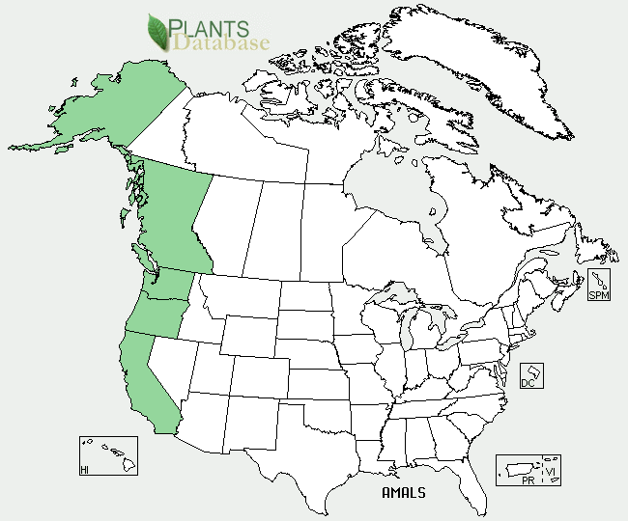 *Saskatoon serviceberry distribution from USDA NRCS PLANTS Database.*

Saskatoon serviceberry occurs west of the Cascade and Sierra Nevada Mountain ranges, from British Columbia south to central California. It may be found in open woods, along canyons, or on hillsides, from near sea level to subalpine altitudes. For updated distribution, please consult the Plant Profile page for this species on the PLANTS Web site.

Establishment

*Seeding:* Seed propagation can result in variability in select traits of 20 to 30%. Many growers use open-pollinated seedlings from named cultivars for commercial orchard establishment as the serviceberry is difficult to vegetatively propagate by conventional means. It is important to note that usually a large percentage of seed collected from wild populations is infertile and insect-infested. Seeds per pound can range from 36,000 to 113,000, with a mean of 61,000. Air-dried seed may be stored in sealed containers with little decline in viability for five years. In the nursery, Saskatoon serviceberry is seeded at the rate of 25 pure live seeds per foot of row. This seeding rate may be reduced to obtain desired or original composition on sites being restored or improved. Unstratified seed is planted in late fall, and moist, pre-chilled seed is planted in spring, at a depth of ¼ inch.

*Cuttings:* Reports of rooting success using softwood cuttings are variable. Timing of cutting and stage of growth of the mother shrub are important factors in rooting success. Transplants or containerized stock should be planted in early spring (harsh, cold sites) or fall. Moist soil, mulch, and partial shade enhance survival and growth. Bare-root stock may be planted in early spring. Two-year-old seedlings may be lifted in fall and stored at 33°F till planting. Seedlings may be planted in rows; between row and within row spacing should be a minimum of 12 ft and 6 ft, respectively.

Management

For orchards and ornamental specimens, branches that are more than four years old should be pruned out for better fruit production and longer life span. Yearly fertilization with 100 pounds per acre of ammonium nitrate will improve color, size, and quality of fruit in older stands. Weed control (chemical and mechanical) and irrigation also enhance fruit production. Well-maintained orchards can produce fruit for twenty years.

For streambank or riparian restoration, Saskatoon serviceberry (2-year-old stock) should be planted on the upper bank. Weed control and supplemental irrigation during the first growing season enhance survival and growth. Moderate browsing can increase twig production. Spring burns on high elevation rangeland can cause mortality, but also significantly increase twig production in Saskatoon serviceberry.

Pests and Potential Problems

This species is susceptible to several pathogens including those that cause rust, witches broom, fire blight, powdery mildew, leaf blights or spots, fruit rot, dieback, canker, root rot, and wound rot. It is also host to several insects including leaf miners, borers, mites, sawflies, scale, root aphids, tent caterpillars, and apple curculio (*Tachypterrellus quadrigibbus*). Of these pests, rust, fire blight, and leaf blights cause the greatest losses; the apple curculio greatly reduces fruit yields. Saskatoon serviceberry is capable of producing toxic levels of hydrogen cyanide (prussic acid). This is toxic to ruminants such as deer and cattle, although prunasin concentration in new growth (leaves) varies with subspecies or variety. Higher levels of this toxin are present in leaves and twigs during bloom stage and rapidly decline thereafter.

Cultivars, Improved, and Selected Materials (and area of origin)

Currently, no cultivars of *Amelanchier alnifolia* var. *semiintegrifolia* have been developed. The development of *A. alnifolia* cultivars has been slow, occurring over many years. The most important of these cultivars have been selected from wild populations. Notable cultivars and improved materials include ‘Smoky’ (Alberta), ‘Pembina’ (Alberta), ‘Forestberg’ (Alberta), and ‘Northline’ (Alberta), ‘Thiessen’ (Saskatchewan), ‘Honeywood’ (Saskatchewan), and ‘Regent’ (MN).

Prepared By:

*Theresa Flessner*, Conservation Agronomist

Corvallis Plant Materials Center, Oregon

**Citation**

Flessner, T. 2000. Plant fact sheet for Saskatoon serviceberry (*Amelanchier alnifolia* var*. semiintegrifolia)*. USDA-Natural Resources Conservation Service, Plant Materials Center, Corvallis, OR.

Published September 2000

Edited: 31Jan2002 jlk; 30May2006 jsp; 21Feb2012 aym

For more information about this and other plants, please contact your local NRCS field office or Conservation District <<http://www.nrcs.usda.gov/>>, and visit the PLANTS Web site <[http://plants.usda.gov](http://plants.usda.gov/)> or the Plant Materials Program Web site <<http://plant-materials.nrcs.usda.gov>>.

**USDA IS AN EQUAL OPPORTUNITY PROVIDER AND EMPLOYER**