

Plant Fact Sheet

# Leadplant

## Amorpha canescens Pursh

Plant Symbol = AMCA6

Contributed by: USDA NRCS Kansas Plant Materials Center

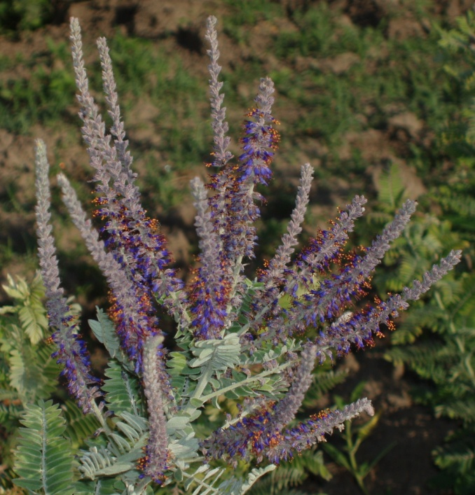

Figure 1. Leadplant showing purple flowers and gray lead-colored leaves. Photo by Alan Shadow (2006) USDA NRCS.

### Alternate Names

Lead-plant, leadplant amorpha, downy indigobush, prairie shoestrings, buffalo bellows, *Amorpha brachycarpa*

### Uses

*Erosion control:* Planted for erosion control because it has deep, branching, woody root system.

*Ethnobotanic*: Many Native American tribes used leadplant in many ways. Most made a tea from the leaves and drank the tea, sometimes as a medicine to treat ailments such as pinworms, eczema, rheumatism, neuralgia, open wounds, and cuts. Some tribes made a substance to smoke from leadplant leaves and buffalo fat. Some believed that it could be used to make a “medicine” to attract buffalo to the person that had it on their clothing. Some tribes named the plant “buffalo bellows” because the timing of flowering coincided with the time of the year that the buffalo were in rut and bellowing.

*Landscaping and restoration*: Leadplant is an ideal ornamental species because it has showy flowers, is drought tolerant, and shade tolerant. It also forms nodules on its roots to fix nitrogen and can be used for prairie restorations.

*Wildlife and livestock*: It is a floral food resource for pollinating insects, including solitary bees. It is very palatable to livestock and wildlife, including cattle, sheep, horses, elk, and deer.

### Status

Please consult the PLANTS Web site and your State Department of Natural Resources for this plant’s current status (e.g., threatened or endangered species, state noxious status, and wetland indicator values).

### Description and Adaptation

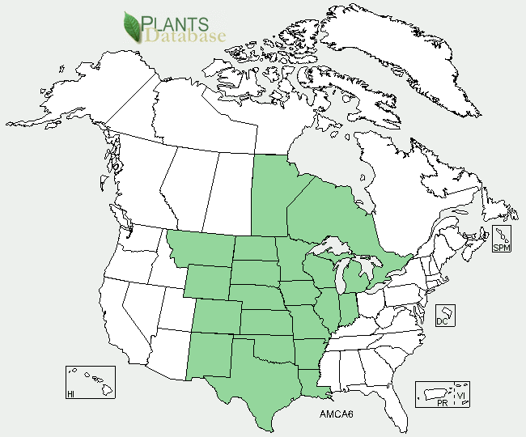

Leadplant distribution from USDA-NRCS PLANTS Database.

Leadplant is a subshrub to herbaceous perennial with multiple stems that can get to about 3 ft tall. Leaves are odd-pinnately compound and covered in dense lead-colored silver-gray hairs (giving the plant its common name). Purple flowers have one petal and are along the top parts of some of the stems. The stamens are orange in color and when found extend out past the petal. The fruits are small pods that contain one seed, which is smooth and brown.

Leadplant can occur in soils that are somewhat acidic to alkaline and can tolerate some salinity. It is resistant to occurrences of fire and can tolerate a moderate amount of grazing. Leadplant is a good indicator of well managed lands that have moderate to low levels of livestock grazing. Leadplant is native to areas in Manitoba and Ontario. In the U.S. it occurs from Montana east to Michigan, and south to New Mexico and Louisiana. For updated distribution, please consult the Plant Profile page for this species on the PLANTS Web site.

### Establishment

### Prepare a firm, weed-free seedbed and plant pods separately or in rows that alternate with grasses. Seed should be inoculated prior to seeding. Seed should be planted 1/4 in. to 3/16 in. deep in the spring or fall, depending on stratification requirements. For full stands of leadplant a seeding rate of 20 to 30 pure live seed (PLS) per square foot is needed. For seeding in grass or grass forb mixtures use a seeding rate of 0.5 to 1 PLS per acre.

### Seed will need to be stratified. Methods for stratification of seed are to sow seeds in the fall and let them stratify over winter or soak in 180-200˚F (82-93˚C) water for 12 hours then moist chill seed at 41˚F (5˚C) for 30 days. Germination will be between 14 and 20 days after planting.

Leadplant can also be propagated by greenwood or hardwood cuttings. Transplanting success is generally poor in prairie restorations.

### Management

Initially grazing should be withheld and weeds controlled by mowing above seedlings during establishment period. Graze or mow conservatively and periodically graze only after dormancy to sustain cover and high production improvement, leaving tall stubble. The presence of leadplant on native rangeland is usually indicative of a well managed area.

### Pests and Potential Problems

Common pests of leadplant are grasshoppers, leafhoppers, and small mammals. Leaf spots, rusts, downy mildew, and *Cytospora amorphae* have been found on leadplant but they are not considered major diseases.

### Environmental Concerns

There are no known environmental concerns associated with leadplant.

### Cultivars, Improved, and Selected Materials (and area of origin)

These plant materials are somewhat readily available from commercial sources. No known cultivars, improved, or selected materials of leadplant are known at this time.

**Photo Credit:** Shadow, A. 2006. Photo of leadplant. USDA-NRCS East Texas Plant Materials Center, Nocogdoches, TX.

**Prepared By:** *P. Allen Casey,* USDA NRCS Kansas Plant Materials Center, Manhattan, Kansas

### Citation

Casey, P. A. 2011. Plant Fact Sheet for leadplant (*Amorpha canescens)*. USDA-Natural Resources Conservation Service, Manhattan Plant Materials Center. Manhattan, Kansas.

Published: March 2011

Edited: 27Jan2011 rlw; 28Jan2011 jmr; 2Feb2011 jd;

For more information about this and other plants, please contact your local NRCS field office or Conservation District <<http://www.nrcs.usda.gov/>>, and visit the PLANTS Web site <[http://plants.usda.gov](http://plants.usda.gov/)> or the Plant Materials Program Web site <<http://plant-materials.nrcs.usda.gov>>

**USDA IS AN EQUAL OPPORTUNITY PROVIDER AND EMPLOYER**