|  |
| --- |
| utah serviceberry |
| *Amelanchier utahensis* Koehne |
| Plant Symbol = AMUT |

*Contributed by: Upper Colorado Environmental*

Plant Center, Meeker, Colorado

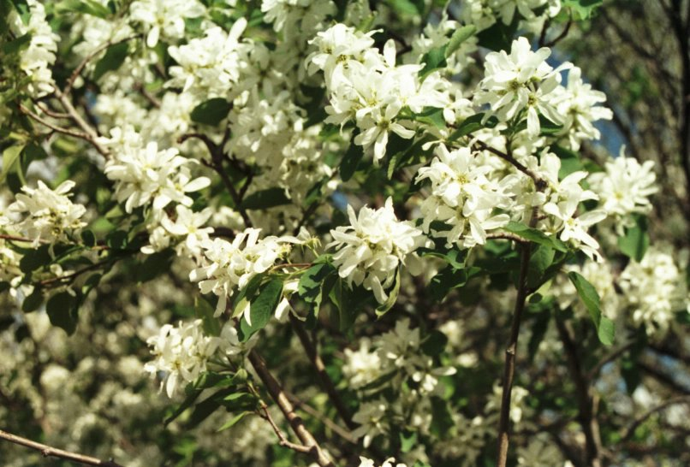

Steve Parr, Upper Colorado Environmental Center

Alternate Names

Serviceberry, juneberry, shadbush, and sarvis.

Uses

Utah serviceberry can be used for food and cover to improve wildlife habitat. Leaves and small branches are used by big game and livestock and berries are consumed by birds and small animals. It also provides nesting and cover for birds. Utah serviceberry can be used for reseeding big sagebrush and pinyon-juniper sites and is also beneficial for conservation plantings on rangeland and mined land. The plant can be used for landscaping and beautification and as a component of windbreaks and shelterbelts. The berries are also a source of food for Native Americans. Berries persist longer on the bush than Saskatoon serviceberry and provide a food source over a longer period of time, especially when the ground may be covered with snow.

Status

Please consult the PLANTS Web site and your State Department of Natural Resources for this plant’s current status.

Description and Adaptation

Rose Family. Considerable variation occurs in the native shrubs or small trees that are generally 2 to 4 meters tall. Deciduous leaves are simple, alternate, and usually serrate-dentate from the middle to the tip. Flowers form in clusters in early May with five showy white petals and the ovary is 2 to 5 celled. The persistent purplish – black pome can remain dry and pulpy. The plant is accustomed to rocky slopes, canyons, and stream banks at elevations of 5000 to 9000 feet from Montana to Oregon, south to New Mexico, and California. It has a deep spreading root system and is found on sites with 12 to 20 inches of annual precipitation with soils that are coarse to medium textured and well drained. It is not tolerant of high water tables or saline soils. Considerable variation occurs when it is found on sites with Saskatoon serviceberry where natural hybrids are sometimes found. It generally occupies drier sites than Saskatoon serviceberry.

Establishment

Utah serviceberry can be established with seed planted about ¼ of an inch deep in the fall months or with container grown plants set in the ground in early spring when soil moisture is present. Sprouting does occur but is not as common as the occurrence in the more northern ecotypes of Saskatoon serviceberry. Establishment can be slow, especially if soil moisture is low, but the plant can survive on drier sites than Saskatoon serviceberry. New plantings can require several years (8 to 10) for flowering and seed production. Protection from browsing and plant competition along with the use of mulch will reduce the time required for establishment.

Management

After seeding or planting live plants, controlled browsing will be important for maintaining vigorous growth. Reducing plant competition is also necessary for rapid plant growth. Controlled browsing will be important for berry production. Once established, the plant can withstand moderate to heavy browsing in years with average to above average precipitation.

Pests and Potential Problems

The plant is host to Apple-cedar rust when growing in close proximity to junipers. The rust affects leaves and berries. No other serious diseases or pests are known.

Environmental Concerns

The plant is not known to be aggressive, invasive, or difficult to control when used in areas where adapted.

Cultivars, Improved, and Selected Materials (and area of origin)

Long Ridge Germplasm Utah serviceberry is the only release of the species. Seed and plants of Long Ridge Germplasm are available from Upper Colorado Environmental Plant Center (UCEPC), Meeker, Colorado.

Prepared By:

*Gary L. Noller*, Upper Colorado EnvironmentalPlant Center, Meeker, Colorado

Species Coordinator:

*Gary L. Noller*, Upper Colorado EnvironmentalPlant Center, Meeker, Colorado

Edited: 080826 jsp

For more information about this and other plants, please contact your local NRCS field office or Conservation District, and visit the PLANTS Web site<<http://plants.usda.gov>> or the Plant Materials Program Web site <<http://Plant-Materials.nrcs.usda.gov>>

*The U.S. Department of Agriculture (USDA) prohibits discrimination in all its programs and activities on the basis of race, color, national origin, age, disability, and where applicable, sex, marital status, familial status, parental status, religion, sexual orientation, genetic information, political beliefs, reprisal, or because all or a part of an individual's income is derived from any public assistance program. (Not all prohibited bases apply to all programs.) Persons with disabilities who require alternative means for communication of program information (Braille, large print, audiotape, etc.) should contact USDA's TARGET Center at (202) 720-2600 (voice and TDD).*

*To file a complaint of discrimination write to USDA, Director, Office of Civil Rights, 1400 Independence Avenue, S.W., Washington, D.C. 20250-9410 or call (800) 795-3272 (voice) or (202) 720-6382 (TDD). USDA is an equal opportunity provider and employer."*

*Read about* [*Civil Rights at the Natural Resources Conservation Service*](http://www.nrcs.usda.gov/about/civilrights/)*.*