# BIG BLUESTEM

## Andropogon gerardii Vitman

Plant Symbol = ANGE

Contributed by: USDA NRCS Jimmy Carter PlantMaterials Center, Americus Georgia

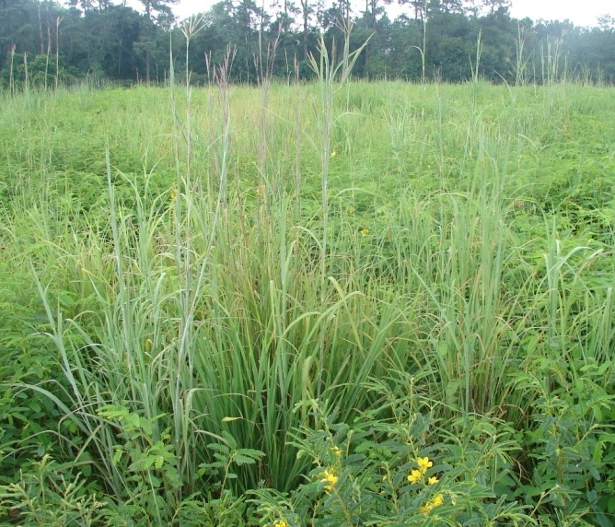

Mike Owsley

Jimmy Carter Plant Materials Center

Americus, Georgia

### Alternate Names

Bluejoint, Bluejoint beardgrass, poptillo gigante, turkeyfoot.

### Uses

*Erosion control*: Critical area seeding, roadside cover, and areas subject to wind erosion.

*Livestock*:High quality forage, with crude protein content up to 16-18% during the growing season, dropping below 6% in late summer. It is grown for pasture and hay production, singly or in mixes.

*Ethnobotanic:* The roots used as a diuretic and to alleviate stomach pains, leaf blade extracts used as a wash for fevers or an analgesic.

*Landscaping:* Used in wildflower meadows and as a border or accent in native gardens.

*Pollinators:* Constitutes part of the native plant community in support of pollinators.

*Restoration:* Used in restoration of native prairie areas and longleaf pine understory.

*Wildlife*: Browsed by white-tailed deer and American bison. In native mixes it provides nest, brood and escape cover for bobwhite quail. Songbirds, prairie chicken, and small mammals consume big bluestem seed.

### Status

Please consult the PLANTS Web site and your State Department of Natural Resources for this plant’s current status (e.g., threatened or endangered species, state noxious status, and wetland indicator values).

### Weediness

This plant may become weedy or invasive in some regions or habitats and may displace desirable vegetation if not properly managed. Please consult with your local NRCS Field Office, Cooperative Extension Service office, state natural resource, or state agriculture department regarding its status and use. Weed information is also available from the PLANTS Web site at [http://plants.usda.gov](http://plants.usda.gov/). Please consult the Related Web Sites on the Plant Profile for this species for further information.

### Description and Adaptation

Big bluestem is a native, perennial warm-season bunchgrass. Scaly rhizomes are 1 to 2 inches below the soil surface, with the main roots extending to 10 feet. It can grow 6-8 feet tall, generally shorter in the northern range, and taller in the southern. Leaf blades range from 0.5-2 feet long. Seed heads consist of 2-6 (usually 3) blooming racemes resembling a turkey foot. Flowering can range from July-October.

The fluffy seeds are oblong, less than 0.25 inches long. It does well in full sun or partial shade. Big bluestem grows best in moist, well-drained sandy and clay loam soils. It does well in low fertility. It is a major component of the tall grass vegetation that dominated the prairies of the central and eastern United States. It is a common grass in the understory of longleaf pine communities of the southeastern U.S

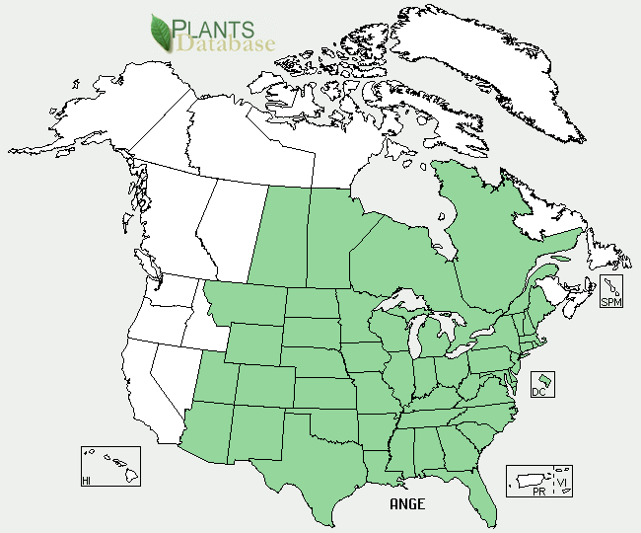

Big bluestem distribution from USDA-NRCS PLANTS Database.

For updated distribution, please consult the Plant Profile page for this species on the PLANTS Web site.

### Establishment

Big bluestem requires a soil temperature above 50°F for germination. The optimum time to plant is usually from early May to late June. In southern states planting is recommended after frost but before dry conditions of early summer are established.

The seed is light and has small awns attached. Debearding removes the awns, producing a free-flowing product. The planting site should be free of weeds. A moist, firm seedbed is essential. Firming the soil with a roller packer before and after seeding helps to ensure that the seed is placed at the recommended seeding depth of 1/8 to 1/4 inch. Packing after planting is especially important if seeded with a broadcast spreader.

If drilled for pasture conditions, use 6 to 8 pounds PLS (pure live seed) per acre. For broadcast seeding, use 10 pounds PLS per acre. The seeding rate for mixed pastures (Indiangrass, switchgrass, big bluestem and little bluestem) are 2-2.5 pounds PLS per acre. Seeding rates for other uses will normally be lower than the pasture rate. Big bluestem has strong seedling vigor, but stands develop slowly where there is competition from broadleaf weeds and cool-season grasses. To minimize the amount of exposed weed seed in seedings use no-till establishment methods. Cool season grasses must be controlled before seeding. Big bluestem is tolerant of most broadleaf herbicides. It is important to follow label instructions for application amounts and grazing requirements.

The most common cause of failure of native warm-season grasses is a loose seedbed and improper seed placement. The seedbed should be firm, showing only a light footprint.

### Management

Fertilizing with moderate amounts of phosphorus and potassium are recommended for establishment. Applications of nitrogen are not recommended until the grass is established. In the establishment year, 20 to 40 pounds per acre of phosphorus and potassium may be applied in late summer. In the second year, phosphorus and potassium may be applied in the early summer at a rate of 40 to 80 pounds per acre. When mature, fertilizer may be applied to enhance vigor for forage production and erosion control. Big bluestem used for purposes other than pasture will require minimal if any fertilization.

Properly managed and maintained stands of big bluestem should not require replanting. Poor stands can be rejuvenated using management practices, such as controlled grazing, the application of herbicides and fertilizer, and prescribed burning. Nitrogen, phosphorus, and potassium fertilizer should be applied according to soil tests.

In rotational grazing systems, remove no more than ½ the above ground growth (no shorter than 8 to 12 inches). With care, the stand will last indefinitely. Forage quality will remain high until the seed head emerges. Grazing should begin when grass is 18 to 20 inches in height. Overgrazing can damage the stand and should be stopped when the plants are grazed to within 8 inches of the soil level. Leaving this much stubble before frost allows the plants to store carbohydrates and ensures the production of vigorous plant growth in the spring.

Prescribed burns increase vigor in the plant and improve its ability to control erosion and increase forage production. They are essential in restoration and wildlife plantings.

### Pests and Potential Problems

Armyworms can become a problem in dry years. Midges can reduce seed viability.

### Environmental Concerns

Cultivars developed for forage production may dominate native big bluestem stands in natural plant communities and restoration sites.

### Control

Please contact your local agricultural extension specialist or county weed specialist to learn what works best in your area and how to use it safely. Always read label and safety instructions for each control method. Trade names and control measures appear in this document only to provide specific information. USDA NRCS does not guarantee or warranty the products and control methods named, and other products may be equally effective.

### Cultivars, Improved, and Selected Materials (and area of origin)

'Bison' (ND), ‘Eldorado’ (TX), ‘Earl’ (TX), ‘Kaw’ (KS), ‘Niagara’ ( NY) and ‘Roundtree’ (MO).

### Prepared By: Jimmy Carter Plant Materials Center

**Citation:** Owsley, Mike, 2011. Plant fact sheet for Big Bluestem (*Andropogon gerardii* Vitman). USDA-Natural Resources Conservation Service, Jimmy Carter PMC Americus, Georgia 31719.

Published: February 2011

Edited: e.g., 08Sep2009 rg, 08Sep2009 jfh; 17Sep2009 jfe, 10 Feb2011 cmo

For more information about this and other plants, please contact your local NRCS field office or Conservation District <<http://www.nrcs.usda.gov/>>, and visit the PLANTS Web site <[http://plants.usda.gov](http://plants.usda.gov/)> or the Plant Materials Program Web site <<http://plant-materials.nrcs.usda.gov>>